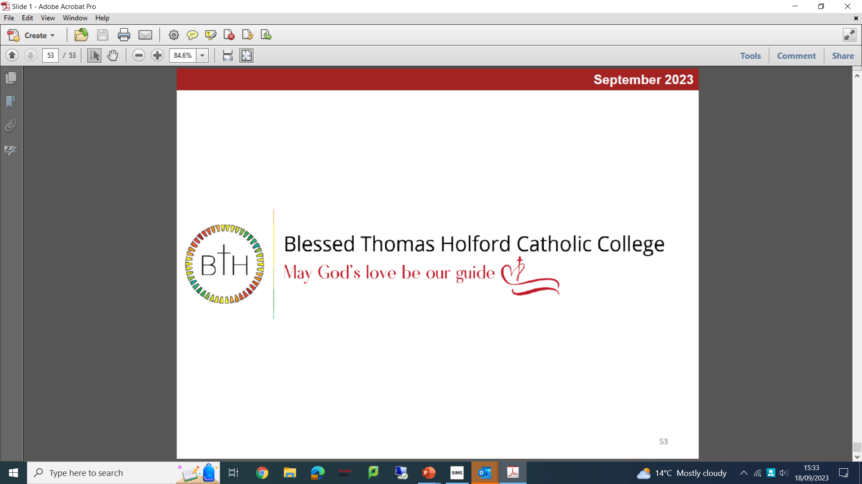
Teaching Assistant Level 1
Required as soon as possible until 31st July 2024
(Fixed Term – Subject to Funding)

To work 30 hours per week (5 days), term time plus 1 week

Band 1: scp 2 to 3 (£20,441 to £20,812 pro rata)
(actual salary: £14,551- for working 30 hours per week/39 weeks)

We are looking to appoint a Teaching Assistant to work in the classroom with the teacher, to support pupils within the SEND department, to ensure that every child succeeds.

Successful candidates will need to have high expectations of all pupils’ attainment and behaviour, be enthusiastic about pupils’ learning, and be determined to get the best out of each pupil.

We are looking for candidates who:
- Have a GCSE or equivalent qualification in English and Maths
- Have experience of working with or caring for children aged 11 to 16
- Can work constructively as part of a team, and understand how children learn
- Ideally have a TA qualification or equivalent, or willing to work towards

If you are someone with determination to get the best out of each pupil and are willing to immerse yourself in all aspects of school life, this TA role is for you.

Candidates must be available to work Monday to Friday, 9.00 am to 3.30 pm.

For informal discussion about the role please email recruitment@bthcc.org

To apply:
The job description and application form are available on the School’s website: http://www.bthcc.org.uk/job-vacancies/

All applications must be made using the CES application forms. CV’s will not be accepted.
Completed applications should be returned to: recruitment@bthcc.org

Closing date: 9.00 am on Monday 9th October 2023
Interviews will be held: week commencing 16th October 2023

Our school is committed to safeguarding and promoting the welfare of children and young people and expects all staff to share this commitment. An enhanced Disclosure and Barring Service (DBS) disclosure will be sought, along with other relevant pre-employment checks for the successful applicant

