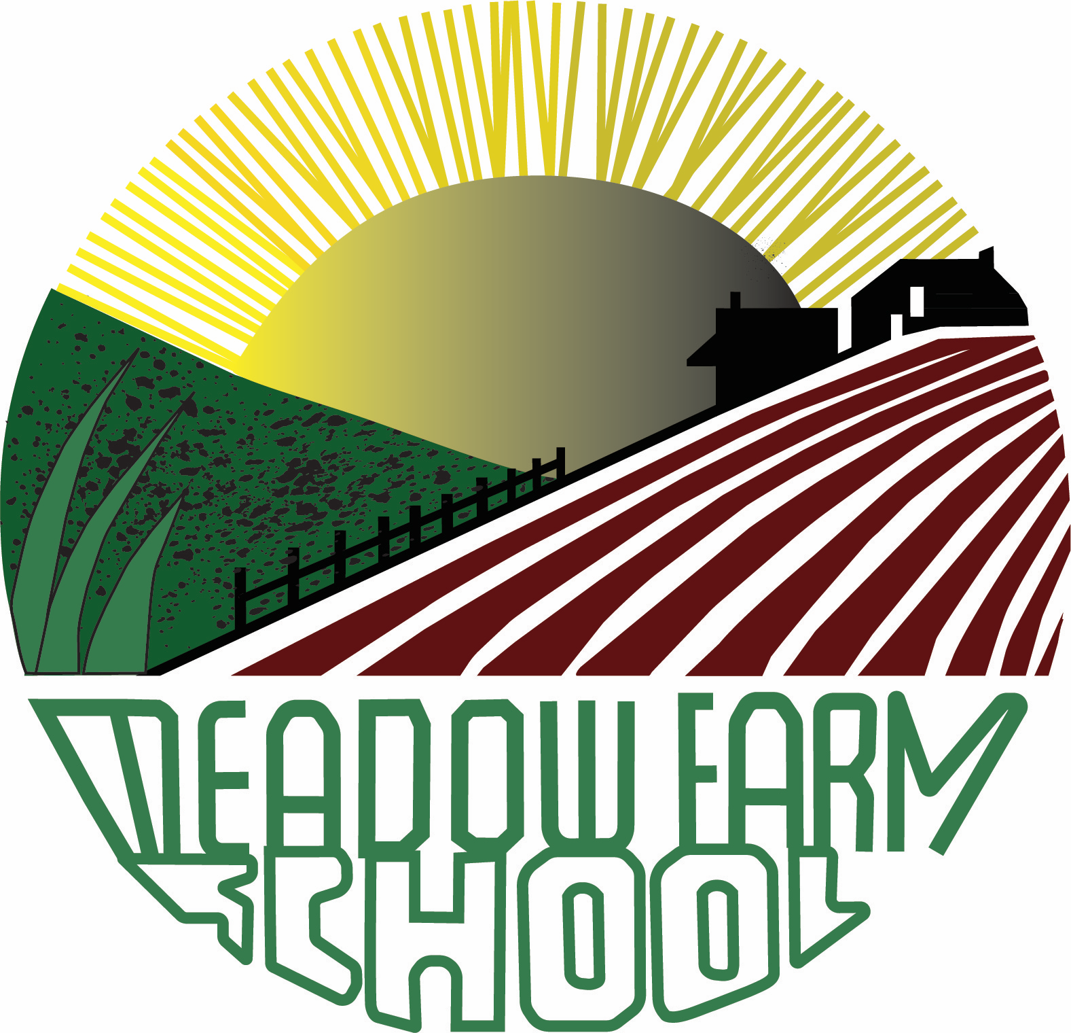

Job vacancy details for | Teaching Assistant Level 1
Department | Children and Young Peoples Directorate
Salary | Grade C Point 5 - £24,790 per annum pro rata
Hours | 16.25 hours (term time only, five days a week)
Contract Type | Temporary for two terms – Spring and Summer
Location | Meadow Farm Community Primary School
Closing date | Friday 6th December 2024 at 12 noon

Governors at Meadow Farm Primary School are seeking a talented teaching assistant to join our experienced team of staff in Early Years.

Meadow Farm Community Primary School is committed to safeguarding and promoting the welfare of children and young people and expects staff to have the same commitment. Appointments will be subject to DBS checks.

““Before applying for this post, please refer to our school website https://www.meadowfarmschool.co.uk/policies-and-documents/ and view our child protection / safeguarding policy”.
“This post is exempt from the provisions of the 1974 Rehabilitations of Offenders Act. It is an offence to apply for the role if you are barred from engaging in regulated activities relevant to children”.
You will have high expectations, be dedicated to our child-centred approach and be bursting with engaging ideas. Joining us, you will be a creative and accomplished practitioner who welcomes collaborative practice and working in a supportive, exciting environment.

To be part of our school you will need to:

• Be able to develop positive relationships with the whole community
• Have high expectations for teaching and learning
• In possession of the personal skills needed to be able to communicate effectively within the school and with a range of external professionals, parents and governors.
• Be committed to continuing professional development
• Be a proactive learner and willing to work collaboratively
• Make a positive contribution to our school
• Passionate about inclusion and the learning and development of every child
• Have experience of working in an early years setting

In return, we can offer you:

• A culture of growth mindset where purposeful practice and effort are rewarded
• A creative, exciting curriculum which we continue to reflect on and adapt
• A dynamic staff who all share the same goals and ethos
• A leadership team that is committed to staff development, teaching & learning and pupil outcomes
• Opportunities to develop your career
• A school that is committed to ensuring that every child succeeds

This opportunity is suitable for applicants at all stages in their career. We are looking for the best candidate for our school!

Visits to the school are warmly welcomed and are a perfect opportunity to see what we offer and discuss your ambitions. To arrange a visit, please contact 01332 662631 to make an appointment for a visit.

To apply, please return your application form with your letter of application to admin@meadowfarm.derby.sch.uk For a paper copy, please send a large, self-addressed and stamped envelope to: Meadow Farm Primary School, Foyle Avenue, Chaddesden, Derby DE21 6TZ

The closing date for this vacancy is Friday 6th December at 12 noon. Any application forms received after the closing date will not be accepted.

