Headteacher:

Mrs Sarah Roberts
Email:
Office@eckingtonfirst.worcs.sch.uk
Website:
www.eckingtonfirstschool.co.uk
School Lane
Eckington
Pershore
Worcestershire
WR10 3AU

Telephone: 01386 750666

Teaching Assistant Level 2 & Wrap Around Care supervisor
24.75 hours over 5 days (see below for breakdown of hours) - Term time only and INSET (pro rata) days, temporary for 1 year from September 2022

Eckington CE Primary School is a welcoming, caring school. We deliver an excellent, inspiring curriculum to engaged learners in a happy, friendly and supportive environment. This is an exciting opportunity to work with delightful children as part of a dedicated and committed staff team.
We are appointing a teaching assistant who can add skills and expertise to our flexible and knowledgeable team of staff. The role will be to mainly provide support for children in our early years class of nursery and reception children. The successful candidate will be expected to provide general classroom support, working alongside the classroom teacher for the development and education of children. There will also be times where you will need to oversee the delivery of learning activities to the class in the short-term absence of the class teacher. The role also includes hours leading our wrap around care with some before and after school sessions. Experience of working across the primary age range is desirable. Applicants should state on their application form any areas of expertise they may be able to bring to the school.

The duties and responsibilities allocated to the post will be based on the skills, experience, knowledge and qualifications of the individual appointed.
Breakfast club/LTS contract – 2 hrs
TA 2 (in class) – 16 hrs
TA 2 (after school club) - 6.75

The successful candidates will:
- Be a good classroom practitioner
- Be sensitive to the needs of individual learners
- Be enthusiastic and determined to make learning fun
- Be passionate about good teaching and learning
- Have good English and maths skills
- Be responsible, well-organised and resourceful
- Have relevant qualifications
- Be committed to raising the level of achievement for all pupils
- Have a positive, cheerful attitude and a good sense of humour
- Be able to work effectively as part of a team
- Be able to reflect the values of our Church school

OUTLINE RESPONSIBILITIES AND TASKS
Under the direction of and within an education plan provided by the classroom teacher:
- To assist the teacher with learning activities generally in the classroom.
- Contributing to the planning and needs of the Foundation Stage relating to the individual needs of pupils and students.
- To carry out appropriate activities as planned within the classroom or with groups of pupils including administration of baseline tests.
- To display and present children's work.
- To prepare resources for lessons and activities.
- General supervision, counselling and discipline of children and students, within the procedures of the school.
- To assist the teacher in liaising with parents and professionals such as speech therapists.
- To assist at an appropriate level with the provision of general care and welfare of children.
- Adhering to and maintaining school routine and codes of conduct.
- Supporting the ethos of the school.
- To assist with the support of group activities within and away from the classroom, i.e. P.E., swimming, educational visits.
- Promote pupil independence in learning, and reinforcing the child(ren)'s self-esteem through praise and encouragement.
- To maintain personal and professional development to meet the changing demands of the job, participate in appropriate training activities and encourage and support staff in their development and training.

Please contact Mrs Lorna Gower (School Administrator) on 01386 750666 or by email to office@eckingtonfirst.worcs.sch.uk for further information. Visits to the school are welcomed and can be arranged by contacting the school office.

Eckington CE First School is committed to safeguarding and promoting the welfare of children and expects all staff and volunteers to share this commitment.

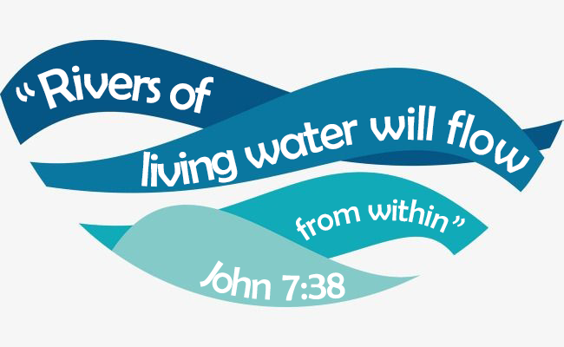
June 2022

