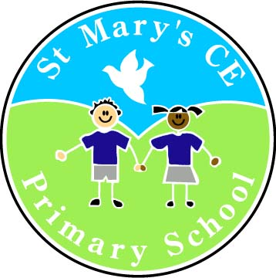 | St Mary’s CE Primary School, Deane  www.st-marys-deane.bolton.sch.uk  office@st-marys-deane.bolton.sch.uk  01204 333494

TEACHING ASSISTANTS LEVEL 2 WITH SNA ALLOWANCE
GRADE 4 + SNA ALLOWANCE
FULL TIME
PERMANENT
REQUIRED AS SOON AS POSSIBLE

The Governors at St Mary’s CE Primary School are seeking to appoint three Level 2 Special Needs Assistants to work with children in receipt of EHCPs. We are looking for candidates who are dedicated and highly motivated, and able to provide high quality support to children with high needs. We have vacancies in the EYFS, Key Stage One and Key Stage Two.

The candidates will have:

- a minimum of 2 years’ experience of working with children of primary school age or NVQ 2 or equivalent in teaching assistance
- experience of working with children with communication and interaction difficulties
- experience of delivering interventions
- knowledge about ASD and how best to support children with a diagnosis
- a good understanding of behaviour and how to prevent and manage episodes of challenging behaviour
- an understanding of sensory processing difficulties and how to support these through sensory circuits and other strategies

The candidates will;

- support children’s development (physical, emotional, social, communication and intellectual development needs)
- help to keep children safe, including maintaining a safe environment, dealing with accidents, supporting safeguarding
- encourage children’s positive behaviour
- contribute to positive relationships with children and adults through communication and interaction
- provide effective support for colleagues
- support learning across the curriculum

Interested candidates are encouraged to visit the school before applying. Please contact the main office to arrange a visit on 01204 333494.

Completed application forms should be returned for the attention of Emma Pilling (Deputy Head teacher).
Closing date: Wednesday 13th November at 4.00pm
Shortlisting: Thursday 14th November
Interviews: Week beginning Monday 18th November.

The application form, job description and person specification are available to download or alternatively please contact the school office on 01204 333494.

Applications should be returned electronically to: office@st-marys-deane.bolton.sch.uk

The school is committed to safeguarding and promoting the welfare of children and young people and expects all staff and volunteers to share this commitment. This post is subject to a fully enhanced DBS check.

