

Teaching Assistant Level 2

St Maxentius CE Primary School

Salary: Grade D point 6-11 – pro rata
Required From: 1st September 2025
Hours: 30 hrs per week (Term Time only)
12-month contract until 31st August 2026

The Governors of St Maxentius CE Primary School invite applications for the above post from suitably qualified, experienced professionals. The person appointed will be expected to provide high quality support of teaching and learning and assessment with children across the school, lead interventions and build strong relationships with everyone in the school community.

We are looking for someone who:
- Is a highly effective and competent practitioner with high expectations of children’s achievements and standards in all areas of school life;
Has the skills and knowledge to support teaching and learning.
- Has excellent communication, interpersonal skills and a good sense of humour;
- Is positive, energetic and enthusiastic making learning fun and engaging for all;
- Is hardworking, committed and will play a full part in the life of the school;
- Would be understanding and supportive to the values of a church school;
- Work in partnerships with our school family and wider community for the good of our children.

In return we can offer a school with:
- Well behaved, friendly and motivated children who love to learn;
- A friendly and skilled staff;
- Commitment to the professional development of staff;
- A welcoming, caring atmosphere where everyone is valued.

Application packs are available from the Greater Jobs website and completed applications should be returned to Mrs Kirsty Diggle (Finance/HR Officer) at Archbishop Temple Trust.

Email: digglek@archbishoptempletrust.co.uk

Closing date: Monday 23rd June 2025 9am
Observations/Interviews: Thursday 26th June

This school is committed to safeguarding and promoting the welfare of children and young people and expects all staff and volunteers to share this commitment. Successful candidates will be subject to an Enhanced Disclosure by the Disclosure and Barring service.

Visits to the school are welcomed. Please contact Kirsty Diggle, digglek@archbishoptempletrust.co.uk

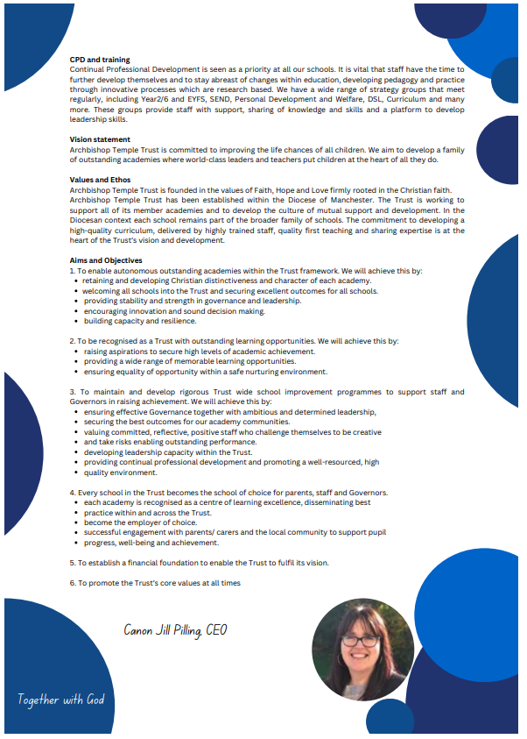

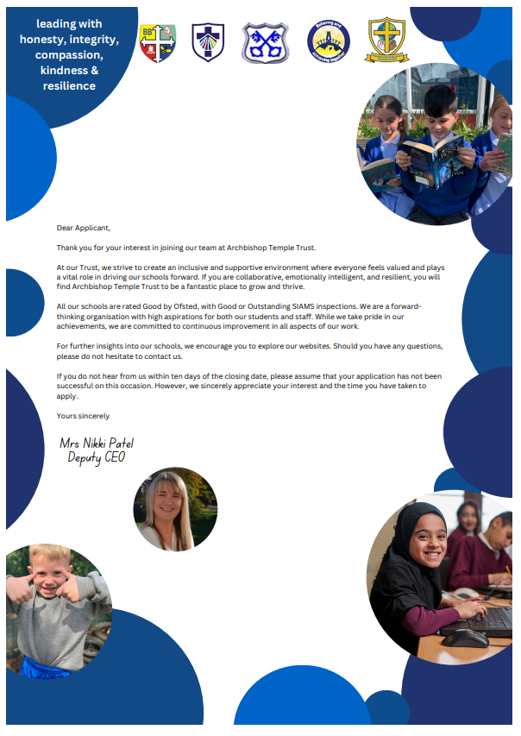


Job Description

Job Details
School Name | St Maxentius CE Primary School
Job Title | TEACHING ASSISTANT LEVEL 2
Grade | GRADE D
Primary Purpose of Job | Provide effective support for teaching and learning in school
Responsible to | Line Manager/Head Teacher/ Deputy Headteacher
Responsible for | N/A
Principal Responsibilities | Provide support for teaching and learning activities  Contribute to children’s development and safeguarding  Provide support to develop the learning environment

Main Duties
Provide support for learning activities across EYFS, KS1 and KS2.
Support children’s needs and development (e.g. physical, emotional, social, communication and intellectual development needs)
Help to keep children safe, including maintaining a safe environment, dealing with accidents, supporting safeguarding.
Encourage children’s positive behaviour using positive reinforcement and by developing strong relationships.
Contribute to positive relationships with children and adults through communication and interactions
Provide effective support for colleagues and work effectively as part of a team.
Support all teaching and learning, helping children to make god progress.
Use technology to support teaching and learning
Observe and report on pupil performance, make on going assessments and talk about the children’s progress and achievements
Create displays and an effective classroom environment conducive to independent learning
Supervise children on educational visits and out-of-school activities including clubs.
Contribute to maintaining pupil records
Contribute to monitoring and maintaining curriculum resources
Invigilate tests and examinations

Other duties for staff with responsibility for supporting play in settings
Support children’s play and learning by making purposeful interactions.
Support children play by setting up effective indoor and outdoor provision.
The post holder may reasonably be expected to undertake other duties commensurate with the level of responsibility that may be allocated, at the discretion of the Head Teacher and to meet the needs of the school

Version Control
Job Description prepared by: | School’s HR
Job Description updated:



Person Specification

Job Details
School Name | St Maxentius CE Primary School
Job Title | TEACHING ASSISTANT LEVEL 2
Grade | GRADE D

The minimum essential requirements for the above post are as follows. Please try to show in your application form, how best you meet these requirements.

Skills and Knowledge |  | Method of Assessment
 | Ability to support the teacher in planning, delivering and evaluating learning activities to ensure effective teaching and learning. Ability to give feedback in a constructive manner. | Application Form/Interview
 | Ability to listen and observe children and share observational findings effectively. | Application Form/Interview
 | Ability to keep children and young people safe during day-to-day work activities. Ability to assess the balance between safety and risk, challenge and protection, and adjust own behaviour and accordingly. | Application Form/Interview
 | Ability to praise and encourage children according to their age, needs and abilities. Ability to deal sensitively with challenging behaviour (in line with setting/school policy and procedures). Act as a role model for positive behaviour. | Application Form/Interview
 | Ability to interact and respond positively to children and adults. Ability to establish and maintain rapport with pupils and the school community. Ability to demonstrate verbal and non-verbal communication skills when dealing with children, colleagues, parents, carers, families and other practitioners. | Application Form/Interview
 | Ability to become an effective member of staff. Ability to work effectively with colleagues and other practitioners. Ability to take an active role in developing own skills and expertise. | Application Form/Interview
 | Ability to help pupils, under the direction of the teacher, to participate in whole class, group and individual English and Maths learning activities. | Application Form/Interview
 | Ability to operate ICT resources safely and effectively as a learning resource. Ability to access and use learning programmes and information. | Application Form/Interview
 | Ability to encourage and support pupils in using ICT during learning activities and feedback on their progress and response. | Application Form/Interview
 | Value people equally, supporting an inclusive ethos | Application Form/Interview
 | Excellent English, Maths and Communication skills | Application Form/Interview
 | Understanding of roles and responsibilities for supporting pupils’ learning and implications for the support you can provide. | Application Form/Interview
 | Knowledge and understanding of children and young people’s development in relation to the ages covered by the school | Application Form/Interview
 | Awareness of safeguarding principles and safe working practices | Application Form/Interview
 | Displays commitment to the protection and safeguarding of children and young people. | Application Form/Interview
 | Knowledge and understanding of importance of consistent behaviour management | Application Form/Interview
 | Knowledge and understanding of the key features of effective communication. | Application Form/Interview
 | Knowledge and understanding of appropriate software packages | Application Form/Interview
 | Competencies  Please note the school’s competencies, which are considered to be essential for all roles, are in the attached Core Competencies document. | Interview

Experience, Qualifications and Training |  | Method of Assessment
 | Experience of working with and/or caring for children within specified age range/subject area | Application Form/Interview
 | Holder of an NVQ Level 2, BTEC Level 2 or equivalent in Teaching Assistant or Supporting Teaching and Learning in Schools | Application Form/Interview

Work Related Circumstances |  | Method of Assessment
 | To attend school events and relevant out of hours training. | Application form/Interview
 | This post is subject to an enhanced disclosure and a barred list check from the Disclosure & Barring Service | Application Form / Interview

These core competencies are considered essential for all roles within Bolton Council. Please be prepared to be assessed on any of these during the interview process and, for the successful applicant, throughout the probationary period.

Developing Self & Others
Promote a learning environment to embed a learning culture. Support others to develop their skills and knowledge to fulfil their potential. Actively pursue your own development. Support and promote the principles of Investors in People.

Civil Contingencies
Bolton Council has a statutory duty under the Civil Contingencies Act to respond in the event of an emergency. If Bolton Council’s Emergency Management Plan is activated, you may be required to assist in maintaining key Council services and supporting the community. This could require working outside of routine working hours and working from places other than your normal place of work.

Equality & Diversity
Uphold the principles of fairness and the Equality Act in all undertakings as a Bolton Council employee, including providing a fair, accessible service irrespective of customer’s race, religion, gender, sexuality, disability or age.

Customer Care
The ability to fully understand, assess and resolve the needs of all customers including those who present with complex situations, in a manner that respects dignity and expresses a caring & professional image.

Health & Safety
Take responsibility for the health and safety of yourself and others who may be affected by your acts or omissions, and comply with all health and safety legislation, policy and safe working practice, including participating in training activities necessary to your post.

Data Protection and Confidentiality
Ensure that any personal data or confidential data you hold is kept securely and is not disclosed, whether electronically, verbally or in writing, to any unauthorised third party. Follow Council policies and procedures on dealing with personal information and information assets, including The Code of Conduct, Data Protection, Acceptable Use and Information Security policies. Personal or confidential data should only be accessed or used for council purposes.

Fluency Duty
Should you be required, as a regular and intrinsic part of your role, to speak to members of the public in English, you must be able to converse at ease with customers and provide advice in accurate spoken English, as required by The Immigration Act 2016.

Working Hours
The nature and demands of the role are not always predictable and there will be an expectation that work will be required outside of normal hours from time to time.

Safeguarding
This Council is committed to safeguarding and promoting the welfare of children, young people and vulnerable adults and expects all staff and volunteers to share this commitment. Should the role involve working with the above groups, you will be subject to an Enhanced Disclosure and Barred List check by the Disclosure & Barring Service.
The values of an organisation are those key principles by which people are expected to work to day to day. They’re our culture and help define what is expected of each and every one of us.



How to apply
We hope that you have enjoyed reading about the Archbishop Temple Trust and our school and that you will feel able to apply for this post.

Please complete the downloadable application form. Please do not send CVs or open references as part of your application as these will not be considered.

It is important that you provide a complete employment history from when you left full time education. If the application form is not fully completed or has unexplained gaps in your employment history, your application will not be considered. Copies of your qualifications will be required at the interview stage; please do not send these with your application.

Please also write a letter of no more than two sides of A4 to explain why you want to work within our Trust, why you are the best candidate for the post and what you would contribute to our schools, with examples from your recent work if possible.

Please let us have both the supporting letter and the application form by 9am on Monday 23rd June 2025 as we will not be able to consider applications received after that.

In accordance with the Data Protection Act, the details provided in the application form will be used for selection and interview procedures, and for employment records if your application is successful.

If you are disabled, please give details of how we can ensure that you are offered a fair selection and interview process.

Successful candidates will be asked to provide, prior to taking up the appointment, documentary evidence (including National Insurance number) showing their entitlement to work in the UK. We will also carry out an enhanced DBS and declaration of health check. References will also be required in line with Keeping Children Safe in Education 2019.

