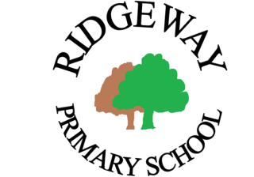
Ridgeway Primary School and Nursery
Southcote Road, South Croydon, CR2 0EQ
www.ridgewayprimaryschool.org.uk

ADVERTISEMENT

Teaching Assistant (Level 2)
– Supporting & Delivering the Learning at Ridgeway Primary School and Nursery

Salary Range – Grade 3 point 5 - 7 £22,575 – £23,400 (pro rata) starting September 2022

Hours: 5 days per week 30 hours – 45.2 weeks per year

We are looking for a person who:
- Has experience and good understanding of working in at least one of the Key Stages in the Primary age range (KS1, KS2, Early Years Foundation Stage), preferably Early Years, and has the flexibility to work in any of the Key stages if required.
- Has NVQ in Supporting Teaching and Learning or equivalent
- Has experience of supporting learners (including those with SEND) in a school setting
- Has high expectations of themselves and the children with whom they work
- Has a good understanding of how children learn and the role of play in children’s learning
- Has a passion for involvement in the children’s lunch-time activities and extended school clubs
- Would enjoy the challenge of working as a member of a team in a lively and supportive working environment.

We are committed to staff development and you will receive a full induction programme and ongoing CPD.

Please complete the application form (via attachment below) and return to office@ridgeway.croydon.sch.uk.

Along with the application form, you will need to attach separate sheet/s telling us how you meet the criteria on the person specification. Your application may not be accepted without this.

Closing date: Friday 10th June 2022

Interviews: W/C Monday 20th June 2022

Ridgeway Primary School and Nursery is committed to safeguarding and promoting the welfare of our children and expects all staff and volunteers, as well as those who work on the premises, to share this commitment. As part of our safeguarding commitment, appointment to any post is subject to receipt of a satisfactory enhanced Disclosure and Barring Service (DBS) disclosure.

Ridgeway Primary School
Southcote Road
Sanderstead
South Croydon CR2 0EQ

Telephone: 020 8657 8063/6957
E-mail: office@ridgeway.croydon.sch.uk

CROYDON COUNCIL
www.croydon.gov.uk

INVESTOR IN PEOPLE POSITIVE ABOUT DISABLED PEOPLE

