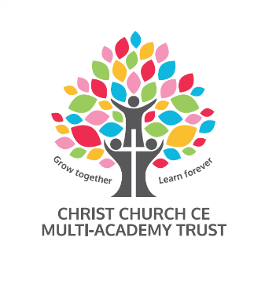

Christ Church CE Multi Academy Trust
School | Radcliffe Hall CE Methodist Primary School
Post | Teaching Assistant Level 3 EYFS
Hours | 32.5
Pattern | 8.30-3.30
Contract | Permanent
Grade | Grade 7
Salary | Scale Point 7 Term Time Only
Required from | As soon as possible
Closing date | Wednesday 22nd September 2021
Shortlisting date | Friday 24th September 2021
Interview date | Tuesday 28th September 2021

Trustees are seeking to appoint a highly skilled Teaching Assistant to work alongside teachers in Early Years Foundation Stage to support the teaching and learning of all children.
The successful candidate will deliver teaching programmes to groups of children and provide one to one support for the academic, behavioural and emotional development of pupils. The role includes the delivery of a range of activities including speech and language, phonics, reading, writing and mathematics work.
We are looking for someone who is:
- Patient and nurturing
- Supportive of children with complex special education needs
- Knowledgeable of early phonics and reading teaching
- Able to support colleagues and children
We are looking for someone who has:
- Excellent interpersonal and administration skills
- Level 3 qualification
- Experience of working in a school based Early Years classroom

In return, we can offer a friendly, supportive and committed staff team with good opportunities to develop your career.

As a member of the team, you will work with:

- A friendly, welcoming Christian community
- Children who enjoy coming to school
- A committed and enthusiastic team of staff under the Christ Church Multi Academy Trust
- An engaged, proactive and supportive Local Academy Committee
- Regular high quality professional development and coaching

We place wellbeing central to our work, striving to ensure that children and adults learn in a safe, supported, nurturing environment, where they feel confident, worthy, enthusiastic and valued.
The Trust is committed to safeguarding and promoting the welfare of children and young people and expects all staff and volunteers to share this commitment.

For further information regarding this post please contact Radcliffe.Hall@bury.gov.uk

Appointment is subject to a satisfactory enhanced disclosure from the Disclosure and Barring Service, Childcare Disqualification Check and other pre-employment checks.

To apply for this position please download the application form and supporting documentation and send completed applications to recruitment@ccmat.co.uk clearly stating the post and school you are applying for.

