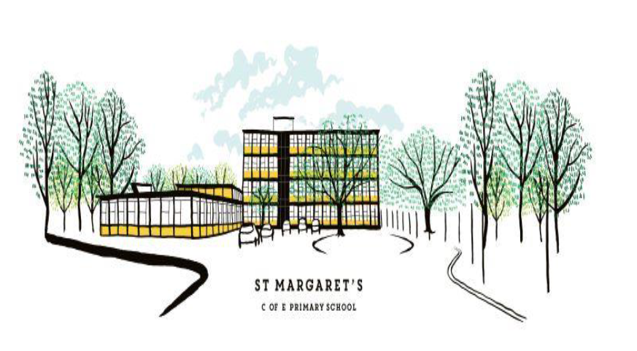

JOB DESCRIPTION

POSITION | Nursery Room Leader- 2-year-old provision
GRADE | TA4 (term time plus one)
HOURS | Full Time
REPORTS TO | Nursery Year Group Leader

KEY PURPOSE OF THE JOB
To take responsibility for the education and welfare of pupils in the 2-year-old provision in accordance with the current School Teachers’ Pay and Conditions document, having due regard to the requirements of the National Curriculum, EYFS framework and school policies.

MAIN ACTIVITIES
1. To take responsibility for implementing appropriate learning programmes for the 2-year-old provision, within the framework of national and school policies.
2. To maintain assessment records and report on pupils’ progress to senior staff and parents in accordance with school policy.
3. To have knowledge and understanding of what constitutes quality in EYFS educational provision, the characteristics of effective Early Years settings, and strategies for raising pupils’ achievement

PRINCIPAL ACCOUNTABILITIES
- To support, supervise and inspire the team of staff within the 2 year old provision room to ensure best practice with children.
- To work with the wider management team within the setting.
- To ensure the 2 Year Old Provision is well-resourced and set up to reflect an enabling environment for children.
- To support and work as part of a whole team to deliver and meet the requirements of the Early Years Foundation Stage for all children.
- To plan, provide and support age-appropriate play opportunities in line with the curriculum and individual needs of the children in your care.
- To teach daily carpet sessions to a group of pupils
- To develop the room staff’s practice to ensure best outcomes for children.
- To ensure the safeguarding and welfare of all children in your care.
- To be a key person to an allocated number of children and their families.
- To tend to the intimate care of pupils.
- To observe, assess and record children’s learning and development progress.
- To ensure all record keeping for a given room is kept up to date, including children’s development records, daily records, risk assessments and accident sheets.
- To build and maintain positive relationships with parents/carers.
- To adhere to and follow the setting’s policies and procedures.
- To ensure confidentiality is adhered to at all times.
- To attend regular team meetings.
- To ensure standards of health and safety, hygiene and cleanliness are maintained at all times to minimise risk.
- To engage in continuous professional development through staff meetings and INSET activities.
- To liaise and work in partnership with external agencies (both statutory and voluntary) to support children within the setting as appropriate.
- To support school’s ethos of inclusion by respecting and celebrating cultural diversity and providing equality of opportunity

KEY ORGANISATIONAL OBJECTIVES
The post holder will contribute to the school’s objectives in service delivery by:
- Ensuring compliance with school and national safeguarding procedures and policies.
- Enactment of health and safety requirements and initiatives as directed.
- Ensuring compliance with data protection legislation.
- At all times operating within the school’s agreed policies and approaches.
- Commitment and contribution to improving standards for pupils as appropriate.
- Contributing to the maintenance of a caring and stimulating environment for pupils.

CONDITIONS OF SERVICE
(Governed by the national agreement on Teachers’ Pay and Conditions, supplemented by local conditions as agreed by the Governing Body).
Because of the nature of the post, candidates are not entitled to withhold information regarding convictions by virtue of the Rehabilitation of Offenders Act 1974 (Exemptions) Order 1975 as amended. Candidates are required to give details of any convictions on their application form and are expected to disclose such information at the appointed interview.
Because this post allows substantial access to children, candidates are required to comply procedures in relation to police checks.

EQUAL OPPORTUNITY
The post holder will be expected to carry out all duties in the context of, and in compliance with, St Margaret’s CE Primary School’s Equal Opportunities Policy.

Date of issue: ………………….… Signed post-holder ……………………..…………………………………………

Signed Headteacher ………………………………………..………………

