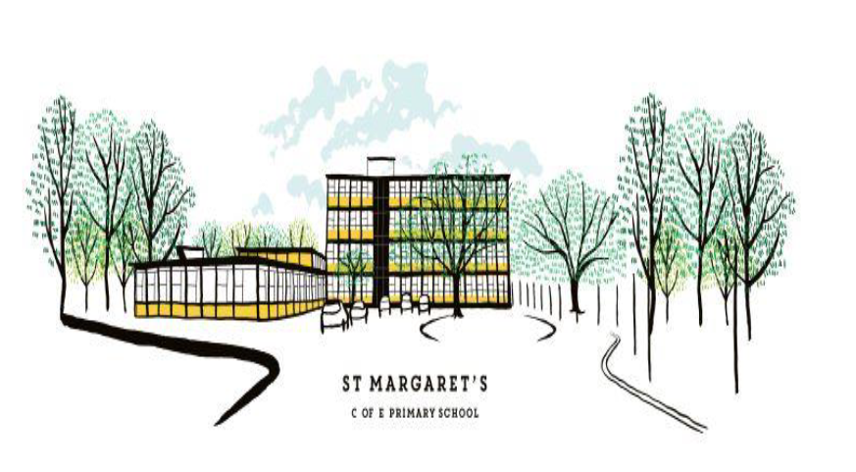

St Margaret’s CE Primary School:
Nursery TA3 Person Specification

A/I=assessed by application, interview or both
Aspect | Essential | A/I | Additional/Desirable
Training | 1.1 Level 2 literacy and numeracy qualifications | A | Level 3 childcare qualification
Experience | - Experience of working with nursery aged pupils (2 – 4 years)  - Recent/relevant CPD  - Experience of/commitment to supporting and delivering effective safeguarding procedures  - A passion for working with children in the early years | A/I A  A/I  A/I | Experience of working in a 2-year-old provision
Understanding Knowledge/Skills (General) | - A knowledge of the EYFS framework  - The ability to provide opportunities for independent and cooperative learning  - The ability to enable pupil progress across a period of time  - The ability to have high quality interactions with pupils  - The ability to deliver carpet sessions which motivate groups of pupils  - The ability to create high quality provision activities  - Outstanding organisational and time management skills; the ability to prioritise and meet deadlines  - Effective use of ICT in the classroom and as a management tool  - Ability to form outstanding teacher/pupil relationships | A/I A/I A/I A/I A/I A/I A/I A/I A/I | Good understanding of the needs of pupils in a mobile, urban school
Understanding Knowledge/Skills (School and role specific) | - Knowledge and understanding of the characteristics of effective education in a highly urban/EAL setting  - Understanding of the benefits of good home/school relationships and the school’s responsibility to parents  - Be willing to meet the self-care needs of pupils | A/I A/I A | Willingness to be involved in extra-curricular activities and the wider life of the school  Experience of outdoor  learning
Professional Values | - High expectations and a passionate desire to drive up standards  - Commitment to teamwork at all levels  - Willingness to promote enrichment opportunities  - Keen interest in own CPD | A/I A/I A/I  A | Support for an enriched curriculum through out of hours learning and  educational visits
Personal Qualities | - The ability to think creatively and imaginatively  - Passion for, and commitment to, working in a multicultural, multi-faith school in a highly urban environment  - The ability to be reflective and adaptable to changing circumstances  - Effective interpersonal and communication skills  - To not be afraid of getting messy  - When all of the above fail, the ability to maintain good humour, a willingness to learn and the will to bounce back and continue to strive for excellence | I I I I I I | Brings personal interests and enthusiasms to the school community

