Vacancy Information Pack

School Name: | Blackwater Community Primary School
Job Title: | Teaching Assistant – Two Posts

Information Pack Contents
Advertisement | Provided in this document
School Information for Applicants | Provided in this document
Welcome to Our School | Provided in this document
General Background | Provided in this document
Class Organisation | Provided in this document
Staff Organisation | Provided in this document
Our Curriculum | Provided in this document
Safeguarding | Provided in this document
Application Information | Provided in this document
Job Description | Attached
Person Specification | Attached
Letter from Chair of Board of Trustees | www.tpacademytrust.org/web/application_pack/604811
Application Form | www.tpacademytrust.org/web/application_pack/604811
Equality and Diversity Monitoring Form | www.tpacademytrust.org/web/application_pack/604811

Blackwater Community Primary School

Job Title: | Teaching Assistant’s with Lunchtime Support
Pay Point / Pay Range: | TPAT Point 4/TPAT Point 1
Full Time Equivalent Annual Salary: | £20,436/£20,252 per annum pro rata
Actual Annual Salary for this Role: | Role 1 – £6364.98 TA £1146.85 LTS  Role 2 – £4629.08 TA £1146.85 LTS
Contract Type: | Temporary – September 2023 start – possibility of becoming a permanent role
Hours Per Week / Weeks Per Year | Role 1 (KS1) – 13.75 TA 2.5 LTS hours per week  Role 2 (EYFS) – 10 TA 2.5 LTS hours per week  Working weeks – 38 weeks  Holiday paid weeks – 43.699
Closing Date: | 12 midnight on 13th June 2023
Proposed Shortlisting Date: | TBC
Proposed Interview Date: | Tuesday 20th June 2023

Temporary contract for a September start, with the possibility of it becoming permanent in due course. This role will have a focus on supporting the children academically and with their social and emotional needs.
For someone who is ready to buy in to our vision with drive, passion and commitment.

To find out more about Blackwater Community Primary School, please visit: | www.blackwater.cornwall.sch.uk
To discuss this position please contact the Headteacher: | Email – blackwater@tpacademytrust.org  Telephone – 01872 560570
Application packs can be downloaded from: | www.tpacademytrust.org/web/application_pack/604811
Please email your completed application form and equality & diversity monitoring form by the closing date to: | blackwater@tpacademytrust.org
Please note that successful candidates will be informed via email.

The Trust is committed to safeguarding and promoting the welfare of children and young people and expects all staff, workers, volunteers, governors and trustees to share this commitment. All successful applicants will be subject to appropriate pre-employment checks and will be required to complete a Disclosure and Barring Service (DBS) Enhanced Check, a Safeguarding Self-Declaration Form and satisfactory online searches undertaken.

School Information for Applicants
School Address: | North Hill, Blackwater, Truro, TR4 8ES
School Telephone Number: | 01872 560570
School Email Address: | blackwater@tpacademytrust.org
Name of Headteacher: | Evey Evison
Website Address: | www.blackwater.cornwall.sch.uk
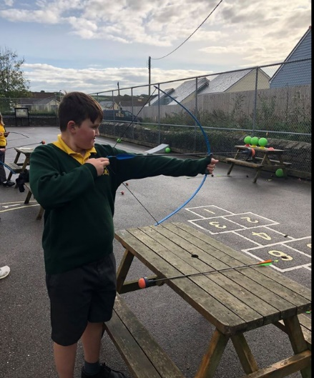
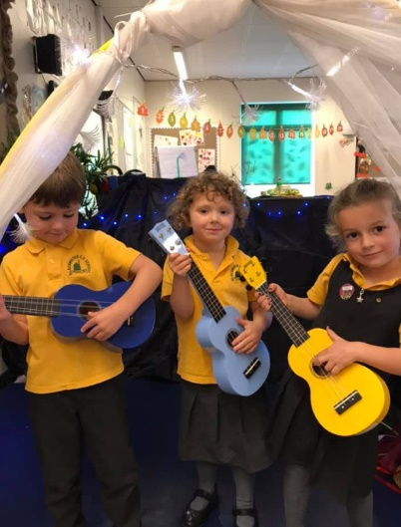

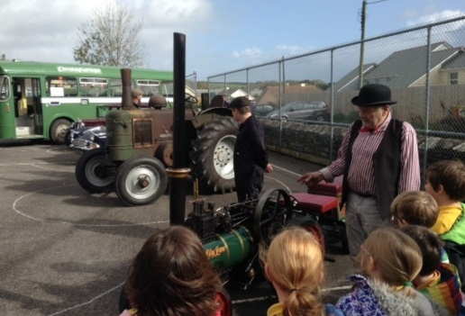
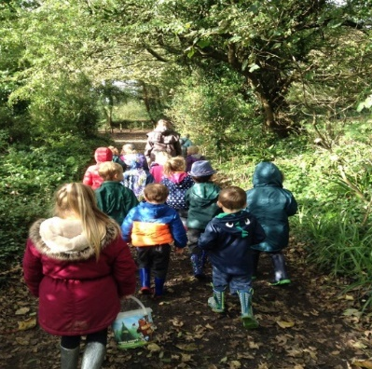
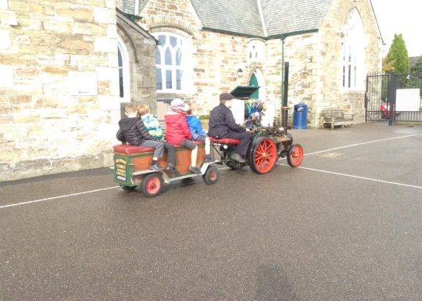

Welcome to Our School
This information pack will provide you with an insight into our school and offer some practical information which will be of use to you as a prospective member of our school community.
We welcome visitors as this is the best way to see our school: experience our outdoor led curriculum and meet our motivated and engaged children. Please ring us and have a look around.

Mrs. Evey Evison - Headteacher

Our School enjoys working collaboratively with our partner schools within Truro and Penwith Academy Trust.
We welcome visitors as this is the best way to see our lovely school, experience our creative and captivating curriculum and meet our motivated and engaged children. Please phone the school telephone number provided if you would like to arrange to look around.

General Background
Blackwater School is located near Truro. The school caters for children between the ages of 3 - 11. We currently have 109 pupils on roll and offer a rich & diverse curriculum – centred around Local, Global and Environmental issues, as well as a full programme of before & after-school activities.
Our outside space is stunning- we have a large playground, huge field, a wild area and an outside classroom. All of our ICT equipment is wireless and mobile and we run both Apple and Windows platforms.
Our highly successful OFSTED report gave rise to our support for children’s mental wellbeing at Blackwater, where we try and help children move towards the attributes and qualities below in the vision statement.
We are part of Truro and Penwith Academy Trust and enjoy working collaboratively with our partner schools as well as having excellent links with Richard Lander School, our local Secondary School.

Class Organisation
The school currently has 108 children on roll in four classes.
Nursery and Reception – Wheal Friendly – Mrs. Murley
Year 1 and Year 2 – Wheal Harmony – Ms. Shuttleworth
Year 3 and Year 4 – Wheal Busy – Mrs. Burton
Year 5 and Year 6 – Wheal Luna – Mr Hurrell

Staff Organisation
There are 14 fantastic teaching assistants and one highly dedicated school secretary, Kerry. Both our catering and cleaning contracts are provided by outside companies.

Our Curriculum
At Blackwater School, we have an amazing two year rolling programme which is designed by us for our children.
We believe that an exciting curriculum which is relevant to our children, as well as being exciting for our staff, is integral to a child’s primary school experience. WOW days at the start of the topic and SHOWCASE days at the end, bring the families in to support learning at home and at school.
We firmly belief that a high level of oracy is at the heart of language; children are encouraged to ‘say it, write it, check it’.
We have a strong connection with the environment around us. Children are taught outdoor skills during Wild Time and outdoor learning runs as a thread through the school. We are passionate about the supporting and saving the environment, with our Eco Committee making decisions about how to run our school.
The School has taken on the mastery approach to mathematics, ensuring that children have a deep and broad understanding of the subject. We use concrete objects to support understanding, before they deepen their understanding with pictorial representatives and then finally the abstract approach.

Safeguarding
TPAT is committed to safeguarding and promoting the welfare of children and young people and expects all staff, workers, volunteers, governors and trustees to share this commitment.
Shortlisted candidates will be required to complete a Safeguarding Self-Declaration Form as part of their application. We will also carry out online searches as part of our due diligence on the shortlisted candidates, as updated in the Keeping Children Safe in Education recommendations. This may help identify any incidents or issues that have happened, and are publicly available online, which the School or Trust might want to explore with the candidate at interview.
Successful candidates will be required to complete a Disclosure and Barring Service (DBS) application and Health Assessment form as part of their pre-employment administration. The amendments to the Rehabilitation of Offenders Act 1974 (Exceptions) Order 1975 (2013 and 2020) provide that when applying for certain jobs and activities, certain convictions and cautions are considered ‘protected’. This means that they do not need to be disclosed to employers, and if they are disclosed, employers cannot take them into account.

Application Information
We hope that you find this pack provides all of the information you need in order to consider your application for the post. Should you have any questions or matters you would like to discuss informally, or to arrange a visit, please contact:
Contact Name: | Kerry Richards
Contact Email Address: | blackwater@tpacademytrust.org
Contact Telephone Number: | 01872 560570
Please note that CVs will not be accepted.
Application packs can be downloaded from: www.tpacademytrust.org/web/application_pack/604811
Closing Date: | Tuesday 13th June 2023
Completed applications must be returned to the email address above and be received by 12 Midnight on the closing date provided.
Interview Date(s): | Tuesday 20th June 2023
To ensure the fairness of the selection process, shortlisting will be based upon information which you provide in your application, and assumptions will not be made about your experience or skills. We will look for demonstrable evidence that you meet the criteria set out in the person specification.
If we have not contacted you within 14 days of the closing date, it is unlikely that you have been shortlisted on this occasion. Many thanks for your interest in this post.

