Blackwater Community Primary School
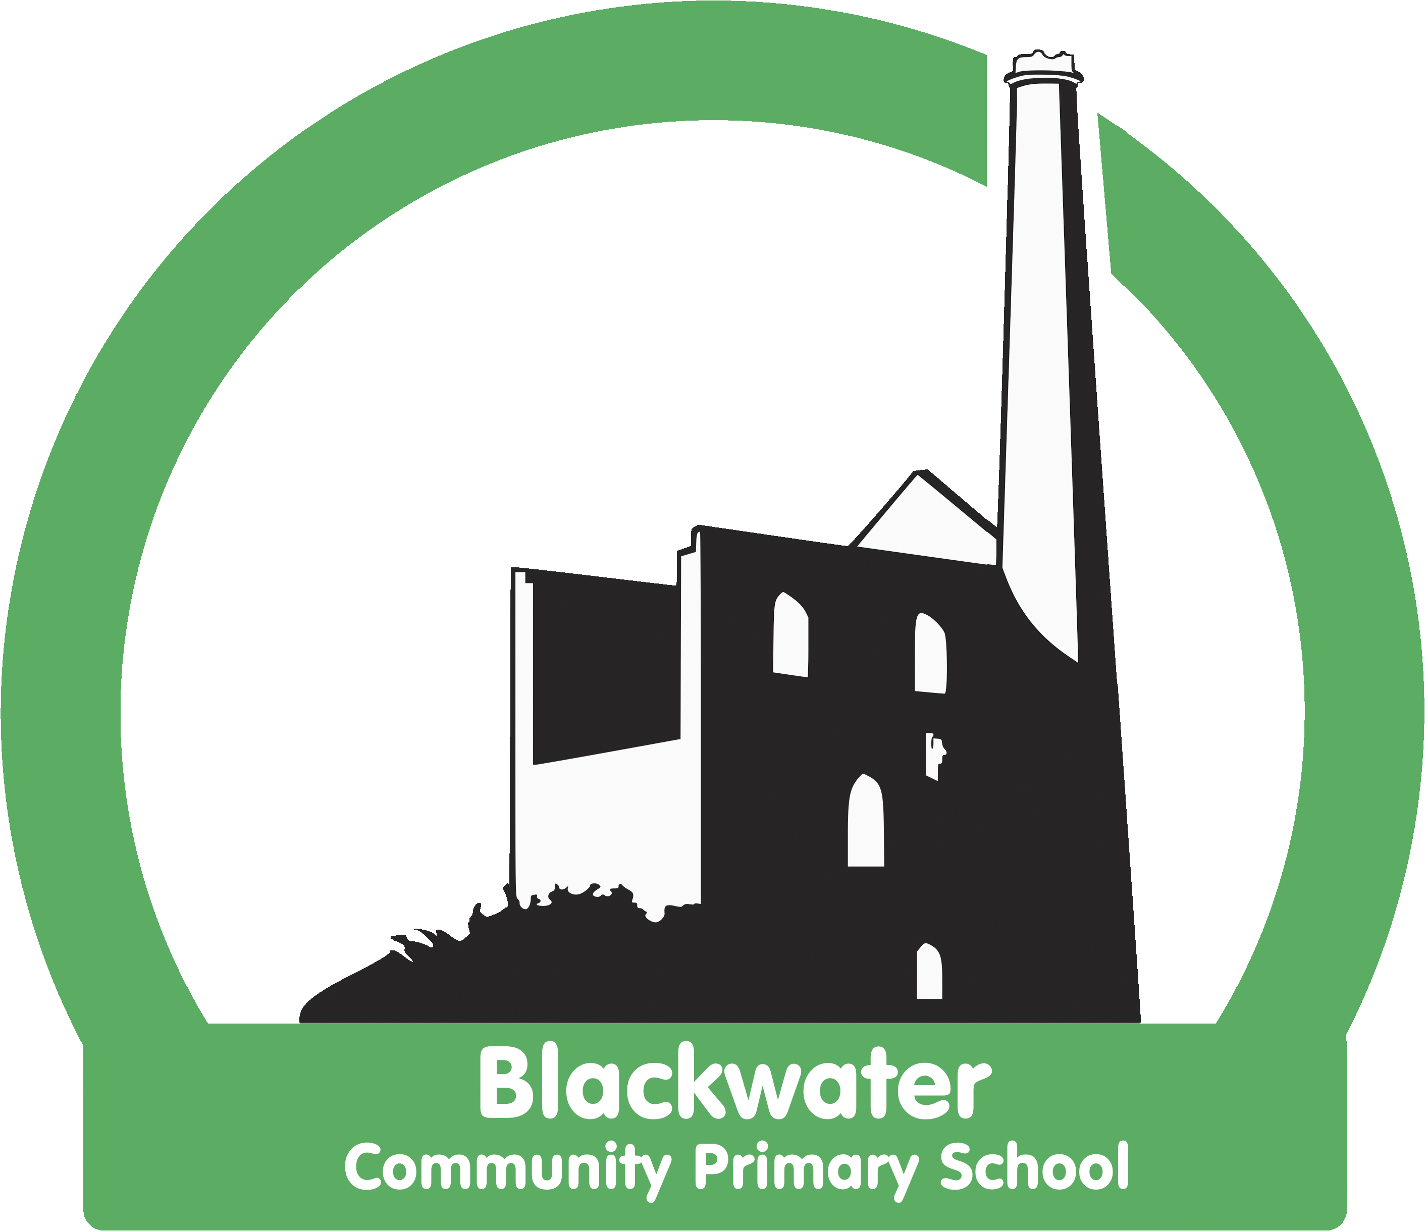

107 on roll
We are seeking to appoint two Teaching Assistants
to support:
1. Our KS1 class in the afternoons and Friday all day
12:45 – 1:15pm – Lunchtime support (TPAT Band 1) = 2.5 hours
1:15 – 3:15 - Teaching assistant (TPAT Band 2) = 13.75 hours
Total Hours: 15.75 hours
2. Our EYFS class in the afternoons
12:45 – 1:15pm – Lunchtime support (TPAT Band 1) = 2.5 hours
1:15 – 3:15 - Teaching assistant (TPAT Band 2) = 10 hours
Total Hours: 12.5 hours

Temporary contract for a September start, with the possibility of it becoming permanent in due course. This role will have a focus on supporting the children academically and with their social and emotional needs.
For someone who is ready to buy in to our vision with drive, passion and commitment.

Applications should be returned to Kerry Richards by 5pm Tuesday 13th June and interviews on Tuesday 20th June in the afternoon.
(blackwater@tpacademytrust.org )
You are welcome to ring / email to come and have a tour of the school prior to the application closing date. Please state in your application form which role you are interested in or both.
Blackwater Community Primary School is committed to safer recruitment and all posts are subject to excellent references and an enhanced DBS check.

