

Teaching Assistant
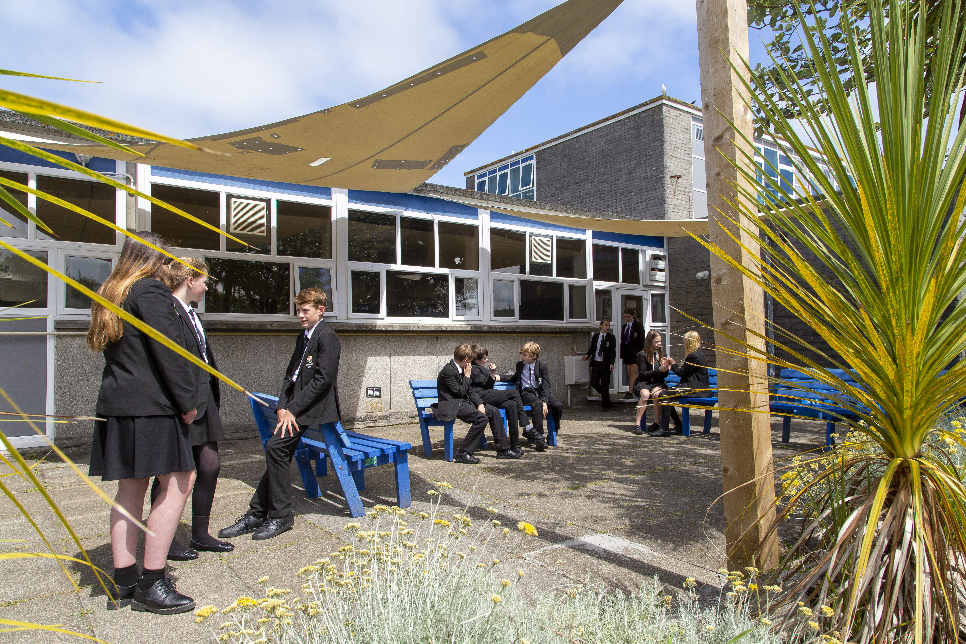
APPLICATION PACK

Principal – Mr S Royle BA (Hons) PGCE NPQH
Mounts Bay Academy
Boscathnoe Lane
Heamoor
Penzance
TR18 3JT
www.mountsbay.org

Salary scale: F1-F6
Contract Type: Full time or Part-time (pro-rata – term time only)
Contract Term: Permanent
Teaching Assistant

Mounts Bay Academy is a caring and dynamic Academy where students are placed at the centre of everything we do. We provide a broad and balanced curriculum to all our students, who are set challenging academic and personal targets and given the inspiration to succeed. We are proud of the integrated and inclusive support we provide to students, in particular those accessing additional needs.
We are seeking to appoint an efficient and enthusiastic individual with excellent communication skills to work with young people in our busy academy. The successful candidate will be approachable, calm, caring and confident, have good ICT skills and have experience of working with and supporting students. A high standard of literacy and numeracy is essential for this post, as is the enthusiasm to help raise the achievement levels of students.
Mounts Bay Academy embraces the use of new technologies, providing 1:1 iPad devices for each child and a Digital Device for each member of staff. We welcome applicants who are innovative in their use of IT and can develop their use as a strategy to raise standards across the curriculum.
In return we can offer:
- Excellent bespoke professional development
- Exceptionally well-resourced learning environment
- A friendly and caring whole academy community
Application forms and information packs are available via our website or upon request by telephoning the Academy.
For further information, please contact Malvina Jenkin HR Manager at Mounts Bay Academy
01736 352399 or email: mjenkin@mountsbayacademy.org

Closing date for applications: 12 noon 05/09/2025
Start: ASAP

Leading Edge Academies Partnership is committed to safeguarding and promoting the welfare of students and expects all staff to share this commitment

21st
Please send your completed application form to Malvina Jenkin at Mounts Bay Academy, Boscathnoe Lane, Heamoor, Penzance, TR18 3JT.
The successful candidate will be subject to reference checks with previous employers and an enhanced DBS disclosure check.

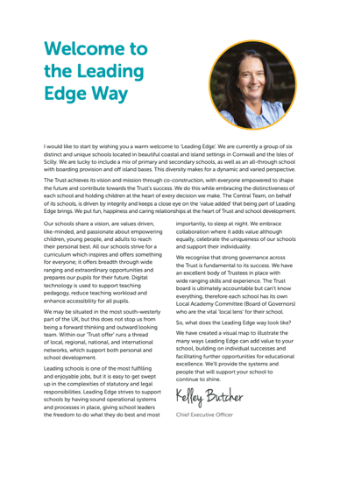
Welcome

Dear Applicant

Thank you for expressing an interest in this post at Mounts Bay Academy, a member of the Multi Academy Trust called Leading Edge Academies Partnership (Leading Edge). I hope you find this information pack helpful and that in due course we shall receive an application from you.

Mounts Bay Academy is located in Penzance, West Cornwall with 950 students aged 11-16 years. This is a beautiful part of the world, enjoying a varied coastline surrounding rugged hills and moorland and it is a wonderful place to live and work.

Mounts Bay school converted to Academy status in 2011 and a year later was awarded an Outstanding grade in a full Ofsted Inspection. In November 2017 the Academy was inspected by Ofsted to review its safeguarding arrangements and the HMI visitors noted that the Academy had a fully inclusive culture and provided excellent support for vulnerable students. Since then, we were awarded a good grade in 2021 under the new Ofsted Framework introduced in 2019.

I have been the proud Principal of Mounts Bay since March 2024, and I am passionate about the Academy and the path that we need to follow. Whilst enjoying an enviable reputation in the local area, there is work to do in terms of outcomes, attendance and the quality of teaching and learning. Our priorities are explicit, and my style is very open and honest – there are no hidden agendas here!

We have recently introduced a new behaviour policy which is having very positive effects and our teaching and learning policy has been stripped back to provide very clear expectations of staff and students. All strategies are supported by a comprehensive evidence-based programme of CPD, both internal, and through external bodies such the PTI, the Cornwall Research School, which we are delighted to lead, and the Challenge Partner network, where we are delighted to be the lead school in the Cornwall hub.

The Academy enjoys a range of impressive physical resources including a purpose-built science area, subject specific teaching areas in the Creative Arts as well as a lively and bouncing Music block. Sports facilities are strong, including a large sports hall, a 3G pitch and extensive outside field areas, all of which have significant community use. Plans are currently being made with Cornwall Council for an on-site ARB to provide further support to learners.

Mounts Bay Academy is an Apple Distinguished school, and each student and staff member is provided with a digital device to support their learning and work. We believe that students should be prepared for the world in which they will live when they leave the Academy and strive daily to ensure that we update our knowledge accordingly.

We are a learning community that aspires to success for all without exception, convinced that everyone can learn at the highest level, when presented with learning experiences that are as engaging as they are adventurous. We believe that all young people can achieve; it is our job to nurture the very best in each person by identifying their strengths and talents and removing any barriers to learning.

Mounts Bay is a caring and dynamic community where students are placed at the centre of everything that we do.

We provide a broad and balanced curriculum which is delivered by a team of skilled and dedicated staff, with the MBA way visible throughout the school, putting ‘Relationships, Respect and Responsibility’ at the centre of everything. Talent is celebrated, curiosity is nurtured, and every individual is given the chance to shine. We help to develop young people with a positive attitude to learning and life, ready to take on the challenges of our fast-changing world and to make a creative contribution to their community.

The successful candidate will be a brave, creative and visionary person, to join our staff to enable all to thrive in this ever-changing world. We are looking for a professional with a spirit of adventure who understands that high personal and academic standards and exciting learning can combine to change young people’s lives.

Mounts Bay Academy is committed to safeguarding and promoting the welfare of young people and we expect the candidate to share this commitment.

Since I joined the Academy, I have felt safe, I have been happy, I have felt challenged, and I have been genuinely welcomed into the Mounts Bay community. Is this not what all of us want from a school?

Please do get in touch if you would like to come and visit. I look forward to meeting you.

Yours sincerely

Simeon Royle
Principal


Application

Application
Please email your application to Malvina Jenkin HR Manager at mjenkin@mountsbayacademy.org. In line with our safeguarding practices we are unable to accept CVs.

Closing Date
Please ensure your application arrives by the closing date/time and that the post for which you are applying has been stated clearly on the application form. Applications received after the closing date will not be accepted.

Interview
Interviews for the post will take place shortly after the closing date. All applicants will be informed on whether their application is successful within 2 weeks of the closing date.
Mounts Bay Academy is committed to safeguarding and promoting the welfare of children and young people and we expect all staff and volunteers to share this commitment.
We follow safer recruitment practices and appointments are subject to an enhanced DBS check and references taken up prior to employment.

Details of our Safeguarding and Child Protection Policy can be found on our website www.mountsbay.org.

Mounts Bay Academy
Boscathnoe Lane
Heamoor
Penzance
Cornwall
TR18 3JT

Phone: 01736 363240

Web:
www.mountsbay.org
www.leadingedgeacademies.org


Job Description

Post Title: | Teaching Assistant
Purpose: | - To take a proactive role in the support of the educational, social and physical needs of the students;  - To support the curriculum and the Academy through the provision of assistance to the teacher in the practical organisation of class activities and small group work.  - To meet the needs of students with specific special educational needs within a mainstream setting.
Reporting to: | Claire Drew
Liaising with: | Principal/Senior/Vice Principals, Teaching/Support staff
Working time: | Part time or Full time
Salary/Grade: | F1-F6
Disclosure level: | Enhanced

MAIN (CORE) DUTIES
Main tasks | - To provide targeted reading intervention for struggling readers in Years 7-10.  - To liaise with the Head of English to establish which students need targeted reading support.  - To plan and deliver intervention cycles that meet the required needs of the students  - To work with the English Faculty to support adaptive learning techniques and hold small group interventions.  - Lisaise with the Head of English with progress reports for students receiving targeted reading support

Key Areas of Responsibility
- To assist individuals and groups of children in developing knowledge, skills and attitudes as defined by the Curriculum. To take into account the learning support involved to aid the children to learn as effectively as possible.
- To establish supportive relationships with the student/s concerned and to encourage acceptance and inclusion of all students.
- To encourage social integration and individual development of students. To develop methods of promoting and reinforcing students’ self-esteem.
- To assist in preparing, using and maintaining relevant teaching resources. To ensure that basic classroom materials are available for use.
- To assist with lunch and break time supervision of students on a rota basis.
- To accompany students on educational visits and outings as requested during the school day.
- To assist with the assessment, monitoring and recording of children’s progress, health, behaviour and general wellbeing. To feedback any information (including concerns) regarding the well-being and educational needs of children to the Teacher, Head of Year, Senior Leader for Student Provision as appropriate.
- To be aware of confidential issues linked to home/students/teacher/school work and to ensure the confidentiality of such sensitive information.
- To supervise an individual or small group of children within a class under the overall control of the Teacher.
- To administer minor first aid (as trained), assist in the dispensing of medically prescribed controlled drugs (as trained and as per the approved procedure) and to assist with the personal hygiene and physical needs of children with regard to health and safety as required (as trained).
- To carry out administrative tasks associated with all of the above duties as directed by the Teacher, Head of Year, Senior Leader for Student Provision as appropriate.
- To remain aware and work within all relevant Academy working practices, policies and procedures.
- To attend staff meetings and academy-based INSET as required.
- To meet with the SENCO on a regular basis, and/or other appropriate staff.
- The post holder is responsible for his/her own self-development on a continuous basis in line with Academy procedures.
- To be aware of and work in accordance with the Academy’s Safeguarding and Child Protection policies and procedures and to raise any concerns relating to such procedures which may be noted during the course of duty.
- To be aware of and adhere to applicable rules, regulations, legislation and procedures including the Academy’s Equal Opportunities Policy and Code of Conduct, national legislation (including Health and Safety, Data Protection).
- To undertake other duties appropriate to the grading of the post as required.
- To maintain confidentiality of information acquired in the course of undertaking duties for the department.
(Applicable to Teaching Assistants supporting students with specific special educational needs within a mainstream setting)
- To meet the mobility needs of the student, assisting in the use of a wheelchair/hoist, ensuring compliance with safe lifting procedures and associated training.
- To meet the needs of incontinent students (with appropriate training)
- To meet the needs of students with emotional and behavioural difficulties. To support students with preventing harm and disruption to themselves or others, within the limits of the post holders training (eg: Team Teach) and school policies and procedures.
- To encourage acceptance and inclusion of all students.
- To develop methods of promoting/reinforcing self-esteem and to promote independence through the development of self-help skills.

Other Specific Duties
- To remain and adhere to the Trust’s Safeguarding Policy and child protection procedures.
- To play a full part in the life of the Academy community, to support its distinctive mission and ethos and to encourage staff and students to follow this example.
- To actively promote the Academy’s corporate policies.
- Be responsible for your own continuing self-development, undertaking training as appropriate.
- To be aware and adhere to applicable rules, regulations, legislation and procedures e.g. the Trust Equality and Diversity Policy, Staff Code of Conduct, national legislation and GDPR Data Protection Regulations.
- To comply with the Academy’s Health and Safety Policy and undertake Risk Assessments as appropriate.

As a restorative organisation we
- Apply the principles of mutual respect and responsibility in all internal and external relationships.
- Actively work to prevent, address and repair harm.

Engage in continuous learning to further develop our communication and problem-solving skills.

Whilst every effort has been made to explain the main duties and responsibilities of the post, each individual task undertaken may not be identified.

Person Specification

Essential | Desirable | Demonstrated By
A commitment to safeguarding children and young people and an awareness of current national legislation relating to safeguarding and child protection. |  | Application Form / Interview
 | Knowledge of KS3 and 4 English Curriculum | Application Form / Interview
Autism experience and sensory processing. | Knowledge of bespoke interevntions to support reading | Application Form / Interview
Previous experience of working with SEND children. | Previous experience of working with children within a classroom environment or similar. | Application Form / Interview
Good levels of literacy and numeracy.  Attainment of 4 GCSE qualifications (or equivalent), or able to demonstrate equivalent knowledge, skills and aptitude. | Qualification in English and Maths (5+ GCSE) or additional higher level qualifications. | Application form / Interview
Organisational skills.  Good communication skills. | Knowledge of issues relevant to education and child development. | Applcation form and Interview
Able to prioritise between different demands.  Ability to work to deadlines.  Self-motivated, and able to work in a team.  An interest in children and education.  Patient and friendly approach. | Able to work without supervision. | Interview

Other
Attendance at some evening and early morning meetings as required.

