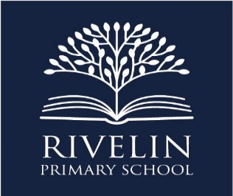
‘Excellence for every child, every day’

Job Title | Teaching Assistant Level 2
School Name | Rivelin Primary School
Contract | Permanent
Hours per week | 15.5 hours (working 2 days one week and 3 days the following week)
Weeks per year | 39
Grade and Salary | Grade 3 £19,312 - £19,698 (pro-rata)
Closing Date | 11th December 2021

The Governors at Rivelin Primary School wish to appoint a Level 2 Teaching Assistant for 2.5 days per week starting Monday 4th January 2022. This will be working 2 days one week and 3 days the following week.

We are seeking to appoint a Teaching Assistant for Year 2. The successful candidate should be enthusiastic, keen to work in partnership with teachers and able to work under instruction as well as having the ability to use their initiative. They will be required to contribute to the educational and social development of children. They should have the ability to build excellent relationships with adults and children and work as part of our whole school team. You will have good literacy and numeracy skills and experience.

Visits to the school are warmly welcomed. Please contact the school office on 0114 234 1304 to arrange a date to visit.

Please download a Microsoft Word application or email enquiries@rivelin.sheffield.sch.uk for an application pack.

Please return your completed application form to the Schools Business Manager, Rachel Cocking by email r.cocking@rivelin.sheffield.sch.uk or by post to Rivelin Primary School, Morley Street, Sheffield, S6 2PL.

We are committed to safeguarding and promoting the welfare and safety of children and vulnerable adults and expect all staff to share this commitment. All successful candidates will be required to complete an Enhanced Disclosure and Barring Service Check.

We value our diverse workforce and aim to work together to make the most of our differences. We welcome applications from everyone. Under the Disability Confident Scheme, disabled applicants, who meet the essential criteria of this job, are guaranteed an interview.

