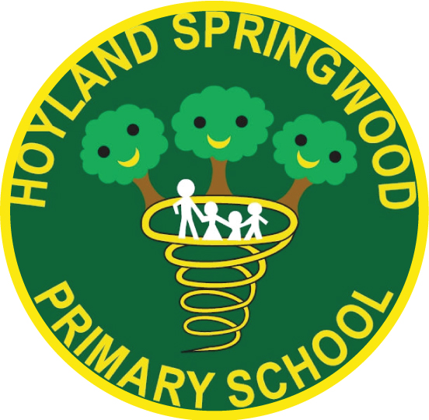
Hoyland Springwood Primary School
Clough Fields Road, Hoyland
Barnsley, S74 0ER

Telephone: 01226 743815
e-mail: springwood@ecmtrust.co.uk

E-mail:

SCALE 4 TEACHING ASSISTANT
A Teaching Assistant Grade 4, Scale Point 7-11 (pro rata)
Permanent from 22nd April 2025 (27.5 hours term time only)

Hoyland Springwood is a small primary school with children starting school in FS2. There are 144 pupils on roll. The school is outward facing and works in a range of partnerships providing development opportunities for the school and its staff.

Hoyland Springwood is an inclusive, forward thinking and fast moving primary school with happy, well-engaged children and committed staff members who ‘go the extra mile’ for our children. We are seeking to appoint a flexible team player who is prepared to support the class teacher, other colleagues and children. You will need to be well motivated, tenacious and be confident enough to use your own initiative when the need arises. You must be committed and have high expectations of all children in terms of progress, attainment, attitudes and behaviour. Hoyland Springwood is a member of the Every Child Matters Academy Trust and works in close partnership with other schools within the trust. This offers opportunity for support and CPD opportunities.
We are looking for individuals to join our team who:
- have the ability to inspire and motivate children to achieve their full potential
- are passionate about learning and teaching
- are creative, forward thinking, innovative and prepared to take risks
- will actively develop positive relationships with parents, carers, colleagues and, most importantly, our children
- have a strong commitment to inclusive practice
- have a minimum of Level 2 qualification in English and Maths, or equivalent
- have NVQ 3 in Supporting Teaching & Learning or equivalent qualification
- have a willingness to undertake training related to the role
- will cover classes as required by leadership to support the smooth running of the school
- have a positive attitude and a desire to work as a member of a team
We can offer:
- enthusiastic learners who are eager to please and achieve
- an opportunity to make a real difference to the lives of children
- a welcoming, friendly and supportive team who work together to ensure the best outcomes for all our children
- a commitment to professional learning and development, including opportunities through ECM
- professional networks with staff from other ECM Trust schools
Interested candidates are encouraged to make contact with Ms Jennifer Clarke, Headteacher, via the school office or using j.clarke@ecmtrust.co.uk to discuss the post further. The closing date for applications is Thursday 27th February at 12pm. Shortlisted candidates only will be contacted on this date to arrange the interview process which will be held on Wednesday 5th March 2025.
Hoyland Springwood Primary School is committed to safeguarding and promoting the welfare of
children and young people and expects all staff and volunteers to share this commitment.
The successful candidate will require an Enhanced Disclosure & Barring Service (DBS) check.

