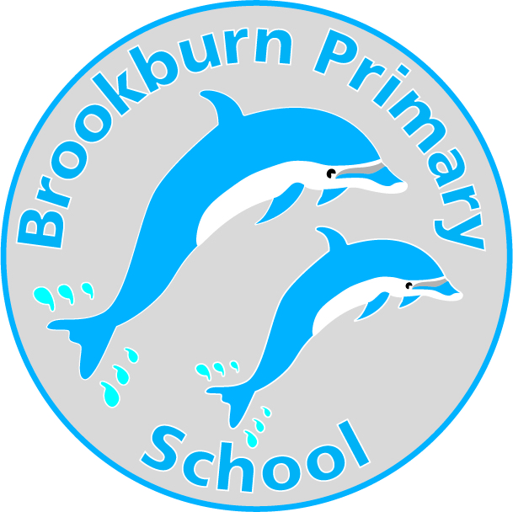

26.05.23

Dear Applicant,

I am very pleased to forward the application pack and hope, that after consideration, you apply to the post of Teaching Assistant (SEN) at our school.

The following information will enable you to make a positive choice about applying to join our team. Please read the information carefully.

Brookburn Primary School is located in Chorlton, Manchester and is part of Link Learning Trust. Barlow Hall Primary School is the other school in LINK Learning Trust. We are a two form entry primary school and currently have 449 children on roll. This includes a 39 place nursery. Approximately a third of our school population come from ethnic minority backgrounds with about 7% of our children having English as an additional language. Approximately 10% of our children are identified as vulnerable learners and 9% of children are eligible for pupil premium funding. The majority of our vulnerable children are or have been previously looked after and therefore inclusive practice and fostering a strong sense of belonging is at the heart of everything we do. We believe that relationships are key to the successful inclusion of all.

To join our team, you will need to have a strong commitment to supporting all children so that they feel personally respected, accepted, included and supported. You will have a strong commitment to ensuring that our children are able to flourish emotionally, academically and socially with an understanding that ‘every minute counts’. Our children’s achievements are very important and the adults at Brookburn Primary work with great dedication and enthusiasm to make sure that each child achieves the very best they can.

We can offer the successful candidate an enjoyable work place with highly trained and supportive staff as well as a commitment to your own learning journey and continuing professional development.

This post will be part of our Inclusion Team and will play a part in assistingoping school wide provision for our vulnerable pupils and in particular those pupils with social, emotional and mental health needs. (SEMH) You will work under the direction of the SENCo and Class Teachers.

The closing date for applications is Noon Friday 09th June 2023 Interviews will be during week commencing 12th June 2023.

Yours sincerely,

Jen Holden

Head of School

Information about children with SEND to help you make a positive choice about applying for this position

Pupils will have a range of additional needs that include:
- Social, Emotional and Mental Health needs (SEMH).
- Difficulties with communication, social understanding and flexible thinking/imagination
- Difficulties regulating their emotions
- Sensory issues e.g. hyper-sensitivity to sounds, tastes, smells
- Limited awareness of safety
- Toileting, self-care and/or eating issues
- Associated conditions including anxiety, epilepsy, ADHD

Pupils need staff to provide:
- Consistent, calm support
- An atmosphere where they feel taken care of, valued and worthy of love
- A flexible approach, responding positively to individual and changing needs
- High levels of visual support
- Activities that are enjoyable and fun
- Activities that are soothing, calming, reassuring and where the world is made to feel predictable, safe and warm
- Individual teaching and small group activities
- Support in mainstream classes, the dinner hall, the playground and during educational visits
- Active encouragement to promote independence
- Reflective practice and effective team work

