


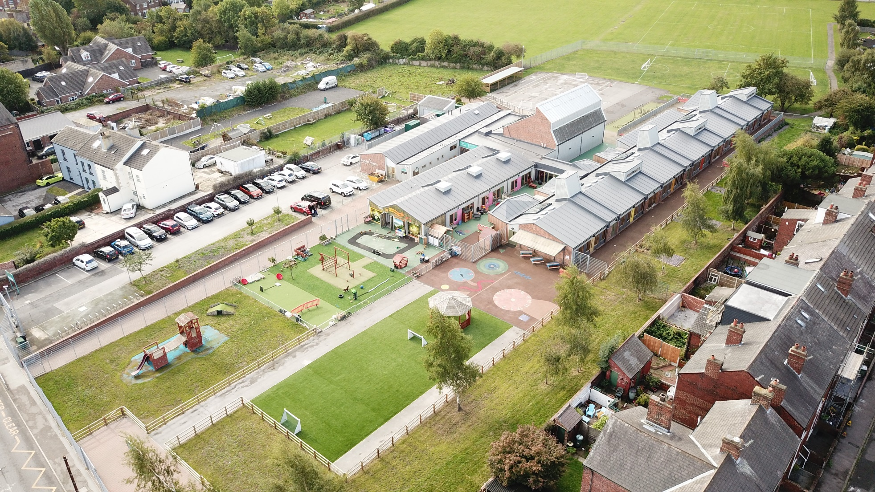
Teaching Assistant (with SEN) + Lunch Cover
Recruitment Pack

Sandal Magna
Community Academy

Advert
Teaching Assistant (with SEN) + Lunchtime Cover:
Hours Per Week: 27.5 hours for Teaching Assistant + 5 hours for Lunch Cover (over 5 working days)
Weeks Per Year: Term Time Only
Grade: Grade 4, Scale Point 5 -6 (£16,135 + £2,801 Gross)
Contract Type: Temporary 1 Year Contract (with potential to extend)
Start Date: ASAP
The Opportunity
At Sandal Magna Community Academy, we're seeking a friendly, reliable individual to join our nurturing family. You'll play a vital role in creating a safe, welcoming environment where pupils thrive and teachers excel. If you're committed to excellence, teamwork, and making a real difference in young lives, we want to hear from you.
We are looking for someone who:
Holds a Level 2 Teaching Assistant qualification and has classroom experience, either in full classes or in smaller 1:1 intervention settings. Experience in supporting SEN pupils would be an advantage.
Visits to the school are welcomed and can be arranged by contacting Julie Pratt, Business Manager, on 01924 767080 or by emailing julie.pratt@sandalmagna.enhanceacad.org.uk
Why join Enhance Academy Trust?
This is a fantastic opportunity to join an outstanding team within a successful and forward-looking academy trust with exciting career prospects for successful applicants.
As a Trust, we have developed a range of employee benefits. Here are just a few examples:

- Membership to the Local Government Pension Scheme
- Physical and mental health support from a team of experienced nurses, counsellors, therapists, physiotherapists, consultants plus NHS GP's and private medical services.
- GP consultations with experienced NHS doctors are available for our employees and members of their household, 24 hours a day, 365 days a year and prescriptions (which have to be paid for) can be delivered to local chemists.
- Free annual flu jab

- Trained Mental Health First Aiders in all our settings
- A paid annual Wellbeing Day - a time for you to use the day for an activity which promotes your own individual health and wellbeing.

Safeguarding Statement
Enhance Academy Trust is committed to ensuring the actions we take, keep children safe and protect them from harm in all aspects of their school life. The Trust is committed to safeguarding and promoting the welfare of all our pupils. The Actions that we take to prevent harm, to promote wellbeing, to create safe environments, to respond to specific issues and vulnerabilities all form part of the safeguarding responsibilities of the Trust. We recognise our moral and statutory responsibility and make every effort to provide a safe environment underpinned by a culture of openness where both children and adults feel secure, able to tale and believe they are being listed to.
To view our Safeguarding and Child Protection Policy please visit the school website: www.sandalmagna.co.uk
To view our Recruitment of Ex-Offenders Policy please use the link on the Enhance Academy Trust website shown under 'Policies'

Closing date for applications: Friday 28th November 2025 (12 Noon)
Shortlisting: Monday 1st December 2025
Interviews: Thursday 4th December 2025

Job Description

REPORTING TO
Senior Management Team
OVERALL PURPOSE OF THE POST
To work under the guidance of teachers and SLT to provide a high quality learning experience and to support and engage in all learning activities whilst providing a caring, safe and welcoming environment for children which will allow each child to develop at their own rate in accordance with the current Curriculum Development Framework Document.

KEY RESPONSIBILITIES
- Support with (and organise) children’s learning experiences.
- Observe, record and assess through interaction, the needs of individual children.
- Engage in strategies and interventions as directed by the teacher and SENDCo
- To provide lunchtime cover on a daily basis.
- Implement and raise awareness of equalities within the establishment.
- To promote Emotional Personal Social Development (EPSD) through good health, safety and caring practices.
- To provide appropriate learning experiences for children with special educational needs.
- To implement child protection procedures and to support children and families through crisis.
- To participate in school outings, adhering to Health and Safety guidelines.
- To support and develop parental participation and relations with the community.
- Work co-operatively and effectively within a professional team whilst respecting each person’s abilities and aptitudes.
- To work collaboratively with other professionals from a variety of disciplines.
- Contribute to staff briefings and training relating to all relevant and current topics.
- To be a positive role model.

Accountability
- Accountable for meeting the needs of all children.
- Developing purposeful liaison with SLT / teachers and all staff
- Liaising and providing information for teachers to share with relevant agencies.
- To adhere to and implement local and national policies.

Job Description

Job Description

Demands
- The ability to respond effectively to children in a stimulating learning environment using a variety of strategies and techniques.
- Participation in both formal and informal staff training activities in order to maintain and update knowledge.
- Lifting and manoeuvring of heavy equipment, which should be undertaken within Health and Safety procedures.
- The job may expose staff to various viruses from Chickenpox to HIV/Hepatitis, which will require compliance with Health and Safety procedures.
- The job may expose staff to physical and verbal abuse, which should be reported through agreed procedures.
- The job may demand certain administrative duties, i.e., collecting money, filling in forms, etc.
- Confidentiality to be respected at all times.

Communications
- The postholder will be required to:
- Contribute, as part of a professional team, to reports made available to relevant agencies.
- Participate in relevant pupil meetings and staff meetings.

Working Environment
- Postholders will predominantly be located within our Key Stage 2 classrooms but must be flexible to work at times in other areas of school such as Key Stage 1 or the EYFS unit.
- This will include working with classroom groups and/or small groups of children plus accompany classes out on outings and within the framework of Health and Safety guidance to staff.

KEY OUTCOMES/ACTIVITIES

- In some positions, postholders will fulfil their remit in other areas of school such as EYFS or different key stages.
- There may occasionally be the need for staff to attend to personal/intimate care requirements but the Intimate Care Procedure will be adhered to at all times.
- The postholder will undertake a one hour lunchtime cover (their own lunch will be taken before or after lunchtimes)

Other duties commensurate with the grade of the post as directed by the Headteacher.

The duties and responsibilities highlighted in this Job Specification are indicative and may vary over time. Post holders are expected to undertake other duties and responsibilities relevant to the nature, level and scope of the post and the grade has been established on this basis.

RESPONSIBILITY OF RESOURCES
Employees (Supervision): None
Financial: None
Physical: Effective use of learning materials and resources.
Customers and Clients:
To work with the class teachers and to help organise and deliver high standards of childcare and education activities for children and parents.

WORKING CONDITIONS
The nature of the post may at time require some ongoing considerable physical effort e.g. regular lifting or carrying, pushing or pulling items of moderate weight.
The post involves contact with people which through their circumstances or behaviour regularly places emotional demands on post holder.
The post holder may be subject to some exposure to disagreeable or unpleasant people related behaviour.

CHARACTERISTICS OF THE POST
The ability to regularly attend meetings as required by the Headteacher/Line Manager.
Employees are encouraged to participate in training activities in order to enhance their own personal development.
All employees of a school have a responsibility for promoting and safeguarding the welfare of children and young people.
The employment checks are required:
- Evidence of entitlement to work in the U.K.
- Childcare Disqualification Declaration (where applicable)
- Evidence of essential qualifications – see page 1 of this job specification
- Two satisfactory references
- Confirmation of medical fitness for employment
- Registration with appropriate bodies (where applicable)

The following employment checks are required for those positions which are based in a school or working with vulnerable young people and adults:
Evidence of a satisfactory safeguarding check e.g. An Enhanced DBS Disclosure

Job Description

Person Specification
Knowledge, Experience and Skills
 | Essential | Desirable
Qualifications/Training
Teaching Assistant Qualification

Knowledge of the individual development needs of young children.
Understanding and respect of the central role of parents/carers in the lives of young children.
Effective communication skills.
Knowledge of ICT.
Appropriate knowledge in First Aid
Child Protection issues.
Health, Safety and Security issues.
Data Protection issues.
Experience
Working or caring for children
Competencies and Other Skills
Some ICT skills required for accurate record keeping
Effective inter-personal skills.
Ability to work independently using own initiative.

