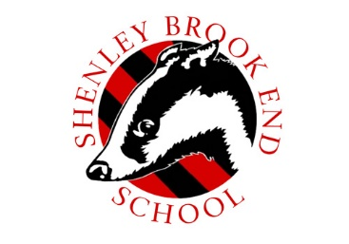
5 Dimensions Trust is currently advertising for the following exciting opportunities at:
Shenley Brook End School
Teaching Assistant
32.5 hrs per week, term time only (39 weeks per year) + INSET Days
Hours of Work: 08.15am – 3.15pm Mon-Fri
Salary: Grade 5DT Grade 4 - £14,947 - £15,861 (actual salary) equivalent to the fulltime salary of
£19,698 - £20,903

We are looking to recruit Teaching Assistants who will work under the direct supervision of the SENCo to support students with special educational needs. Your role will include being with students in lessons and delivering interventions on a 1:1 basis. You must enjoy the challenge of working with young people and want to make a difference to their wellbeing and education. Ideally, you will have previous experience of working with young people and/or an understanding of special needs. However, we welcome applicants interested in entering teaching who would like to gain experience before applying for teaching training. Please note that due to the nature of the
role, the hours of work are unfortunately not negotiable.

This is an ideal opportunity for anyone looking to enter the teaching profession and will
enhance your chance of obtaining a place on teacher training programmes.

5 Dimensions Trusts Academies are consistently ranked amongst the highest-achieving schools in
Milton Keynes. We are on a mission to make our Trust the very BEST place to work and study and
place the wellbeing of our staff at the forefront of our actions.

Our wellbeing provision is enriched through our staff wellbeing programme which includes; access
to a fitness suite at Shenley Brook End School, health promotion events such as the Cycle to Work
scheme, Friday morning social briefing with breakfast, social events, such as quiz nights, coffee
mornings, bike rides, arts and crafts events, such as bake off challenge and Christmas wreath
making. In addition, we offer a generous pension scheme, access to high quality training,
incremental pay progression and free on-site parking.

Closing Date: Tuesday 21 September @ 10.00am
To view full details and apply online, please visit: https://www.mynewterm.com/trust/5-DimensionsTrust/136844 or alternatively you can contact recruitment at the address below. The Academy reserves the right to close the application process at any stage should we receive sufficient
applications. We are unable to accept CV’s. The 5 Dimensions Trust is an equal opportunities employer. The Trust is committed to safeguarding and promoting the welfare of children and expects all staff to share this commitment. An enhanced DBS check is required for all successful applicants. Recruitment, Shenley Brook Ends School, Walbank Grove, Shenley Brook End, Milton Keynes, MK5 7ZT
Tel: 01908 520264
Website: www.5dimensionstrust.com

