 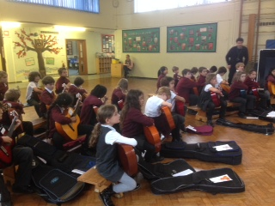  

**We are looking for an outstanding and inspirational**

**Teaching Assistant**

**to join our team in October 2022**

St James is a friendly, one form entry, Church of England primary school in Muswell Hill, North London N10.

**Our Executive Head is Mrs Geraldine Gallagher and our Head of School is Mrs Jessica Williams**

Our web address is www.stjamesprimaryschool.co.uk

 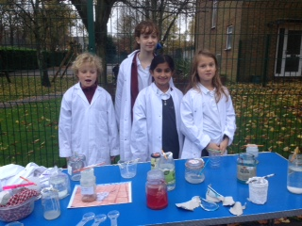 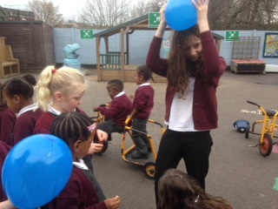 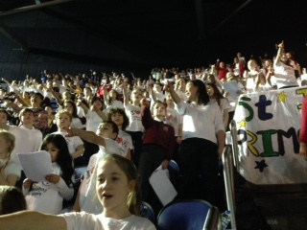

**Contents**

1. Letter from the Head teachers

2. Job advertisement

3. Job description and person specification

Dear Applicant,

We are very pleased that you are considering joining our friendly, one form entry school. We are very fortunate; our pupils are highly engaged and we are a very supportive community. We are situated in Muswell Hill, a beautiful part of London, next to Highgate Woods. We have excellent facilities within school and in Muswell Hill. Our great transport links make us easily accessible.

We are very proud of our school, staff and our pupils. Our children thrive and this is reflected in their outstanding academic, music, arts and sport achievements. This is an exciting opportunity for a Teaching Assistant committed to exceeding expectations in what we believe is the most important and rewarding profession.

We look forward to meeting you,

Geraldine Gallagher Jessica Williams

Executive Headteacher Head of School

**Job advertisement**

**Teaching Assistant**

Muswell Hill, London N10 3JA

Tel: 0208 883 6540

E-mail: office@stjamesprimaryschool.co.uk

Post: Teaching Assistant

Required: October 2021

**Closing Date: 9:00am, 27th September 2022**

Scale: 4

Location: Haringey

Contract Term: Fixed Term contract

We offer:

* A supportive, experienced and committed leadership team
* Excellent professional development opportunities
* A friendly, supportive community
* Enthusiastic learners
* A creative and innovative curriculum

We are committed to the Haringey pledge to -

 'Raising Black Caribbean and BAME Achievement Pledge', an initiative to raise standards of achievement for BAME students within the London Borough of Haringey.

“Every child and young person in Haringey matters. Every child and young person deserves the best life chances, especially when they face additional barriers due to ethnicity and disadvantage. It is everyone’s responsibility to make this a reality and create the equality of opportunity we want to see.”

We are seeking an excellent Teaching Assistant to join our wonderful school.

If you are:

* An enthusiastic, excellent classroom practitioner
* And excellent communicator
* Reflective and highly motivated
* Committed to equality of opportunity

We would love to hear from you. Please visit the school website [www.stjamesprimaryschool.co.uk](http://www.stjamesprimaryschool.co.uk) to download your application pack and application form or email the address above.

Visits to the school are welcomed please contact the school to arrange an appointment by calling us on 0208 883 6540 or emailing us at [office@stjamesprimaryschool.co.uk](mailto:office@stjamesprimaryschool.co.uk).

**St James Primary School is committed to safeguarding our children and we expect all our staff to share this commitment to their protection. We practice safer recruitment and will carry out enhanced DBS checks before start dates.**

**Teaching Assistant Job Description and Person Specification**

**GRADE: Scale 4**

**RESPONSIBLE FOR: EYFS, KS1, KS2 & 1:1 SEN support**

**HOURS: 32.5 hrs per week, TTO**

**REPORTING TO: Head of School**

The School is committed to safeguarding and promoting the welfare of children and young people and expects all staff to share this commitment.

**PURPOSE OF THE JOB**

To provide support for pupils, the teacher and the school in order to raise standards of achievement for all pupils, to encourage pupils to become independent learners, to provide support for their welfare, and to support the inclusion of pupils in all aspects of school life. To supervise children and lead playground activities during mealtimes.

**MAIN RESPONSIBILITIES**

1. Work as part of the staff team at the direction of the Headteacher/Deputy Headteacher/SENCO/Class Teacher to support teaching provision and pupils' learning.
2. Under the guidance of the Class Teacher, to work with individuals and groups of pupils in class, including those pupils with additional educational needs, Special Educational Needs or Statements of SEN, to help them to achieve to the best of their ability.
3. At the direction of the Class Teacher, to help to plan and organise learning activities. Help to develop and prepare resources, and plan and implement strategies for teaching and learning for individuals and groups of pupils, taking into account their specific needs, including Special Educational Needs.
4. Support the teaching of the National Curriculum and be familiar with lesson plans, IEP targets and learning objectives
5. Observe pupils performance and using the systems in place in the school/class provide the teacher with feedback on pupil progress in relation to provision.
6. Provide support for pupils' emotional and social development by encouraging and modelling positive behaviour, and dealing with disruption as agreed in the school's Behaviour Management Policy. Contribute to programmes of support for identified pupils.
7. Ensure the physical welfare of pupils and assist pupils with their physical needs as appropriate and agreed.
8. Communicate and liaise with other members of school staff in order to ensure the most effective provision for pupils’ academic, emotional and social development.
9. Under the direction of the Class Teacher, communicate and liaise with professionals from outside the school and contribute to meetings held to review pupil’s progress.
10. Alongside the SENCO, attend and contribute to meetings to review pupils' progress.
11. In collaboration with the Class Teacher, communicate and liaise with parents and carers to facilitate the progress and inclusion of pupils.
12. Supervise pupils in the playground and plan and organise play time activities during break and lunchtimes.
13. Attend outings with pupils, in accordance with school policies and safety guidelines, providing assistance with pupils' care and welfare and with the learning activities undertaken.
14. Undertake any other reasonable duties from time to time as may be directed by the Headteacher or his/her nominee.

**PERSONAL DUTIES**

1. Be aware of key school plans, policies and procedures, especially the school development plan, health and safety procedures and child protection procedures.
2. Take part in Performance Management in order to identify and agree development and training needs.
3. Within your contracted hours, and as identified in Performance Management Processes, undertake specific training such as may be required to enable you to provide the school with effective support. This may include accredited training, training in a particular area of SEN, or in particular aspects of the National Literacy and Numeracy Strategies, or Key Stage 3 Strategy, in behaviour management or particular areas of learning need. Training may be provided centrally or in school.
4. Within your contracted hours, attend staff meetings as required.
5. Understand the specific learning and physical needs of the pupils you support, and know how to respond appropriately.
6. Respect the confidentiality of pupil information and respond sensitively to pupils' needs.

**Other**

1. Any other duties required by the class teacher, Deputy headteacher, or the headteacher, which is within the scope of this post.
2. At all times carry out duties with due regard to the school’s Health and Safety policy.
3. To work within and encourage the school’s Equal Opportunity policy and contribute to diversity policies and programmes in relation to discriminatory behaviour.
4. To promote the safeguarding of children and young people.

The person specification sets out the criteria to be used in determining whether an individual is likely to be able to undertake the duties in the job description.

|  |
| --- |
| **EDUCATION AND EXPERIENCE** |
| 1. Demonstrable levels of numeracy & literacy equivalent to GCSE (A-C) 2. NVQ level 2 (or higher in a relevant field) or working towards NVQ level 3 or equivalent accredited qualification. 3. Attend induction training as appropriate and training relevant to the post, including behaviour management and Child Protection training. 4. Experience of working with children (either paid or unpaid capacity) preferably in an education setting. 5. Experience of working with children with additional needs (SEND or more able pupils, for example). |
| **KNOWLEDGE & UNDERSTANDING** |
| 1. Knowledge & understanding of the National Curriculum including the literacy and numeracy strategies. 2. Understanding of behaviour management strategies. 3. Understanding of First Aid procedures. 4. Knowledge and understanding of the schools health and safety policy 5. Understanding of and commitment to work within the scope of the schools policies and procedures 6. Understanding the importance of lesson plans, IEPs and learning objectives and to contribute to pupils learning |
| **SKILLS** |
| 1. Effective oral and written communication skills. 2. Excellent interpersonal skills both in working relationship with young pupils and in forming effective professional relationships with a wide range of contacts. 3. Good organisational and time management skills. 4. Sound IT skills to support learning and maintain electronic information systems. |
| **ABILITIES** |
| 1. Able to form and maintain appropriate professional relationships and personal boundaries with children and young people. 2. Ability and willingness to work constructively as part of a team 3. Ability to supervise pupils effectively both in and out of school in line with the school’s behaviour policy. 4. Ability to organise the classroom activities e.g. preparing and setting out resources. 5. Ability to organise the classroom activities e.g. preparing and setting out resources and implementing strategies for T& L (under direction) 6. Ability to deal with sensitive information in a confidential manner. 7. Ability to help children and young people to transfer their learning to other parts of their lives. 8. Ability to provide a good role model to young pupils. 9. Ability to work in partnership with parents and teachers and a variety of different people. 10. Willingness to attend and participate in meetings to review pupils progress 11. Ability to use own initiative and work flexibly. 12. An awareness of the learning and physical needs of pupils |
| **OTHER** |
| 1. Willingness to attend school training sessions. 2. Empathy with young people facing barriers to their learning. 3. A commitment to helping young pupils achieve, through education and learning. 4. An understanding of and a genuine commitment to Equal Opportunities. |

|  |
| --- |
|  |