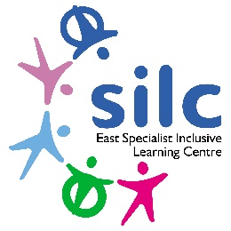
Employee Specification – Teaching Assistant Level 1
Detailed below are the types of skills, experience and knowledge that are required of applicants applying for the post. The ‘Essential’ requirements indicate the minimum requirements, and applicants lacking these attributes will not be considered for the post. The points detailed under ‘Desirable’ requirements are additional attributes to enable the applicant to perform the position more effectively or with little or no training. They are not essential but may be used to distinguish between
 | KEY
 | A | = Application
 | SP | = Selection Process
Person Specification | Essential | Desirable | Method of Assessment
Skills and Ability.
Good numeracy/literacy skills. | ✓ |  | A & SP
Use basic technology – computer, video, photocopier. | ✓ |  | A & SP
Ability to relate well to children and adults. | ✓ |  | A & SP
Ability to work constructively as part of a team. | ✓ |  | A & SP
Maths and English Grades GCSE A-C or CSE level 1. | ✓ |   | A & Certificate
Knowledge & Understanding.
Working with or caring for children of relevant age. | ✓ |  | A & SP
Understanding classroom roles and responsibilities and your own position within these. | ✓ |  | A & SP
Appropriate knowledge of first aid. |  | ✓ | A & SP
To be aware of policies and procedures relating to child protection, health, safety and security, confidentiality and data protection. |  | ✓ | A & SP
Qualifications & Training.
Needs to have a good level of physical fitness and be prepared to take part in training relating to physical interventions (Team Teach) | ✓ |  | A & SP
Participate in development and training opportunities. | ✓ |  | A
Completion of DfES Teacher Assistant Induction Programme. |  | ✓ | A & Certificate

Safeguarding:
The East SILC is committed to safeguarding and promoting the welfare of children and young people and expects all staff and volunteers to share this commitment. Appointments are made subject to a satisfactory Disclosure and Barring Service check (DBS formally CRB) and medical clearance from Leeds City Council’s Occupational Health Service.
It is illegal to apply if you are on the children’s barred list.

The East SILC promotes diversity and wants a workforce which reflects the population of Leeds.

