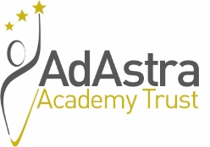
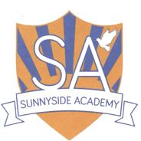

SUNNYSIDE ACADEMY

Manor Farm Way, Coulby Newham, Middlesbrough, TS8 ORJ

Teaching Assistants x 2 posts – both posts to be based in the specialist Key Stage 2 Higher Needs Base.

Post 1 - Teaching Assistant (Band 6) SCP 6-7, £16,307.85 - £16,634.12 per annum. 35 hours per week, term time only including PD days (195 days per year). Permanent.

Post 2 - Teaching Assistant (Band 6) SCP 6-7, £14,910.03 - £15,208.34 per annum. 32 hours per week, term time only including PD days (195 days per year). Fixed-term which is expected to continue until 31st August 2023 providing maternity leave cover.

Sunnyside Academy is a large mainstream primary school situated in Coulby Newham with three support bases for children with a Deaf/Hearing Impairment, children with a Visual Impairment and children with moderate learning difficulties. The successful applicants will work alongside a dedicated team within the Key Stage 2 Higher Needs Base. These positions would be to start on 1st September 2022.

The successful candidates will work with teachers to support teaching and learning by working with individuals and/or small groups of pupils, adjusting activities within set parameters under the direction, guidance and supervision of teaching staff. The successful candidates will also have responsibility to provide short term emergency cover by supervising classes.

Candidates should be suitably qualified and experienced, possessing a NVQ level 3 or equivalent and having worked as a classroom or teaching assistant within a primary school, for a minimum of 12 months, together with having experience of supporting learners with SEND and be able to meet the criteria detailed on the person specification.

Candidates must only apply using the application form provided; CV’s will not be accepted.

For an informal discussion about these positions please contact Julie Sutton, Headteacher on 01642 596422.

Sunnyside Academy is committed to safeguarding and promoting the welfare of children and young people and expects all staff and volunteers to share this commitment. As such the successful candidates will be required to undergo an enhanced DBS check.

This post is exempt under the Rehabilitation of Offenders Act 1974 (Exceptions) Order 1975 (2013 and 2020).

Requesting an application form

Application forms and further details are available via the Ad Astra website:

http://www.adastraacademytrust.com/careers/

Completed application forms to be emailed to recruitment@adastraacademytrust.com

Closing Date – 9am on Monday 20th June 2022
Interviews to take place on Friday 24th June 2022

