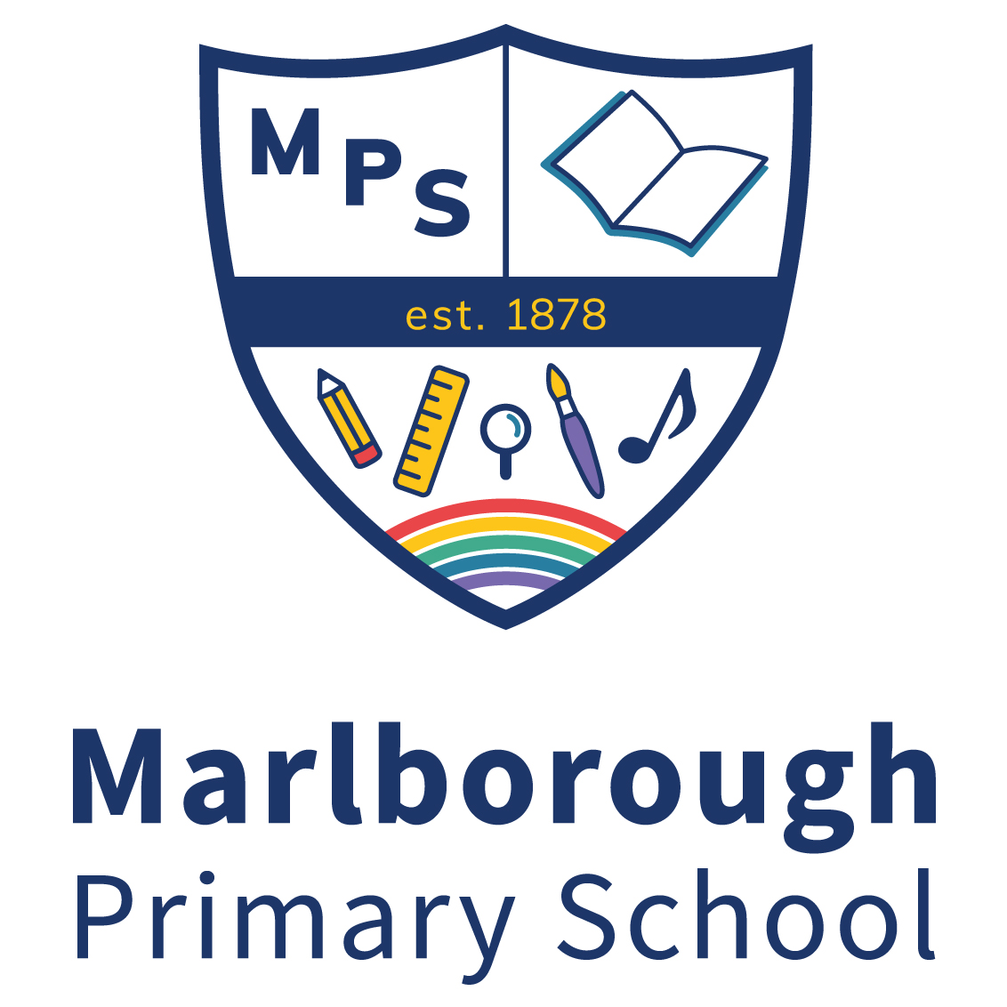
Draycott Avenue, London, SW3 3AP

TEACHING ASSISTANTS
(Partner Teachers)

Salary: £23,427 - £25,614 per annum, (£20,235 - £22,124 pro rata) according
to experience.
Hours: 35 hours - Term Time only

Start Date: September 2022

Pupils and staff at Marlborough benefit from a state of the art building with amazing facilities for learning and we are seeking to appoint Teaching Assistants (Partner Teachers) across the Key Stages to enhance our dynamic Team. You will be joining a committed, enthusiastic and diverse school community which benefits from the skills of our highly experienced in school team and links with our partner school, Colville Primary.

We are seeking highly qualified applicants with a positive attitude who proactively work towards ongoing improvement in quality practices within their work. Additionally, to support in planning and assessment, applicants will need to demonstrate excellent written English. Graduate candidates wishing to develop and move into teaching are encouraged to apply.

The posts are initially temporary for one year with the possibility of a permanent position thereafter.

At Marlborough, we value working effectively and positively as a team. The role requires an applicant who is able to work collaboratively and develop positive professional relationships with colleagues, parents and children.

To obtain an application pack, please email info@marlborough.rbkc.sch.uk
Visits to the school are encouraged.

Closing date: 25th May 2022

Interview date: To be Confirmed

Please return your application form to janet.wallace@marlborough.rbkc.sch.uk

We are committed to safeguarding and promoting the welfare of children. This position requires the post holder to hold an enhanced Criminal Record Bureau Disclosure before an appointment is confirmed.

