Being the best we can be

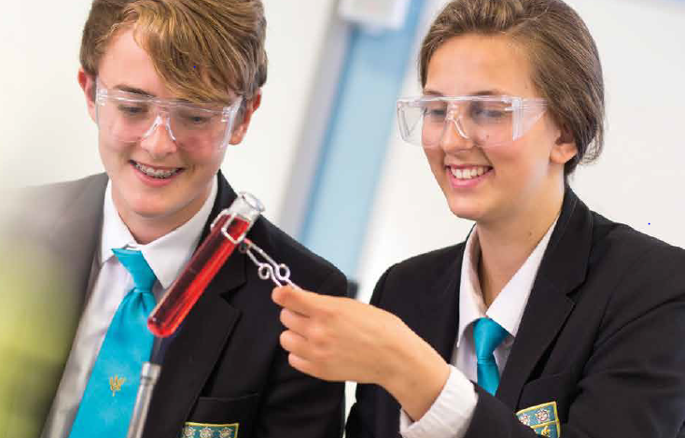

Teaching Assistant x 2
Required as soon as possible in February 2022
Recruitment Information Pack
Scalby School
Fieldstead Crescent, Scarborough, YO12 6TH

Contents

Welcome from the Headteacher 3
Our results 4
Our schools 5-6
Application process and how to apply 7
Job Description/Person Specification 8-13

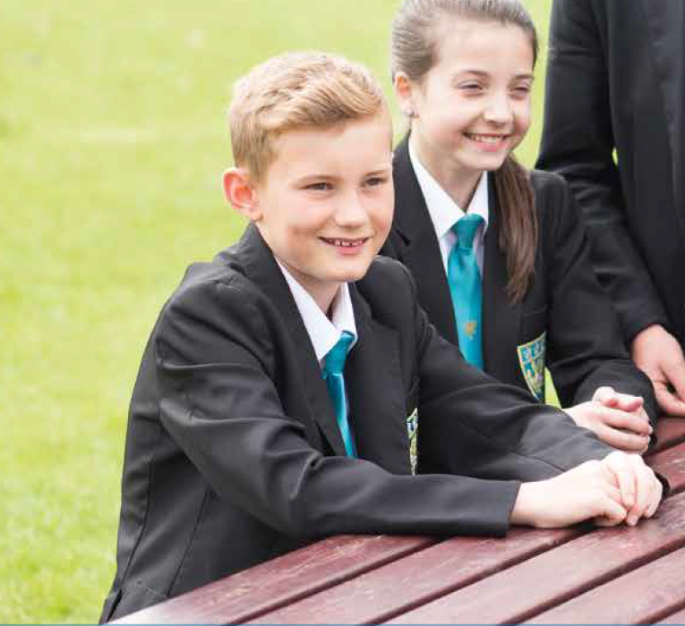

Dear applicant,

Allow me to extend a warm welcome from all governors, staff and students of Scalby School.

I was delighted to be appointed Head of School and while any Head will say their school is special – I truly believe Scalby is.

It is hard to encapsulate in words the full dynamism and vibrancy of our school. We are hugely proud of our students and privileged to serve them and this community. We see it as our professional and moral duty to prepare them as individuals to play their part as active citizens – rounded and centred and aware of all they might contribute to the world. In practical terms, this commitment is manifested in the lessons we deliver, the extra-curricular opportunities we offer and in the wider opportunities we promote.
Scalby is a school with a strong academic tradition but we are equally committed to the Arts, to sport and to collective and individual achievement beyond the classroom. Our annual productions held at the Stephen Joseph theatre are testament to this, and over the years we have seen productions of Macbeth, Romeo and Juliet, Our House to name but a few.
We have developed and benefited from our partnerships within Scalby Learning Trust, Scarborough Teaching Alliance and local secondary and primaries – a few reasons to join us!

In recent years enormous strides have been made to further increase learning standards. This hard work has seen results improve consistently and led to Ofsted rating our school as ‘Good’ in 2012 and in 2019. I truly believe we are a school with highly effective teachers and support staff producing outstanding outcomes for our students.

I hope you can see that this is an excellent time to join Scalby. If successful you will join a staff team of wonderful professionals who have ambition for our students and for themselves. I take pride in ensuring colleagues receive opportunities to develop their skills and experiences – and we have an enviable reputation for delivering high quality professional development.

I hope that you will take the time to come and see and experience for yourself the warm and welcoming atmosphere which makes our vision a reality.

Good luck with your application.

Chris Robertson
Head of School

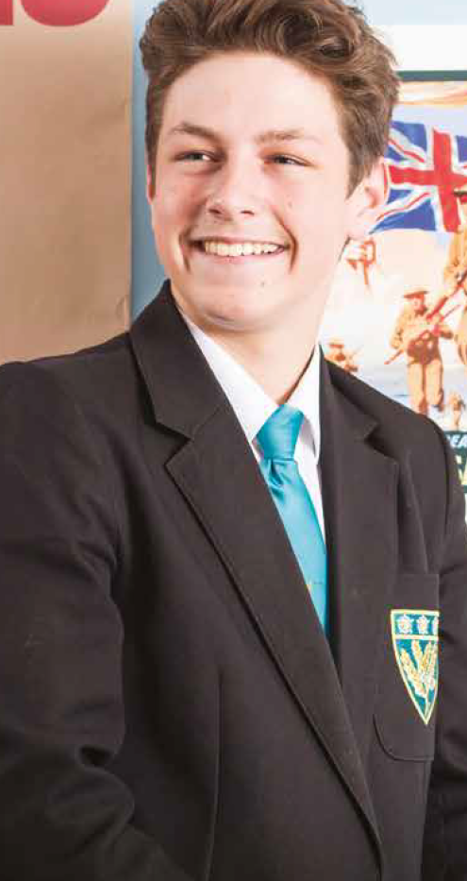
Our results

Scalby School’s 2019 GCSE results are once again characterised by high levels of achievement.

Provisional analysis shows that, for the fourth year in a row, our students made significantly better progress than their peers did nationally. Results in English, Maths and Science are above the national averages at Grade 4 and Grade 5, with 36% of students achieving a Grade 7 or better in English, 28% achieving Grade 7 or better in Maths and 21% achieving Grade 7 or better in two sciences.

This year’s results are particularly pleasing because of the high number of students who achieved Grade 8 and 9 across a number of subjects.
None of these fantastic results would have been possible were it not for the professionalism and dedication of our teachers and learning support teams. These results mean that our students leave us now being able to access a wide range of post-16 courses at college and they have the skills and knowledge valued by employers.”

Our success in our GCSE results follows our positive Ofsted inspection in February this year. With a similar Progress 8 score to 2018, which places us in the top 20% of schools nationally, we are delighted that the high quality of education on offer has been doubly validated at a national level.

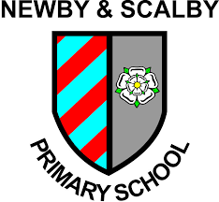
Our schools

Newby and Scalby Primary School

We are one of the schools of choice in our community and we are within commutable distance of Whitby, Teeside, York and surrounding areas. Ofsted in 2018 judged us to be ‘good’ in all areas and as a school we are very much outward facing both in terms of teaching and learning and in constantly thinking about how we can improve.
Since our “good” Ofsted, we continue to build on our successes and we are a family and a team, where everyone is given the challenge and support to be the best they can possible be in a safe, welcoming and positive environment. Children and staff will work and play together developing skills so that we all become ambitious and reflective lifelong learners as well as being respectful and respected members of the community.
To learn more about us please visit us at:
Newby and Scalby Primary School - Home (coastandvale.academy)

Friarage Primary School
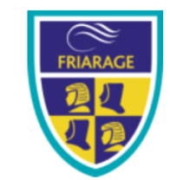
We are proud to serve the communities around the Castle Ward area of Scarborough as ‘Together we can’ make a real difference to the life chances of children and young people in Scarborough.

Children and staff will work and play together developing skills so that we all become ambitious and reflective lifelong learners as well as being respectful and respected members of the community.
We are committed to Restorative Practice Principles to nurture respect for all in our school community.

To learn more about us please visit us at: Friarage Community Primary School - Home (coastandvale.academy)

Scalby School

Scalby School is a successful and popular 11-16 community school and in recent years we have become the school of choice in our local community. We were judged ‘good’ by Ofsted in 2019 and in 2019 we celebrated sustained results. Our provisional P8 score has placed us in the top 20% of schools nationally. We are proud of our broad and balanced GCSE based curriculum.
To learn more about us please visit us at: Scalby School - Home (coastandvale.academy)

Lady Lumley’s School

Lady Lumley’s School (11-18) in Pickering is on a transformational journey. We are a school that is popular with parents and is easily accessible across North Yorkshire, East Riding and Wolds and Vale. The communities we serve around the Pickering, Ryedale and wider Coastal area deserve and need our school to play a leading role in terms of teaching, learning, progress and outcomes.

In April 2020 we welcomed our new Headteacher Clair Foden who joined us at the same time we joined our Trust - Coast and Vale Learning Trust. Lady Lumley’s is on an ambitious journey of school improvement.

To learn more about us please visit us at Lady Lumley's School - Home (coastandvale.academy)

Application Process
The closing date for all applications is 9am Wednesday 26th January 2022
Interviews will be held shortly after the closing date.

Completed applications must be returned to Garry Morrison at garry.morrison@northyorks.gov.uk

If you think you’re the person for the job, please complete the enclosed application form and send to the email address above by the closing date.

An email will be sent to shortlisted candidates with details of the interview process. If you have not heard from us within a week of the closing date please assume your application has been unsuccessful.

Queries
Please contact Garry Morrison at garry.morrison@northyorks.gov.uk or on 07814935700
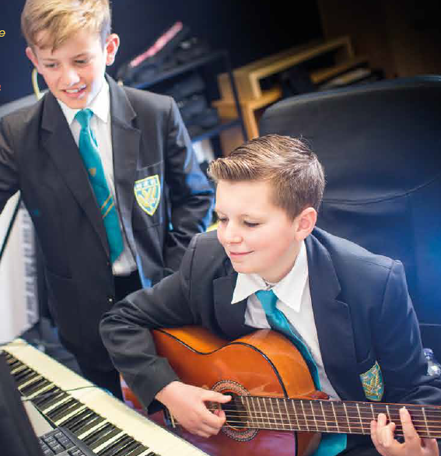

Job Description

Teaching Assistant

Post Responsible to: SLT/Head of Department

Salary Scale: Grade C

Main purpose of the post:
To work as part of the Student Support Department in supporting and integrating students with special needs into mainstream classes. The Teaching Assistant may work with and receive instructions from the Assistant Head Teacher for Teaching and Learning, SENDCo, Teachers, SEN Manager and other professionals. The post covers all areas with regard to provision and access for students at Scalby School. Teaching Assistants are expected to support students’ cognition and learning; behavioural, social and emotional, medical, sensory and physical, communication, and interaction needs, as directed by the SENDCo through the SEN Manager. Teaching Assistants will work in our Access to Learning Centre (ALC) with students who find mainstream education difficult as directed by the SENDCo.

Main Duties:
In relation to the students:
- To develop an understanding of the special needs of the student/s concerned.
- To take into account the students special needs and ensure their access to the lesson and its content through appropriate clarification, explanations, equipment and materials.
- To help them record work in an appropriate way.
- To develop study and organisational skills.
- To help keep the students on task and to build motivation.
- To help reinforce learning.
- To help build the students confidence.
- To encourage the inclusion of the student/s within the class.
- To undertake medical training, if required.
- To administer specialist programmes with students, under the direction of the specialist external services.
- To support students with their personal care – in some cases this can mean assistance with going to the toilet, support for eating food at breaks and lunchtimes.
- To provide medical support and administer medication, as required such as epipens, and the daily medication of students, under the direction of the SEN Manager and Senior Leader of Engagement and Safety.
- To assist students with changing for PE and other activities.
- To support the behavioural and emotional needs to students, in line with classroom and school policies.
- To undertaken assessments of students preferred learning styles.
- To support year group mentor times.

- To provide emotional support for students and support additional programmes and therapy offered.
- To work with students on enrichment activities and support students during examinations and internal assessments.
- To scribe, read and provide practical assistance for external examinations, under the direction of the Examinations Officer and SENDCo.
- To support individualised programmes for students on withdrawal from lessons – including SALT programmes and OT support.
- To deliver intervention programmes to small groups of students away from the mainstream classroom.

In relation to outside agencies and other professionals, including Annual Reviews:

- To liaise with outside agencies and attend meetings and training as required.
- To provide written reports for Annual Reviews and meetings, as required.
- To complete daily Record of Work sheets to support the tracking of students and identify areas for additional support.

In relation to the teachers:

- To support the teacher in the development and the presentation of the students individual programme.
- To have clear lines of communication with the students teacher.
- To have formal meetings with teachers to enable planning and preparation for lessons, where time permits.
- Where appropriate, to act as liaison between students and the teacher.
- Involvement in keeping records and evaluation of students programmes.

In relation to the school:

- To assist in Educational Visits for students with additional needs and other whole school events.
- To support college transition and work with students off site for KS4 placements and work experience.
- To support whole school events and educational visits for all students of the school.
- To work as part of the team in relation to individual students, liaising, advising and consulting where appropriate.
- To be aware of school policies and procedures, including those relating to confidentiality.
- To identify personal in-service needs and to attend appropriate internal and external in-service training.
- Any other tasks as directed by the Headteacher, which fall within the scope of the post.
Please note:
We reserve the right to review and change the job description, in consultation with the postholder, dependent on the changing circumstances of the school.

Person Specification

JOB TITLE: Teaching Assistant

GRADE: Grade C

Assessment: 1. Test prior to shortlisting (i.e. all applicants)
2. From application form
3. Test after shortlisting
4. Probing at interview
5. Documentary Evidence
6. OTHER (Please specify)

CRITERIA | ESSENTIAL | DESIRABLE | ASSESSMENT
Qualifications & Training  Childcare Qualification at Level 2 (or equivalent).  Appropriate first aid training  (Dependent on the schools needs - insert as appropriate)  Tracheotomy Training |  | X  X  X | 2 & 5  2 & 5
Experience  Experience appropriate to working with children in an education setting. | X |  | 2 & 4
Skills & Knowledge  Good written and verbal communication skills: able to communicate effectively and clearly with a range of staff, children, young people, their families and carers.  Good understanding of child development and learning processes.  Behaviour management. | X  X | X | 2, 3 & 4  2 & 4  2, 3 & 4
Personal Qualities  Demonstrable interpersonal skills.  Ability to work successfully in a team.  Confidentiality. | X  X  X |  | 2 & 4  2 & 4  2 & 4
Other Requirements  To be committed to the school’s policies and ethos.  To be committed to Continuing Professional Development  Motivation to work with children and young people.  Ability to form and maintain appropriate relationships and personal boundaries with children and young people.  Emotional resilience in working with challenging behaviours; and, attitudes to use authority and maintaining discipline. | X  X  X  X  X |  | 2 & 4  2 & 4  2 & 4  2 & 4  2 & 4
Equal opportunities  To assist in ensuring that Trust equalities policies are considered within the school’s working practices in terms of both employment and service delivery | X |  | 2 & 4

