INFORMATION PACK
2 x Administrators: 2 Year Fixed Term Contracts
Teaching School Hub Administrator
Early Years Stronger Practice Hub Administrator
Based at The Lodge (Altrincham Grammar School for Girls) – hybrid working available
Overview of the Role
The role of both the Teaching School and Early Years Stronger Practice Hub Administrators is to provide outstanding administrative support to our Hub leaders. The nature of the support required will vary from day to day, key responsibilities will involve a huge variety of administrative tasks as well as supporting with paperwork and record keeping. The post holders will work closely with the leadership team of either the Teaching School or Early Years Stronger Practice hubs drawing on resources as and when necessary. We have a flexible approach to working arrangements and would discuss this with successful candidates.
The full job description and person specification are at the end of this pack.

Bright Futures Educational Trust

Bright Futures Educational Trust (The Trust) is a multi-academy trust (MAT) set up in 2011. The Trust is made up of a richly diverse group of schools in Greater Manchester and Blackpool. We are passionate about working together within and beyond the Trust to achieve our aspirational vision: the best for everyone, the best from everyone. We are an organisation that is underpinned by values of: community, integrity, and passion. In everything we do, we remember that we are accountable to the children, families, and communities that we serve.

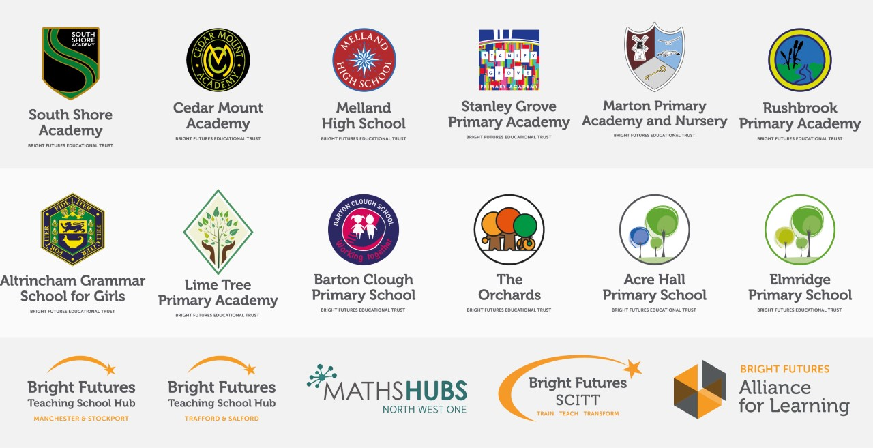

Our schools have their own identities and form one organisation and one employer, Bright Futures Educational Trust. Bright Futures’ Board of Trustees maintains strategic oversight of the Trust and delegates some of its responsibilities to the Executive Team, Principals, and local governing bodies. We place a high value on integrity and probity and take seriously our accountabilities for making the best use of public money. How decisions are made is described in our delegation framework. You can find out more about the Trustees and the Executive Team on our website: About Us

The central team comprises the Executive Team: John Stephens, CEO; Edward Vitalis, Chief Operating Officer; Gary Handforth, Director of Education; Lisa Fathers, Director of Development, Partnerships and Teaching School Hubs; Lynette Beckett, Director of HR & Strategy. The focus of these roles is to work with schools, providing high quality and timely guidance, leadership, challenge, and support. In addition to the Executive Team, we have central operations for Finance, HR, Educational Psychology, Marketing and Communications, and Digital Technologies. Please see our website brochure which explains our central operations: Working together for a Bright Future.

Bright Futures Development Network is another important outward facing component of our organisation made up of a number of hubs and networks at the heart the Trust. In January 2021, after significant national reforms to the teaching school policy Bright Futures was designated with two new large-scale Teaching School Hubs, which replace the Alliance for Learning Teaching School. This growth and expansion in our outward facing work brings about a significant increase in accountability and reach. The two Bright Futures Teaching School Hubs are designed to provide strong strategic regional leadership to build robust partnerships to support teachers and leaders in every phase and type of school, at each stage of their development. A crucial part of the hub remit is carefully ensuring structured collaboration.
The Teaching School Hubs are at the forefront of providing high quality professional development, playing a significant role in the implementation and delivery of: The Early Career Framework, National Professional Qualifications (NPQ), Initial Teacher Training and Continuous Professional Development (CPD). The Hubs work directly with the Department for Education and national NPQ/ECT providers. In addition to this, the Hubs enhance the professional development needs of Bright Futures schools and academies.
Within this outward facing area of Bright Futures Educational Trust, we have a commercial offer run through the Alliance for Learning which provides first-class school improvement services and CPD to over 700 schools, further complementing the work of our Teaching School Hubs. Our School-Centred Initial Teacher Training (SCITT) Bright Futures SCITT is also an integral part of the Teaching School Hubs, with over 10 years’ experience and judged Good by Ofsted, we offer Early Years, Primary and Secondary teacher training programmes. Within the Bright Futures Development Network, we are also proud to have a Maths Hub: NW1 Maths Hub offering a wide range of maths specific high-quality professional development opportunities and training/coaching to 500 schools.
Early Years Stronger Practice Hub
Throughout the pandemic, the youngest children in the most disadvantaged areas of England were among the hardest hit by lockdowns and social distancing. A responsive programme of support for staff and children has been developed by the Government to assist recovery and address the disruption of Covid-19. This includes new funding to support settings to address the impact of the pandemic on young children by sharing effective evidence-informed practice and building lasting local networks via the Stronger Practice Hubs programme.
The Stronger Practice Hub model works directly with the sector on a system leadership approach, with strong settings becoming a base for support, collaboration and practice sharing for and with other parts of the sector. The DFE has commissioned the National Children’s Bureau (NCB) to manage the relationships with Early Years Stronger Practice Hubs, including providing support, oversight and quality assurance, as well as running the selection process.

Our Early Years Stronger Practice Hub (EYSPH) will support settings to adopt evidence-informed practice improvements – in line with the framework developed for the programme by the Education Endowment Foundation, as well as with the reformed Early Years Foundation Stage, Development Matters.

Collaboration and strong relationships form one of the ‘commitments’ in our Strategy and all components of the Bright Futures’ family work closely together. Our Strategy was developed collaboratively and can be found on our website: Our Strategy

WHY WORK FOR US?
We offer a great opportunity to join an organisation which really lives its values. Our working environment is very inclusive and whilst you can expect to be challenged in your role, you will be supported through professional learning, treated fairly and with dignity and respect. Please see the Equality,
Diversity, an Inclusion statement on our website.

Terms and Conditions

Salary: NJC scale points 4 to 6 (Bright Futures scale Grade 3). The full time equivalent pay is £21,189 rising to £21,968 per annum. The actual pay based on the below working pattern commencing £18, 144.12 rising to £18,811.18 per annum actual pay. Pay progression is linked to performance.

Working weeks: This is a great opportunity for flexible working as the role will work 38 weeks during school term time and an additional 1 week to be agreed. A total of 39 weeks. The contract is fixed term for 2 years.

Hours: 36.25 hours per week over 5 days. Flexible working will be considered, please discuss at interview if you wish this to be considered.
Holidays: You will be paid for the prorate equivalent of 25 days, plus 8 public holidays. This increases to 30 days plus 8 public holidays after 5 years’ service.

Pension: Local government pension scheme. Please take a look at the website: https://www.gmpf.org.uk/.

Other: We offer salary sacrifice schemes for purchasing bikes used for travel to work and technology for personal use, through monthly interest free salary deductions.
We also offer opportunities for professional development.

For a full explanation of our employment offer please see the booklet on our website:
Great-Place-booklet.pdf (bfet.co.uk)

How to Apply
We can only accept completed application forms, rather than CVs. This is because the regulatory guidelines of
Keeping Children Safe in Education (2021), require us to check various details of job applicants and an identical
application format for each candidate enables us to do this. We use a process that does not identify personal
characteristics to the shortlisting panel. This is part of our commitment to equalities and diversity.

NO AGENCIES PLEASE.

Our application form is available online, along with the disclosure of criminal background form. The portal link is Hub Administrators (jotform.com) Alternatively, you can click Apply Now on this role via the current vacancies page of our website. Please upload the forms by Thursday 5th January 2023 Midday. You will be considered for both roles, however, should you have a preference for one of these roles please state so in your supporting information.

The selection process may be conducted virtually, so candidates will need access to a device with a camera and a microphone to participate. However, we will confirm this following the closing date. The selection will take place on Tuesday 10 January 2023. You will be notified after the closing date whether you have been shortlisted.

Keeping Children Safe in Education
Bright Futures Educational Trust is committed to safeguarding and promoting the welfare of children and young people and we expect all staff and volunteers to share this commitment. This post is exempt from the Rehabilitation of Offenders Act 1974; pre-employment checks will be carried out and references will be sought for shortlisted candidates and successful candidates will be subject to an enhanced DBS check and other relevant checks with statutory bodies.

Data Privacy
You can read the details of how we use the personal data that you provide us with in our Job Applicants’ privacy notice on our website: Applicant Privacy Notice
JOB DESCRIPTION
Administrator: Teaching School Hubs & Early Years Stronger Practice Hub
Reporting to Deputy Director of Teaching School Hubs & Head of Early Years Stronger Practice Hub

JOB SUMMARY

The role of the Hubs Administrator is to provide outstanding administrative support to our Hub Leaders . The nature of the support required will vary from day to day, key responsibilities will typically include:
- General administrative support for the Hub e.g., scheduling of meetings and making any necessary arrangements such as room bookings, ordering refreshments and making any travel arrangements, photocopying, printing, handling outgoing and incoming post, general typing, establishing electronic and paper filing systems.
- Communicating effectively with Hub stakeholders on behalf of the Hub team eg schools and senior leaders, Trust schools, DfE colleagues, programme participants and programme leads/facilitators.

KEY RESPONSIBILITIES AND ACCOUNTABILITIES

Main Responsibilities
We are seeking an experienced, highly skilled administrator who is committed to Hubs and trust vision and values and who will provide outstanding administrative support. The post holder will support the administration and coordination of the Hubs objectives as defined by the Department for Education (DfE) & the National Children’s Bureau (NCB) by:
- Producing all correspondence as required - letters, emails, mail merges - in a timely and professional manner
- Maintaining the Hub diaries and maintaining administrative oversight of Hub activities
- Ensuring records are well maintained
- Preparing and proof reading communications and documents eg newsletter content as requested by the hubs team
- Compiling and formatting documents, including presentations and reports, to a high standard
- Providing administrative support to the leaders of the Hubs

Programme Management Administration
Support the Hubs leaders to:
- Communicate effectively with Hub stakeholders, programme participants, leads/facilitators and external/accredited delivery partners
- Coordinate programme leads/facilitators, establishing and providing delivery needs according to external provider requirements
- Ensure records are maintained in line with programme license requirements, directly via DfE/NCB and internal/Hubs systems

Partnership Administration:
- Support the Hubs leaders to build effective and positive relationships with all key stakeholders including Hub schools, Early Years settings and external/accredited delivery partners
- To organise, attend and take minutes of meetings as required by Hub leaders
- Provide coordinated communication to Hub stakeholders
- Support the Hub leaders to maintain internal records for programme participation, attendance and successful completion and reporting systems
- Assist Hubs team with updating any external databases/IT systems
- Respond to queries in a positive manner to ensure the building of effective and beneficial relationships with all key stakeholders Hub schools and senior leaders, Trust schools, DfE colleagues, NCB Colleague, participants and leads/facilitators

Other duties may be undertaken from time to time to support the more general and wider work of Bright Futures Development Network. These may include:
- To undertake any general administrative work for members of the Development Network and on other projects when requested
- To liaise with project partners of the Development Network both nationally and internationally
- To work with the Development Network to organise any visiting delegations
- To perform any other duties requested by the Director of Teaching School Hubs & Partnerships and Hub leaders

Other

We will always consider a flexible approach to working –just ask at interview
- Attend relevant meetings as required, acting as a role model consistently promoting the Trust’s vision, values and commitments.

Acting as an ambassador ensuring that the Trust’s high standards are promoted at all times.
- A commitment to maintaining confidentiality and discretion inside and outside work

PERSON SPECIFICATION
Category | Essential | Desirable | Method of assessment
Qualifications, Education, training | - GCSE English and mathematics up to GCSE level grade C or above  - Evidence of Continuous Professional Development | - A relevant and related qualification | - Application form
Relevant Experience | - Experience of providing high quality administration support within a professional organisation  - Experience of coordinating events  - Experience of diary and email management  - Strong interpersonal skills and relationship management  - Customer service experience | - Experience of working in a school environment | - Application form  - References  - Interview
Knowledge, skills and abilities | - Excellent written and verbal communication skills  - Excellent telephone manner and oral skills  - Excellent IT skills, including working knowledge of Microsoft Office, including Word, Excel and PowerPoint  - A willingness and ability to provide assistance across a range of departments  - Ability to maintain confidentiality and discretion  - Ability to work under pressure and multi-task pressure and stay calm at all times  - Excellent organisational skills  - Ability to prioritise  - Ability to be self-motivating  - Ability to work efficiently at speed | - A working knowledge of health and safety practices within an office environment | - Application form  - References  - Interview  - Tasks
Personal Qualities/Other | - A commitment to the vision and values of the Hubs  - A positive approach to challenges, which seeks solutions to problems and addresses difficulties with cheerfulness and good humour.  - Smart, professional appearance  - Flexibility and adaptability  - Initiative and self-confidence and the ability to deal with difficult situations  - Being prepared to work flexibly outside school hours on occasion  - Commitment to further training and development  - Friendly manner  - Supportive nature  - Team player |  | - Application Form  - References  - Interview  - Tasks
Safeguarding | Commitment to demonstrating a responsibility for safeguarding and promoting the welfare of young people |  | - Application form  - Interview  - Task
Our Values | Community: Evidence of working together for a common purpose and encouraging diversity |  | - Interview  - Tasks
 | Integrity: Evidence of doing the right things for the right reason |  | - Interview  - Tasks
 | Passion: Evidence of taking personal responsibility, working hard and having high aspirations |  | - Interview  - Tasks

