

WALTHAMSTOW SCHOOL FOR GIRLS
Mathematics Faculty Information

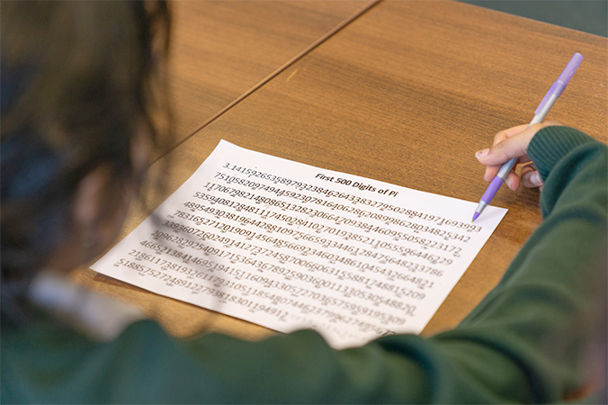
Thanks to the exceptional attitudes of our students and the dedication of their teachers, maths is flourishing at Walthamstow School for Girls. GCSE results are consistently outstanding compared to national averages.

In year 7, students are initially taught in mixed ability groups. During the second half of the Autumn term students are grouped based on their class work, assessments, and home learning. Students who have not met the expected standard at the end of KS2 are set in a smaller group from the start of year 7 to provide them with focused support immediately. Once we have got to know them, students are grouped by attainment to allow teachers to target their precise needs. All groups learn the same core content, with targeted extension and support to promote progress for all students. Students in years 7 and 8 are taught in two year-halves of four groups and follow a curriculum designed with the big ideas of teaching for mastery in mind. We expose students to a variety of representations and manipulatives to build their understanding of mathematical structures, while giving them plenty of opportunities to think deeply and reason. We use department time to collaborate and think about pedagogy and regularly engage with the Maths Hub to ensure our students experience the highest quality teaching.

We currently offer a three-year KS4 curriculum where fluency, reasoning, problem solving, and retrieval practice are the cornerstone of ensuring every student makes exceptional progress. Our curriculum is carefully planned so that all students have access to the core knowledge they need to succeed in maths, ensuring as many as possible have access to the higher tier. Short assessments for each topic allow us to give meaningful feedback, while longer cumulative assessments twice a year give us a clear indication of students’ progress over the entire course.

The successful candidate will be expected to teach in every year group and cover the full range of ability levels.
October 2025

