May 2025

Dear Prospective Candidate

Temporary Reception Class teacher (maternity leave cover) required from January 2027 (M2-6)
Thank you for your interest in the class teacher vacancy at The Gattons Infant School. Please find attached an application form and some information about the post and the school. You are encouraged to visit the school – please telephone the school to make an appointment.

Closing date is 9am Thursday 22nd October 2026
We will hold interviews week commencing 2nd November 2026

The Gattons Infant School is committed to safeguarding and promoting the welfare of children and young people and expects all staff to share this commitment. The successful applicant will need to undertake an enhanced DBS (Disclosure and Barring Service) and a Health Check.

Please contact me if you need any further information head@thegattons.co.uk

We look forward to receiving your application.

Yours sincerely

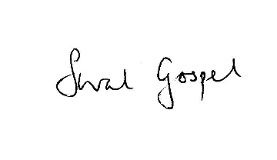
Sarah Gospel
Headteacher

The Gattons Infant School
The atmosphere at The Gattons is very special and particular to an infant school. We work hard to ensure that all children feel secure and valued and are able to meet high expectations. We actively encourage social and moral awareness and a striving to do one’s best in all areas of school life.

The teaching and support staff are enthusiastic, hard-working and supportive. We have a strong commitment to the professional development of all staff and will support and encourage your career progression.

We work closely with parents and involve them in their child’s learning and the life of the school in many ways. The Governors play their full part in the running of the school and are very appreciative of the work done by the staff.

The school, which was built in 1964, is situated on the western side of Burgess Hill. There are about 260 pupils aged 4 – 7 on roll, organised into nine classes. Outside there are three playgrounds; all classes open directly into their outdoor learning area/playground. At the rear of the school there is a large, attractive playing field which includes many outdoor learning resources including a wild area, huge sandpit, swings, a slackline gym and slide.

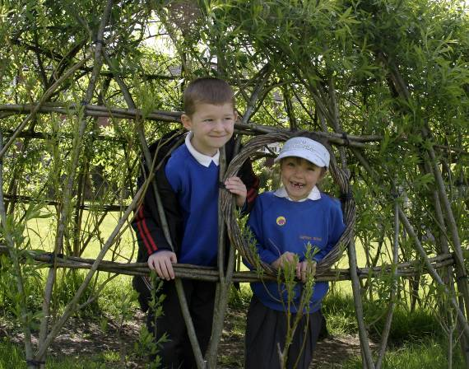

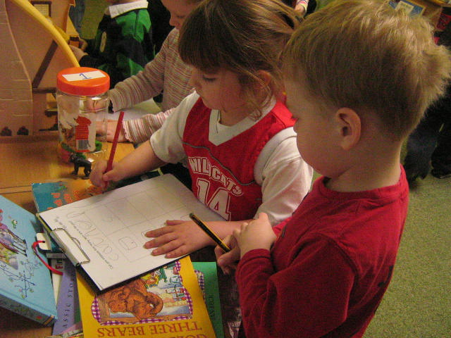

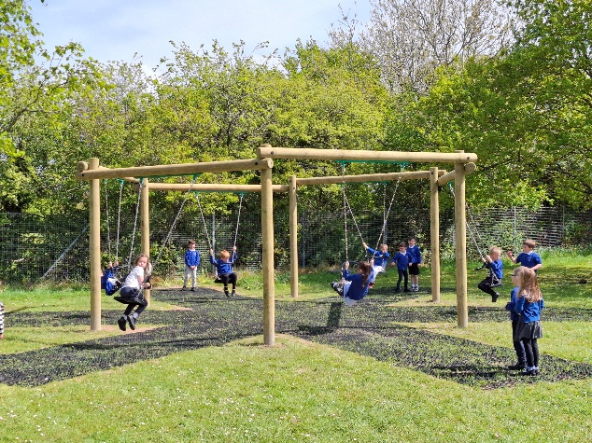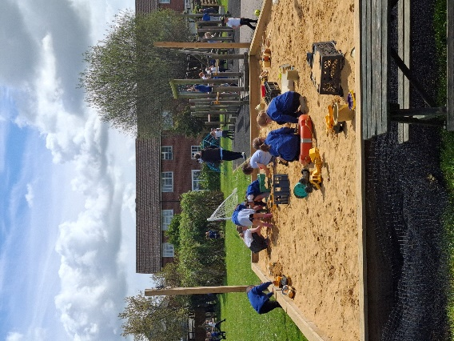

The post
We are looking for an excellent, inspirational class teacher to join our successful and friendly school. We invite applications from excellent teachers who are interested in teaching in both the Early Years Foundation Stage and Key Stage 1.

Please state your strengths and curriculum interests in your application.

We are looking for:
- An exemplary practitioner – this is more important than any particular curriculum strength;
- An inspirational, enthusiastic, creative and confident teacher with an excellent understanding of how young children learn;
- A teacher committed to ensuring that all pupils achieve their very best;
- A person who can contribute ideas;
- A person who sees herself/himself as a learner;
- Someone who can support the therapeutic ethos of the school, is flexible and will be able to respond to the changing needs of the school as it continues to develop.

Person Specification

 | Classteacher | Essential Criteria | Desirable Criteria
Teaching and Learning | Has Qualified Teacher Status | X
Teaching and Learning | Demonstrates and promotes the positive values, attitudes and behaviour that they expect from their pupils | X
Teaching and Learning | Has experience of teaching in Key Stage 1 | X
Teaching and Learning | Has experience of teaching in the Foundation Stage |  | X
Teaching and Learning | Has experience of teaching in the Foundation Stage and Key Stage 1 |  | X
Teaching and Learning | Has excellent teaching skills appropriate to teaching in the infant years | X
Teaching and Learning | Understands the characteristics of effective teaching and learning and strategies for improving and sustaining high standards of pupils achievement | X
Teaching and Learning | Has high expectations of all children underpinned by a therapeutic approach to managing behaviour | X
Teaching and Learning | Can demonstrate the use of effective planning and assessment strategies | X
Teaching and Learning | Has excellent classroom and organisation skills | X
Teaching and Learning | Understands the importance of an appropriate, high quality learning environment | X
Teaching and Learning | Is enthusiastic and well organised | X
Teaching and Learning | Is a reflective practitioner | X
Working with others | Works effectively with support staff and other professionals | X
Working with others | Works well within a team, forming positive working relationships | X
Working with others | Has high expectations of self and others | X
Working with others | Displays good communication skills | X
Working with others | Involves and works effectively with parents and carers | X
Working with others | Can offer experience in subject/area leadership |  | X
Working with others | Demonstrates the ability to contribute to the work of the wider school; | X
Working with others | Is able to contribute to, and share responsibility in, the corporate life of the school | X
Professional development | Is committed to his/her own professional development | X
Other qualities | Demonstrates a positive and flexible attitude | X

