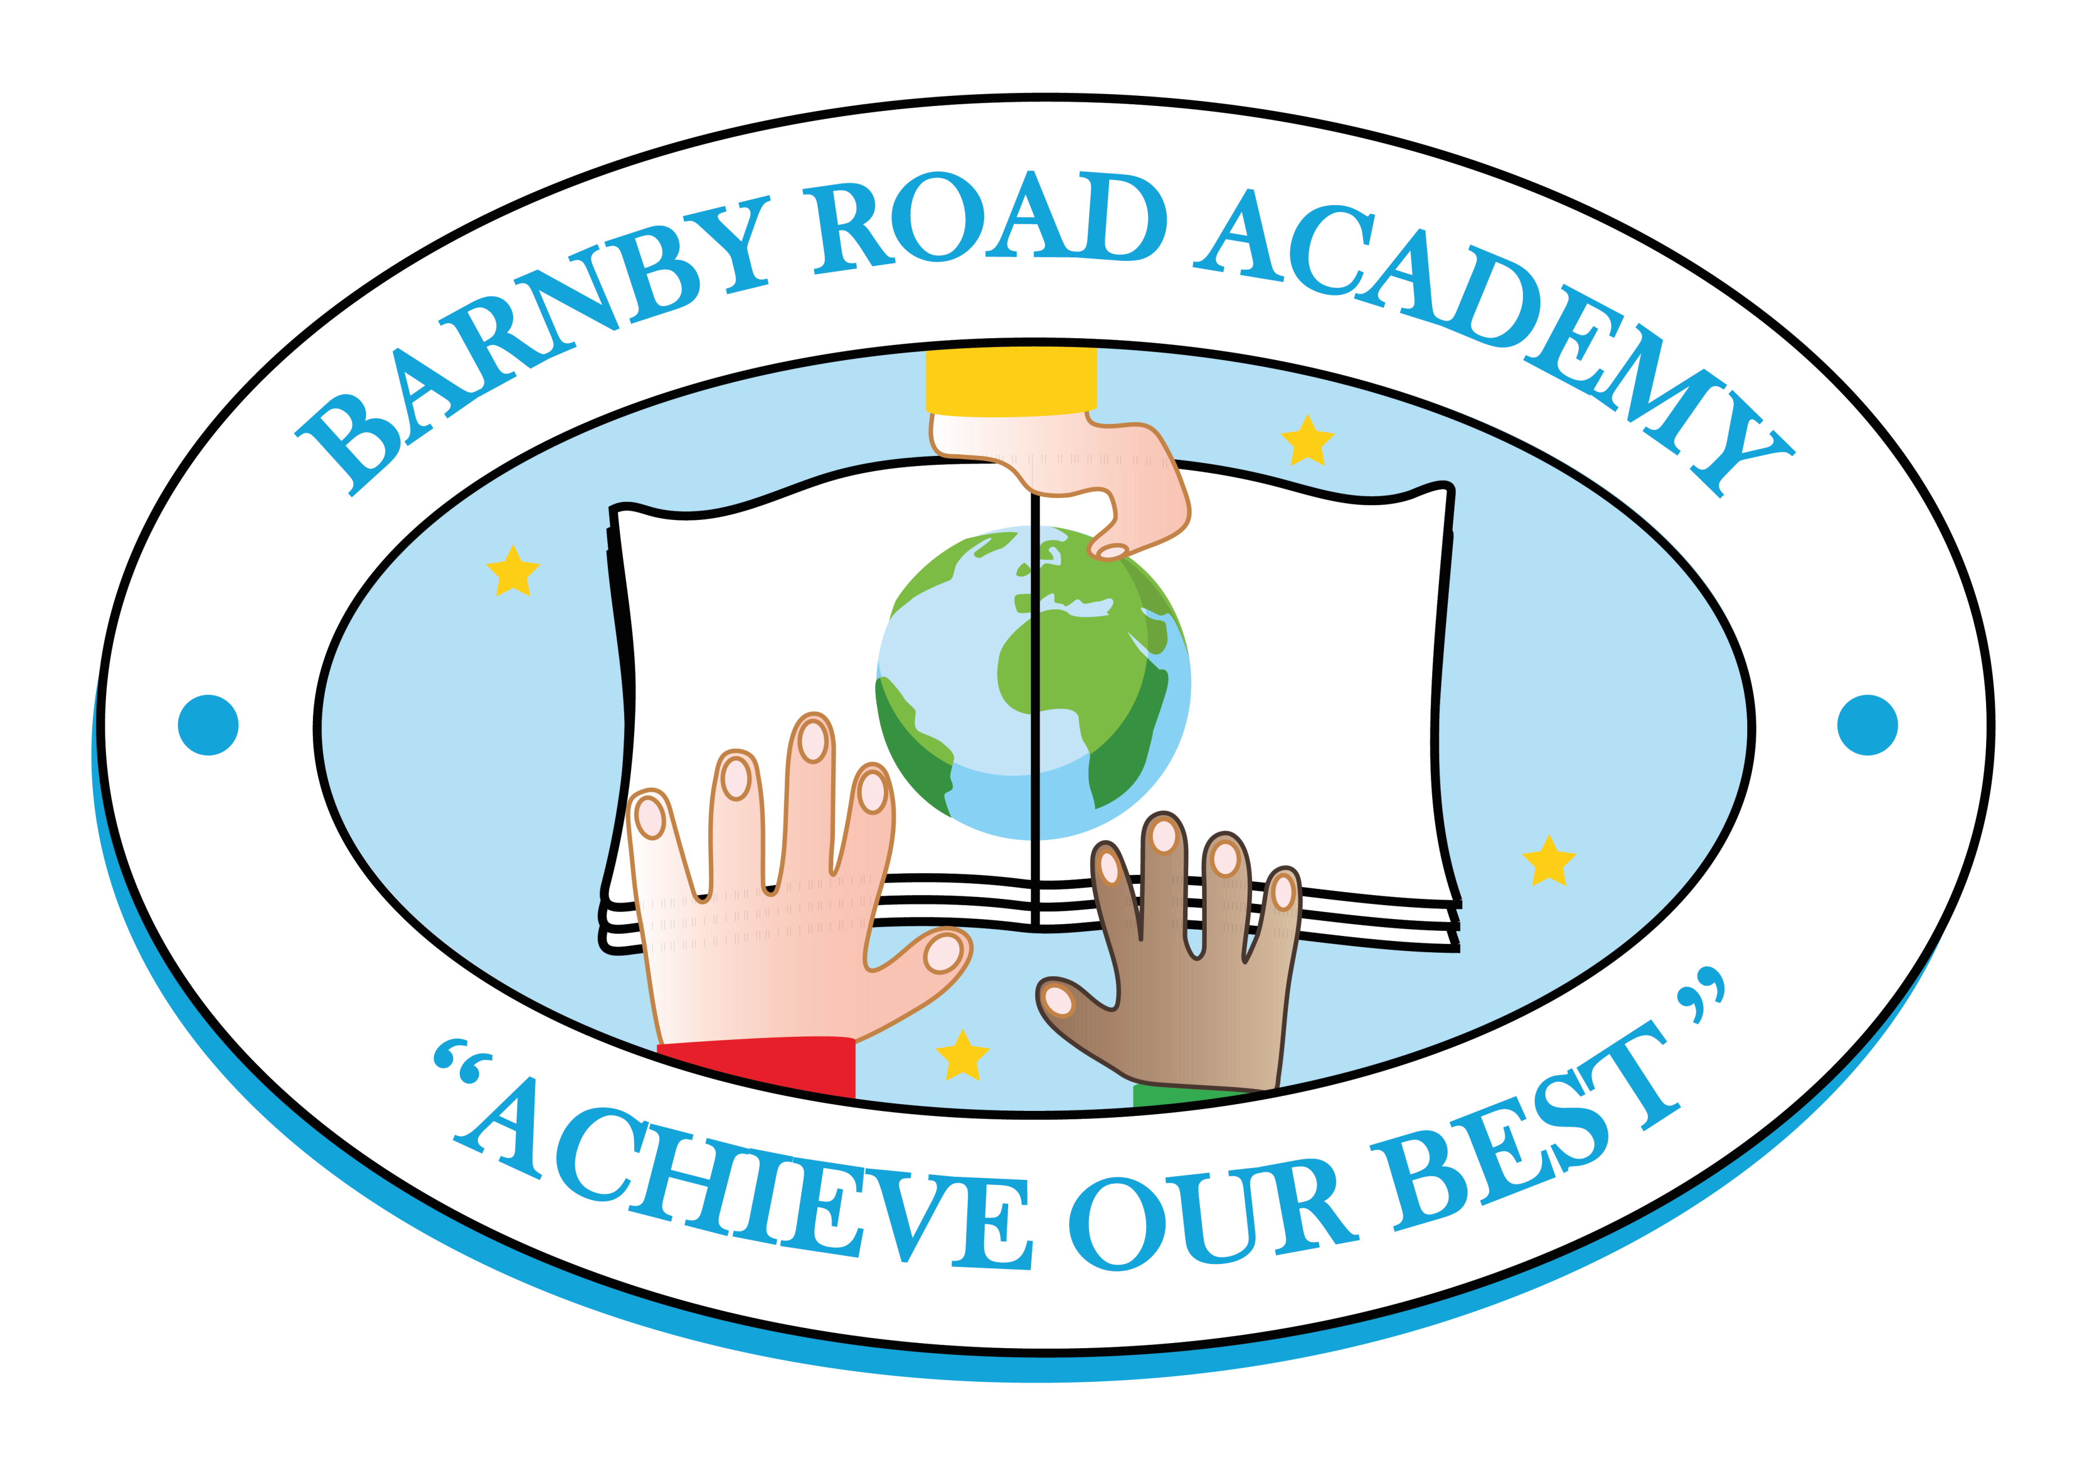
Barnby Road Academy
Person Specification – Teaching Assistant
Essential | Desirable
Qualifications
- Suitable Teaching Assistant qualification | - Evidence of commitment to continuing professional development  - Paediatric first aid
Experience
- Experience of working with EYFS children  - Experience of working within a team | - Experience of working with children with special educational needs/English as an additional language  - Experience of working with children with speech, language and communication difficulties  - Experience of working with children with special educational needs/English as an additional language  - Experience of working with other adults in the classroom e.g. students, parent helpers
Knowledge and Understanding
- Knowledge and understanding of the EYFS curriculum  - A secure understanding of the processes by which young children learn  - An ability to differentiate/adapt learning to meet the needs of all children  - Competent use of ICT  - An understanding of the importance of establishing positive behaviour and learning attitudes  - An understanding of the importance of safeguarding children | - Knowledge and understanding of working with parents to develop a learning partnership
Personal Qualities
- A caring ethos  - Excellent communication & organisational skills  - A commitment to working co-operatively as part of a team  - Energy, creativity and passion  - A sense of humour  - An ability to embrace change with enthusiasm and a positive outlook  - High expectations of self and others  - An ability to motivate and inspire children to achieve their best | - A commitment to supporting all aspects of school life

