Bengeworth Multi Academy Trust
‘Dream, Believe, Achieve’

Year 4 Class Teacher
(Maternity Cover)
Commencing 10th January 2022

Information for Candidates

A Message from the Chair of Governors

Thank you for the interest you have shown in the above vacancy that has arisen at our school. I hope that, after reading this information pack, you will feel able to apply for the post. Our website is well worth a visit as it gives a good flavour of our school.

This is an exciting time for Bengeworth CE Academy as we are looking forward to welcoming Year 4 Class Teacher to cover a maternity leave position and to join our strong, friendly and dedicated staff and enthusiastic, confident children.
The closing date for completed applications is Monday 15th November 2021 at 9.00am. Interviews are scheduled to take place during the week beginning Monday 22nd November 2021.
To submit your application please email the completed form to; vll3@bengeworth.worcs.sch.uk or post to the address below before the closing date.
I look forward to receiving your application.

Yours sincerely

Andy Martyr-Icke

Chair of Governors

Bengeworth CE Academy,

Kings Road, Evesham, Worcestershire, WR11 3EU

Telephone: 01386 442047
Fax: 01386 48303
Email: office@bengeworth.worcs.sch.uk
Web Page: www.bengeworthacademy.co.uk

The advertisement

Role: Year 4 Class Teacher (Maternity Cover)

KS2 Year 4 Class Teacher

Salary: Main Scale

Year 4 Class Teacher (Maternity Cover) required from 10th January 2022

You are invited to join this highly successful Multi Academy Trust where we are committed to giving the best to our pupils. We are an over-subscribed, forward thinking school with happy children, a strong teaching team and excellent facilities.

We are seeking to employ an enthusiastic and committed teacher to join our highly motivated and hardworking team at our Kings Road setting. We are looking for candidates who wish to teach in Key Stage 2. The post would suit teachers, either Early Career Teachers (ECTs) or experienced, who are able to demonstrate high quality teaching with exceptionally high expectations for every child.

In your letter of application, please state your curriculum strengths and any particular talents and abilities you could offer our school and trust.

Bengeworth Multi Academy Trust is committed to safeguarding children and promoting the welfare of all children and young people and expects all staff to share this commitment. All successful candidates will be subject to a Disclosure and Barring Service (DBS) enhanced check.

We would encourage you to look at our website, www.bengeworthacademy.co.uk to find out more about our schools and download our MAT application form and further details. (Please do not apply online through Eteach). Please send completed applications to vll3@bengeworth.worcs.sch.uk or send via post to the address above.

Closing Date and shortlisting: 9am Monday 15th November 2021
Interviews: TBC week beginning Monday 22nd November

About Bengeworth Multi Academy Trust

Bengeworth Multi Academy Trust is a growing MAT currently made up of two schools, Bengeworth CE Academy and Bretforton Village School.

Bengeworth CE Academy is on two sites situated east of the River Avon. The Reception and Year 1 setting is on Burford Road and the Year 2 and KS2 Setting is a quarter of a mile away at the end of Kings Road.

Our Ofsted Report in 2011 said:
“Bengeworth is a fantastic school that continually strives for excellence. It promotes a rich and varied curriculum which my child enjoys immensely.” This comment from a parents’ questionnaire captures the outstanding nature of the school. Pupils’ achievements are outstanding. From below expected levels of attainment on entry to Reception, pupils make exceptionally rapid progress to reach high attainment by the end of Year 5.
Bengeworth Academy serves a close-knit community made up of older houses and new developments in Evesham. The school consists of 8 classrooms in the Burford Road setting and 12 more classrooms at King’s Road, making a total of 18 classrooms in all. Both settings are well equipped, resourced to a high standard and are set in attractive grounds.

About our Christian Values

Bengeworth CE Academy is a Church school and we have close links with St Peter’s Church. We believe that our agreed Christian values should underpin all that we do. The Christian values that have been agreed by all stakeholders are: Friendship, Perseverance, Respect, Trust, Forgiveness and Responsibility and it is also our belief that the theme of love runs through all of these values. Our Challenge Partners review in November 2015 confirmed that this is an Area of Excellence in our school.

The school’s vision is that every individual, child and adult, is encouraged to “Dream, Believe, Achieve.” This is evident in all aspects of the school’s work. The Leadership Team lead by example through their commitment to inspire and mentor others.

About the children

There are currently approximately 530 pupils aged between 4 and 10 years at the school who come mainly from the Bengeworth area, which is of mixed housing, some of which is Housing Association-provided. The children are enthusiastic, hard working and well behaved. They are treated with respect, loved for themselves and valued for their contributions.

About the staff team

The trust leadership team is made up of the CEO, three Heads of School, an associate Headteacher with responsibility for inclusion across the trust and two Deputy Heads of School.
In addition to this the staffing team at Bengeworth CE Academy comprises of fourteen full-time teachers, eleven part-time teachers, two secretaries, two receptionists, a school business manager and finance assistant, an assistant bursar, a team of lunchtime supervisors, a cook, deputy cook, three kitchen assistants, a cleaner in charge, extensive cleaning team and and one caretaker. We also have twenty five support professionals, which allow us to ensure that the additional needs of children can be met and rapid progress made. The staff are friendly, hardworking and committed.

About the post

The Governors are seeking to appoint a full time Year 4 Class Teacher to cover a maternity post at Bengeworth Academy alongside an experienced team of professionals. We are looking for a teacher who can demonstrate high quality teaching and have aspirational expectations of children. Early Career Teachers are welcome to apply and we have a well-established bespoke support programme. All teachers have access to a tailored programme of professional development at all stages of their career.

In your letter of application, please state your curriculum strengths and any particular talents and abilities you could offer our school.

We are looking for a teacher to join our team who:
- Is an excellent classroom practitioner
- Is well organised
- Is able to foster an effective partnership with parents and the wider community
- Has the personal qualities of enthusiasm, flexibility, creativity, passion and commitment
- Is ambitious in their aspirations

In return we offer:
- Delightful, well-motivated children
- A supportive, warm and friendly environment
- A modern, well-resourced and forward thinking school
- Exciting professional development opportunities within and outside the school
- Highly motivated, dynamic and talented colleagues

The Job Description

Job Title: Year 4 Class Teacher

Responsible to: Head of School

Grade: Main scale

Contract Type: Year 4 Class Teacher Maternity Leave Contract from 10th January 2022

Overall Purpose of this post

The appointment of a Main Scale Teacher is subject to QTS status and the current conditions of employment for teachers contained in the School Teachers’ Pay and Conditions Document (STC PD 2019) and other current legislation.

Main responsibilities:
To be a consistently outstanding, reflective classroom practitioner and support the leadership and management of the school by:
- Undertaking duties as required in the ‘Teachers’ Standards’;
- Being an advocate of the school’s ethos, Christian Vision and values, promoting change and school improvement that improves the life chances for all groups of pupils;
- Being familiar with the school’s systems, structures, policies and procedures;
- Taking responsibility both personally and collectively;
- Upholding and supporting the school’s Behaviour Policy through effective classroom management;
- Understanding the school’s safeguarding procedures and actively promoting pupils’ wellbeing and safety;
- Working with the DSL and deputies to ensure safeguarding is promoted;
- Providing consistently high-quality teaching for all groups of pupils that promotes high standards of learning and achievement;
- Adapting teaching styles to suit all pupils and providing a supportive learning environment;
- Being familiar with the ‘Special educational needs and disability code of practice: 0 to 25 years’, and supporting pupils with SEND appropriately;
- Working with the Inclusion Lead and SENDCo to ensure pupils with SEND are appropriately supported;
- Scaffolding work and differentiating resources and equipment so lessons can be accessed by all pupils;
- Working as part of a team to evaluate and develop pupils’ learning needs;
- Being a reflective practitioner and self-evaluating their teaching to improve effectiveness;
- Encouraging pupils to develop and use their creativity and initiative, gain increased independence, and undertake new responsibilities.
- Actively supporting school activities where required, including attending educational trips, extra-curricular activities and parents’ evenings, which may require some out- of-hours availability.
- Actively participate and contribute in staff meetings as required;
- Building an effective partnership with parents so that they feel a shared responsibility to secure successful outcomes for their child;
- Communicating clearly with pupils and all stakeholders;
- Contributing to the school’s process of self-evaluation and development.

Professional Knowledge, Understanding and Skills:
The teacher will:
- Deliver learning in accordance with the curriculum, national guidelines and the school’s strategy;
- Have strong subject knowledge of the primary curriculum;
- Keep their knowledge, skills and understanding up to date;
- Continually be reflective, critically evaluating their own practice;
- Have an understanding of what constitutes good practice and high standards in teaching and learning;
- Provide quality educational provision for all groups of pupils and demonstrate effective practice for raising pupils’ achievement;
- Effectively use a variety of teaching strategies to engage all learners;
- Have a good knowledge of how scaffolding can support the learning of all pupils and put this into practice;
- Have an understanding of how the curriculum supports the ethos and values of the school;
- Promote pupils’ spiritual, moral, social and cultural development;
- Promote equality as an integral part of the role and to treat everyone with fairness, respect and dignity;
- Be a role model to pupils and all stakeholders;
- Have high expectations of standards and behaviour;
- Have a positive approach to behaviour management, using the school’s behaviour policy for guidance;
- Commit to the personal welfare and safeguarding of all children, including having a sound knowledge of child protection;
- Have an ability to make cross curricular links and use these to enhance learning; Recognise health and safety is a responsibility of every employee, take reasonable care of self and others and to comply with the school’s Health and Safety policies and any school-specific procedures or rules that apply to this role;
- Ensure that records of pupils and the provision made to meet their needs are kept securely in line with GDPR are maintained and kept up to date.
Planning and Assessment:
The teacher will:
- Have a thorough knowledge of all pupils in the class, understanding their starting points and capabilities;
- Alongside colleagues, plan a varied, balanced and appropriate curriculum which supports the needs of all pupils and ensures all pupils reach their potential;
- Assess, plan and deliver teaching and learning, consistently monitoring and reviewing outcomes to overcome barriers to pupils’ learning and secure progress;
- Systematically assess and record pupils’ academic progress and other areas of their progress and use the results to inform next steps;
- Using data, analyse pupils’ progress and achievements, barriers to learning and plans to support individuals at half-termly Pupil Progress meetings;
- Report pupils’ progress to parents annually;
- Develop an understanding of how to use current research findings to inform practice.
Other:
The current main duties and responsibilities of this post are outlined in this job description. The list is not intended to be exhaustive. The need for flexibility, shared accountability and team working is required. The post-holder is expected to carry out any other related duties that are within the employee's skills and abilities, commensurate with the post’s banding and whenever reasonably instructed.

Person Specification

Attributes | Essential | Desirable
Relevant experience | - Teaching experience in KS2  - Willingness to work closely with colleagues in preparing for teaching and learning  - Experience and understanding of positive behaviour management strategies  - Experience of assessment to inform teaching and learning | - Further qualifications and or evidence of CPD relevant to primary education  - Ability to offer extra- curricular activities in Reception, KS 1 or 2
Education and training | - Qualified teacher status.  - Evidence of relevant training  - English and maths training in the relevant  - Curriculum  - Evidence of continuous commitment to further professional development | - Evidence of creative and innovative teaching
Knowledge and understanding | Up to date knowledge and understanding of;  - current educational developments in  - teaching and learning and accelerated  - ways of learning  - providing effectively for the individual needs of all children, including disadvantaged children, children with special educational needs and those who are more able, gifted or talented  - the statutory National Curriculum requirements  - monitoring, assessment, recording and reporting of pupils’ progress  - positive links necessary within school and the importance of community cohesion  - Child Protection / Safeguarding procedures | - A clear understanding of differentiation in tasks  - Knowledge and understanding of developing links between schools
Skills | - An excellent classroom practitioner with work planned to a high standard and regular assessment and record keeping to promote and support high quality teaching and learning  - Insistence on high standards and expectations of attitudes and behaviour  - Well-organised and managed classroom where children’s independence is fostered  - A creative and exciting learning environment, where children’s work is celebrated and well displayed  - An ability to plan for the full Year 4 curriculum, including an ability to plan creatively for continuous provision | - Evidence of involvement in the wider school community
Personal characteristics | - Ability to work cooperatively as part of an effective team with colleagues, parents and the wider community  - Creative ideas and support for the future development of the school  - An ability to inspire children with innovative and exciting learning opportunities to encourage learning from mistakes  - Flexible and adaptable – with a willingness to take a whole school perspective, support colleagues within the ethos of the whole school family and cope positively with change  - Good inter-personal and communication skills  - Willingness to be involved in extra-curricular activities and events and engage in all aspects of school life  - Supportive of the Christian ethos of a Church School, evidenced by the demonstration of the school’s Christian values.  - Committed to the Academy’s vision  - Two excellent references  - DBS check | - To have career aspirations beyond classroom teaching

What to do next
We would encourage you to take a look at our website which will give you a flavour of the school.

Send a completed application form complete with a letter of application to the school via email to vll3@bengeworth.worcs.sch.uk or by post.
Closing Date: 9am Monday 22nd November 2021

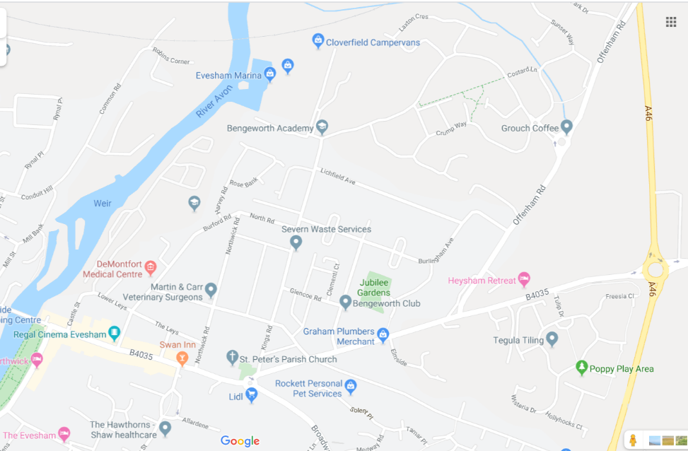

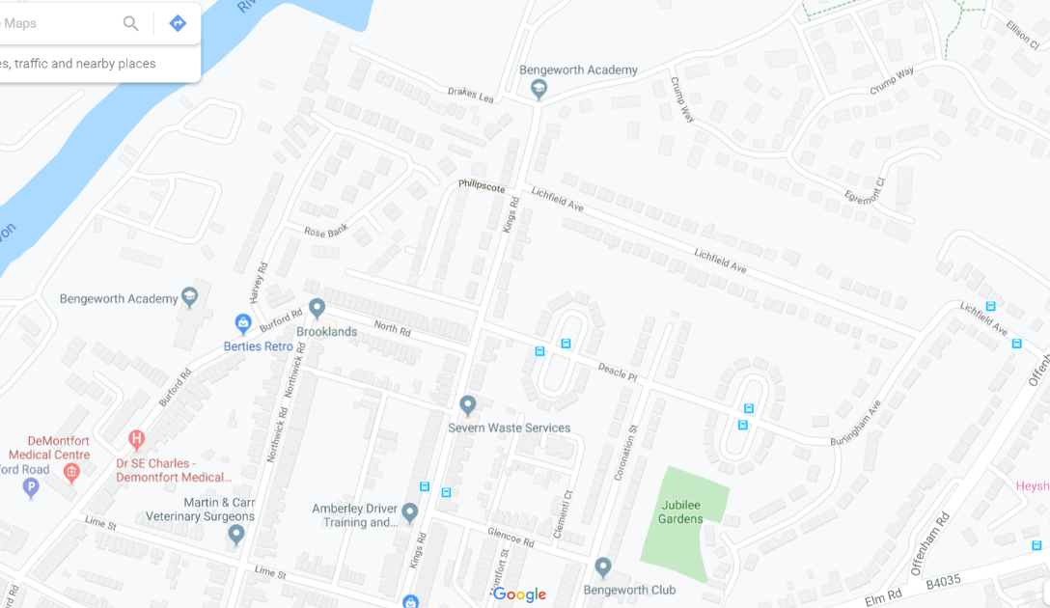
Bengeworth CE Academy
Burford Road Setting
Evesham
WR11 3HB
Bengeworth CE Academy
Kings Road Setting
Evesham
WR11 3EU
(vehicular access via
Kings Road only)

