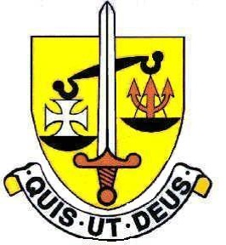
St Michael’s Catholic Grammar School
Drama Department

The Drama Department has four members of staff currently, some of whom also teach English or hold other management responsibilities within the school.
The Department has a drama room but also utilises other larger classrooms and the school chapel to teach lessons.
Students are currently taught in mixed form groups in years 7, 8 and 9, and these groups have approximately 23 students. In Year 10 and 11 there are GCSE groups of approximately 18-20 girls. The department is committed to raising achievement at all levels and students are assessed at the end of each half term. Targets are set through CATs testing in Year 7.
The Drama Department offers opportunities for personal expression and appreciation of the theatrical world. Pupils are encouraged to be open to all styles of theatre and to acknowledge the significance of the social, cultural, political and historical context of performance. Pupils explore their own emotions through performances and are encouraged to share their talent with others. The diversity of opportunities offered in the curriculum and in extra-curricular activities allows an individual to develop their own talents and experience many different forms and styles of performance. Positive responses are always expected when watching live performances and all contributions are valued. An encouraging and comfortable atmosphere is created to give the best opportunity for everyone to reach their potential. Pupils end KS3 with all the skills they need to perform effectively in the speaking and listening tasks in English and achieve top grades at GCSE drama.
At GCSE the Department teaches AQA Drama (8261) and currently studies The Crucible by Arthur Miller as it’s set text. Theatre trips have now returned with this Year’s 10 and 11 seeing Wuthering Heights at the National Theatre and The Life of Pi at Wyndham’s Theatre. Department results at GCSE are consistently good and the students who take Drama at GCSE are passionate about the subject and eager to do well.
Great importance is attached to drama in the liturgies with girls from all key stages involved Pupils explore the Liturgy through drama and dance which enables them to further their understanding and interpret the Gospel.
The school show gives an excellent opportunity to develop St Michael’s sense of community. Pupils from different classes and year groups work together towards a common aim with older pupils given the opportunity to take a leadership role and support other members of the cast.
The drama, music and art department have always worked closely together to promote the Arts at St Michael’s we have currently been working towards Artsmark status and have been developing both Arts provision within the community and also develop an outreach programme. Careers in the arts are strongly encouraged and many of our pupils continue to develop their passion for the arts when they leave St Michaels.

March 2022

