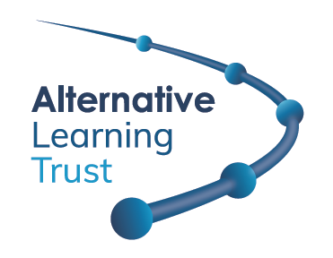
INFORMATION FOR APPLICANTS

Post of Transition Coach

Thank you for your interest in the post of Transition Coach. This position is available as soon as possible.

We are looking to appoint an experienced person to provide support and guidance to transitioning KS4 students who are experiencing significant barriers preventing them from progressing into positive destinations and are at risk of being not in employment, education, or training (NEET) post-16.

This role will be shared between two schools within The Alternative Trust; The Limes College in Sutton and Saffron Valley Collegiate in Croydon.

Background to Alternative Learning Trust

The Alternative Learning Trust became a multi-academy trust (MAT company number 11788031) in June 2019. There are now four schools within the Trust; The Limes College, North West Kent Alternative Provision Service (NWKAPS), Will Adams Academy, and Saffron Valley Collegiate. The Department for Education would like Alternative Learning Trust to consider other alternative providers.

The Trust has been established to work with Pupil Referral Units (PRUs) and alternative providers who support vulnerable students to access and engage with education. Many of our students have special educational needs and have been excluded from mainstream education.

As a Trust, we have the following core set of values for our staff and the families we support:
- the need for people to flourish in all areas of their lives;
- we are stronger through a sense of community;
- social justice is vital.

The Sutton West Centre is the registered address for the Trust from where the Executive Team operate. This post will partly be based there and also at Safron Valley Collegiate in Croydon; however, the post holder may be expected to travel between other academies within the Trust, when required, for which expenses are reimbursed.

Background to The Limes College and Saffron Valley Collegiate

The Limes College and Saffron Valley Collegiate are Pupil Referral Units (PRUs) which offers alternative education provision outside of a traditional schooling environment; they accept students from mainstream schools in Sutton and Croydon respectively with educational and behavioural needs. The current roll of students consists of those who have been permanently excluded or those at risk of exclusion. Many students are with us for only a short time while some will remain on roll for their entire GCSE courses.

Some students have a range of needs. Additional support is provided through a strong pastoral team which includes tutors and Outreach Workers in order to engage them back into mainstream education.

We make a difference at The Limes College and Saffron Valley Collegiate; we never give up. We change lives and futures.

Hours of work

The normal working hours of duty are 36 per week, based around the following usual pattern:

- Monday, Tuesday, Wednesday and Thursday, 8.45 am to 4.45 pm;
- Friday 8.45 am to 3.15 pm.

These hours include a 30-minute unpaid lunch break each day.

This position is term time only, including five INSET days plus an additional one week to be worked during the school holidays (0.887 Full Time Equivalence).

Salary

The successful applicant will be placed on scale 6 of the NJC scale, the starting salary would be £31,926 if the post were full time. Working 36 hours per week term time including INSET days plus an additional week to be worked during the school holidays, the actual salary will be of £28,326. Salaries are currently paid on the 24th of each month.

Checks

This appointment is subject to an enhanced DBS check, online check, medical screening and confirmation of qualifications and references.

Further questions

If you have any further questions or would like to visit, please contact Soodesh Roopchund, our School Business Manager, on 020 8652 1150.

Closing date

The closing date is on Wednesday, 9 October 2024 (12pm). Interview date TBC.

