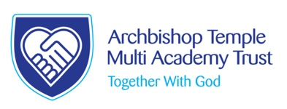
Welcome to Archbishop Temple Church of England Primary Multi Academy Trust

Chief Executive, Canon Jill Pilling
A very warm welcome from The Archbishop Temple Church of England Primary Multi Academy Trust. I am deeply proud of our schools, where each individual is welcomed, respected and loved. Our Trust was established on 1st August 2016. Our schools are happy, thriving environments, where learning and individual successes are celebrated through our Trust values of faith, hope and love.

I passionately believe that each of our schools, whilst maintaining their distinct character, community and identity, has greatly benefitted from the ethos of collaboration and support that we provide as a Trust. The schools in our Trust are: Bishop Bridgeman Church of England Primary School; St James Church of England Primary School, St Maxentius Church of England Primary School, St John’s Church of England Primary School and Bolton Parish Church of England Primary School. They are situated in Bolton, each taking a role in their local clusters of schools. We are proud to have very strong link with Manchester Diocese.
Please take some time to view our school’s web sites and our Ethos website.
https://www.bishop-bridgeman.bolton.sch.uk

https://www.st-james-farnworth.bolton.sch.uk

https://www.st-maxentius.bolton.sch.uk

https://www.st-johns-kearsley.bolton.sch.uk

https://www.bolton-parish.bolton.sch.uk
We also have a Trust Ethos website
https://www.ethosatarchbishoptemple.org
Curriculum development is key for providing excellent learning opportunities that enable our children to flourish. Staff from our schools work together to shape the curriculum, sharing good practice and tailoring experiences to meet the needs of individual school communities. We are committed to providing high quality training opportunities for all staff to ensure the very best quality of teaching and learning for every child within our Trust. I am delighted that all our schools are all rated good by Ofsted due to the combination of high quality teaching and learning, an engaging curriculum and a shared vision.
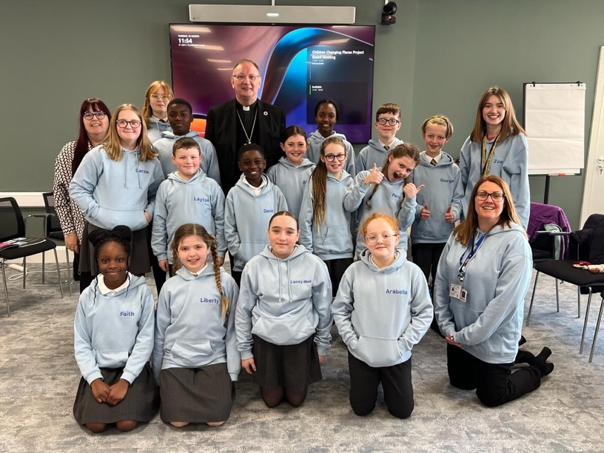
Our committed Trustees work closely with the immensely supportive Local Governing Boards and parents to determine the unique direction of each school, to make a difference in their local community.
Spirit Blazers
Prayer Spaces
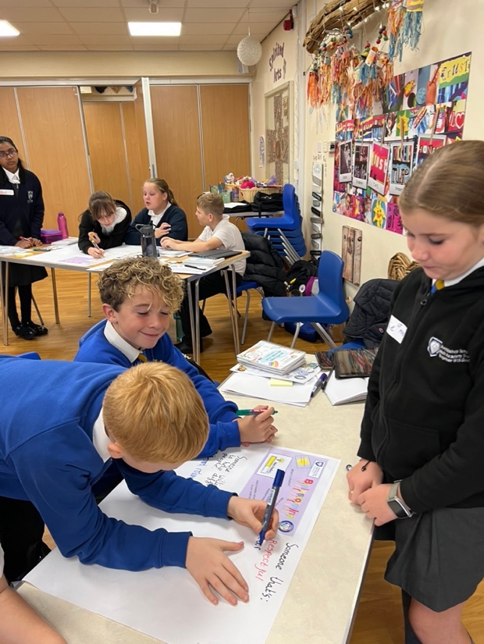
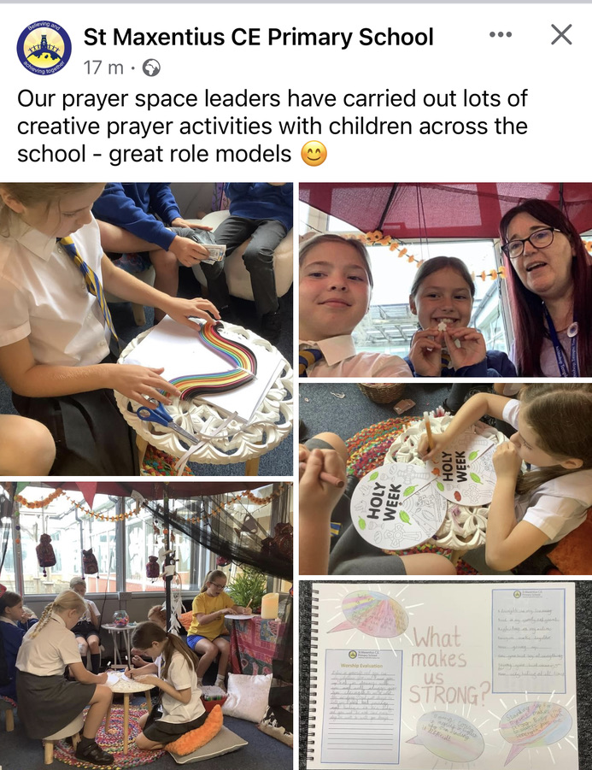
Children’s Chaplains

Wiggle Worship

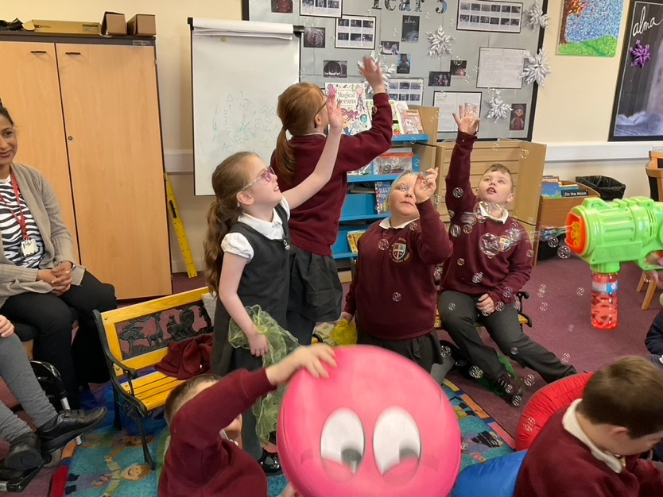

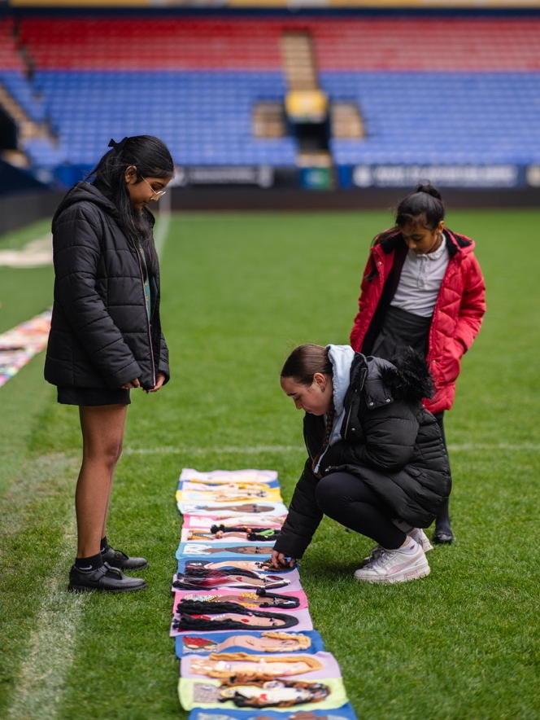
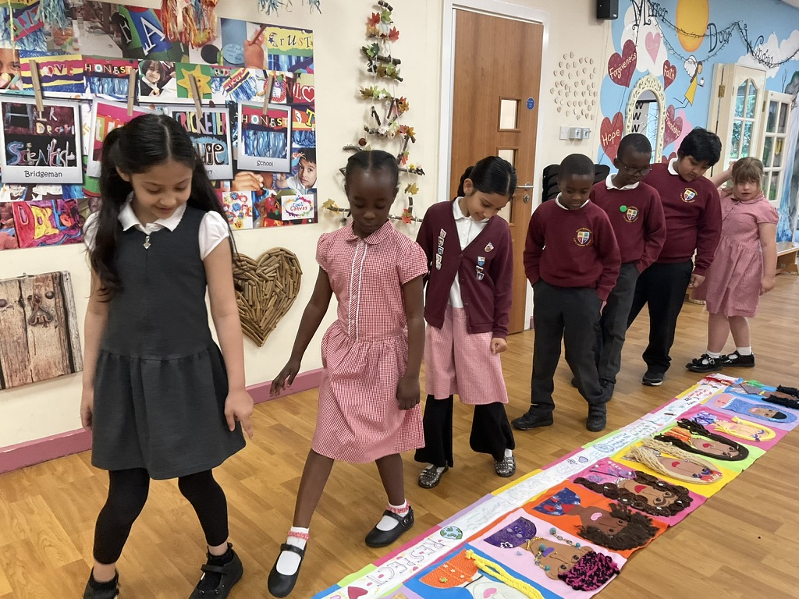
Racial Justice Project
Bolton Wanderers

Racial Justice Project

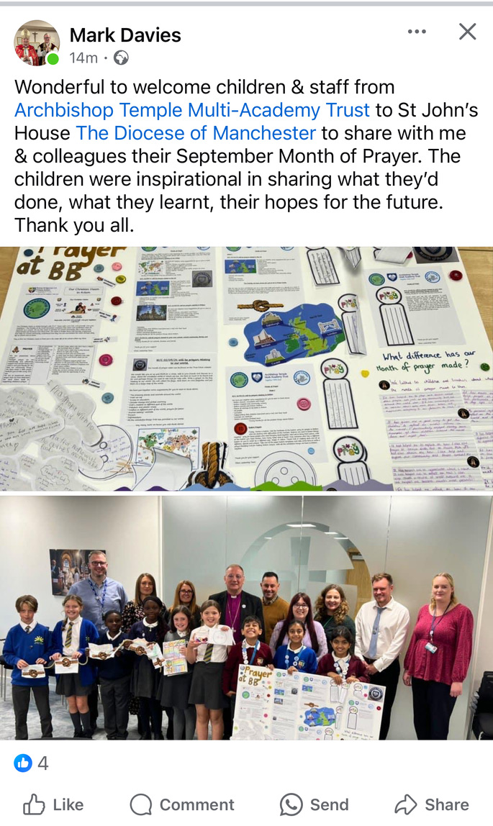

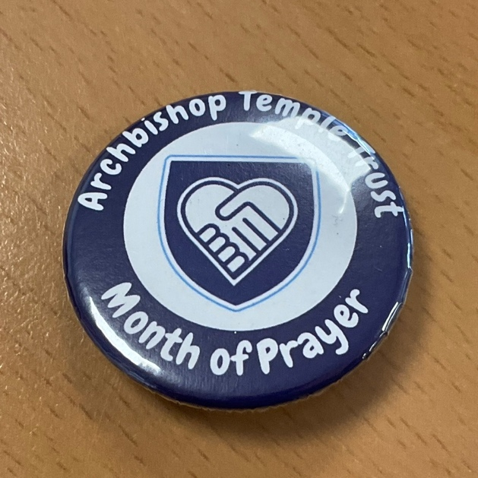
Archbishop Temple Month of Prayer
September 2024
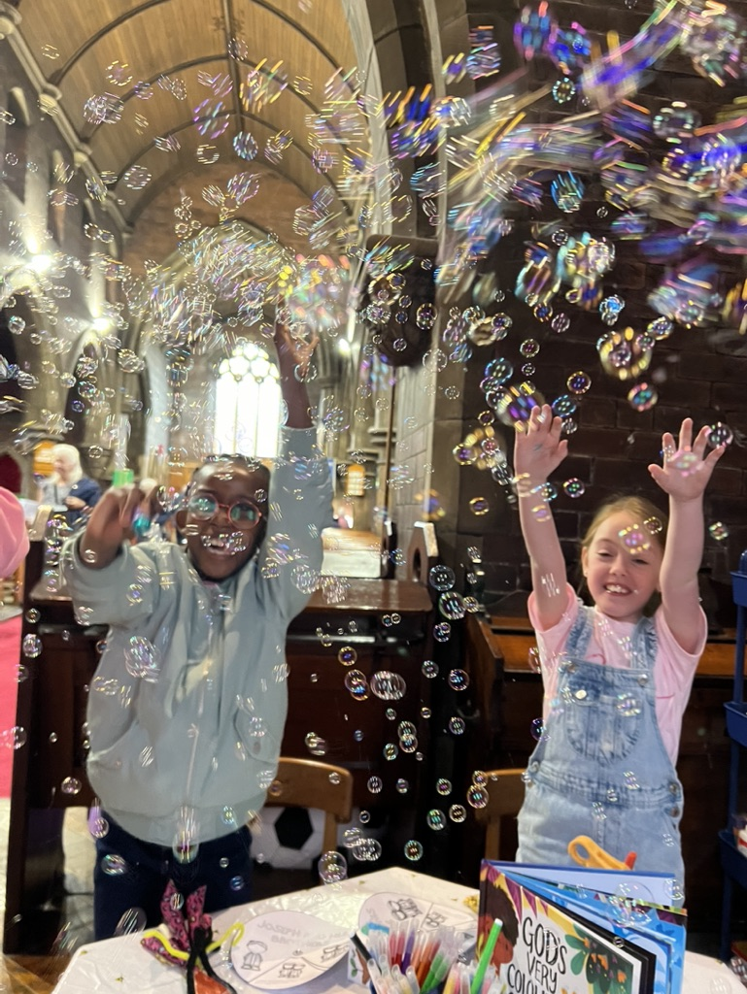
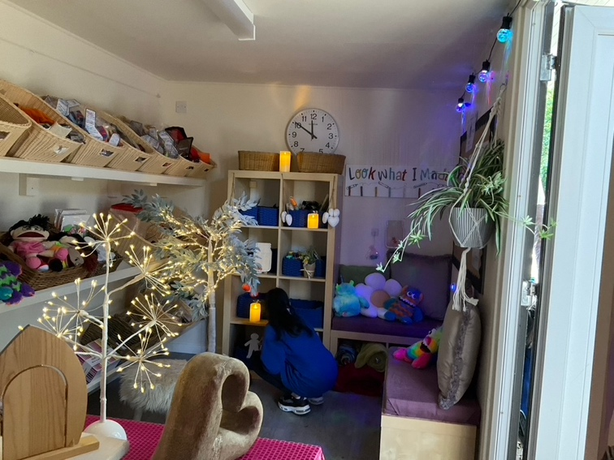
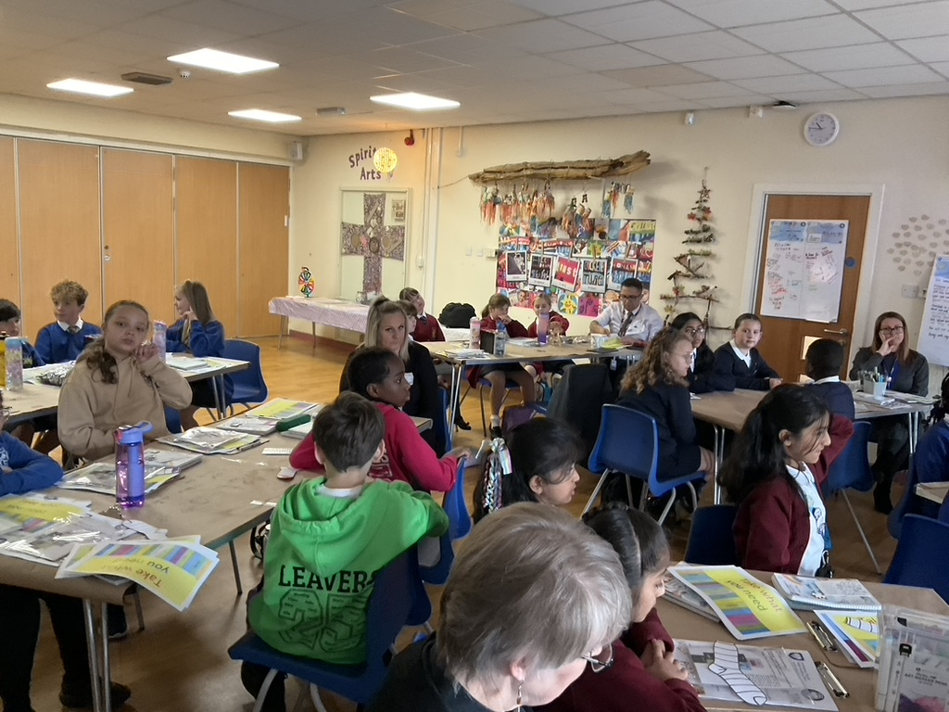
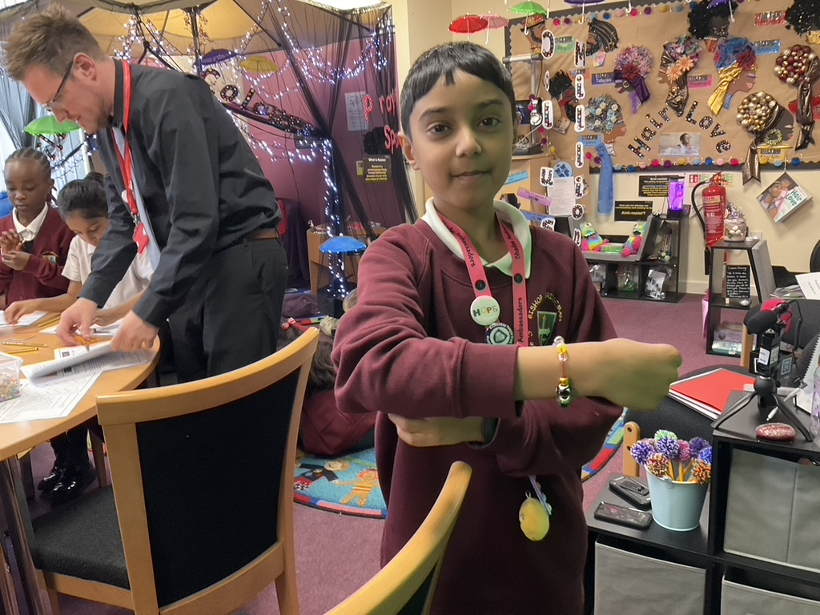
Outside Prayer Cabin
Childrens Chaplain Training Day
September 2014
Wiggle in Church
Shades Activities

