

**Trust Chaplin**

**Archbishop Temple Trust**

**Salary:** Grade F/G point 17-27 – pro rata

**Required From:** 1st September 2025

**Hours:** 37 hrs per week (Term Time +5)

**Contract type:** 3 years fixed term contract

**Post:** Full time Trust Chaplin, working across all schools within the Trust.

The Trustees are seeking to employ an excellent and inspirational full-time chaplain who will work with children, staff, parents, local clergy and governors to promote and maintain the Christian ethos and spiritual values of our Trust.

Applications are sought from practising Christians with a genuine passion for finding new ways of enthusing and encouraging children and adults on their faith journey.

We can offer you:

* Warm and welcoming schools with a very supportive Christian ethos.
* Supportive Trustees and Governors that are committed to school improvement and who will work with you to achieve your goals.
* Dedicated and talented staff who are keen to build on high standards.
* Supportive parents and active local communities.
* A commitment to continuing professional development.
* Inclusive schools with happy children who enjoy learning.
* A paid well-being day every year
* A budget of up to 2k per school
* Access to a spiritual advisor
* Office base and technology

We are looking for someone who is:

The successful candidate will be a practising Christian with a strong personal faith and a passion for encouraging children and young people in their faith, and the ability to lead and develop the spiritual, liturgical and prayer life of our school communities.

* This role has an Occupational Requirement to be a practising Christian (who as permitted under Schedule 9, Part 1 of the Equality Act 2010) committed to ensuring that children and young people engage with their faith
* A person who can inspire children and young people in their faith
* Someone with experience and an interest in engaging all ages in worship
* An excellent communicator with children and young people adults
* Counselling skills would be an advantage
* The ability to use ICT/social media is required

Application packs are available from the Greater Jobs website and completed applications should be returned to Mrs Kirsty Diggle (Finance/HR Officer) at Archbishop Temple Trust.

Email: digglek@archbishoptempletrust.co.uk

Closing date: Friday 27th June, 12pm (Midday)

Observations/Interviews: Tuesday 8th July at Bishop Bridgeman CE Primary School

*This school is committed to safeguarding and promoting the welfare of children and young people and expects all staff and volunteers to share this commitment. Successful candidates will be subject to an Enhanced Disclosure by the Disclosure and Barring service.*

Visits to the trust are welcomed. Please contact Cannon Jill Pilling, pillingj@archbishoptempletrust.co.uk



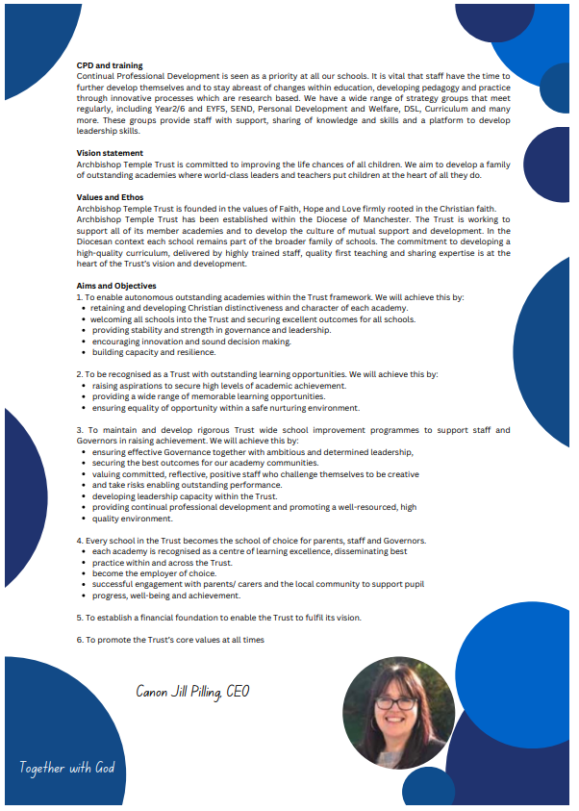

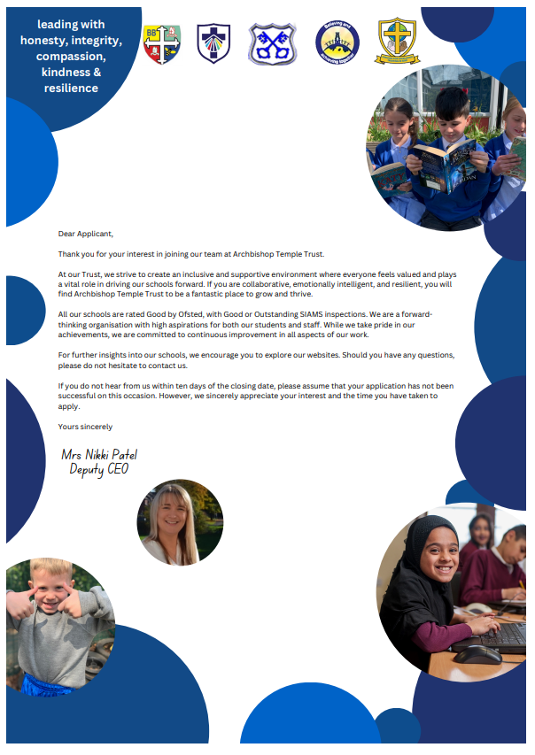



**Job Description**

|  |  |  |  |  |
| --- | --- | --- | --- | --- |
| Job Title: | | Trust Chaplain | Department/Group: | Pastoral |
| Level/Salary Range: | | £34,776.60 pro rata | Reporting to: | CEO Canon Jill Pilling |
| Contract term: | | 37 hours | Weeks per annum: | Term time only, plus up to 5 days |
| Safer Recruitment Statement | | | | |
| **The Archbishop Temple Trust is committed to safeguarding and promoting the welfare of children and young people and expects all staff and volunteers to share this commitment.** | | | | |
| Vision statement | | | | |
| Our Trust prides itself on its professionalism and the ability to put the needs of learners, families and staff first. We ensure that pupils are challenged so that they reach the highest expectations, but they do so in a nurturing and caring environment. Our schools and Trust fully understand our learners and their needs, and this is at the centre of all that we do. We find the talents of our pupils and staff and ensure that they have an opportunity to develop that talent so that they can be the best and exceed all possible expectations. Our Trust is committed to improving the life chances of all children. We aim to develop a family of outstanding academies where world-class leaders and teachers put children at the heart of all they do. Archbishop Temple Multi Academy Trust is founded in the values of Faith, Hope and Love firmly rooted in the Christian faith, working together with God.  Each of our academies is recognised for its own distinctive and inclusive Christian ethos demonstrating its unique Christian character under its own theologically rooted, contextually appropriate vision by providing an inspirational and holistic education which enables all to flourish.  ”And we know that all things work together for good to them that love God, to them who are called according to his purpose.”  Romans 8 v 28  We achieve this by:   * Offering a high quality, inclusive and distinctive education * A caring and nurturing environment based on our Christian values * Recognising the unique nature of each child   We can offer you:   * Warm and welcoming schools with a very supportive Christian ethos. * Supportive Trustees and Governors that are committed to school improvement and who will work with you to achieve your goals. * Dedicated and talented staff who are keen to build on high standards. * Supportive parents and an active local communities. * A commitment to continuing professional development. * Inclusive schools with happy children who enjoy learning. * A paid well-being day every year * A budget of up to 2k per school * Access to a spiritual advisor * Office base and technology | | | | |
| All staff employed by the Archbishop Temple Trust are required to | | | | |
| * Uphold and promote the Trust’s vision * Uphold and promote the Christian ethos of all schools in the Trust * Support and contribute to the achievement of all pupils academically and pastorally * Support and contribute to the Trust’s responsibility for safeguarding all pupils * Undertake professional training to enhance personal development and job performance; * Comply with all Trust and individual school policies and procedures including safeguarding, child protection, health, safety and security, confidentiality and data protection * Maintain high professional standards of attendance, punctuality, appearance, conduct and positive relationships with all pupils, parents/carers, colleagues, governors, trustees and members; upholding our Trust professional behaviours of compassion, integrity, honesty, kindness and resilience. * Share best practice, expertise and skills with others | | | | |
| Main Objectives of Role | | | | |
| * To be our Trust chaplain – and therefore to share with us the love of God in Christ for each member of the school; * To support our schools in collective worship planning and at times deliver worship with children; * To contribute to the provision of a pastoral presence within our school communities; * To link our churches together and more widely with the churches in Bolton and further afield; * To support the spiritual and personal development of each person in our schools. | | | | |
| Job Description | | | | |
| **Specific duties:**  **Liturgy, worship and children’s leadership groups:**   * To support Headteachers and leadership teams in planning collective worship and at times deliver worship; * To support Wiggle Worship, Lift Off transition in EYFS and transition work in Y6 in preparation for secondary school. * To develop an offer of Holy Communion for staff and where appropriate children through engagement with local clergy * To support the CEO in planning and delivery of all major services such as the annual Trust service at Bolton Parish, individual school services such as Christmas Carol services, Services of Celebration, Remembrance service, etc. * Arrange, plan and deliver the Trust Month of Prayer work * Develop and overview of Ethos groups, Shades groups, Worship groups in all schools * Support staff in each school to plan and deliver work relation to Ethos groups, Shades groups and Worship groups * Work with the Music subject leads to develop singing and music in our worship; * Encourage pupils to take part in and to take ownership for worship in their schools and year groups and where appropriate support children delivering worship as part of a Sunday service; * Support Headteachers and senior leaders to monitor and evaluate worship to ensure that it is consistently valuable to all staff and pupils; * To carry out Trust training days for Children’s Chaplains and support their work in their own schools. * To support the Places project and diocesan initiatives   **Support school learning mentors and pastoral leads**   * Work within the pastoral team of the school and assist staff in dealing with pastoral issues with pupils and families; * Develop links as part of the pastoral team, with parents, carers and other agencies; * Support and encourage children in their faith and discipleship path; * Support children in raising awareness on injustice in the world and courageous advocacy   **Outreach:**  As the leader of our links to the wider Church community, the Chaplain should:   * Develop links with our feeder churches including presiding at occasional church services at weekends and out of term time; * Build strong links with local church leaders of the various denominations, who are in fellowship with “Churches Together” or who share the same statement of the basis of faith as “Churches Together”; * Co-ordinate and oversee outside churches leading provision at lunchtimes.   **General school duties:**  As a key member of the Trust team, the Chaplain should:   * Support the teaching of Religious Education and other subjects in the school, particularly in terms of Christian values; * Attend meetings of the Senior Leadership Team when appropriate, to advise, support and be a “critical friend”; * Assist in the induction of new staff in the duties and expectations of employees working in a Church school; * Advise on the spiritual and moral growth of our children; * Be present at and lead in prayer as appropriate; * Report on chaplaincy and worship to the Local Governor Boards and to full Trust Board;   The post holder may reasonably be expected to undertake other duties during the course of the working week. These will be authorised by the CEO. Such duties will be commensurate with the level of this post and will be suited to the skills and abilities of the post holder. The main duties of this post may be reviewed in the light of experience and development in the post. The post holder will have an Appraisal as part of the Trust’s annual process. | | | | |
| All Staff employed by the Archbishop Temple Trust will: | | | | |
| * Seek to be positive and build up the common good through their own individual contribution to the life of their school * Uphold our Trust professional behaviours of compassion, integrity, honesty, kindness and resilience. * Offer ideas and suggestions for making things better * Engage actively in the appraisal and performance review process * Seek to develop a better work/life balance * Appreciate that whilst every effort has been made to explain the main duties and responsibilities of the post, each individual task undertaken may not be identified in this job description * Work within the Trust and individual school’s Health & Safety Policies to ensure a safe working environment for all staff and pupils. * Follow any reasonable request from the Headteacher or SLT to undertake work of a similar level that is not specified in this job description. * Be courteous to colleagues and provide a welcoming environment to visitors and telephone callers. * Promote equality and celebrate diversity, seeking to reduce disadvantage, and to encourage aspirations and participation from people who might not otherwise join in.   This job description is current at the date shown, but following consultation with you, may be changed by the CEO to reflect or anticipate changes in the job which are commensurate with the salary and job title. It allocates duties and responsibilities but does not direct the amount of time to be spent on carrying them out. The above responsibilities are subject to the general duties and responsibilities. | | | | |
| Last Updated: | **June 2025** | | | |

# 

**Person Specification**

**Key: (AF) - Application Form (I) - Interview IT - Interview Task**

|  | **Trust Chaplain - CRITERIA** | **E**ssential / **D**esirable | **Method of Assessment** |
| --- | --- | --- | --- |
| **Professional values and practices of the Archbishop Temple Trust** | Able to uphold, promote and develop the Trust’s Christian ethos and professional behaviours | E | AF/ I/ IT |
| An ability to provide care for children and young people, by listening to them, by offering them support and guidance, by praying for them, and by working within a team of staff providing that care | E | AF/ I/ IT |
| **Personal Qualities** | This role has an Occupational Requirement to be a practising Christian ( who as permitted under Schedule 9, Part 1 of the Equality Act 2010) committed to ensuring that children and young people engage with their faith | E | AF/I |
| Ability to respect matters of confidentiality | E | AF/ I/ IT |
| Prayerfulness | E | I/IT |
| Be an advocate for the Gospel, presenting the love of God in Christ to the Trust community | E | AF/I/IT |
| Pastoral awareness of a wide range of challenges that children and young people experience | E | AF/ I/ IT |
| Effective time management and personal organisation | E | AF/ I/ IT |
| Able to work as part of a team, flexible, dependable and loyal | E | AF/ I/ IT |
| Approachable, courteous patient and kind with a sense of humour | E | AF/ I/ IT |
| **Role Specific Professional Dispositions** | Knowledge of the issues involved in children and young people’s lives and how to respond to them effectively | E | AF/ I/ IT |
| An ability to relate well to children and young people and enjoy their company, as well as be able to develop and establish good relationships with a broad range of people | E | AF/ I/ IT |
| **Qualifications** | A levels or equivalent Level 3 qualifications | E | AF |
| Degree qualification or equivalent | D | AF |
| **Experience** | Have a good understanding of the Church’s liturgy and be able to encourage and enthuse children and young people to take part in school worship | E | AF/ I/ IT |
| Effective counselling / listening skills | D | AF/ I/ IT |
| Willing to undertake training relating to the post | E | I |
| Experience of working with primary age students either in a school or its wider Church family | E | AF/ I/ IT |
| Experience in a parish or youth ministry | D | AF/I |
| An appreciation of the diverse communities in our Trust, Bolton and the wider Diocese and a sensitivity to those of other faiths and beliefs | E | AF/I |
| **Skills and Knowledge** | At ease with the aims, values and diversity of the Church of England | E | AF/ I/ IT |
| Be comfortable working in a classroom environment when the role requires it | E | I |
| Good communication skills, both written and verbal | E | AF/ I/ IT |
| Excellent digital and social media skills | E | AF/I/IT |
| Ability to work on own initiative, working independently and proactively to develop ministry opportunities | E | AF/I |
| **Safeguarding of Children and Young People** | Ability to form and maintain appropriate relationships and personal boundaries with children and young people | E | AF/I |
|  | A working understanding of child safeguarding policy and procedures. | E | AF/ I |
| **Work related circumstances** | Able to work flexibly with some evening and weekend work | E | AF/I |
| Willingness to travel by car | D | AF/I |

June 2025

**These core competencies are considered essential for all roles within Bolton Council. Please be prepared to be assessed on any of these during the interview process and, for the successful applicant, throughout the probationary period.**

**Developing Self & Others**

Promote a learning environment to embed a learning culture.  Support others to develop their skills and knowledge to fulfil their potential. Actively pursue your own development. Support and promote the principles of Investors in People.

**Civil Contingencies**

Bolton Council has a statutory duty under the Civil Contingencies Act to respond in the event of an emergency. If Bolton Council’s Emergency Management Plan is activated, you may be required to assist in maintaining key Council services and supporting the community.  This could require working outside of routine working hours and working from places other than your normal place of work.

**Equality & Diversity**

Uphold the principles of fairness and the Equality Act in all undertakings as a Bolton Council employee, including providing a fair, accessible service irrespective of customer’s race, religion, gender, sexuality, disability or age.

**Customer Care**

The ability to fully understand, assess and resolve the needs of all customers including those who present with complex situations, in a manner that respects dignity and expresses a caring & professional image.

**Health & Safety**

Take responsibility for the health and safety of yourself and others who may be affected by your acts or omissions, and comply with all health and safety legislation, policy and safe working practice, including participating in training activities necessary to your post.

**Data Protection and Confidentiality**

Ensure that any personal data or confidential data you hold is kept securely and is not disclosed, whether electronically, verbally or in writing, to any unauthorised third party. Follow Council policies and procedures on dealing with personal information and information assets, including The Code of Conduct, Data Protection, Acceptable Use and Information Security policies. Personal or confidential data should only be accessed or used for council purposes.

**Fluency Duty**

Should you be required, as a regular and intrinsic part of your role, to speak to members of the public in English, you must be able to converse at ease with customers and provide advice in accurate spoken English, as required byThe Immigration Act 2016.

**Working Hours**

The nature and demands of the role are not always predictable and there will be an expectation that work will be required outside of normal hours from time to time.

**Safeguarding**

This Council is committed to safeguarding and promoting the welfare of children, young people and vulnerable adults and expects all staff and volunteers to share this commitment. Should the role involve working with the above groups, you will be subject to an Enhanced Disclosure and Barred List check by the Disclosure & Barring Service.

**The values of an organisation are those key principles by which people are expected to work to day to day. They’re our culture and help define what is expected of each and every one of us**.







**How to apply**

We hope that you have enjoyed reading about the Archbishop Temple Trust and our school and that you will feel able to apply for this post.

Please complete the **downloadable** **application form.** Please do not send CVs or open references as part of your application as these will not be considered.

It is important that you provide a complete employment history from when you left full time education. If the application form is not fully completed or has unexplained gaps in your employment history, your application will not be considered. Copies of your qualifications will be required at the interview stage; please do not send these with your application.

Please also write **a letter of no more than two sides of A4** to explain why you want to work within our Trust, why you are the best candidate for the post and what you would contribute to our schools, with examples from your recent work if possible.

Please let us have both the supporting letter and the application form by **noon** on **Friday 27th June 2025** as we will not be able to consider applications received after that.

In accordance with the Data Protection Act, the details provided in the application form will be used for selection and interview procedures, and for employment records if your application is successful.

If you are disabled, please give details of how we can ensure that you are offered a fair selection and interview process.

Successful candidates will be asked to provide, prior to taking up the appointment, documentary evidence (including National Insurance number) showing their entitlement to work in the UK. We will also carry out an enhanced DBS and declaration of health check. References will also be required in line with Keeping Children Safe in Education 2019.