Apply for something different | Apply to make a difference
Apply to work with The Evolve Trust

Teaching Staff

Application Form

Please complete ALL sections of this form in BLOCK capitals.

SECTION 1 : DETAILS OF THE OPPORTUNITY WITHIN THE EVOLVE TRUST
Opportunity of interest: |  | Closing date:
SECTION 2: PERSONAL DETAILS
Surname: |  | Forenames:
Title: (Mr/Mrs/Miss/Ms/Other) |  | Date of Birth:
Address for  Correspondence: |  | Permanent Address  (if different):
Postcode: |  | Postcode:
Home telephone no: |  | Email address:
Work telephone no: |  | National Insurance No:
Extension (if applicable): |  | Teacher Reference No:
Mobile telephone no: |  | GTC Registration No:
SECTION 3: CURRENT/MOST RECENT EMPLOYMENT
Name and address of employer: |  | Name and address of establishment where employed (if different):
Postcode: |  | Postcode:
Present Post: |  | Date Appointed:
Current Annual Salary: |  | Point on pay spine:
Additional Responsibility Points: |  | Trust Name:  (if applicable)
Age range of pupils: |  | Number on roll:
Brief description of duties:

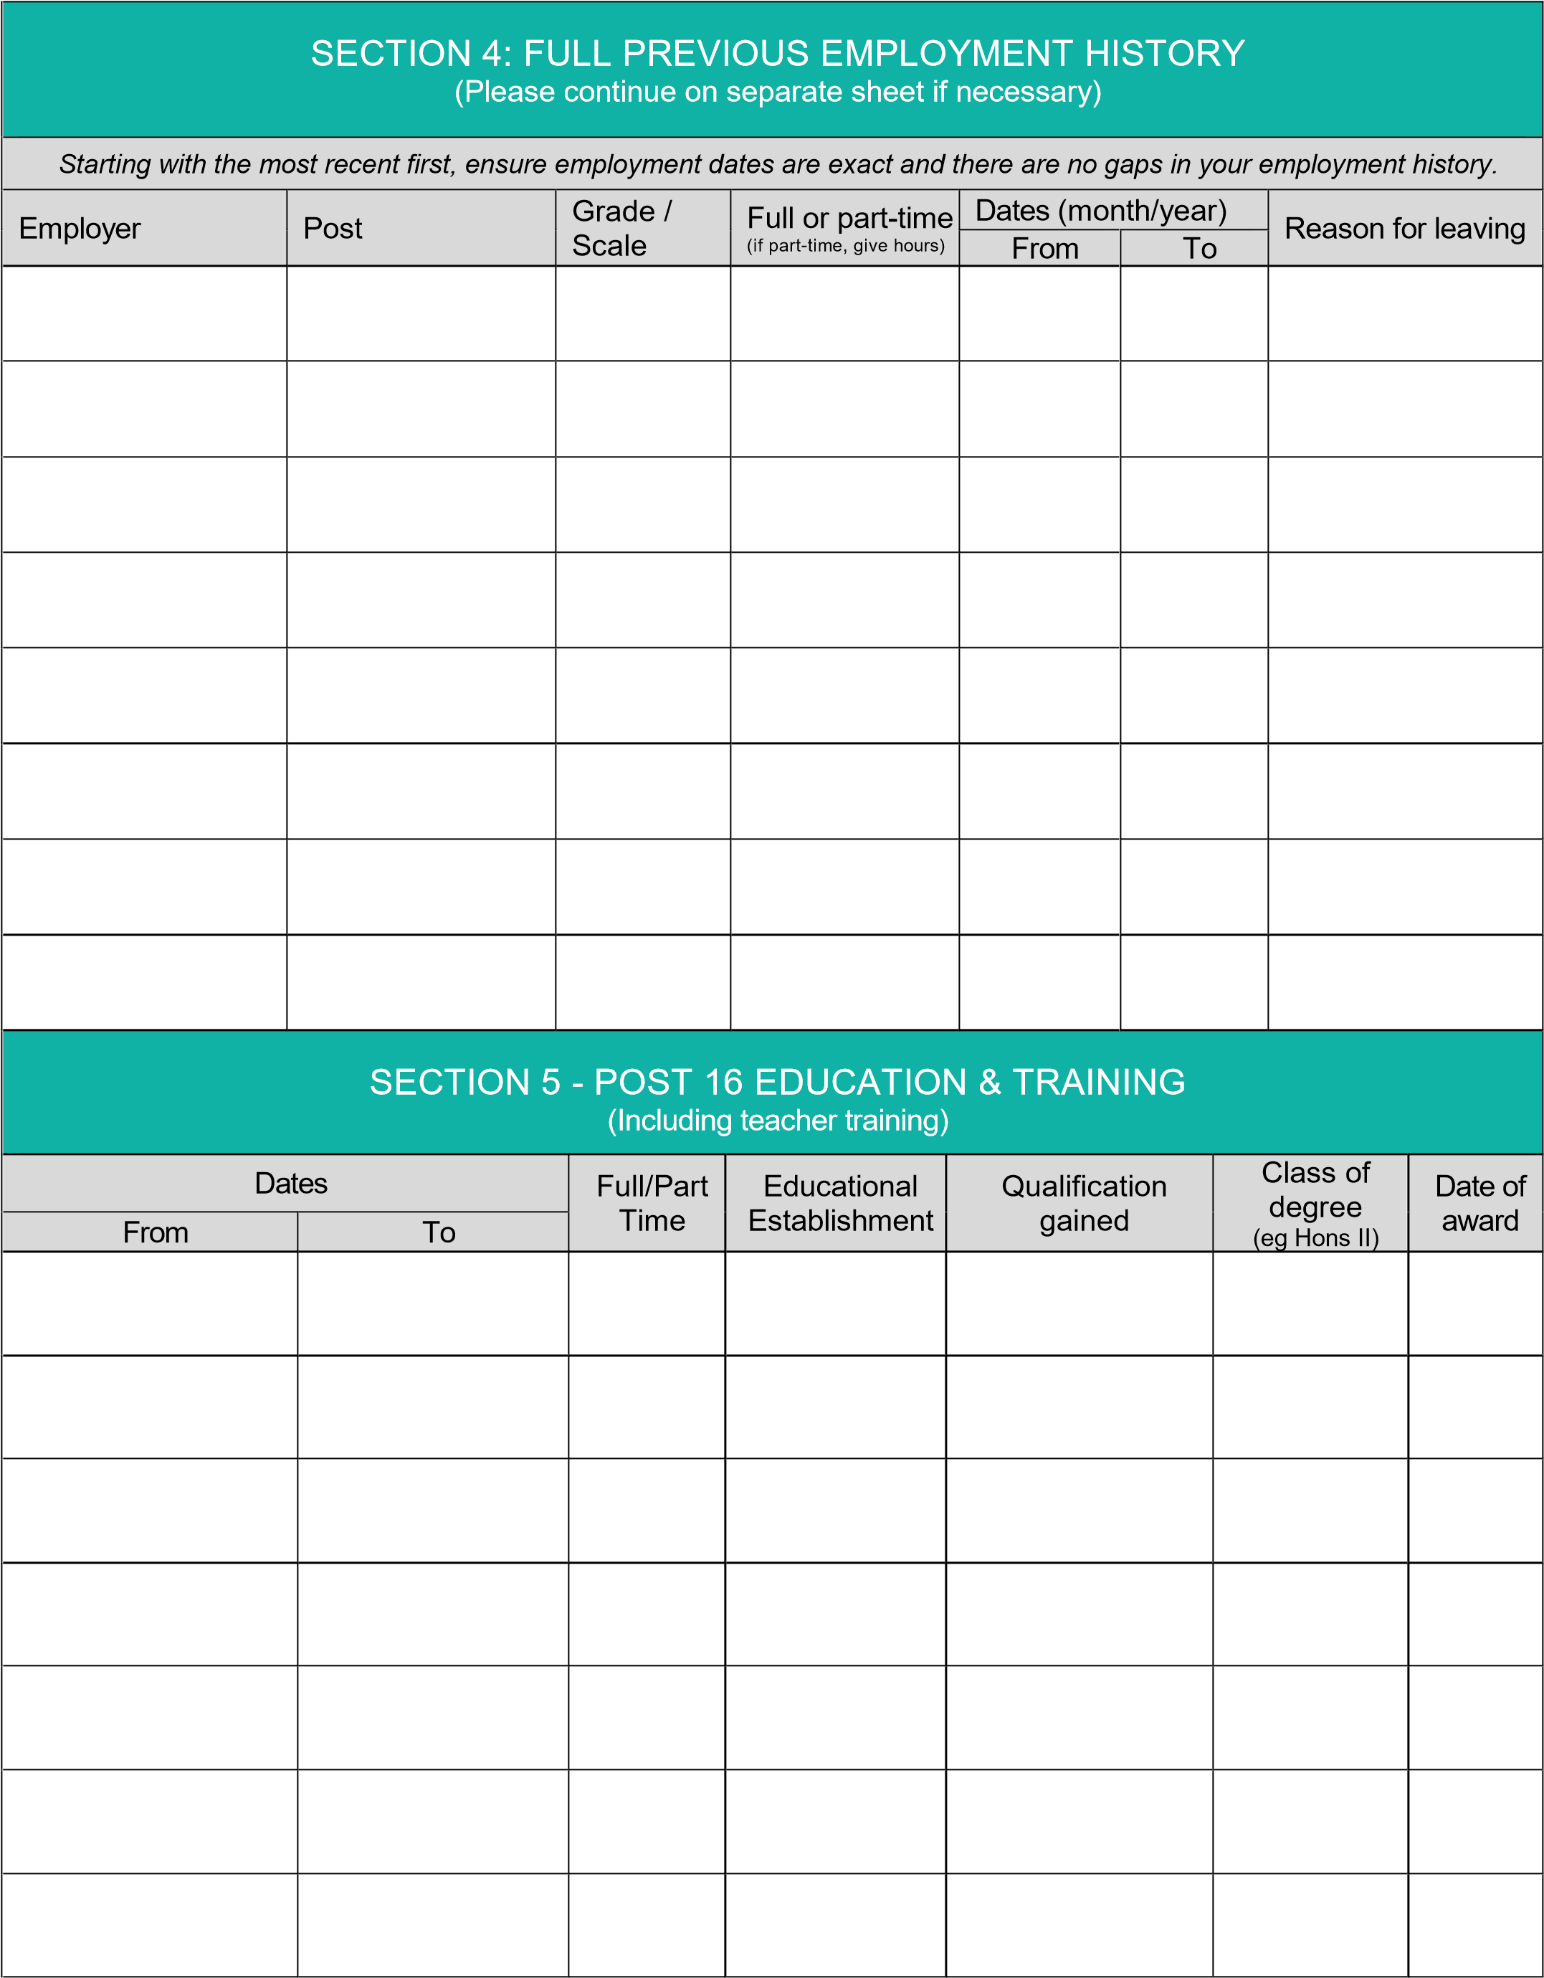

SECTION 6 - DETAILS OF TEACHER TRAINING
If qualified since 1999, please give date when Newly Qualified Teacher status awarded: |  |  |  |  | Age range for which trained:
For newly qualified teachers only
Please confirm current status of Induction Period including dates / outcomes of reviews:
1st Review
2nd Review
3rd Review
Phase: (Please tick as appropriate) |  | Primary Secondary Further
Main teaching subject: |  |  |  | Subsidiary subjects:
Other recent courses and INSET in which you have been involved in the past 3 years and which you consider
relevant to this post. (Please continue on a separate sheet if necessary)
SECTION 7 - PERIODS OF UNREMUNERATED ACTIVITY
Have you had any periods of unremunerated activity after the age of 18 years, e.g. raising family, unpaid voluntary work? |  |  |  |  |  | YES NO
If yes, please give details |  |  |  |  |  | Dates
 |  |  |  |  |  | From |  | To

SECTION 8 – THE EVOLVE TRUST CORE VALUES
The Evolve Trust is a values driven organisation which has its 5 core values at the heart of everything they do.
It is important for staff to not only understand these values but also live by them, day in, day out.
Please give recent examples (within the last 12 months) of how you have demonstrated:

AMBITION

INTEGRITY

INCLUSIVITY

SECTION 8 - CONTINUED

ENDEAVOUR

RESILIENCE

SECTION 9 - SUPPORTING INFORMATION
You may wish to include additional information in support of your application.
This additional information should include some indication of why you are interested in this particular post and what experience, interests and skills you can offer in relation to the job description / person specification.
This should be brief but in any case, no more than two sides of A4 size paper.

SECTION 10 - REFERENCES
Please provide details of two referees below. One of the referees must be your present/or most recent employer and normally no offer of employment will be made without reference to him/her. If you have not previously been employed, then Head Teachers, College Lecturers, or other persons who are able to comment authoritatively on your educational background and/or personal qualities, are acceptable as referees.
Friends and relatives are NOT acceptable referees.
The Evolve Trust reserves the right to approach any previous employer or manager.
Name (Referee 1): |  | Name (Referee 2):
Status: |  | Status:
Organisation/School Name  (if appropriate): |  | Organisation/School  Name (if appropriate):
Address: |  | Address:
Postcode: |  | Postcode:
Telephone No: |  | Telephone No:
Email address: |  | Email address:
Do we have your permission to approach the above prior to interview? |  |  | YES | NO
If No, you may wish to give reasons:

Where references are taken up on shortlisted candidates prior to interview, an opportunity will be given to discuss the content of references with the interviewing panel

SECTION 10 – PENSION
Please give details of any pension scheme to which you have contributed:
If you have opted out of the Teachers’ Pension Scheme please give details:
Have you elected to have any part time relief employment treated as pensionable? |  |  | YES | NO
If YES, please give date of election:
SECTION 11 – GENERAL
You are required to declare any relationship with or to an employee of The Evolve Trust.
Please state name and position:
Have you ever been the subject of formal disciplinary proceedings? |  | YES NO
If yes, please give details including dates:

This information is required, including that related to warnings regarded as "spent" in order for The Trust to ensure safe recruitment and meet its obligations, for relevant appointments, to safeguard vulnerable users of The Trust’s services. However, you should be aware that any disciplinary history declared will not automatically prevent or inhibit appointment and will depend on the dates and circumstances related to the disciplinary action, outcomes and the type of post being applied for.
Note that you are also required to include information if you were subject to a disciplinary process but resigned before it was completed.
SECTION 12 - DISCLOSURE OF CRIMINAL BACKGROUND
The Evolve Trust is required under the Police Act 1997, the Protection of Children Act 1999 and the Criminal Justice & Court Services Act 2000 to check the criminal background of those employees whose jobs give them access to children or other vulnerable members of society. Decisions to appoint will be subject to consideration of a disclosure from The Disclosure and Barring Service (DBS).
Under the Safeguarding Vulnerable Groups Act 2006, there will be phased arrangements for anyone who wants to work or volunteer with vulnerable people, which may require you to be subject to further checks. Further information can be found on the DBS GOV.UK website: https://www.gov.uk/disclosure-barring-service-check/overview
Due to the nature of the work for which you are applying, this post is exempt from the Rehabilitation of Offenders Act 1974 and therefore you must provide information about all convictions, including those which for other purposes are ‘spent’ under the provisions of the Act.

Please answer the following questions.
Have you ever been convicted of a criminal offence? | YES NO
Have you ever been cautioned for a criminal charge? | YES NO
Are you at present the subject of a criminal charge? | YES NO
If YES to any of the above questions, please give brief details including dates.
The Evolve Trust is committed to safeguarding and promoting the welfare of children and young people and expects all staff and volunteers to share this commitment. The successful candidate will be required to undertake a criminal record check via the Disclosure and Barring Service (DBS).
SECTION 13 - HEALTH/MEDICAL DETAILS
Successful applicants will be required to complete a confidential medical questionnaire and may be required to undergo a medical examination.
SECTION 14 - THE EQUALITY ACT 2010
The Equality Act 2010 defines disability as, "physical or mental impairment that has a ‘substantial’ and ‘long-term’ negative effect on your ability to do normal daily activities." and covers people with cancer, HIV and MS from the date of diagnosis. The Act requires an employer to make "Reasonable Adjustments" to working conditions, in order to enable disabled applicants to have equal access to employment opportunities. The information disclosed here will only be used to enable a fair decision to be made and will not be used to discount applicants.
Do you consider yourself to be disabled? | YES NO
Is there any information that we need in order to offer you a fair selection interview/process?

SECTION 15 - DATA PROTECTION ACT
The personal information collected on this form will be processed on computer to manage your application. If successful, your personal information will be retained whilst you are an employee and used for payroll, pension and personnel administration. It will not ordinarily be disclosed to anyone outside The Trust without first seeking your permission, unless there is a statutory reason for doing so. The Evolve Trust are under duty to protect the public funds it administers and to this end may use the information you have provided on this form for the prevention and detection of fraud. We may also share this information with other bodies responsible for auditing or administering public funds for these purposes.
For further information visit: www.ico.org.uk
SECTION 16 - DECLARATION
By submitting this application, I declare that, to the best of my knowledge and belief, the information I have provided on ALL parts of this form is correct. I understand that, should my application be successful and it is discovered subsequently that information has been omitted, misrepresented or falsified, then disciplinary action may be taken which may include withdrawal of offer or dismissal from the post.
I confirm that I have a legal right to work in the UK and if this application is successful, I undertake to produce appropriate documentary evidence to prove this, prior to commencing work with The Evolve Trust.
If you return your application form to us by email and you are subsequently invited to interview, you will be required to sign a printed copy of your form.
Signed |  | Date
Please return your completed form to arrive by the closing date via:
Post:
Human Resources, The Evolve Trust c/o The Beech Academy,
Fairholme Drive,
Mansfield,
Nottinghamshire,
NG19 6DX
Email: jobs@evolvetrust.org
If you have not received a reply within 2 weeks from the closing date, you should assume that your application has been unsuccessful.

PAGE 9

AMBITION
I
INTEGRITY
I
INCLUSIVITY
I
ENDEAVOUR
I
RESILIENCE

Apply for something different | Apply to make a difference
Apply to work with The Evolve Trust

