

Crofty Education Trust

Applicant Pack for Teachers




Contents:

Page 3: Message from our Chair of Trustees and CEO

Page 4: Crofty Education Trust Culture and Working for Crofty

Page 6: Job Description

Page 8: Person Specification

Page 9: How to Apply
Safeguarding Statement
Online Searches
Timeline

Page 10: Further Information or Visits to the School
Where to find us.



Message from our Chair of Trustees and CEO

Dear Colleague,

Thank you for your interest in becoming a teacher in one of our schools. The information that is contained in this Applicant Pack will give you a flavour of what it is like to work for Crofty, as well as providing the Job and Person Specifications. We would also encourage you to pay a visit to our schools, and indeed any other part of the Trust, including our base here at Tolvaddon, Camborne.

Crofty Education Trust was formed in 2016 from a long-established partnership of schools dedicated to providing the best education for children in the Camborne, Pool, and Redruth area. Since then, it has flourished into a high-quality educational support and development community for eighteen Cornish schools, backed by excellent professional services and moral leadership.

Although located in a most beautiful area of the country, our communities can face a number of significant challenges including social deprivation, the impact of excess numbers of second homes, and an overall lack of economic opportunity. To seek to address these issues our core purpose as a Trust is to provide our children with the best possible start in life, to unlock possibilities and enable them to be able to make choices about their future.

The most powerful driver for achieving this purpose is our culture which is a product of our shared values. Our shared values of Learning, Integrity and Community define our attitudes and behaviours and, through our key strategy of “working as one,” ensures we have a genuine shared responsibility for all children in all of our schools. The combination of values, culture and strategy are what makes Crofty such a great community in which to work.

These teaching posts offer an exciting opportunity to play an important role in helping Crofty Education Trust to continue to improve, and to develop even further in achieving our purpose.

If you share our values, have the enthusiasm, skills, and qualities to thrive in our Trust, we would be delighted to hear from you, so please get in touch.

Kind Regards

Mike Hosking Simon Hague

Mike Hosking Simon Hague

Chair of Trustees Chief Executive Officer
Crofty Board of Trustees



Crofty Education Trust Culture

Education is a basic human right and it is our chosen vocation because there is no greater reward than seeing children and young people thrive and succeed. It is a privilege to know that our work improves children's lives and the lives of future generations.

To do this, we have an amazing team of staff, committed to our core purpose, which is to give our learners the best possible start in life, to unlock possibilities and enable them to make choices about their future.

Crofty is a values led organisation, built on the three core values of Learning, Integrity, and Community. Our values are the principles that underpin everything we do. We describe our values in terms of the behaviours and attitudes we most want to see in each other. This is important to us because it is our behaviours and attitudes that create the Crofty culture.

If this resonates with you, then please get in touch. Every school or person who joins us helps to shape and evolve the culture further, so we are always looking to attract like-minded colleagues who would like to be part of the journey.

Professional Development

In order to deliver on our commitments, we have hard wired our values into our systems. For example, our systems for appraisal and professional development ensure that every staff member receives professional development, tailored to their individual circumstances and requirements. That might not sound so ground-breaking, but what makes us really different is that in Crofty we don’t just link pay to exam or test results, we reward staff for the commitment they demonstrate to our values, and in particular to how they engage in their own development and the development of others. We do this because we know that the only way to improve outcomes for our children and young people is to improve how we teach. So, we reward staff whose commitment ensures everyone’s teaching keeps getting better. At the heart of this is a coaching-based approach, specific to the individual. All these things make Crofty a ‘deliberately developmental’ organisation.

School Improvement

When it comes to school improvement, we ensure each school within Crofty Education Trust receives the support it needs, bespoke to its unique context and priorities. This is in addition to the regular, timetabled challenge and support from trusted and experienced colleagues. To achieve this bespoke approach, we use our greatest resource; the staff in other trust schools. Of course, much of the school improvement work happens organically, a product of the many and varied network groups, sharing practice and motivating each other to ever better ways of working. If all this sounds idealistic then don’t worry. We also employ external (Ofsted registered) partners to check what we’re doing. We don’t want to be accused of marking our own homework. In reality, we love the challenge that external scrutiny brings, it keeps us on the ball and helps us live our commitment to learning.

Freedom to be Creative

We are particularly pleased with the way colleagues from across all schools redesigned the schools’ broad and balanced curricula. Curriculum Leads from across the Trust co-created a solid foundation of ‘small steps,’ and from this each school’s leaders and staff designed a curriculum unique to their school. From our creation we have always believed in the principle of maintaining each school’s individual character. Our Headteachers operate with the autonomy to set their school’s vision and curriculum so that it meets the unique character and needs of the school’s community.

When Working for Crofty Education Trust you can expect:

- A culture that encourages and supports staff to be creative and innovative, making a difference to the lives of our communities’ young people.
- To be part of a supportive professional community with opportunities for career development within the Trust’s schools.
- Access to the teacher’s pension scheme.
- Appraisal and professional development, based in the Crofty values, which ensures that every staff member has personalised support to succeed.
- Access to an incredible package of employee benefits



Job Description

All teachers are required to carry out the duties of a school teacher as set out in the current School Teachers Pay and Conditions Document. Teachers should also have due regard to the Teacher Standards. Teachers’ performance will be assessed against the teacher standards as part of the performance management process as relevant to their role in the school.

Purpose:
- Deliver the curriculum as relevant to the age and ability group/subject/s that you teach.
- Be responsible for the preparation and development of teaching materials, teaching programmes and pastoral arrangements as appropriate.
- Be accountable for the attainment, progress, and outcomes of pupils you teach.
- Be aware of pupils’ capabilities and their prior knowledge - plan teaching and differentiate appropriately to build on these demonstrating knowledge and understanding of how pupils learn.
- Demonstrate an understanding of and take responsibility for promoting high standards of literacy including the correct use of spoken English (whatever your specialist subject).
- Demonstrate a clear understanding of appropriate teaching strategies e.g. systematic synthetic phonics.
- Use an appropriate range of observation, assessment, monitoring and recording strategies as a basis for setting challenging learning objectives for pupils of all backgrounds, abilities and dispositions, monitoring learners’ progress and levels of attainment.
- Give pupils regular feedback, both orally and through accurate marking, and encourage pupils to respond to the feedback, reflect on progress, their emerging needs and to take a responsible and conscientious attitude to their own work and study.
- Set homework and plan other out-of-class activities to consolidate and extend the knowledge and understanding pupils have acquired as appropriate.

Behaviour and Safety
- Establish a safe, purposeful, and stimulating environment for pupils, following the school behaviour policy.
- Be a positive role model and demonstrate consistently the positive attitudes, values, and ethos of the school.
- Carry out playground and other duties as directed and within the remit of the current School Teachers’ Pay and Conditions Document.
- Be responsible for promoting and safeguarding the welfare of children and young people within the school, raising any concerns following school protocol/procedures.

Team Working and Collaboration
- Participate in any relevant meetings/professional development opportunities.
- Work as a team member, sharing and developing effective practice.
- Ensure that colleagues working with you are appropriately involved in supporting learning and understand the roles they are expected to fulfil.
- Take part as required in the review, development, and management of the work of the school.
- Cover for absent colleagues within the remit of the current School Teachers’ Pay and Conditions document.

Administration
- Register the attendance of and supervise learners, before, during or after school sessions as appropriate.
- Participate in and carry out any administrative and organisational tasks within the remit of the current School Teachers’ Pay and Conditions Document.
Professional Development
- Regularly review the effectiveness of your teaching and assessment procedures and its impact on pupils’ progress, attainment, and well-being, refining your approaches where necessary, and responding to advice and feedback from colleagues.
- Be responsible for improving your teaching through participating fully in training and development opportunities identified by the school or as developed as an outcome of your performance management review.

General/Other:
- To recognise how this role impacts on Crofty Education Trust and the Trust’s pupils at all times
- To provide support and cover for other staff where needs arise inclusive of occasional.
- To be aware of and adhere to all Trust policies and procedures.
- To undertake other duties appropriate to the post as required
- work at other sites within a reasonable travel distance

Curriculum Leader (to take effect after successful completion of ECT years)
- Have a secure subject knowledge and a model of consistently good practice.
- Develop an annual plan for the improvement of the area of responsibility (linked to the Whole School
- Development Plan) with measurable success criteria and time line.
- Ensure policies relevant to your subject are up to date.
- Maintain a whole school awareness of standards across the school, taking responsibility for continuous improvement.
- Develop and review a high-quality curriculum for your subject area which meets all National Curriculum requirements.
- Review, monitor and evaluate current practice and provide feedback to staff and incorporate findings into subject action plan e.g. through work scrutiny, data analysis, learning walks and pupil conferencing.
- Hold staff to account for implementation of agreed policies and practice.
- Support, motivate and advise staff and work with them to develop their classroom practice.
- Disseminate information to the staff and lead staff development (within area of responsibility)
- Maintain an up-to-date knowledge of local and national initiatives.
- Be responsible for the budget allocated to the subject area.
- Work with members of the Crofty Learning Trust to develop good practice.

Trust Accountabilities
- To contribute towards and demonstrate the culture and values of the Trust through your actions and behaviours.
- Demonstrate a commitment to equal opportunities and use a variety of strategies and practices to promote the diverse cultural and equality issues.
- To ensure that pupil needs are prioritised and to have a clear sight of how this role impacts on the quality of Teaching and Learning.
- To be aware of and adhere to all applicable rules, regulations, legislation, and procedures including all Trust policies, Safeguarding & Child protection policies and procedures, Equal Opportunities Policy and Code of Conduct, Health and Safety, Data Protection.
- To be responsible for your own continuing self-development and attend meetings as appropriate.
- To familiarise yourself with all critical Trust polices and follow then, including the staff code of conduct.

Person Specification

Person Specification: | Essential | Desirable | Recruiting method
Education and Training | - Qualified Teacher Status |  | Application
Skills and Experience | - Ability to create a stimulating and safe learning environment.  - Ability to plan, prepare and deliver the curriculum as relevant to the age and ability group/subject that you teach.  - Ability to assess and record the progress of pupils’ learning to inform next steps and monitor progress.  - To teach using a wide variety of strategies to maximise achievement for all children, including those with special educational needs and high achievers.  - Ability to successfully deploy a wide range of effective behaviour management strategies.  - High level of oral and written communication skills and an ability to work in partnership with other staff. | - Knowledge of current education and professional  developments and an understanding of their  application in a whole school context | Application/  Interview/  Assessment
Knowledge and understanding | - Extensive knowledge and understanding of how to use and adapt a range of teaching, learning and behaviour management strategies, including how to personalise learning to provide opportunities for all learners.  - Extensive knowledge and well-informed understanding of the assessment requirements and arrangements for the curriculum areas being taught.  - Demonstrates an awareness, understanding and commitment to the protection and safeguarding of children and young people.  - Demonstrates an awareness, understanding and commitment to equal opportunities |  | Application/  Interview/  Assessment
Behaviours and Values | - Resilient and resourceful.  - Works well as part of a team.  - Can use own initiative.  - Good sense of humour  - Inclusive and compassionate  - Committed to own professional development.  - Passionate about education and learning. |  | Application/  Interview/  Assessment

How to Apply

This pack contains the Job Description and Person Specification, which list the key competencies that we are looking for.

Please complete the Application Form in full and submit to our HR Coordinator, Laura Finney laura.finney@croftymat.org

CVs will not be considered however, should you wish to include a covering letter, please ensure that it is no more than two sides of A4.

Please make sure that you address the criteria outlined in the Job Description and Person Specification when writing your Supporting Statement.

Safer Recruitment

Crofty is an equal opportunities employer and is committed to safeguarding and promoting the welfare of children and young people. There is an expectation that all staff and volunteers will share this commitment. This post is subject to the necessary pre-employment checks including an enhanced check with the Disclosure and Barring Service, and the receipt of satisfactory references.

If you have any concerns or questions in relation to the pre-employment checks, please contact our HR Coordinator via email (address above) or on 01209 311135.

Timeline

Closing date and shortlisting:
Closing at noon on Sunday 28th June 2026 – noon with shortlisting taking place on Tuesday 30th June 2026.

Interview dates:
10-minute online task, Thursday 2nd June.
Interviews on Monday 6th July and Friday 10th July 2026.

Start date:
September 2026

Further information or visits to the school

We strongly encourage you to visit our Shared Services Office and a selection of our schools before applying for this position. To arrange a visit of for further information, please contact our HR Coordinator.

Where to find us
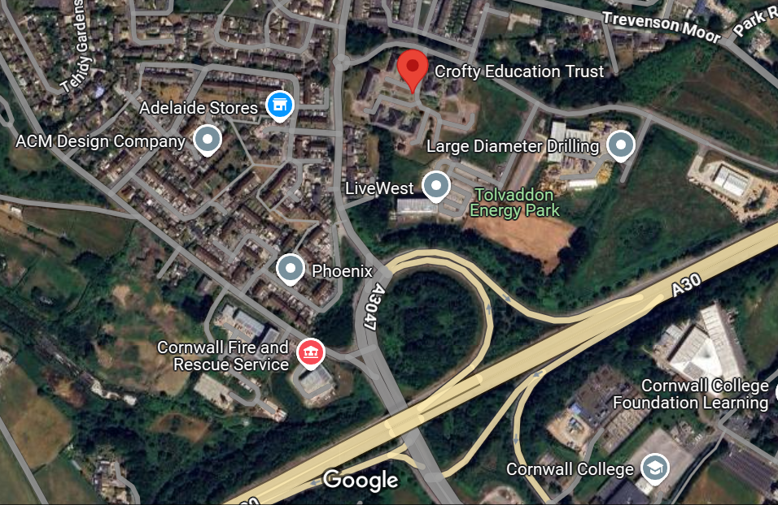

Crofty Education Trust
Unit 1 North Crofty
Tolvaddon Energy Park
Camborne
TR14 0HX
https://croftymat.org

