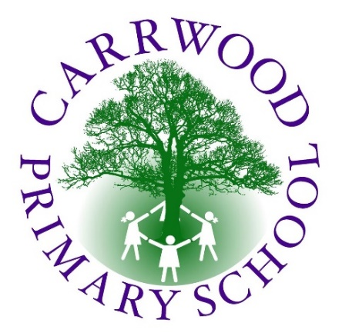**Dream Big!**

***Believe – Aspire - Achieve***

**Eversley Drive, Holmewood, Bradford, BD4 0ED**

**Tel: 01274 664864 Mobile: 07949 899113**

**Email:** [**office@carrwood.bradford.sch.uk**](mailto:office@carrwood.bradford.sch.uk)

**Website: www.carrwoodprimaryschool.co.uk**

*“We would like a teacher who is friendly and kind, respects us and has time to listen. We need them to be firm but fair and someone who has lots of interesting stories to share with us.”*

*Pupils of Carrwood*

**Full time Class Teacher required for January 2022 within Upper Key Stage 2**

**Fixed term until July, pay scale varies depending on experience and responsibility within school**

Carrwood Primary School are seeking to appoint outstanding teachers to start from January 2022 to work within our Upper Key Stage 2 Phase to reduce class sizes. We are looking to appoint a child-centered, inspirational teacher with a passion for transforming lives.

Our school is an oasis in the heart of our community and is a place where we nurture, care for, support and inspire our children to be the very best that they can be. Ofsted (2019) stated that our *school’s curriculum provides valuable learning experiences for pupils, which enrich their lives and enable them to become responsible, self-confident citizens.*

In our school, you will find: -

* Wonderful pupils who are ready for learning and who are waiting for someone to inspire them.
* A committed staff team who are supportive, dedicated and passionate about the children that they work with.
* An environment which promotes positive mental health and wellbeing for staff and pupils alike.
* Professional development focused on pupil’s needs which will ensure rapid and sustained improvements.

**We would encourage anyone wishing to join our team to contact Joanne Hirst on 01274 664864 or via e-mail at office@carrwood.bradford.sch.uk to arrange a convenient time to discuss this post further.**

Interested candidates are requested to apply online for this post through Prospects Online. Further details and an application pack can be found on our school website or alternatively email us at: [office@carrwood.bradford.sch.uk](mailto:office@carrwood.bradford.sch.uk)

**Closing date: Monday 6th December 2021 12.00 noon**

**Interviews: Wednesday 8th December**

Due to the current situation regarding COVID-19, we will be following the social distancing guidelines as set out in the current government policy.

In line with the immigration Act 2016; the Government has created a duty to ensure that all Public Authority staff working in customer facing roles can speak fluent English to an appropriate standard – for this role the post holder is required to meet the following

Advanced Threshold Level

The post holder should demonstrate they can:

* Express themselves fluently and spontaneously at length effortlessly.
* Explain difficult concepts simply without hindering the natural smooth flow of language.
* Take responsibility for promoting high standards of literacy, articulacy and the correct use of Standard English in School.

Carrwood Primary School is committed to safeguarding and promoting the welfare of children and all posts are subject to an enhanced DBS check, proof of eligibility to work in the UK will be required.