

Allerton Bywater Primary School

Allerton Bywater

West Yorkshire

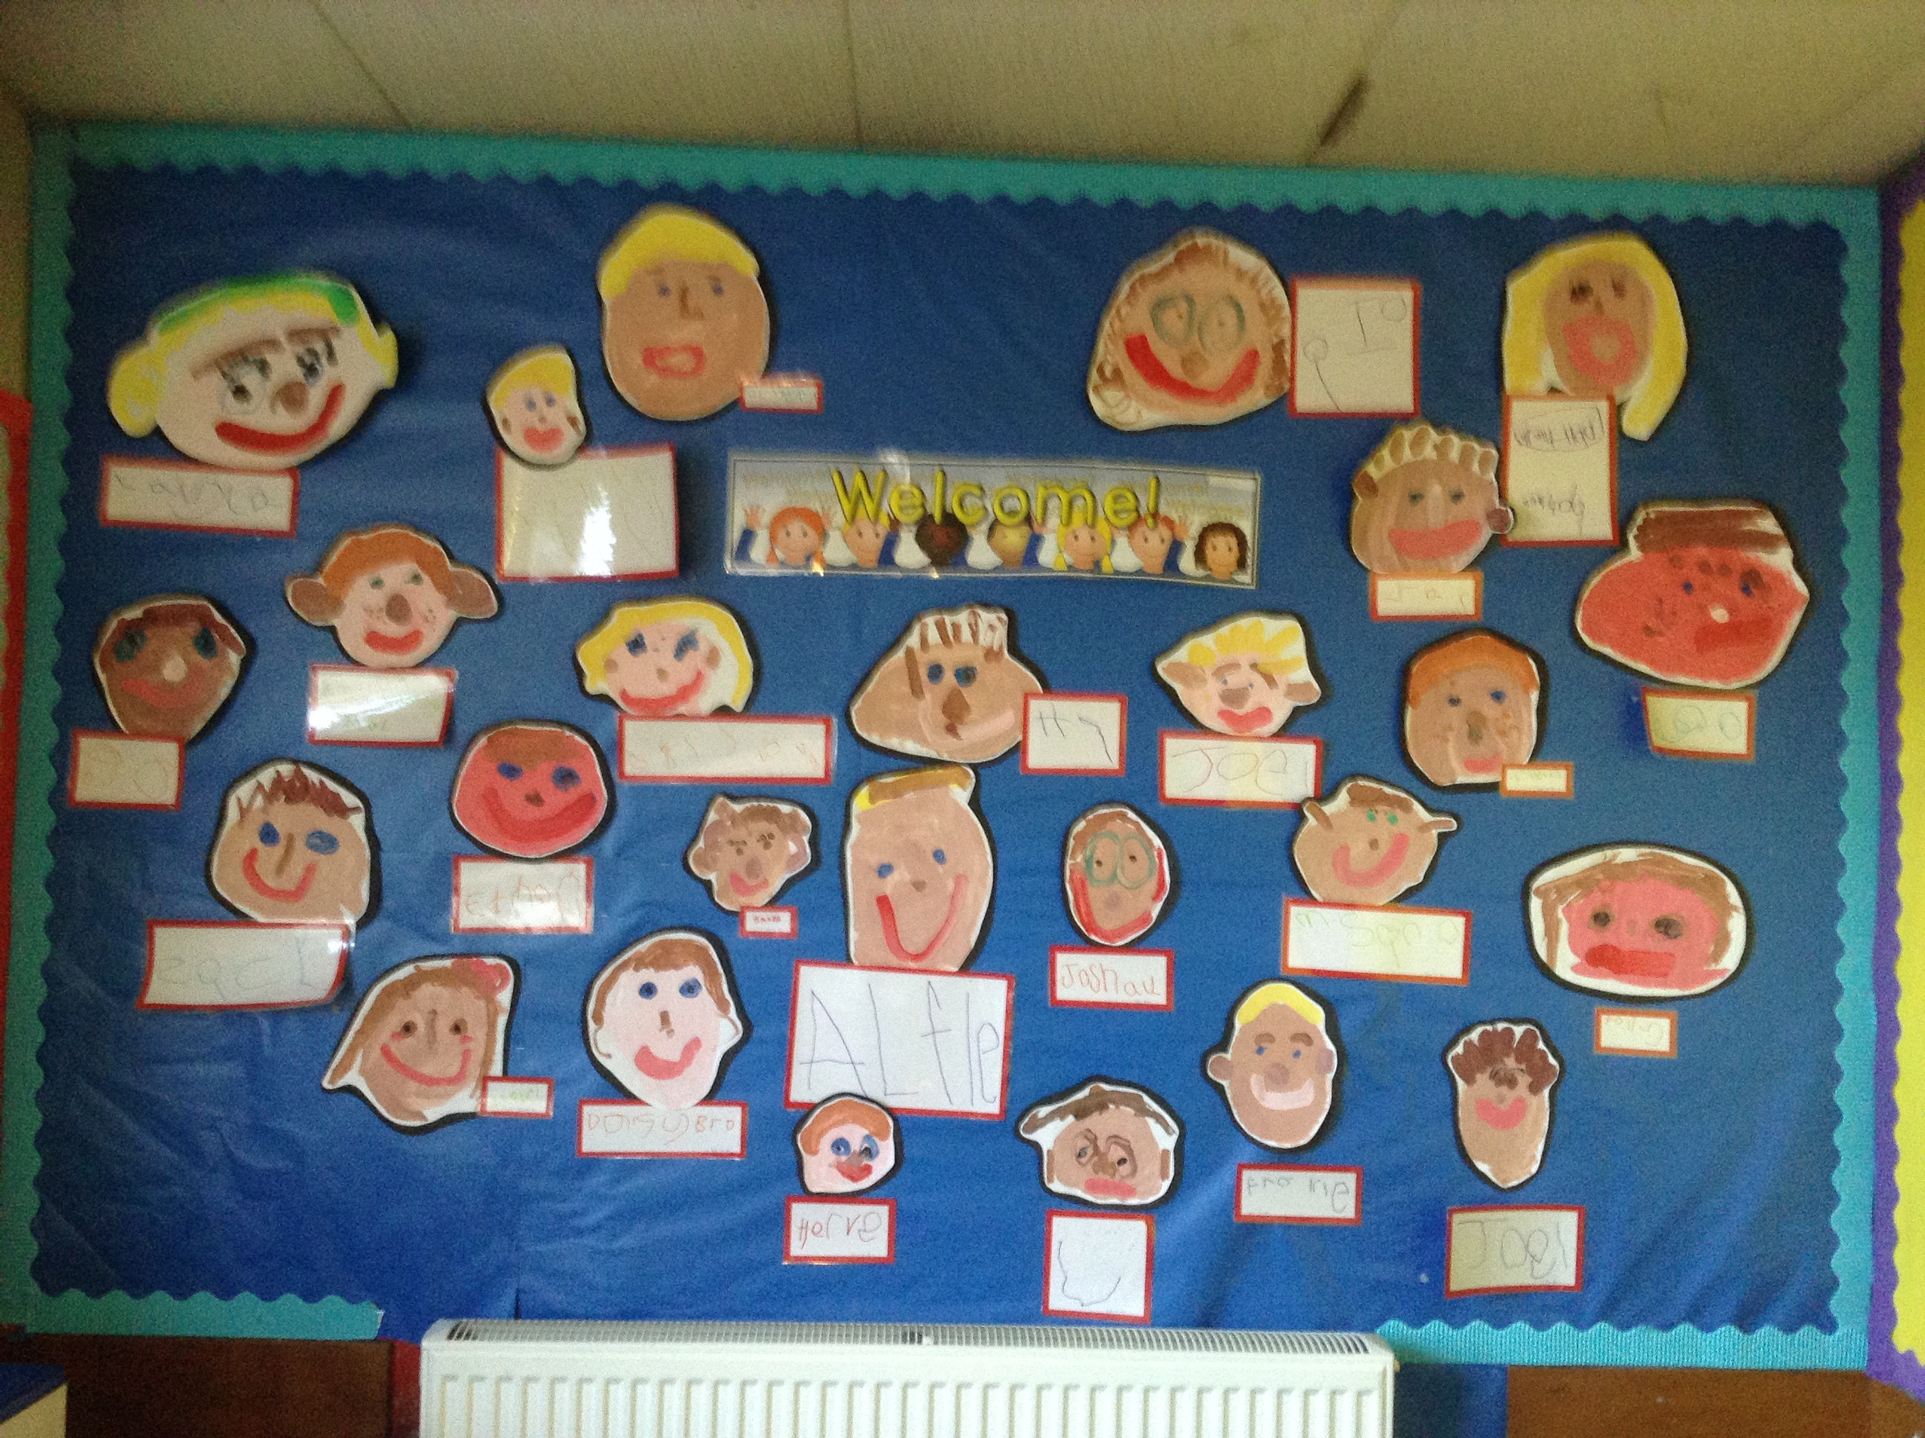

*“through creativity, challenge and connection, we unlock our true potential”*

Maternity Cover

Upper KS2 Primary School Class Teacher

Required from April/May 2021

Recruitment Information Pack

**Contents**

Further Information / Visits/ Overview of the Application Process

Letter from the Head Teacher

Applying for a job at Allerton Bywater

Job Description

Person Specification



Further Information

Please feel free to view the following links for more information:

School Website: <http://www.allertonbywater.leeds.sch.uk>

Latest Ofsted Report – Jun 2019 : https://reports.ofsted.gov.uk/provider/21/143242

Visits

Visits: Please contact the school office on 01977 522620 to discuss a possible visit.

Overview of the Application Process

The closing date for all applications is 9th March 2021 - 12 Noon

Shortlisting will be taking place on 9th March 2021 - 12 Noon

Candidates will be interviewed on 18th March 2021

Completed applications must be returned to Tara Ainsworthat: [**ainswot01@brigshawtrust.com**](mailto:ainswot01@brigshawtrust.com)

**If you think you are the person for the job, please complete the enclosed application form with a covering letter, no more than two sides of A4, and email to** [**ainswot01@brigshawtrust.com**](mailto:ainswot01@brigshawtrust.com) **by the closing date.**

An email will be sent to shortlisted candidates with details of the interview process. If you have not heard from us within a week of the closing date, please assume your application has been unsuccessful.

***The Brigshaw Learning Partnership is committed to safeguarding and promoting the welfare of children and young people and expects all staff and volunteers to share this commitment. This post is subject to an enhanced Disclosure and Barring Service check.***

**Allerton Bywater Primary School**

Leeds Road, Allerton Bywater

Castleford, WF10 2DR

Head teacher: Richard Cairns

01977522620

www.allertonbywater.leeds.sch.uk





Applying for a job

at

Allerton Bywater Primary School



**Letter from the Headteacher**

Thank you for taking the time to look at our advertisement and for considering making an application for the role of Class Teacher at Allerton Bywater Primary School.

Further information about the school, including a map, can be found on our website, [www.allertonbywater.leeds.sch.uk](http://www.allertonbywater.leeds.sch.uk) and on our Academy Trust website [www.brigshawlearningpartnership.com](http://www.brigshawlearningpartnership.com)

In the past six years our school has grown from a one form to a two form entry school. We have had six state of the art classrooms built to provide for our extra children. The academic results for 2019 were some of the best the school has had for some years (above national in all phases). Unfortunately, these improved results arrived after our June Ofsted inspection where, due to historic data, the overall grade for the school was requires improvement. Much of our work was judged as good, and the report praises many aspects of our work, including Behaviour, Personal Development and Welfare and Leadership and Management. We are working very hard to ensure this category is reversed at the next inspection.

I would draw your attention to the sheet within the pack which outlines the requirements of the Asylum and Immigration Act 1996 and the relevant document required, if you are invited for interview.

I think we have the best children in all of Leeds. They are keen to learn, well behaved and they really enjoy coming to school. Our parents and carers value education and support the school brilliantly. We are a happy, successful and forward-thinking school set in a community on the outskirts of Castleford. We are able to use the local area and amazing countryside around us, to bring the curriculum to life and make learning meaningful to children.

You need to know whether the school “feels right” for you before you apply, and where possible a visit is the best way to do that. We want the best candidates for our Class Teachers, inspirational people who can use current teaching strategies to engage our hardworking children in learning.

As Headteacher, this is my ninth year at Allerton Bywater, a school that strives to achieve high results. We are not complacent though, and are continually seeking to improve outcomes for our children.

Allerton Bywater Primary School is part of The Brigshaw Learning Partnership Multi Academy Trust. The Trust is made up of a community of local schools who work together to support all of our children achieve their best in learning and in life. Other schools in the BLP are Kippax Ash Tree Primary School, Kippax North Primary School, Kippax Greenfield Primary School, Swillington Primary School, Methley Primary School and Brigshaw High School. Our staff, pupils and families benefit from a wide range of opportunities developed by the BLP.

Please contact our school office on 01977 522620 if you are able to visit at the times offered. If you are unable to visit, do please email me with any questions that you may have before you apply to:

[cairnsr02@brigshawtrust.com](mailto:cairnsr02@brigshawtrust.com)

I look forward to hearing from you soon,

Regards

Richard Cairns

**This school is committed to promoting and safeguarding the welfare of all children.**

Thank you for expressing an interest in joining our school. The enclosed application pack contains a number of documents providing background information about our school and the vacancy that we are advertising. We hope you will find this information useful and we look forward to hearing from you.

**Interview and Selection Process**

Those candidates who meet all the requirements for the post will be short listed and details of the interview programme will be confirmed in writing.

As part of the selection process, in addition to assessing your skills and knowledge against the requirements of this role, specific questions will be asked to assess your suitability to work with children.

Under the disability Discrimination Act 1995 and 2005, we are legally required to consider making reasonable adjustments to ensure that disabled people are not disadvantaged in the recruitment and selection process. We are therefore committed to meeting, wherever possible, any needs you specify on the application from. Please contact the school if you need to discuss this in any detail.

We will consider any reasonable adjustments under the terms of the Disability Discrimination Act to enable an applicant with a disability (as defined under the act) to meet the requirements of the post.

**Induction and Continuous Professional Development**

The head teacher and governing body are committed to ensuring your well-being and continuous professional development in this role. On appointment the head teacher will discuss an appropriate induction programme with you that will help familiarise you with the culture of the school, local practices, policies and expectations.

You will be offered the opportunity to further develop your professional knowledge by participating in local training events and, where appropriate, working towards further qualifications.

**Making an Application**

**Application Form**

If you wish to be considered for this post please complete the enclosed application from providing full details of your education and employment history, including any unpaid or voluntary work. Where there are gaps in your employment please state the reasons why (e.g. gap year, career break, unemployed etc.). The person specification, provided with the details of the post, lists the essential and desirable criteria against which each application will be assessed at each stage of the Recruitment and Selection Process.

You will note that we require details of two referees, one of which must be your current or most recent employer. **Please provide ‘phone and email contact details for all referees.**

CVs are **not** accepted as part of the application process.

**Supporting Information**

This section of the form is very important. It gives you an opportunity to explain why you are applying and why you are the best person for this job. Use the job description and person specification as your guide and give specific examples, where possible, to demonstrate how you match the requirements for this post. If you do not have enough space, please attach a separate sheet.

**Please remember to sign the declaration on the final page of the application form.**

For teaching posts: in addition to the application form, please submit a formal letter of application (up to 2 sides of A4) detailing your experience of teaching and learning and the impact your contribution will make in terms of raising standards at our school.

Completed forms should be sent by email to

ainswot01@brigshawtrust.com or by post to

**Allerton Bywater Primary School**

**Leeds Road, Allerton Bywater.**

**WF10 2DR**

**Validation of Qualifications**

All short listed candidates will be asked to bring original certificates of relevant qualifications to interview. These will be photocopied and kept on file and may be confirmed as genuine with the relevant awarding bodies.

**Requirements of the asylum and immigration Act 1996**

**In order to comply with the requirements of the Asylum and Immigration Act and to confirm your eligibility to work in the UK you will be required to produce one or more of a statutory list of documents. A photocopy will be taken of the documentation before your interview and will be destroyed in the event that you are unsuccessful in your application. If you are appointed the photocopy of the document confirming your identity will be placed on your personal file.**

**The documents that you may use are listed below:**

* **United Kingdom passport**
* **European Economic Area passport**
* **National Identity Card**
* **United Kingdom residence permit**

**OR**

**An official document with a National Insurance Number**

**PLUS**

**One of the following:**

* **A full birth certificate from the United Kingdom, Channel Islands, Isle of Man or Ireland**
* **A letter from the Home Office**
* **An Immigration Status document endorsed b the Home Office**

**The original document will be returned to you as soon as it has been photocopied.**

**Pre-employment checks**

**References**

**Please provide ‘phone and email contact details for all referees.**

If you are short listed we will normally take up references **before** the interview date. One of your referees must be your current or most recent employer. Two satisfactory references must be received before we can confirm any offer of an appointment. The information we request will relate to salary, length of service, skills and abilities, suitability for the job, disciplinary record and suitability to work with children.

Copies of references or references that are addressed ‘to whom it may concern’ will not be accepted. On receipt of references your referees may be contacted to verify any discrepancies, anomalies or relevant issues as part of the recruitment verification process.

**DBS Checks & Disqualification checks**

Employment at this school is subject to an enhanced check with children’s barred list through the Disclosure and Barring Service. Employment is also subject to a childcare disqualification check. Checks will also be made against the Protection of Children List (PoCA) and the DCSF List 99. All such checks must be satisfactory before we confirm any offer of an appointment.

Under the Rehabilitation of Offenders Act 1974 (Exemption Amendment) Order 1986, there are a number of jobs where we must take account of convictions, even though they are ‘spent’. All posts at this school are regarded as such. However, spent and/or unspent convictions may not necessarily make you unsuitable for appointment. Please ensure you complete the Criminal Record Declaration Form and submit this alongside your completed application form.

**Prohibition checks (Teaching posts only)**

Prior to confirming an offer of employment, the school is required to make a mandatory check. You will be offered the opportunity to further develop your professional knowledge by participating in local training events and, where appropriate, working towards further qualification.

**Equal opportunities**

We are committed to promoting best practice in our efforts to eliminate discrimination and to create a working and learning environment where all are treated fairly and with respect.

We take action to ensure that nobody is treated less

**Medical Assessment**

A satisfactory medical assessment will be required for all new staff before we confirm any offer of an appointment.

**School Policies**

**Child Protection**

This school is committed to safeguarding and promoting the welfare of children and young people and expects all staff and volunteers to share this commitment. We have a designated senior member of the leadership team who is responsible for referring and monitoring any suspected case of abuse. All members of staff will receive training in line with our child protection policy.

**Whistle Blowing**

We recognize that children cannot be expected to raise concerns in an environment where staff fail to do so. Therefore our policy is to ensure that all staff are made aware of their duty to raise concerns about any inappropriate attitude or actions of colleagues.

**Code of Conduct and Personal Behaviour**

The school believes that it is essential for standards of conduct at work to be maintained to ensure delivery of quality services and also to protect the well-being of all its employees and pupils.

The head teacher and governing body regard everyone at our school as a role model to our pupils. As such employees should conduct themselves with integrity, impartiality and honesty. Furthermore, everyone in school has an absolute duty to promote and safeguard the welfare of children.

favorably than anyone else because of their colour, race, ethnic or national origin, religion, gender, sexual orientation, disability or age.

**Full details of all these policies are available in school.**

**Allerton Bywater Primary School**

**Job Description**

**Job Title: Class teacher**

**Grade: Main scale and full time**

Working under the supervision/management of the Senior Leadership Team of the school and at the direction of the governing body

Accountable for: Carrying out the professional duties of a teacher, as detailed in the School Teacher’s Pay and Conditions Document as issued by the DfE.

Any Special Conditions of Service: No Smoking Policy

**Purpose of the role:**

• To be accountable for the standards of teaching and learning and pupil progress for a class of children

• To exercise professional skills and judgement

• To impact on the educational progress of all pupils in the school

This job description should be read alongside the range of professional duties of Teachers as set in the Teacher’s Pay and Conditions Document. The post holder will be expected to undertake duties in line with the professional standards for qualified teachers and uphold the professional code of the General Teaching Council for England.

**Main Duties:**

Teaching and Managing Pupil Learning

• Ensure effective teaching of whole classes, groups and individuals so that teaching objectives are met, momentum and challenges are maintained, and best use is made of teaching time.

• Use learning and teaching methods which keep pupils engaged, including stimulating pupils’ intellectual curiosity, effective questioning and response, clear presentation and good use of resources.

• Set high expectations for pupils’ behaviour, establishing and maintaining a good standard of behaviour through well-focused teaching and through positive and productive relationships.

• Encourage the provision of and participation of targeted extra-curricular activities

• Support transition arrangements.

Planning and Setting Expectations/Pupil Achievement

• Identify clear teaching objectives, targets, content, lesson structure and sequences appropriate to the subject matter and the pupils being taught.

• Set appropriate and demanding expectations for pupils’ learning and motivation. Set clear targets for pupils’ learning, building on prior attainment.

• Identify pupils who have special educational needs, including the gifted and talented and know how to support these children in order to raise their attainment. Implement and keep records on Individual Education/Behaviour Plans (IEPs/IBPs) where appropriate.

• Encourage the provision of and participation in targeted extra-curricular activities,

• Support transition to the next Key Stage.

• Ensure deadlines are met, commenting on each report and identifying achievement issues.

• Establish and maintain high standards in line with the school’s ethos and expectations.

• Provide leadership for children through assemblies and Key Stage activities.

• Ensure that children are aware of what is expected and that they have contributed to the setting of standards.

Assessment and Evaluation

• Assess how well learning objectives have been achieved and use this assessment for future teaching.

• Mark and monitor pupils’ class and homework providing constructive oral and written feedback, setting targets for pupils’ progress in line with school policies and procedures.

• When applicable, understand the demands expected of pupils in relation to the National Curriculum and Early Years Foundation Stage curriculum.

• When directed ensure national tests are completed in accordance with national guidelines.

Relationship with Parents and the Wider Community

• Establish good and effective communications with parents/carers and agencies, including how they can support children’s learning.

• Prepare and present informative reports to parents.

• Provide opportunities to develop pupils’ understanding by relating their learning to real and work-related examples, recognising that learning takes place outside the school context.

• Liaise with agencies responsible for pupils’ welfare.

• Work alongside, to support and develop teaching and other students, as necessary.

Managing and Developing Staff and Other Adults

• Identify own and staff training needs.

• Support class teachers and Teaching Assistants.

• Share corporate responsibility for the implementation of school policies and practices.

Managing Resources

• Advise senior managers of staff and resource needs.

• Ensure the effective and efficient management and organisation of learning resources.

• Use accommodation to create an effective and stimulating environment for teaching and learning in.

• Ensure that there is a safe working and learning environment in which risks are properly assessed.

• Select and make good use of ICT and other learning resources which enable learning objectives to be met.

Principal Responsibilities are to:

• Teach a class/classes/groups of children.

• Work within the policies and guidelines of the school.

Supervise the work of classroom support staff as necessary.

• Be responsible for maintaining a learning environment which is organised and stimulating and which supports children learning.

• Encourage the development of mutually beneficial home/school partnerships.

• Take responsibility for identifying own development needs and plan career development with SLT. Manage own performance and development.

• Be responsible to the Headteacher through the school management structure.

• Accept other delegated responsibilities as may arise from time to time which are in keeping with the post and may be determined and required by the Headteacher.

Role Specific Competences

Teachers should:

• Comply with legislation, school regulations and professional and organisational codes.

• Show commitment to the values and objectives of the school.

• Schedule work to meet school’s prioritised objectives, making best use of time and resources.

• Develop supportive working relationships with colleagues which enable the sharing of good practice.

• Respond positively to change as an opportunity for improvement.

• Have a professional approach and appearance.

• Work within the Safer Working Practice guidance. (Document available in school)

February 2021

|  |  |  |  |  |  |  |
| --- | --- | --- | --- | --- | --- | --- |
| **PERSON SPECIFICATION**  **Class Teacher** | | | | | | |
| **Skills and Knowledge** | | | | | | |
|  | |  | **How Identified** | | | |
| 1. Secure commitment and confidence among staff to meeting the needs of pupils within the primary range | | Essential | App/Ref/SP | | | |
| 1. An outstanding classroom practitioner | | Essential | App/Ref/SP | | | |
| Iii Up to date knowledge of educational issues | | Essential | App/Ref | | | |
| 1. Make effective use of data to monitor and evaluate pupil progress | | Essential | App/Ref | | | |
| 1. Make informed use of resources | | Essential | App/Ref/SP | | | |
| 1. Prioritise, plan and organise | | Essential | Ref/SP | | | |
| 1. Deal sensitively with people, recognise individual needs and take account of these in securing a consistent team approach to raising achievement | | Essential | App/Ref/SP | | | |
| 1. Acknowledge and utilise the experience, expertise and contribution of others | | Essential | App/Ref/SP | | | |
| 1. Be able to plan and use a variety of methods and approaches to match curricular objectives to the needs of the child | | Essential | SP | | | |
| **Decision-making skills – the ability to solve problems and make decisions** | | | | | | |
| 1. Make decisions based upon analysis, understanding and interpretation of relevant data and information | | Essential | SP | | | |
| 1. Contribute to senior leadership team decision-making in respect of issues involving all pupils | | Essential | App/SP | | | |
| 1. Judge when to make decisions, and when to consult with others, including external agencies | | Essential | SP | | | |
| **Communication skills – the ability to make points clearly and to listen and understand the views of others** | | | | | | |
| 1. Communicate effectively orally and in writing to a range of audiences | | Essential | App/SP | | | |
| 1. Negotiate and consult effectively | | Essential | App/Ref/SP | | | |
| 1. Explain to pupils the objectives of any interventions | | Essential | App/SP | | | |
|  | |  |  | | | |
| **Self-management skills – the ability to plan time effectively and to organise oneself well** | | | | | | |
| 1. Prioritise and manage their own time effectively | | Essential | | SP | | |
| 1. Take responsibility for their own professional development | | Essential | | SP | | |
| **Attributes** | | | | | | |
| 1. Personal impact and presence | | Essential | Ref/SP | | | |
| 1. Adaptability to changing circumstances and new ideas | | Essential | Ref/SP | | | |
| 1. Energy, vigour and perseverance | | Essential | Ref/SP | | | |
| 1. Self-confidence | | Essential | Ref/SP | | | |
| 1. Enthusiasm | | Essential | Ref/SP | | | |
| 1. Intellectual ability | | Essential | Ref/SP | | | |
| 1. Reliability and integrity | | Essential | Ref/SP | | | |
| 1. Commitment | | Essential | Ref/SP | | | |
| **Training and Qualifications** | | | | | | |
| 1. Qualified Teacher Status or other educational qualification | | Essential | App / Checking at interview | | | |
| **Disposition and Attitude** | | | | | | |
| 1. Positive and optimistic attitude towards School Improvement and Inclusion | | Essential | | | SP | |
| 1. Open-minded and receptive to new ideas, approaches and challenges | | Essential | | | SP | |
| 1. Places high priority on effective team working and works easily and comfortably in a team environment | | Essential | | | SP | |
| **Other Special Working Conditions** | | | | | | |
|  |  | | | | |  |
| 1. The school operates a no smoking policy | Essential | | | | | SP |
| 1. To attend any training as deemed appropriate by the Governing Body |  | | | | |  |
| 1. Agreement to the Governing Body undertaking an Enhanced DBS Disclosure |  | | | | |  |

**Key:**

**App** – Application Form

**Ref** – Reference

**SP** – Selection process. This could include a range of exercises, including an interview.