
Candidate Information Pack
Unqualified Teacher
Birley Spa Primary Academy



Contents
About the Trust | 3
Working at Birley Spa Primary Academy | 6
Benefits of being part of L.E.A.D. Academy Trust | 7
How to apply | 9
Job description and person specification | 10

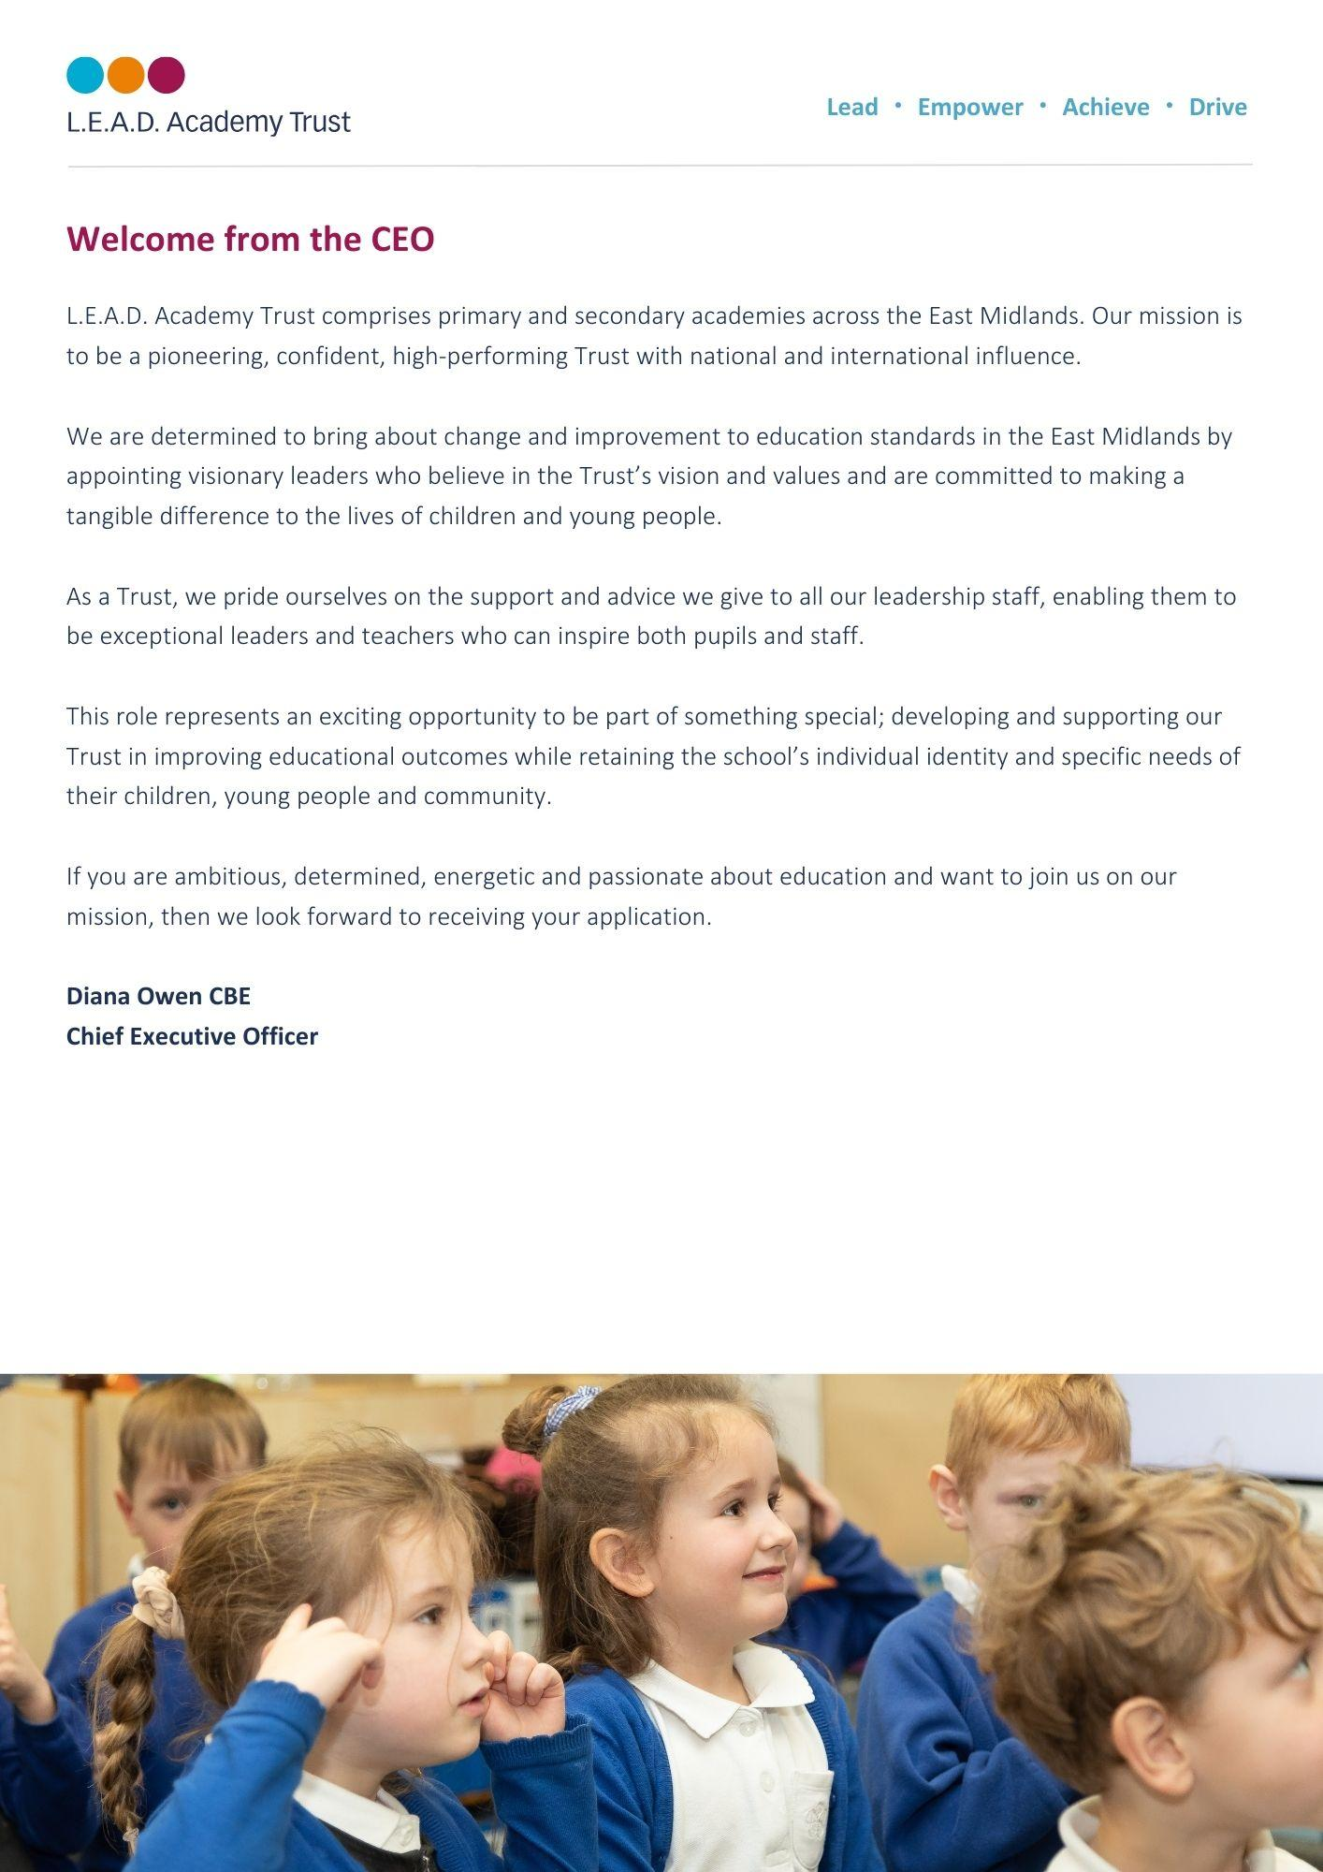
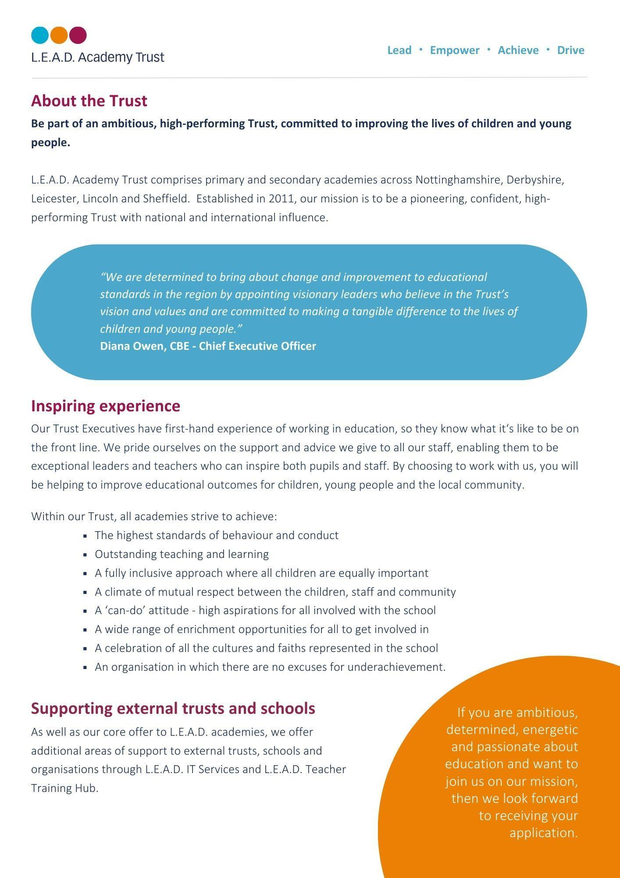
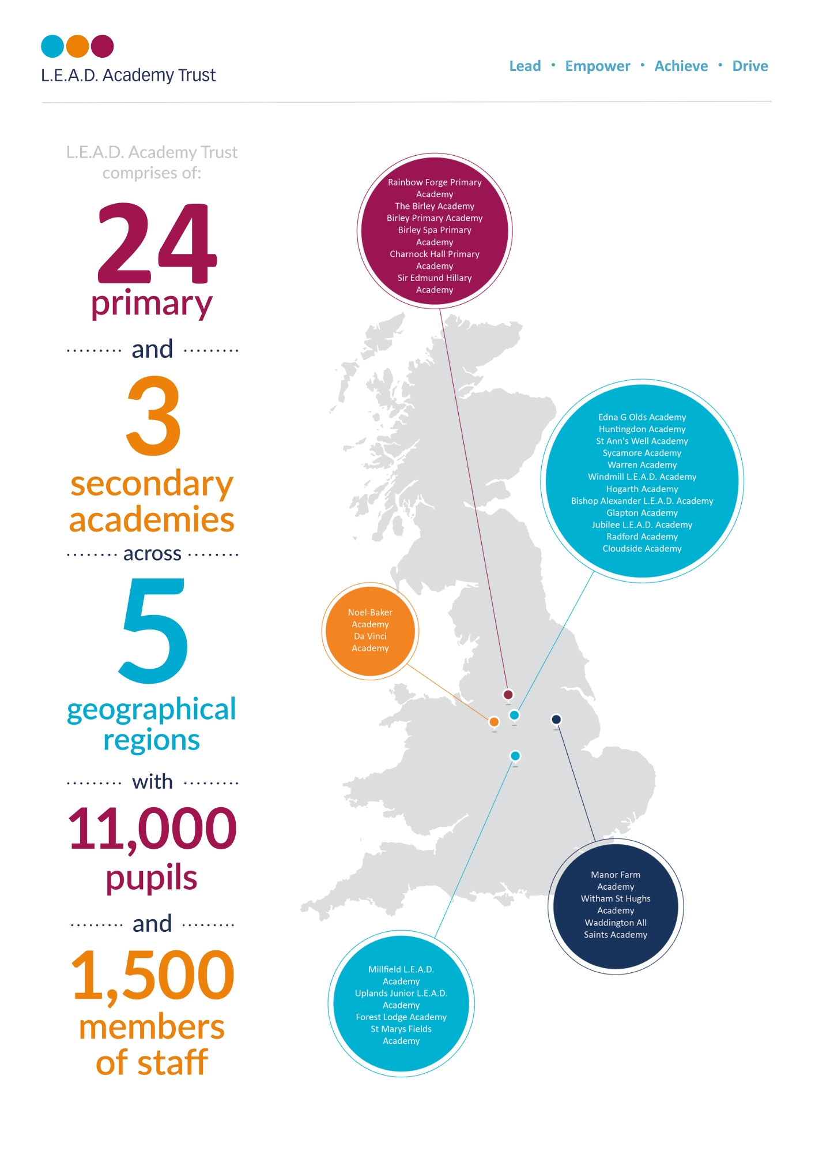

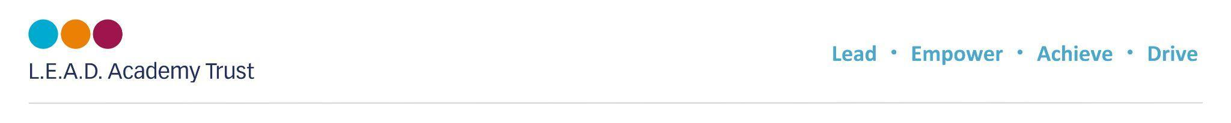
A message from the Executive Headteacher and Head of School
We are a busy and friendly school with lots going on. Birley Spa Academy is a passionate community of life-long learners who strive for excellence. We are inspired by each other’s achievement and success. We constantly develop and update our resources and curriculum offer to ensure that our pupils can succeed now and in the future.
We warmly welcome visits to the school to discuss this exciting opportunity.
Melany Pemberton, Executive Headteacher and Cathy Gibson, Head of School
About Birley Spa Primary Academy
Our school values equip every child with the core strength and resilience to confidently burst through barriers to learning and become confident, conscious citizens, equipped for the challenges of the modern world. We create an aspirational cultural climate in which every member of Birley Spa Primary Academy thrives and articulates a passion for inspiring leadership beyond learning.
Through the pursuit of excellence, our children, no matter their age or need, are encouraged to become ambassadors with the highest aspirations; learners who confidently express themselves and articulate their knowledge with passion.
Our inspirational learning environments motivate our children to develop a desire and love of learning in our “Everyone is a Leader” community.
Our children pride themselves on the range of responsibilities they have within the classroom and the school. They develop a sense of pride in their community and independence. They learn to understand and balance risk to challenge themselves and grow as learners. Children demonstrate initiative to question, lead and explore from the first day of their Birley Spa journey until they move onto secondary education.




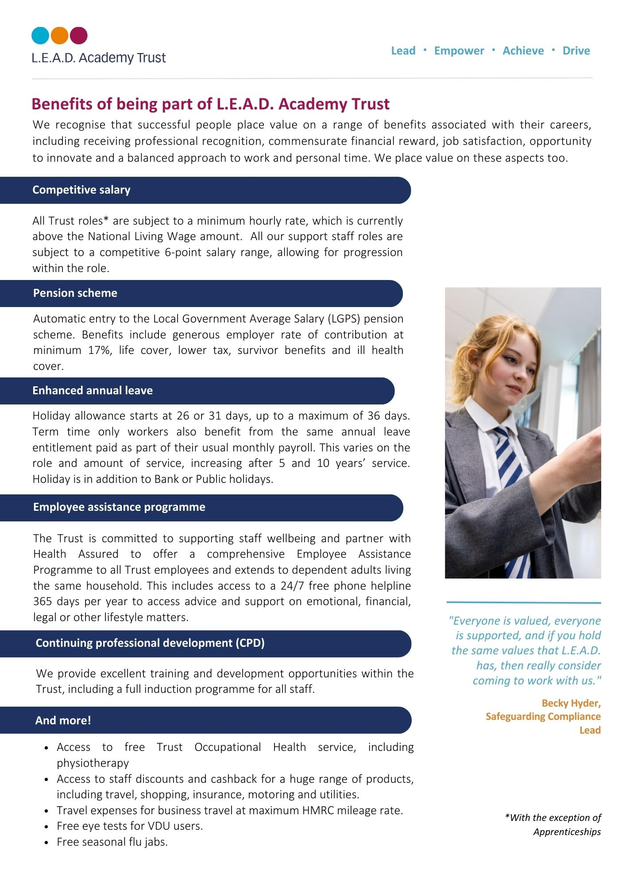


“The school’s provision for pupils’
personal development is strong.
Pupils take full advantage of a wide
range of activities on offer
at the school.”

Ofsted report, 2023.

How to apply
Please send a completed application form and covering letter explaining your interest in the role and how you meet the person specification to: Officemanager@birleyspaacademy.co.uk
CLOSING DATE: Friday 16th May 2025

Applications will be reviewed upon receipt, therefore shortlisted candidates may be contacted in advance of the closing date.
L.E.A.D. Academy Trust is committed to safeguarding and promoting the welfare of children and young people and we can expect all staff and volunteers to share this commitment. This post is subject to an enhanced DBS check.
For an informal, confidential discussion about this opportunity, please email: enquiries@birleyspaacademy.co.uk

Job description
Key responsibilities and accountabilities
Unqualified Teacher
Salary: NJC 12 - 17 (£27,711 – £30,060 full time equivalent) actual salary pro rata on 39 weeks per year.

This role will support teachers and students as directed and ensure that classes are appropriately managed during times of teacher absence.
Main Responsibilities:
- To undertake classroom activities as directed by teachers to support teaching and learning process
- To assist in the preparation of resources and display
- To mark students’ work in accordance with Academy policies and teacher instructions
- To undertake administrative duties as requested by teachers
- To cover tutor groups as and when needed
- To input data to support Academy policies in Assessment, Recording and Reporting
- To maintain student records in accordance with statutory procedures, Academy policies and as directed by the Assistant/Deputy Headteacher
- To liaise with Learning Resource staff and ICT staff to ensure teachers requirements are met to ensure high quality teaching and learning
- To manage the behaviour of pupils to ensure a constructive environment is maintained, by using a range of strategies
- To assist the teacher in the classroom as timetabled / requested
- To respond to student needs as they arise in the classroom
- To undertake break and lunchtime activities
- To undertake examination invigilation duties where required
- To work with teachers to prepare appropriate lessons / resources when absence is known in advance
- To compile appropriate lesson activities / resources in liaison with other teachers when absence is not known in advance
- Ensure that all communications with parents demonstrate the values of the academy and the L.E.A.D. Academy Trust
- Attend all meetings and functions necessary to support the work in this job description, ensuring that

The Trust is committed to safeguarding and promoting the welfare of children and young people and expects all staff and volunteers to share this commitment and individually take responsibility for doing so.

At L.E.A.D we have a strong vision and four core principles, to lead, empower, achieve and drive, which you will be expected to demonstrate in your working practices.

Person specification
The person specification listed below outlines the competences, knowledge and behaviour of candidates who would be suitable for this role. The two right-hand columns provide guidance as to whether these items are essential (E) or desirable (D) criteria.
 |  | E | D
Qualifications and Attainments | - Studied to a minimum standard of GCSE (grade A* - C), or equivalent, in English and Maths  - Level 3 qualification  - A degree or post graduate qualification | E  E | D
Skills and  knowledge | - Ability to contribute to the delivery of lessons.  - High level of oral and written communication skills  - Ability to work as part of a team  - Able to work to tight deadlines, managing and prioritising time effectively  - Self-starter, with and ability to work independently & use own initiative to overcome obstacles | E  E  E  E  E
Experience | - Previous paid or voluntary work with young people  - An understanding of Keeping children safe in education  - An understanding basic school organisation  - A basic knowledge of the work of a school  - Experience working with children with Special Educational Needs | E  E  E  E | D
Personal Attributes | - Have an openness to learning and change  - Have a positive attitude to personal development and training  - Be able to work in ways that promote equality of opportunity, participation, diversity and responsibility | E  E  E
Additional Requirements | - This role is subject to an enhanced DBS  - May be required to work out of school hours to support the academy


Email address:
enquiries@birleyspaacademy.co.uk
Phone number:
0114 239 9106

