The Stoke Poges School

CLASS TEACHER – Main Scale
Job Description

_____________________________________________________

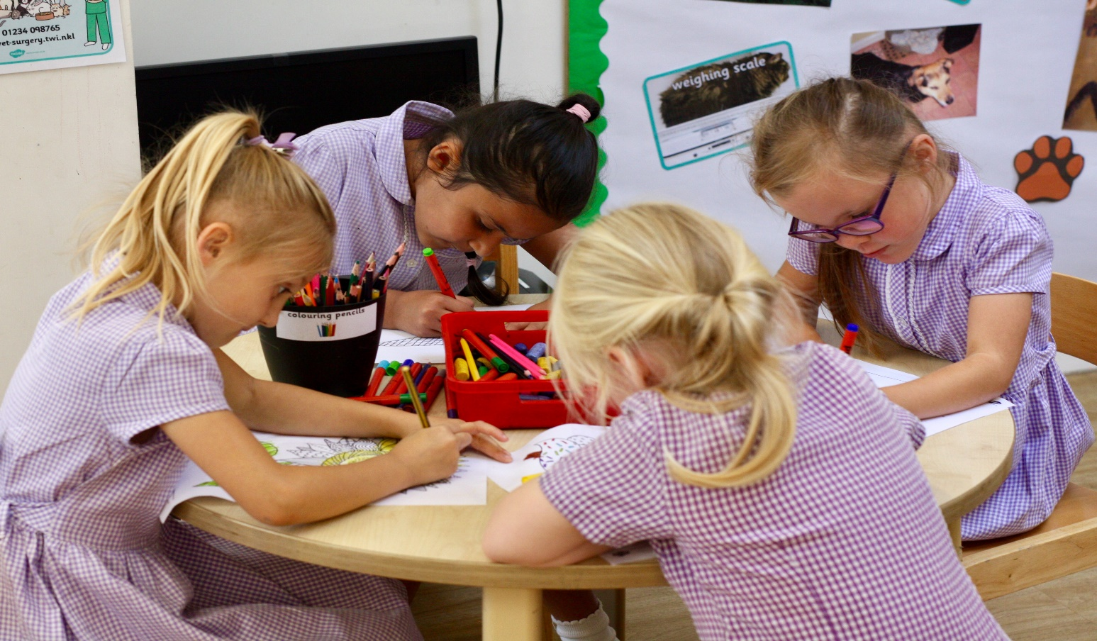

The Stoke Poges Job Description
Class Teacher

Job Title: | Class Teacher
Salary and Grade: | Main pay scale range 1-6 in line with the current School Teachers’ Pay and Conditions Document
Responsible to: | Headteacher, Deputy Headteacher and line manager
Non-contact time: | 10% Planning, Preparation and Assessment Time per week  Subject leadership time, as appropriate

The appointment of a teacher is subject to QTS status and the current conditions of employment for teachers in the School Teachers’ Pay and Conditions Document (STCPD) and other current legislation. Teachers should have due regard to the Teacher Standards (2012).

This job description may be amended at any time following discussion between the Headteacher and the member of staff, and will be reviewed annually as part of the appraisal process.

The performance of all the duties and responsibilities shown below will be under the reasonable direction of the Headteacher. She will be mindful of her duty to ensure that the employee has a reasonable workload and sufficient support to carry out the duties of the post.

Main Purpose

The teacher will:
- Fulfil the professional responsibilities of a teacher, as set out in the School Teachers’ Pay and Conditions Document
- Meet the expectations set out in the Teachers’ Standards

Duties and responsibilities

Teaching
- Plan and teach well-structured lessons, following the school’s plans, curriculum and planning format
- Assess, monitor, record and report on the learning needs, progress and achievements of pupils, making accurate and productive use of assessment and feedback
- Adapt teaching to respond to the strengths and needs of pupils
- Set high expectations which inspire, motivate and challenge all pupils
- Promote good progress and outcomes by pupils
- Demonstrate good subject and curriculum knowledge
- Set up a positive and motivating learning environment within the classroom which reflects current learning, support children with their learning, is inviting and engaging and which celebrates children’s work
- Set homework and plan other out-of-class activities to consolidate and extend the knowledge and understanding pupils have acquired as appropriate

Whole-school organisation, strategy and development
- Contribute to the development, implementation and evaluation of the school’s policies, practices and procedures, so as to support the school’s values and vision
- Make a positive contribution to the wider life and ethos of the school
- Work with others on curriculum and pupil development to secure co-ordinated outcomes

Health, safety and discipline
- Promote the safety and wellbeing of pupils
- Always follow the procedures set out in the school’s Behaviour Policy
- Maintain good order and discipline among pupils, promoting positive behaviour and managing behaviour effectively to ensure a good and safe learning environment

Professional development
- Take part in the school’s appraisal procedures
- Take part in further training and development in order to improve own teaching

Team working and collaboration
- Participate in any relevant meetings/professional development opportunities at the school, which relate to the learners, curriculum or organisation of the school including pastoral arrangements and assemblies
- Work as a team member and identify opportunities for working with colleagues and sharing the development of effective practice with them
- Take part as required in the review, development and management of the activities relating to the curriculum, organisation and pastoral functions of the school
- Contribute to the development, implementation and evaluation of the school’s policies, practices and procedures, so as to support the school’s values and vision

Fulfil wider professional responsibilities
- Work collaboratively with others to develop effective professional relationships
- Deploy support staff effectively as appropriate
- Communicate effectively with parents/carers with regard to pupils’ achievements and well-being using school systems/processes as appropriate
- Communicate and co-operate with relevant external bodies
- Make a positive contribution to the wider life and ethos of the school
- Be willing to support PTA activities by attending events
- Be willing to run an after-school club or activity

Administration
- Register the attendance of and supervise learners, before, during or after school sessions as appropriate
- Participate in and carry out any administrative and organisational tasks within the remit of the current School Teachers’ Pay and Conditions Document

Personal and professional conduct
- Uphold public trust in the profession and maintain high standards of ethics and behaviour, within and outside school
- Have proper and professional regard for the ethos, policies and practices of the school, and maintain high standards of attendance and punctuality
- Understand and act within the statutory frameworks setting out their professional duties and responsibilities
- Provide a positive role model to children in terms of following the professional code of conduct

Additional responsibilities

Code of Conduct
The school expects all staff to ensure that their standards of conduct are, at all times, compliant with The Stoke Poges Code of Conduct for Employees.

NOTE:
Notwithstanding the details in this job description, the jobholder will undertake such duties as maybe determined by the Headteacher from time to time up to or on a level consistent with the principal responsibilities of the job.

Signed to indicate agreement………………………………………….[Post-holder] Date………………

Signed…………………………………………………………………….[Headteacher] Date……………..

The Stoke Poges Person Specification
Key Stage 1 and 2 Class Teacher

 | Essential | Desirable
Teaching Qualification | - Qualified Teacher Status  - Evidence of Continuing Professional development  - Evidence that practice consistently meets the expectations of the Teacher Standards 2012 | - More than two years successfully teaching in Key Stage 1 or 2
Skills and knowledge | - A clear understanding of primary education and the National Curriculum  - Knowledge of effective teaching and learning strategies  - A good understand of how children learn  - Ability to adapt teaching to meet pupils’ needs  - Knowledge of guidance and requirements around safeguarding children  - Knowledge of effective behaviour management strategies  - Good ICT skills, particularly using ICT to support learning | - A proven record of raising standards  - Experience of successful coordination of a curriculum subject area
Personal qualities | - A commitment to getting the best outcomes for all pupils and promoting the ethos and values of the school  - High expectations for children’s attainment and progress  - Ability to work under pressure and prioritise effectively  - Commitment to maintaining confidentiality at all times  - Commitment to safeguarding and equality  - Ability to work collaboratively  - An effective communicator with a good sense of humour  - Willing to share knowledge and skills  - Keen to develop as a professional  - Willing to participate in and contribute to the life and work of the wider school community  - Ability to be flexible  - Imaginative and enthusiastic  - High standards of professional and personal conduct

