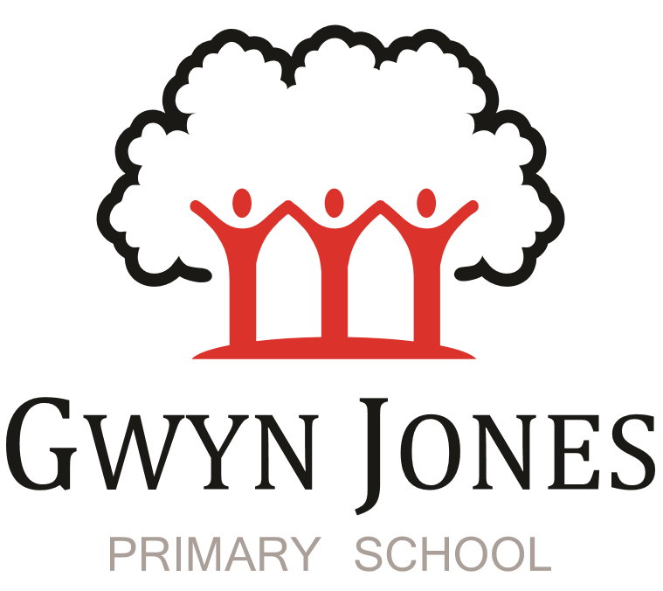

Recruitment Pack

Upper Keystage 2 Class teacher
with a TLR for Leading on Rights Respecting Schools
Permanent Full Time Contract
Grade: MPS/UPS
September 2024 start

Dear Applicant,

Thank you for your interest in this exciting opportunity to join Gwyn Jones Primary School as a member of team in the role of upper key stage two class teacher with the responsibly for leading on Rights Respecting Schools. We are looking to appoint an outstanding class teacher for a September 24 start.

We are a two-form entry, culturally diverse school based in East London and we are very proud of our school. Visitors comment on the warmth of the school and the friendliness of both staff and pupils alike. Our dedicated staff team are incredibly hard working and are committed to creating a happy, secure and stimulating environment in which every child can achieve their potential and develop a life-long love of learning.

At Gwyn Jones Primary School we are a Rights Respecting School and we actively teach our children about the rights of the child. The Rights Respecting ethos permeates all parts of school life and into our school motto “Inspired and Empowered”. This motto epitomises the staff’s genuine commitment to provide a rich, creative and challenging curriculum which inspires children’s curiosity and empowers our pupils to have a voice and be knowledgeable, active global citizens. We strive to ensure that every child thrives academically whilst benefiting from excellent pastoral care that nurtures and develops emotional wellbeing.

We are looking for someone who has good communication skills and is flexible in their approach when supporting children and working alongside other colleagues. We know it is important to be positive, inspirational and a real team player. To add to our team, we wish to appoint an excellent class teacher who will draw upon their experience and expertise in teaching to raise standards. Together, we will drive outstanding learning and teaching that is challenging, interesting and motivational to all pupils building inquiring lifelong learners who care for their world and all that live in it.

I hope this application pack and the information available generally on our website and on social media will give you a flavour of our School. I would be delighted to show you around our friendly and caring school. To arrange a visit please contact the school office on 02085567904 or email: HR@gwynjones.waltham.sch.uk

I look forward to meeting with you
Sian Boutalbi
Headteacher

Dear Applicant,
Thank you for your interest in the position of class teacher at Gwyn Jones Primary School.
Gwyn Jones is a successful and very popular school within the local area. We are fortunate in having an engaged and culturally diverse community, a hardworking and talented staff team and amazing pupils.
As Governors, we work alongside the Head and her dedicated team in our common belief in the fundamental importance of Primary Education as the foundation for developing a lifelong love of learning in our children. Our Governing Board is keen to develop its skills and knowledge of the school and its community and supports the drive within school for continuous improvement within a nurturing and supportive environment.
Our curriculum is rich, diverse and challenging and aims to provide a range of exciting and meaningful experiences which foster confidence and provide aspirations. Staff plan for children to be academically challenged, creatively inspired and supported in their personal development.
Gwyn Jones maintains strong links with other local schools within Waltham Forest. As a member of our staff team you would receive ongoing support and development in your role.
If the thought of this role in our school excites you, we look forward to receiving your application.
Liz Jackson
Chair of Governors

Vision and Values

At Gwyn Jones, we are committed to ensuring that every member of our school community is inspired and empowered each day.
We aim to inspire and empower our children by:
- Providing excellent teaching which nurtures our children’s innate curiosity, allowing them opportunities to take risks and to think for themselves.
- Supporting our children to have responsibility for their own learning; to have their own opinions and the skills to articulate them.
- Allowing all children access to a rich and broad curriculum which fully prepares them to be active, global citizens.
- Ensuring all children participate in a variety of trips and visitors in their local and wider community.
- Acting as role models who respect others and enjoy the rich diversity of our school family.
- Insisting that every child is known well, safe and nurtured to achieve their personal best.
We aim to inspire and empower our staff by:
- Providing a wide range of relevant and innovative professional learning in school which focuses on collaboration and sharing good practice, including lesson study, planning support, team teacher and action research.
- Forging strong links with external agencies to deliver professional development - teaching schools, higher education institutes etc.
- Giving developmental feedback with clear and specific actions for staff and leaders.
- Establishing coaching and mentoring relationships which encourage reflection.
- Identifying and nurturing leadership talent.

Rights Respecting School

What is UNICEF's Rights Respecting Schools?
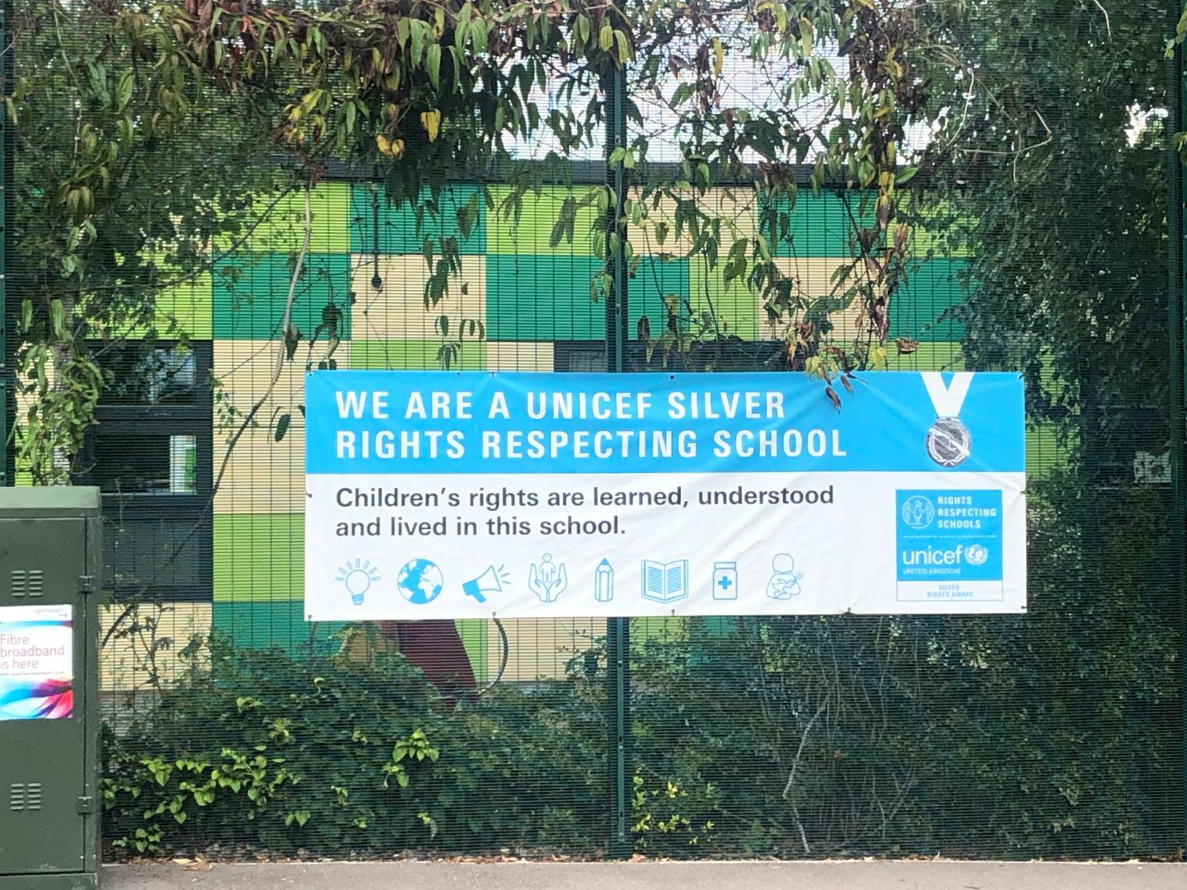

We are committed to placing the UN Convention on the Rights of the Child at the heart of our core values and ethos; believing children’s participation is integral to all aspects of school life. This results in empowered and self-confident children who can advocate for the rights of children everywhere.
This ethos further fosters a sense of community, respect and responsibility. It encourages the children to be active and informed citizens, who look to develop a positive future for all; campaigning and raising awareness.
The children’s experiences at Gwyn Jones Primary ensure the children know that they have the Rights of the Child and that these rights are inalienable. They also understand responsibilities they have as members of our local and global society.
How to Apply
Should you wish to apply for the post, please complete an application form and include a personal statement, which clearly demonstrates your suitability for this role. Please send your completed applications to HR@gwynjones.waltham.sch.uk

Closing Date
Please ensure your application arrives by 5pm on the closing date of 26th April 2024.

Shortlisting
Shortlisting will take place on Monday 29th April 24 if you have not heard from us by Tuesday 30th April 24 please assume that unfortunately, on this occasion, your application has not been successful.

Interview
Interviews will take place on Tuesday 7th May 2024.

Safeguarding
Applicants called for interview are kindly requested to contact their referees so that references are received ahead of the interview dates.
Gwyn Jones Primary School is committed to safeguarding and promoting the welfare of children and young people and expects all staff and volunteers to share this commitment. The school follows safer recruitment practices and the successful applicants will be required to apply for an Enhanced Disclosure and Barring Service check.
Following KCSIE guidance 2023 an online search may be conducted on publicly available social media for shortlisted candidates only prior to interview.
A copy of our Safeguarding Policy is available to view on our website.
Location
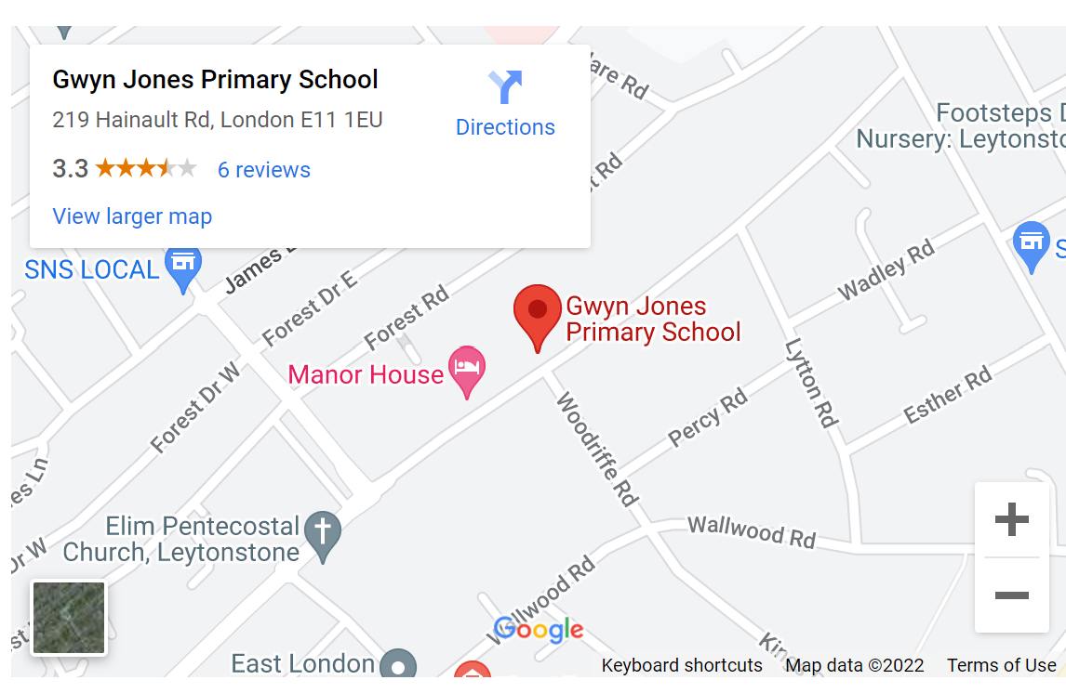

Class Teacher – Job description

Position: Class Teacher

Grade: Teachers’ Main Scale MPS/UPS

Main purpose
The teacher will:
- Fulfil the professional responsibilities of a teacher, as set out in the School Teachers’ Pay and Conditions Document
- Meet the expectations set out in the Teachers’ Standards

Duties and responsibilities

Teaching
- Plan and teach well-structured lessons to assigned classes, following the school’s plans, curriculum and schemes of work
- Assess, monitor, record and report on the learning needs, progress and achievements of assigned pupils, making accurate and productive use of assessment
- Adapt teaching to respond to the strengths and needs of pupils, including those with SEND
- Set high expectations which inspire, motivate and challenge pupils
- Promote good progress and outcomes by pupils
- Demonstrate good subject and curriculum knowledge
- Participate in arrangements for preparing pupils for external tests
- Teach consistently good lessons

Whole-school organisation, strategy and development
- Contribute to the development, implementation and evaluation of the school’s policies, practices and procedures, so as to support the school’s values and vision
- Make a positive contribution to the wider life and ethos of the school
- Work with others on curriculum and pupil development to secure co-ordinated outcomes
- Provide cover, in the unforeseen circumstance that another teacher is unable to teach

Health, safety and discipline
- Promote the safety and wellbeing of pupils
- Maintain good order and discipline among pupils, managing behaviour effectively to ensure a good and safe learning environment
- Safeguard and promote the welfare of children and young people, and follow school policies and the staff code of conduct.

Professional development
- Take part in the school’s appraisal procedures
- Take part in further training and development in order to improve own teaching
- Where appropriate, take part in the appraisal and professional development of others

Communication
- Communicate effectively with pupils, parents and carers

Working with colleagues and other relevant professionals
- Collaborate and work with colleagues and other relevant professionals within and beyond the school
- Develop effective professional relationships with colleagues

Personal and professional conduct
- Uphold public trust in the profession and maintain high standards of ethics and behaviour, within and outside school
- Have proper and professional regard for the ethos, policies and practices of the school, and maintain high standards of attendance and punctuality
- Understand and act within the statutory frameworks setting out their professional duties and responsibilities

Notes:
This job description will be reviewed regularly and may be subject to modification and amendment after consultation

Signed by Class teacher: Date:

Signed by Head Teacher: Date:

Person Specification and Criteria
Class teacher

Candidates should provide evidence for all the essential criteria required at application

Keys: E = essential; D = desirable; EB = evidence base;
A = application R = reference I = interview & task
 | Education and Qualifications | E | D | EB
1 | Qualified teacher status for primary phase | x |  | A
2 | Recognised degree or specialism in a core subject | x
3 | Higher degree in curriculum development or school improvement |  | x
4 | Evidence of continuous professional development | x

 | Knowledge and skills | E | D | EB
1 | A track record of good and outstanding teaching across the primary phase | x |  | A, R & I
2 | A role model of good teaching and behaviour management within and beyond the classroom | x
3 | Evidence of involvement in successful whole school curriculum development |  | x
4 | Good knowledge and understanding of legislation and ongoing developments in education at local and national level |  | x
5 | Experience of using ICT effectively and innovatively to improve the quality of teaching and learning | x
6 | Excellent communication skills | x
7 | Proven ability to bring about improvement in the quality of teaching and learning across a curriculum area that results in improved outcomes for pupils | x
8 | Up to date knowledge of relevant legislation and guidance in relation to working with, and the protection of, children and young people and demonstrate an understanding of safeguarding issues and the ability to follow procedures | x
9 | An excellent understanding of current theory and best practice in teaching and learning | x
10 | Understand the role of parents and the community in school improvement and how this can be promoted and developed | x

 | Personal qualities | E | D | EB
1 | Ability to build and maintain effective relationship with pupils, parents, colleagues and other key stakeholders | x |  | A, R & I
2 | Ability to work in a team | x |  | A, R & I
3 | Ability to prioritise, plan, manage time effectively and organise self and others | x |  | A, R & I
4 | Ability to use comparative data and information about pupils’ attainment to set targets and raise standards |  | x | A, R & I
5 | A strong sense of professionalism, commitment to upholding standards and setting an appropriate example | x |  | A, R & I
6 | Integrity, loyalty, enthusiasm and dynamism | x |  | R
7 | Good understanding of the challenges faced by inner-city schools | x |  | A, R & I
8 | Approachability, accessibility and flexibility, good personal presence and a sense of humour | x |  | R
9 | A desire to be part of the school | x |  | A,I
10 | A commitment to support the wellbeing of self and others | x |  | A, I

