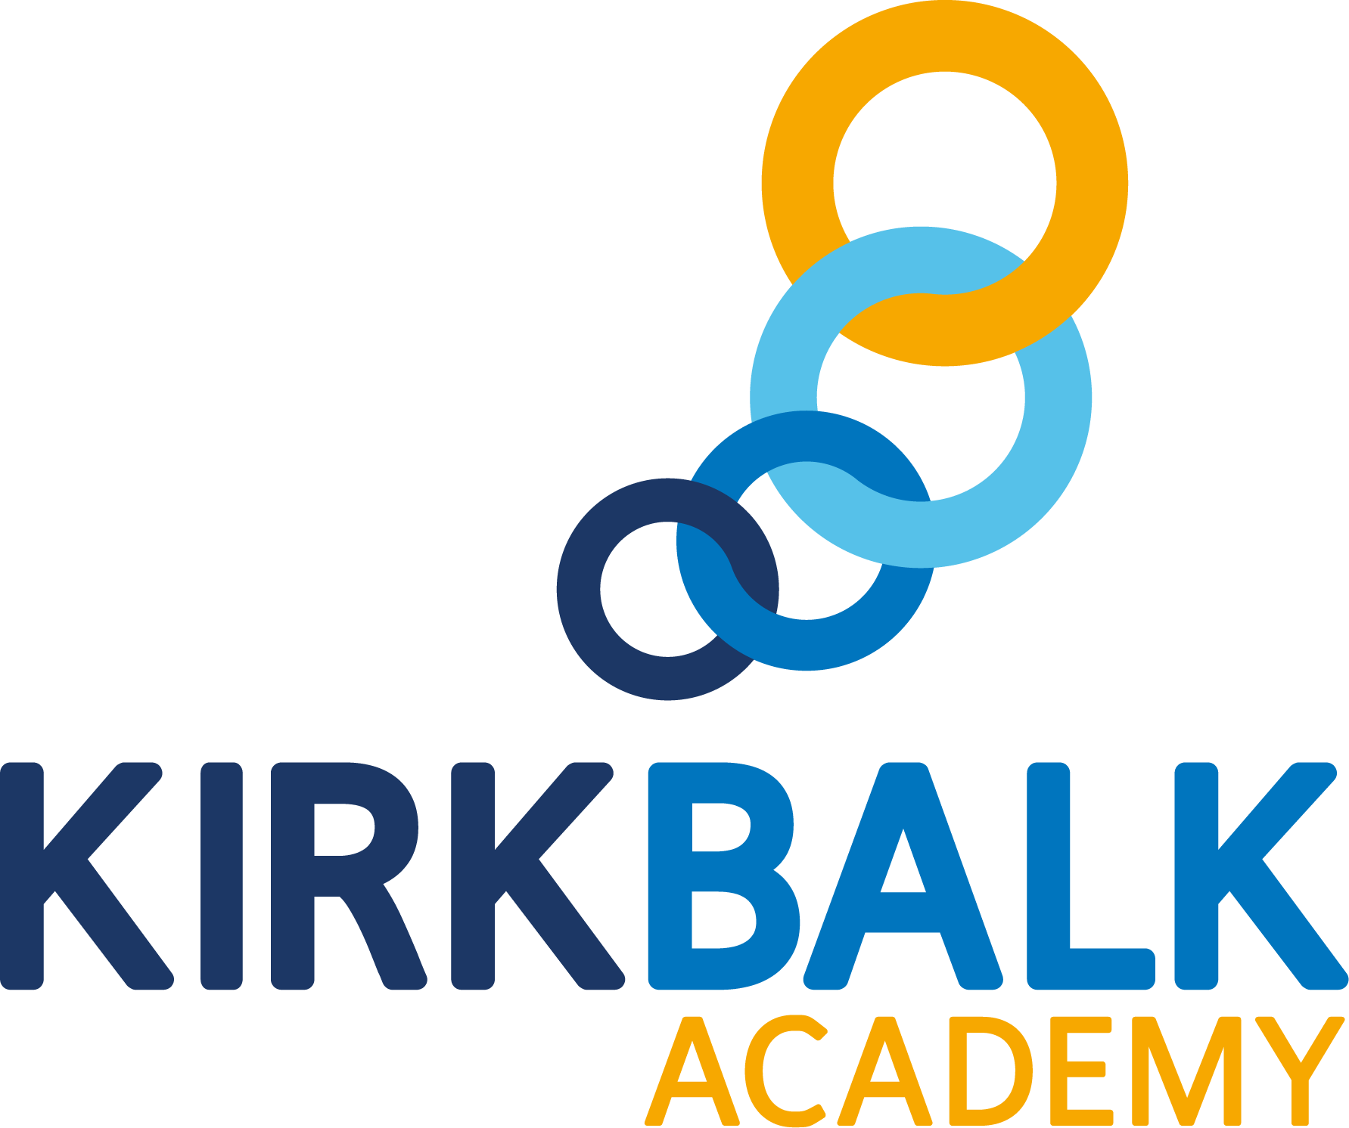

**Outcomes Focused, Child Centred**



**VICE PRINCIPAL**



**Contents**

|  |  |
| --- | --- |
| Welcome from the Chief Executive | **03** |
| Welcome from the Principal | **04** |
| Introduction to Kirk Balk Academy | **06** |
| Northern Education Trust | **09** |
| Staff and Students | **10** |
| Enrichment | **11** |
| The Application Process | **12** |
| Where to Find Us | **13** |
| Job Advert | **14** |
| Job Description | **15** |
| Person Specification | **18** |

**Welcome from the Chief Executive**

**On behalf of the Northern Education Trust Board, welcome to the Northern Education Trust.**

We are unswerving in our commitment to ensure that the outcomes our young people secure prepare them fully for life beyond school. Our Academies are happy and thriving communities where children both achieve and feel safe and cared for. As an inclusive Trust, we strive to help young people overcome any barrier to learning.

We are a caring employer and invest heavily in professional development, allowing our staff opportunities to take the next steps in their career. We hope you find our website holds all the information you need to believe that whether you are a parent or prospective employee, your next steps should be taken with us.

**Welcome from the Principal**

**Mr Dean Buckley**

**I am extremely proud to be able to offer a warm welcome and to thank you for your interest in the Vice Principal positions at Northern Education Trust, Kirk Balk Academy.**

Our wonderful academy has a strong reputation for high standards of academic achievement as well as high quality pastoral care and commitment to learning in the widest sense. People very quickly understand that we ‘live and breathe’ our vision of being ‘Outcomes Focused, Child Centred’ and this is something of which we are most proud.

I have served here as Principal for over four years now, having been Vice Principal beforehand. Every day, I find work at Kirk Balk exciting, challenging and hugely rewarding. I am delighted that every member of staff here is committed to providing the best opportunities and experiences to enable all students to flourish, achieve their full academic potential and develop as confident individuals.

Over recent years, our outcomes have transformed; this has been particularly evident in English and Maths, where we now boast **outstanding results** that are amongst the best nationally. Prior to the pandemic, Progress 8 had significantly improved. We were also delighted when judged to be ‘good’ in all categories against the new Ofsted Framework; this proved to be an extremely proud moment for all who are associated with the academy. A snapshot of some of the comments from our report are included in this pack.

That said, the work is not yet done and these posts still provide **career defining roles** for the right candidates who are able to embrace this **extraordinarily rare opportunity**. Put simply, positions like this do not come around that often!

For the successful candidate, our school will offer a fantastic chance to work with a collaborative and passionate staffing body and dedicated and extremely talented senior leadership team, who wholeheartedly understand school improvement and focus on the things that matter.

We work hard to foster our collaborative ethos and reward our staff with good career opportunities, a clear focus on ensuring ‘teachers can teach’, numerous benefits, and ultimately the satisfaction of supporting schools like ours in their quest to give every child the opportunity to succeed and reach their full potential.

The best way to get a real flavour of our school is to visit us.

Senior Leaders, including myself as Principal, are in and amongst the school all day and are rarely in offices whilst students are on site. Consequently, I am able to facilitate visits in the school day. If you would like to visit, please contact me. My email address is [d.buckley@northerneducationtrust.org](mailto:d.buckley@northerneducationtrust.org).

I’d also strongly encourage you to visit our website at[www.kba.northerneducationtrust.org](http://www.kba.northerneducationtrust.org) and to take a look at our Social Media on @KirkBalk.

As I hope you can see, we wish to appoint a well-qualified, capable, enthusiastic and highly motivated individual to lead our strong and forward-thinking school towards our goal of being recognised as ‘outstanding’ with overall outcomes that are amongst the best in the country

We are proud of the existing post holders who have secured headship and associate headships both within our own Trust and beyond. In terms of the roles, the exact portfolios will be determined upon the successful appointment of the individuals. Please note that we are as interested in a person’s ‘capacity’ as we are their actual experiences and would not wish to detract anyone from applying, should they feel that they meet the expectations we have outlined in our criteria.

After reading the supporting job description and information pack, I hope you will pursue an application for these wonderful and rewarding roles. In the meantime, I very much look forward to hearing from you. I do understand the amount of time that goes into preparing an application, so thank you in advance for thinking about joining our team.

Please send your completed application to [kirkbalkhr@northerneducationtrust.org](mailto:kirkbalkhr@northerneducationtrust.org). The closing date for receipt of application is **midday Monday 31st January 2022**; interviews are then scheduled to take place shortly after this date**. Applicants are encouraged to apply promptly, as we may call candidates for interview at any time and close the advert early.**

Dean Buckley

November 2021

**Introduction to Kirk Balk Academy**

Residing approximately six miles south of Barnsley, Kirk Balk Academy serves the communities of Hoyland, Hoyland Common, Elsecar, Platts Common, Blacker Hill, Jump, Birdwell, Pilley and Tankersley; all of which were traditional mining villages before pit closures. These closures, along with other factors, caused community aspirations to suffer although these are now beginning to rise and we are proud of the part we are playing in regenerating the area.

The Key Stage 2 APS *(Average Points Score)* for every year groups in line with the national average although this is decreasing each year as the academy grows in population. That said, we are brazenly ambitious for our students and believe determinedly that they are as capable as any other students; anywhere.

We are resolute in our conviction that our curriculum is helping redress the inequality that once existed; to give the young people of Hoyland a better deal and a better chance to break the legacy circles of underachievement and low aspirations in the town to transform the life chances of every young person we serve.

Kirk Balk has good rail and road links, and is within easy reach of Sheffield, Huddersfield, Leeds, and Wakefield, located minutes from J36 of the M1 motorway. There are beautiful country areas and parks within a short distance, the Peak District and other parts of Yorkshire are easily reached. Kirk Balk is proud of our tradition of encouraging young people to succeed not only in the classroom, (where examination results have steadily improved over the last decade), but also in other spheres including Sport and the Arts.

Ten years ago, Barnsley initiated a re-organisation of its secondary stock, with some schools merging and all becoming new builds. Kirk Balk has stayed within its locality and simply moved into a new building in April 2011. The building took the staff, head teacher, local officers and architects over three years to plan, and a further 20 months to complete.

With every room and facility purpose built, Kirk Balk is a great environment in which to teach and work. Over £30 million has been invested in making a bright building that gives the local community every chance for success. The spaces in the building provide opportunities to teach in rooms that are larger than the average classroom, with Interactive Whiteboards providing scope for multi-user kinaesthetic learning at a touch.

There are several specialist areas in the building including a four-court sports hall, a super lab, ICT suites, 2 drama studios, a lecture theatre, a construction centre, an industrial engineering room, a catering kitchen and spaces to allow students to study independently.

Our intent is to make all lessons outstanding.

Teachers plan and prepare effectively and make lessons as engaging as possible using the very best practice. Our departments work collegiately with subject directors and colleagues across the trust to ensure the best ideas and practices are consistently applied in all lessons.

Our entire pedagogical approach is based upon collaborative learning as we truly believe in the power of working collaboratively to promote the inclusion and progress of all.

We have developed a wide range of well-understood ‘Collaborative Learning Structures’, underpinned by some key structures that we believe enable our lessons to be consistently effective, engaging and exciting. Students react positively to the consistency of the learning structures and embrace the collaborative approach to learning.

**We believe a teachers’ time outside of the classroom should be focused on planning exciting and effective lessons. We also believe students respond best to feedback that is immediate and meaningful. Therefore, at Kirk Balk Academy, staff do not mark students’ books outside of lessons. Apart from formal assessments, all marking is live during a lesson and students’ respond immediately.**

There is a strong culture of praise and celebration at Kirk Balk Academy. Students are regularly applauded for contributing to lessons and each member of the senior leadership team makes six calls home a week to praise students. Student praise is further enhanced by our 'Proud Thursday' initiative, by which students nominate work of which they are especially proud. Teachers encourage students to recognise and value their own success by using live feedback and PROUD stickers to celebrate achievement and therefore building students’ self-esteem. This work is publicly rewarded by members of SLT on a weekly basis and participating students receive certificates celebrating their effort.

We understand that personal development is important to our dedicated team. Therefore, time is dedicated to staff development on a weekly basis through L&P. A detailed calendar is shared with staff and includes topics requested by teachers and department leaders. We also understand that staff development should be personalised and reflect the career stage and experiences of staff. Therefore, different staff development packages, routes and support strategies are in place to meet the different needs of our teaching team. Time to work together as a team is also important. Therefore, time is provided for departments to work together on issues relevant to their subject area.

At Kirk Balk Academy, we believe appraisal should be developmental. Therefore, **there are no numerical targets or formal lesson observations**. Instead, teachers are invited to select a personal development goal and have opportunities to discuss their practice with colleagues in a supportive and reflective environment. **This removes unnecessary stress and time consuming administrative tasks from teaching staff.**

Northern Education Trust offers a range of staff benefits to employees. For example, the Tusker car scheme is available to all staff as is a range of health benefits such as free flu vaccinations.

Staff views are also important to us and we are keen to listen to staff opinions. For example, two extra holiday days per year was voted for by staff through disaggregating INSET. Staff also voted for where the extended holiday should take place.

We are proud of our talented staff and believe they should be given opportunities to flourish within the academy. We provide leadership opportunities through the DEEPs system every year. All staff, including NQTs and support staff, are welcome to apply for a range of leadership roles allowing staff to grow as leaders and develop projects they are passionate about.

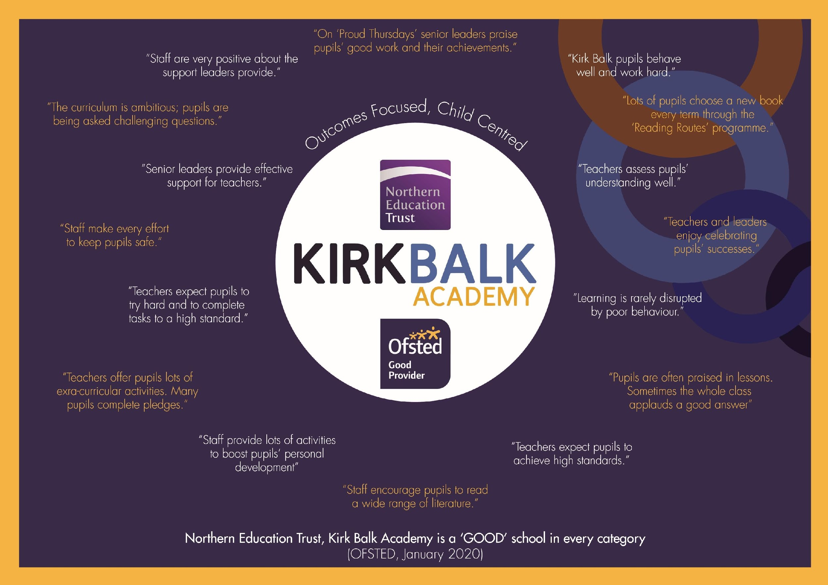

**Northern Education Trust**

**Our Vision**

We constantly focus on standards as we understand outcomes are paramount. Our decision making is driven entirely by what is best for children. By doing this we enhance the life chances of the children and young people in our care.

**The 10 values which underpin our vision:**

1. We care passionately about the education and welfare of young people
2. We believe that all young people, irrespective of background or ability will be successful in our Trust
3. We are not and will never be selective. We believe that local schools are for all children
4. We are always inclusive. Our mechanisms to support the most vulnerable child to succeed and overcome barriers to learning are a key aspect of our work
5. Our approach to education recognises that outcomes are paramount and also allows children to gain experiences and values which prepare them fully for life in modern Britain. This includes workplace skills and appropriate advice for future progression
6. We have high expectations of behaviour
7. We adopt the local authority admissions protocol and work closely with them
8. We would always wish to act in such a way that has a positive effect on a neighbouring school or community. We care passionately about children in all schools, not just our own
9. That all employees act with integrity and embrace the value that ‘we are the Trust’
10. We work regionally and nationally to develop approaches to MAT improvement that influence the wider school-led system

**Staff and Students**

The leadership of Northern Education Trust Kirk Balk Academy is undertaken by the Principal, Mr Dean Buckley who is supported by a team of senior leaders including Vice Principals, Assistant Principals, Associate Assistant Principals and a Business Manager.

The staffing structure and curriculum are constantly being reviewed but departments are primarily suited in faculties, with TLR holders supporting the Heads of Department. Non-teaching ‘Learning Managers’ leaders help support the well-being and pastoral development of all students.

We believe teachers’ work best when they are focused on the progress of their students and not on dealing with distractions. Therefore, we have a no office rule during the academy day for all senior leaders to ensure they are on hand to support teaching staff. Senior leaders, alongside support staff, visit lessons to support behaviour management (with a particular focus on praise), live marking and assist teaching. In addition, our detailed and well managed behaviour policy supports teachers in establishing an excellent climate for learning.

Senior leaders are also on duty every morning, break, lunch and after school. This enables the academy to reduce staff duties to a minimal again free staff to focus on teaching and learning.

There are currently 1315 students on roll. The admission number for each year group is 270. The clear majority of our students live in the local villages, come from a wide range of backgrounds and cover the full range of ability – a truly comprehensive intake. The students are well behaved and attendance is very good.

In addition to being ‘’Outcomes Focused, as an academy we are also ‘child centred’. As such we have a vibrant Student Voice programme which ensures that all students are represented in decisions which affect their education.

Dedicated Student Voice teams are chosen to represent different areas of school life, these include; Teaching and Learning, Safeguarding and Hospitality. Students apply to represent their chosen area and meet regularly with a dedicated staff facilitator. Student Voice representatives regularly present to the Senior Leadership Team and have played an important role in developing school policies on rewards and praise, as well as representing the academy with distinction at social events and academy events.

**Enrichment**

Our intent is to deliver a student learning experience which is appropriately challenging and meets the needs of individual students. We are proud of our wider enrichment offer, open to all students, which allow students to access a range of activities designed to broaden horizons and to equip our students with the confidence to face the future.

We offer students across all year groups the opportunity to develop their knowledge, skills and interests through an extensive provision of extended learning and diverse enrichment. A multitude of subject specific and special interest enrichment groups are held during after school enrichment time. These range from Sporting and Drama Clubs to Coding, Creative Writing and STEM club. These also include a raft of bespoke enrichment subject sessions available to students in Year 10 and Year 11.

We offer intensive intervention for identified students to ensure all individual needs are met. Students to join the school in Year 7 who are not at age related expectation for reading are afforded additional reading based library lessons in which they are provided with weekly one-to-one reading opportunities, with their progress being measured through both the testing of reading age as well as through the number and range of books they have read.

Identified students in Year 10 and Year 11 are also afforded a range of intensive interventions, including access to one-to-one Maths and English tutor sessions. These interventions support progress in the core subjects as well as supporting progress across the curriculum by helping students to access topics and develop understanding in all subjects.

We recognise that our staff are committed to supporting the life chances of young people through raising outcomes and dedicate time after school to run enrichment opportunities. We wish to celebrate and reward their commitment. Each term, departments who have ran enrichment programmes for students, are provided money and time to take part in a team building activity of their choice. Staff have enjoyed a range of activities such as: escape room experiences, sport events, meals out, theatre trips and staff quizzes.

**The Application Process**

All details, including the Application Form, Job Description and Person Specification can be found on our academy website: [kba.northerneducationtrust.org](http://kba.northerneducationtrust.org)

We would expect that all prospective candidates spend some time reviewing our website where a vast array of further information about our Academy exists. However, should you require any additional information about this post or would like an informal discussion/visit, please contact us on telephone number 01226 742286 or email [kirkbalkhr@northerneducationtrust.org](mailto:kirkbalkhr@northerneducationtrust.org).

Informal visits are welcome before the closing date – please see the specific job advertisement for further details. For further information and an application form for the post, please contact us as above.

To apply, please email your completed application and recruitment monitoring form to Chloe Garland, Trainee HR Advisor, at c.garland@northerneducationtrust.org

All applications that have been submitted electronically will receive an email from the recruitment team confirming receipt. A letter will be sent to shortlisted candidates with details of the interview process.

If you have not heard from us within 2 weeks of the closing date, please assume your application has been unsuccessful.

Kirk Balk is committed to safeguarding and promoting the welfare of children and young people and expects all staff and volunteers to share this commitment. This position is, therefore, subject to a satisfactory enhanced Disclosure and Barring Service application. We are an Equal Opportunities employer with excellent CPD provision.

If you have any queries on any aspect of the application process, or need additional information, please contact Chloe Garland on [0191 406 6383](tel:01914066383) ext.4032 or by e-mailing [c.garland@northerneducationtrust.org](mailto:c.garland@northerneducationtrust.org)

**Where to Find Us**

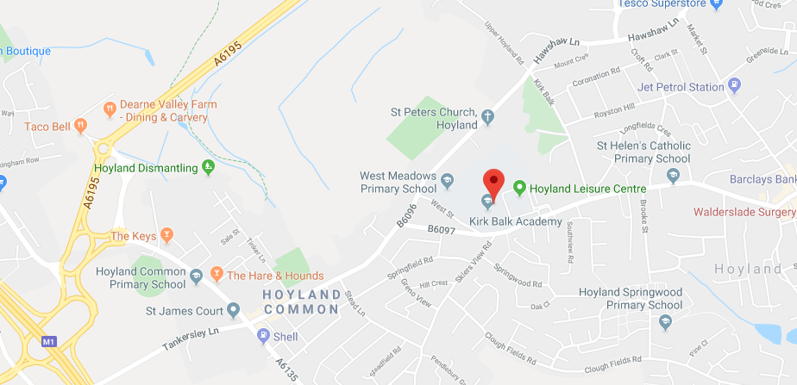

**Directions to Kirk Balk Academy**

From Junction 36 of the M1 motorway, at the initial roundabout follow signs to Barnsley. At the second roundabout take the turning towards Hoyland [A6135]. You will pass a Jet petrol station on the left and a Primary School on your right. After the pedestrian crossing, turn left at the traffic lights. You will pass the

Co-op supermarket on the left. Continue until see Hoyland Police Station on your right, take the next right-hand turn signposted Hoyland. You are now on West Street. As you approach the

Academy, there is Hoyland Leisure Centre and a bus stop shelter on the left. Turn left into the

car park that we share with the Leisure Centre (just before the bus shelter) and then sharp left up the drive to the Academy and into a further car parking area.

**Contact Details**

Kirk Balk Academy

West Street

Hoyland

S74 9HX

**Phone:** 01226 742 286

**Email:** [kirkbalk.enquiries@northerneducationtrust.org](mailto:kirkbalk.enquiries@northerneducationtrust.org)

**Web:** <https://kba.northerneducationtrust.org>

**Vice Principal**

**Full Time, Permanent**

**L18-22**

We are truly excited to be able to present to you this exceptional and career defining opportunity to join our wonderful academy as our new Vice Principal.

Required from April 2022, we are looking for forward-thinking, hardworking and can-do leaders who understand our vision of being ‘Outcomes Focussed, Child Centred’. The specific areas of responsibility will be tailored to the strengths and interests of the candidate and the needs of the academy.

The appointed candidate will be an exceptional teacher. They will blend a track record of successful leadership experience as well as demonstrating that they have the capacity to manage a complex and wide-ranging remit. This is an exciting opportunity to lead a substantial portfolio and would be excellent preparation for further career progression in a few years’ time.

Visits to the academy are strongly recommended. Please email [kirkbalkhr@northerneducationtrust.org](mailto:kirkbalkhr@northerneducationtrust.org) to book your visit.

The closing date for this post is noon**Monday 31st January 2022. Interviews are then scheduled to take place soon after this date.**

*Northern Education Trust is committed to safeguarding and promoting the welfare of children and expects all staff to share that commitment. The appointment is subject to an enhanced DBS check and references.*

**Job Description**

|  |  |  |  |
| --- | --- | --- | --- |
| **Job Title:** | Vice Principal | | |
| **Base:** | Kirk Balk Academy | | |
| **Reports to:** | Principal | **Grade:** | L18-22 |
| **Service responsibility:** |  | **Salary:** |  |
| **Additional:** | Permanent. Regular travel will be required. | **Term:** | Full Time |

**JOB PURPOSE**

* To provide; high quality Leadership and Management commensurate with the needs of the Academy and Trust
* Carrying out the professional duties of a teacher as circumstances may require and in accordance with Academy policies, under the direction of the Principal
* Promoting the achievement of high standards through effecting teaching and learning within subject area(s), preparation, evaluation and action planning
* Being central in the delivery of the ECM agenda, paying regard to the provision of personalisation for students
* Modelling the vision and values of the Academy
* Being part of the team driving the development of the Academy and Trust to become an ‘outstanding’ Academy
* Receiving and acting on feedback to build on the strengths and improve personal performance within the Academy systems
* Contributing, where appropriate, to implementing policies and practice and to promote collective responsibility for their implementation
* Taking into account and constantly reviewing Academy contextual factors and prior attainment when planning and teaching lessons
* Working in a cross-curricular way to support subjects across the Academy in the use of active learning approaches to enrich curriculum and skills delivery
* Recognising, promoting and celebrating diversity

**JOB SUMMARY**

1. Supervision and progress of students in allocated classes
2. Supervision of work of any classroom support staff during times they are allocated to classes

**Develop and sustain DEEP LEADERSHIP across the Academy through:**

1. Be accountable for student progression for allocated classes
2. Be responsible for effective classroom management
3. Co-ordinate class work with any classroom assistant support
4. Develop and sustain knowledge of current educational practices and be responsible for own continuing professional development
5. Evaluate lessons, incorporating students’ views and responses in order to reflect and act on strengths and areas for development
6. Contribute to the self-evaluation systems in the Academy
7. Develop policies for departmental handbooks
8. Aide in co-ordinating events and experiences which support the Academy to raise standards

**Develop and sustain DEEP LEARNING across the Academy through:**

1. Work to student targets and ensure that progress is tracked through a range of strategies
2. Take account and review Academy contextual factors and prior attainment when planning and teaching lessons
3. Reflect on the success of teaching strategies, individual lessons and SoW in meeting the needs of students
4. Apply current guidelines on effective learning and teaching
5. Take part in coaching and mentoring programmes to support colleagues and develop own practice
6. Apply and expand teaching repertoire and feedback to colleagues on effectiveness
7. Strive to deliver outstanding lessons
8. Deliver interactive lessons with students
9. Provide good quality assessment using formative and summative methods in conjunction with the Academy’s AfL policy
10. Record test results and ongoing teacher assessments, keep portfolios of evidence

**Develop and sustain DEEP EXPERIENCE across the Academy through:**

1. Have responsibility for developing and implementing SoW.
2. Be responsible for identifying and reporting issues and developing solutions
3. Be responsible for the day to day delivery within subject area, including assessment and reporting process
4. Develop communications and training with staff in Department/methodology
5. Develop use of ICT within the curriculum
6. Provide means of gathering information for Self Evaluation: Student Voice, questionnaires, viewpoints of stakeholders and use opportunities for co-construction of the curriculum
7. Take responsibility for planning and execution of Immersion Days
8. Adapt lessons and identify next steps in response to evaluation of student progress
9. Set effective homework and extension work to encourage and enliven student learning
10. Ensure differentiation and personalisation of learning for all students
11. Be aware of the KS2 curriculum and the standards of progression and attainment for KS3 students
12. Co-ordinate displays with regards to events, opportunities and work which promote the Department/Academy

**Develop and sustain DEEP SUPPORT across the Academy through:**

1. To comply with the Academy’s Child Safeguarding Procedures and to report concerns to the Designated Child Protection Officer
2. Take responsibility for upholding standards of behaviour and classroom management within the classroom and the Academy’s environment
3. Through the role, develop systems which address the social health of students to raise standards
4. Promote the consistent and fair use of the Expectations for Learning system within the classroom and the Academy environment
5. Be the first line of contact for parents and carers concerns with regards to their child’s performance and well-being
6. Perform the duties of a Vertical Mentor Tutor if required, including the provision of information, advice and guidance for students

This job description will be reviewed annually and may be subject to amendment or modification at any time after consultation with the post holder. It is not a comprehensive statement of procedures and tasks, but sets out the main expectations of the Academy in relation to the post holder’s professional responsibilities and duties. Elements of this job description and changes to it may be agreed at the request of the Principal or the incumbent of the post.

Post holders will be expected to comply with any reasonable request for a senior leader to undertake work of a similar level that is not specified in the job description.

**GDPR**

1. To adhere to GDPR and Data Protection Regulations, whilst maintaining confidentiality

**General**

1. To participate in wider Trust meetings and working groups as required

Whilst every effort has been made to explain the main duties and responsibilities of the post, each individual task undertaken may not be identified and the post holder may reasonably be expected to undertake other duties commensurate with the level of responsibility that may be allocated from time to time

NET is committed to safeguarding and promoting the welfare of children and young people. We expect all staff to share this commitment and to undergo appropriate checks, including an enhanced DBS check.

Signed: …………………………………… Date: ……………………………….

**Person Specification**

**Northern Education Trust**

Post: Vice Principal

**PERSON SPECIFICATION**

|  |  |  |  |  |
| --- | --- | --- | --- | --- |
|  |  |  | **Assessed by:** | |
| **No** | **Categories** | **Essential / Desirable** | **App Form** | **Interview / Task** |
| **QUALIFICATIONS** | | | | |
| 1. | Degree | E |  |  |
| 2. | QTS | E |  |  |
| 3. | Recent participation in relevant professional development | E |  |  |
| 4. | Master’s degree or equivalent | D |  |  |
| 5. | Evidence of further professional development in the Leadership and Management of whole Academy improvement | D |  |  |
| **EXPERIENCE** | | | | |
| 6. | Successful and effective leadership in raising achievement and attainment | E |  |  |
| 7. | Effective leadership and management of change | E |  |  |
| 8. | Successful teaching experience at Key Stages 3 and 4 | E |  |  |
| 9. | Effective leadership of a team | E |  |  |
| 10. | Teaching experience at Key Stage 5 | D |  |  |
| 11. | Leadership of a subject / year team | D |  |  |
| 12. | Leadership of the development of literacy or numeracy | D |  |  |
| 13 | Developing classroom practice to meet the needs of all learners including those who are most able and those who are DSEN | D |  |  |
| 14. | Experience of managing a significant budget | D |  |  |
| **ABILITIES, SKILLS AND KNOWLEDGE** | | | | |
| 15. | Experience of using assessment data to identify underachievement and lead successful intervention strategies | E |  |  |
| 16. | High level interpersonal skills | E |  |  |
| 17. | Ability to lead effective student achievement and intervention programmes | E |  |  |
| 18. | A clear vision and understanding of ways to remove barriers to learning | E |  |  |
| 19. | Ability to communicate effectively in a variety of situations | E |  |  |
| 20. | The ability to build and sustain effective working relationships with staff, students, Governors and parents / carers | E |  |  |
| 21. | Ability to plan strategically | E |  |  |
| 22. | Knowledge of current thinking in promoting the attainment of able students | D |  |  |
| 23. | Knowledge of current thinking in utilising latest technologies to promote learning | D |  |  |
| 24. | Knowledge of how to use Pupil Premium funding to bring about sustained improvement | D |  |  |
| 25. | Experience of working within the Senior Leadership Team | D |  |  |
| 26. | Experience of reporting to Governors | D |  |  |
| **PROFESSIONAL DEVELOPMENT** | | | | |
| 27. | Commitment to own professional development | E |  |  |
| 28. | Evidence of leading successful staff development and training | E |  |  |
| 29. | Evidence of recent training and development | D |  |  |
| **PERSONAL QUALITIES** | | | | |
| 30. | Pleasant and friendly manner | E |  |  |
| 31. | Polite and punctual | E |  |  |
| 32. | Reliable | E |  |  |
| 33. | A commitment to working as part of the whole Academy team and supporting the vision and aims of the Academy | E |  |  |
| 34. | Commitment to lifelong learning | E |  |  |
| 35. | Flexibility and adaptability | E |  |  |
| 36. | Ability to demonstrate personal initiative and independent thinking, whilst working in a team environment | E |  |  |

NET is committed to safeguarding and promoting the welfare of children and young people. We expect all staff to share this commitment and to undergo appropriate checks, including an enhanced DBS check.

**Chief Executive: Mr R Tarn**

Northern Education Trust

c/o Thorp Academy

Main Road

Ryton

NE40 3AH

**Phone:** 0191 406 6383

**Email:** public.enquiries@northerneducationtrust.org

**Web:** www.northerneducationtrust.org