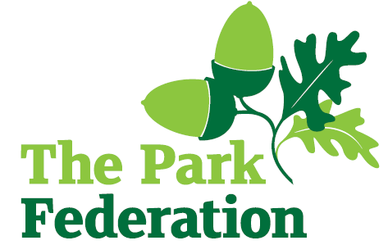
Vice Principal

Salary (actual): £53,880 - £59,332
Grade: L8 – L12
Hours: Full time
Contract: Permanent
Start: As soon as possible

Montem Academy has a wonderfully diverse community, which comprises of pupils and adults from a wide range of nations, ethnicities and cultures. We celebrate this diversity and believe it is a key strength of our academy. We offer all children an education in a safe, calm, inclusive and stimulating environment where evefy child is valued as an individual. We aim to nurture well-rounded, respectful and confident children who will develop skills for life-long learning.
Montem Academy is part of The Park Federation Academy Trust. The federation educates and cares for 4,000 children across West London and Slough. The Trust is an approved Sponsor Academy for the Department for Education. Montem Academy wishes to appoint an ambitious and highly motivated Vice Principal to join our Senior Leadership Team.
The successful candidate will play an important part in the school’s next stage of development and will be responsible for a Key Stage phase of the school. The phase will be allocated based on the skill set of the person appointed.
We are looking for an individual who:
- passion for the leadership of teaching and learning
- a proven track record of securing and maintaining high standards and excellent progress
- the ability to produce and analyse data and use it to inform teaching and learning
- a reflective mind-set and be committed to continual improvement.

For the right candidate, we will offer
- extensive support and CPD;
- the opportunity to work with other professional colleagues across the Multi-Academy Trust;
- a welcoming school, with friendly, enthusiastic and supportive staff team;
- an ambitious and dynamic Senior Leadership Team;
- a dedicated Governing Body;
- supportive parents and children who are keen to learn;
- an employee assistance programme (EAP).

We welcome visits to see us working and learning. To make an appointment, please contact Raf Nowotynski on 01753 528050 or email rnowotynskima@theparkfederation.org
Please visit the school website for an application pack.

Closing Date: 5th December 2022
Interview Date: Week commencing 12th December 2022

The school is committed to safeguarding and promoting the welfare of children and young people and expect all staff and volunteers to share this commitment. The successful applicant will be required to undertake an Enhance DBS Check with a check of the BDS Barred List.

