Dear Candidate,

Vice Principal – 0.5, substantive
Start date – September 2024

Thank you for expressing an interest in the position of Vice Principal at St Teresa’s Catholic Primary School. The vacancy has arisen due to the current Deputy Headteacher retiring.

St Teresa’s is a mixed Catholic Primary school of 210 pupils, with 30 pupils in each year group. St Teresa’s serves families within the Diocese of Clifton including parts of Bristol and South Gloucestershire. Our core mission is to provide a Catholic education that inspires our school family to excellence in all our God given talents, where we let our lights shine for all to see!

Our school vision is ‘Inspiring each other to excellence, in the Light of Christ’.

The school received a Section 8 Ofsted inspection, in February 2023.

89% of our children are of Catholic background. There is a higher than average number of pupils who are from black and minority ethnic groups, 74% in 2022/2023, and 54% of our pupils have English as an Additional Language. 12% of pupils are known to be eligible for Free School Meals (Pupil Premium), which is lower than the National average.

Performance across the school is good or better and by the time children leave school at the end of Year 6, their attainment in all subjects (reading, writing and maths) is ‘significantly above average’ (ISDR Report 2023).

The Governors are seeking to appoint a, dynamic, motivated, creative and inspirational successor. The successful candidate will be a practising Catholic who can build upon the strong links within our 2 parishes and wider community and who can continue to drive our school to be outward facing, work collaboratively with the other schools in our diocese and local community and overall promote best practice. You will need to be dedicated to achieving high educational standards and have experience across the primary age range, have a strong visible presence throughout the school and its community and be able to nurture good and effective working relationships with parents, governors and other key stakeholders.

If you think this is you then we would love to hear from you. To apply, please submit a letter of application that details your personal philosophy of Primary Education, why you want to work at St. Teresa’s, what you can offer the school and how you would fulfil the requirements of the person specification together with a completed CES application form.

Please find enclosed the following:
- Job Description
- Personal Specification
- CES Application Form

As part of the selection process you are now requested to complete the application form and return it together with a letter of application and any references you may wish to include. Your letter should state:
- your reasons for applying for the Vice Principal post at St Teresa’s
- a summary of your beliefs about Catholic education and its enhancements
- what vision and type of leadership you believe you would bring to our school
- your views as to what constitutes an effective Vice Principal

The completed documents should be marked for my attention and returned to St Teresa’s school at the above address, to arrive no later than 1pm on Monday 22 April 2024.

Visits to the school prior to application are encouraged. Please contact the school office on 0117 9030412 to let them know if you would like to attend.

As stated in the advert, the closing date for applications is Monday 22 April at 1pm. Interviews are planned for Tuesday 30 April 2024. For your information, we became an Academy in December 2012 and joined the Cardinal Newman Educational Trust in March 2022.

Thank you once again for your interest in being Vice Principal at St Teresa’s, I wish you well in your application and look forward to receiving your correspondence.

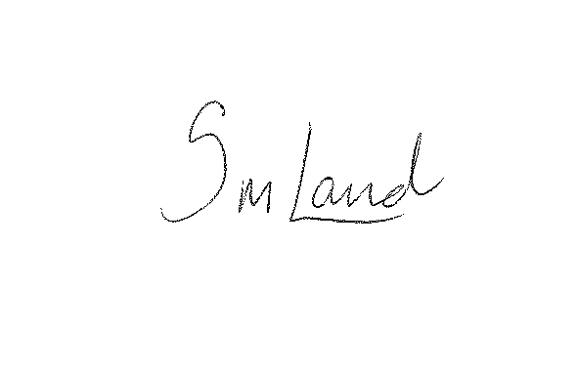
Yours sincerely,

Samantha Land
Executive Principal

