Candidate Information Pack

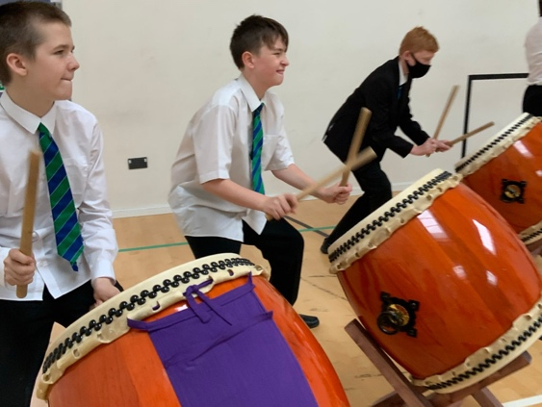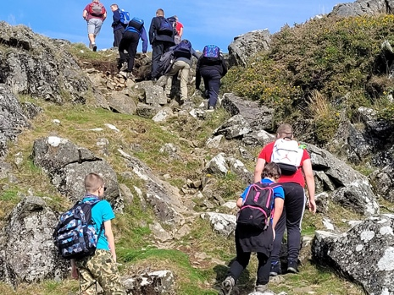

Work Related Learning
Co-ordinator

Closing date Midday Friday 16th June 2023
Interviews w/b Monday 19th June 2023.

A Message from the Headteacher
Thank you for requesting an information pack for the post of
Work Related Learning Co-ordinator
A warm welcome to Brook Green Centre for Learning, we are an 11 – 16 special school for young people with Cognition and Learning Difficulties and associated SEMH. The school was built in 2008 and designed for 84 students we currently have 102 students on roll and an average class size of 10 with one teacher and a range of Teaching and Learning Assistants. Our students come from across the city and from the surrounding areas. Our school provides our students with a sense of community.
Our amazing young people are best described as having complex learning difficulties and disabilities (CLDD) with a condition for admission that all children have ‘Low’ cognitive ability (MLD) and are working well below age related expectations. A Local Authority ‘Single Multi Agency Panel’ refers children on these criteria, and all have Education Health and Care Plans. Additionally, many of our students have SEMH needs but may also have ASD, Speech, Language and Communication Needs and / or other neuro-developmental or medical needs. There has been a significant increase in the number of students with an ASD diagnosis in the last 36 months. Students come from a range of schools on entry but the majority are from a special primary school with a minority joining from mainstream schools. Less than 10% of students are independent travellers to school.
We include therapeutic support from speech and language therapists, an occupational therapist, CAMHS worker and counsellors in our provision to better meet the holistic needs of our young people and therefore impact upon student progress. We have a regular clinic on site with a Paediatrician to review student needs. We also work closely with the school nursing team and with our Educational Psychologist.
We offer a range of in-house therapies, delivered by our Teaching and Learning Assistants including Playworx, ELSA, Let’s Talk Girls / Let’s Talk Boys, Construction Play, Music therapy and life skills.
Our curriculum is based on the secondary school model to enable inclusion to and from mainstream. Our students take GCSE, BTEC, Foundation Level and Entry Level Pathway qualifications and the Duke of Edinburgh award. At the end of Year 11 our students either transfer to a College of Further Education, a specialist provider or to a mainstream sixth form with appropriate provision. The range of provisions which our students access Post -16 has become more diverse and bespoke in recent years due to the varying needs of our students.
Our school website provides a real insight into our school and will help you get a flavour of who we are – a visit will bring this to life for you.
Brook Green Centre for Learning is a truly unique place to learn and to work and if you feel you would like to join our thriving and happy school community in this exciting new post, we really would like to hear from you.

Best wishes
Sara Jordan

Job Description
Post title: Work Related Learning Co-ordinator
Responsible to: Assistant Headteacher - Preparing for Adulthood
Salary: Grade E
Hours: 37 hours x 39 weeks
Main purpose
As Work-Related Learning Co-ordinator under the direction of the Assistant Headteacher you will:
Responsibilities

- Plan and arrange year 10 and year 11 work experience placements
- Liaise with and organise suitable Independent Training Provider placements and use of alternative provisions for our students
- Maintain up to date records on student placement allocations
- Complete requisition documentation - have a working knowledge of the cost per day per student for each of the providers or the cost of the course that they are on
- Support students and families with transport to provisions off the school site
- Advise students and parents on post 16 provisions and the application processes
- Liaise with CSW advisor with regards to post 16 applications and placements
- Support the Careers Leader with providing evidence for the Gatsby Benchmarks
- Record student employment encounters using Compass+, Student passports and Work Experience diaries.
- Maintain our student tracker
- Lead and support the delivery of Life Skills programme at KS4
- Attend KS4 EHCP’s reviews
- Lead on Independent Travel training to aid students in getting to placements
- Maintain provision of travel vouchers
- Plan and support ‘Year 11 Transition Days’ with students where required
- Contribute to multi agency review documents

Please note that this is illustrative of the general nature and level of responsibility of the role. It is not a comprehensive list of all tasks the Work Related Learning Co-ordinator will carry out.
The post holder may be required to do other duties appropriate to the level of the role, as directed by the Headteacher.

Person Specification
We will use this person specification as the selection criteria for the post, gained from application, references and interviews
Qualities | - Be a strong and positive role model to students, staff, parents and other members of the community  - Be prepared to go ‘the extra mile’ to do what it takes to continually improve Brook Green Centre for Learning  - Understand the importance of having a good work/life balance.  - Be able to meet deadlines  - Be able to work under regular and sustained pressure whilst demonstrating high quality work and decision making  - Remain open to suggestions and be open minded in your general approach  - Be prepared to develop both personally and professionally  - Developing a strong network of partners locally and regionally  - Be forward thinking  - Be able to prepare ideas and initiatives thoroughly, present them articulately.  - Understand the importance of both initiating and completing tasks whilst understanding how to consult appropriately  - Be motivated, curious and have a passion to facilitate excellent education, interactions, experiences and relationships with students who can challenge
Experience and Job knowledge | - Experience of working with students with additional needs  - Experience of working with disengaged students  - Experience of post-16 provision in and around Plymouth  - Knowledge of how to inspire students to raise their own self expectation and aspirations  - Experience of using ICT  - Experience of producing maintaining accurate records and producing clear and accurate reports  - Experience of working under pressure and meeting deadlines.  - Evidence of Continual Professional Development
Essential  Job Related Abilities | - Good communication skills  - Good attendance record  - Ability to work closely within a team  - Ability to maintain confidentiality  - Ability to work within school policies  - Driving licence
Desirable  Job Related Abilities | - Minibus licence  - Experience of Compass+  - Use Careers South West work experience database  - Classroom management experience  - Knowledge and understanding of the Gatsby Benchmarks and Provider Access Legislation

SAFEGUARDING
The safer recruitment of staff in schools is the first step to safeguarding and promoting the welfare of children in education.
Brook Green Centre for Learning is committed to safeguarding and promoting the welfare of children and young people and expects all staff and volunteers to share this commitment. It is recognised that this can only be achieved through sound procedures, good inter- agency co-operation and the recruitment and of competent, motivated employees who are suited to and fulfilled in the roles they undertake.
We implement robust recruitment procedures and checks for appointing staff and volunteers to ensure that reasonable steps are taken not to appoint a person who is unsuitable to work with children, or who is disqualified from working with children, or does not have the suitable skills and experience for the intended role.

