
Breakfast Club Work and After School Club Play Worker (Primary)
Applicant Pack

Contents
The vacancy 3
Post advert 3
Role summary 3
Job description 4
Specific duties and responsibilities 4
Support for the trust/school 4
Changes to these duties 4
Person Specification 5
Job Title: After School Club Play Worker (Primary) 5
Knowledge, experience and skills 5
Qualifications 5
Other skills 5
Interpersonal skills 6
Child protection 6
Stocksbridge Junior School 7
Chorus Education Trust 8
To apply 9

The vacancy

Post advert
Deadline for applications: | 11.59pm on 01.06.2025
Interviews to be held: | Week beginning 09.06.2025
To start: | September 2025

Stocksbridge Junior School is looking for a Play Worker to be responsible for the delivery of safe play care within a primary school setting.
Breakfast Club Worker:
We are looking for a caring and reliable Breakfast Club Worker to help provide a safe, welcoming environment where children can enjoy a healthy breakfast and prepare for the school day ahead.
After School Club Worker:
We are seeking a friendly and enthusiastic After School Club Worker to support the delivery of fun, engaging activities in a safe environment at the end of the school day.

Role summary
Post title: | Breakfast Club Worker and/or After School Club Play Worker (Primary) PLEASE INDICATE ON YOUR APPLICATION IF YOU WISH TO BE CONSIDERED FOR ONE OR BOTH ROLES
Profile: | LD 1
Grade: | 1
Grade spinal point range: | SCP 2
Salary: | Breakfast club worker - £22366 (pro rata £3303)  After school club worker £22366 (pro rata £6606)
Accountable SLT post: | School Manager
Line manager (if different): | Play Worker Co-ordinator
Staff to be supervised or line managed by post holder: | N/A
Post holder will work with: | Other teaching and support staff
Holiday and sickness relief: | Other support staff
Purpose of post: | To deliver play care in a safe and caring environment.
Version revised: | July 2022

Contract: | Temporary | Breakfast club worker - 7.5hours/38 weeks  After school club worker - 15/38 weeks  (will consider job share on a rota basis)

Job description
The post holder must at all times carry out their responsibilities within the spirit of the school and trust policies and within the framework of legislation relating to academies and education, with particular regard to the statutory responsibilities of the trust and the governing body of the school.
The specific duties and responsibilities include but are not limited to:

Specific duties and responsibilities
Main Duties and Responsibilities:
- The delivery of creative play opportunities in a safe and caring environment
- The provision of full care for the children including safe delivery to parents / carers
- Ensuring that refreshments are provided and meet the required standards of hygiene, health and safety
- Assist in the preparation of appropriate play activities
- Setting out, clearing away and maintaining materials and equipment required by the children
- Administering basic first aid as appropriate
- Encouraging parental support and involvement in play activities
- Maintain close liaison with parents and other extended services staff

Support for the trust/school
- Be aware of and comply with policies and procedures relating to child protection, health, safety and security, confidentiality and data protection, reporting all concerns to an appropriate person.
- Work in a flexible way to respond to the needs of the trust and to fulfil other duties and responsibilities appropriate to the grade and role as and when required.
- Be aware of and support difference and ensure equal opportunities for all.
- Appreciate and support the role of other professionals.
- Attend and participate in relevant meetings as required.
- Contribute to the overall ethos/work/aims of the trust/schools.
- Participate in relevant training, other learning activities and performance management as required.
- Team responsibilities: all staff are considered part of the overall trust team and may be required to provide assistance to colleagues in other areas from time to time commensurate with the role, skillset and grade.
- From time to time, to meet the needs of the trust, you may be asked but not expected to work hours additional to your normal working hours. The trust will give you as much notice as possible and you will be paid/recompensed for such work. Situations where this might be required are, for example: relevant key school events such as open evenings, exam results days, trips, clubs, training etc.

Changes to these duties
The above duties are not exhaustive and the post holder may be required to undertake tasks, roles and responsibilities as may be reasonably assigned to them by the Headteacher/Principal.
The job description and allocation of particular responsibilities will be kept under review and may be amended via consultation with individuals, the governing body or board of trustees and/or senior leadership team as required. Trade union representation will be welcomed in any such discussions.

Person Specification

Job Title: Breakfast Club Worker and After School Club Playworker (Primary)
REQUIREMENTS | Essential | Desirablee | Assessment method  A = application  I = interview  R = reference

Knowledge, experience and skills
Generic administrative experience to include word processing/typing, filing, collating, proof-reading of material, data entry and spreadsheet use, using Microsoft Office packages. | P |  | A
Customer services experience. | P |  | A
Working in a busy environment with many priorities and conflicting deadlines. | P |  | A / I
Experience of an education, training or similar environment. |  | P | A
Organisation and bookings for events. |  | P | A / I

Qualifications
Good level of literacy and numeracy eg GCSE Maths and English at grade 4 or above. | P |  | A
Evidence of regular, relevant and recent personal development. | P |  | A

Other skills
Communicate effectively with people at all levels eg school staff, students, governors and external contacts/ suppliers. | P |  | I
Work effectively as part of a team recognising own role as a team member. | P | P | A / I
Able to maintain a positive focus, accepting constructive criticism positively and learning from it. | P |  | A / I
Demonstrate an enthusiastic and positive approach regarding change, having a definite ‘can do’ mentality. | P |  | I
Ability to learn from experiences. | P |  | I
Ability to carry out instructions accurately and effectively as directed by line manager. | P |  | I
Demonstrate customer care. | P |  | A
Ability to work alongside young people (not necessarily in school environment). | P |  | A / I

Interpersonal skills
Ability to maintain confidentiality | P |  | A
Accuracy when receiving information (verbally and written) and communicate information effectively and accurately. | P |  | I
Able to make a positive contribution to the team. | P |  | A
Able to reflect on performance and further develop own knowledge and skills to improve performance. | P |  | I
Maintains standards set by the organisation. | P |  | I
Takes responsibility for own actions. | P |  | I
Ability to work alone unsupervised and manage own workload. | P |  | A / I

Child protection
A commitment to the responsibility of safeguarding and promoting the welfare of young people. | P |  | I

Stocksbridge Junior School
Stocksbridge Junior School strives for its children to have no limits to their ambitions and to aspire to reach their full potential. We prepare children for life-long learning, valuing the uniqueness of every child and providing for their needs within a safe, happy and caring environment in which everyone is equal and all achievements are celebrated.
Everyone at Stocksbridge Junior School aims to combine high standards with a broad and rich curriculum where education is the fusion of excellence and enjoyment. The curriculum is adapted to suit the needs of our pupils to ensure they are all ‘learning together’.
The school, situated to the north-west of Sheffield, welcomes 270 pupils through its doors, from Year 3 to Year 6.


In addition to trust-wide benefits for all staff, those at Stocksbridge Junior School also have access to:
- Supportive and friendly staff and leadership team.
- Free staff parking.
- Well equipped and comfortable staffroom.
You can view the school website at: www.stocksbridgejunior.chorustrust.org.

Chorus Education Trust
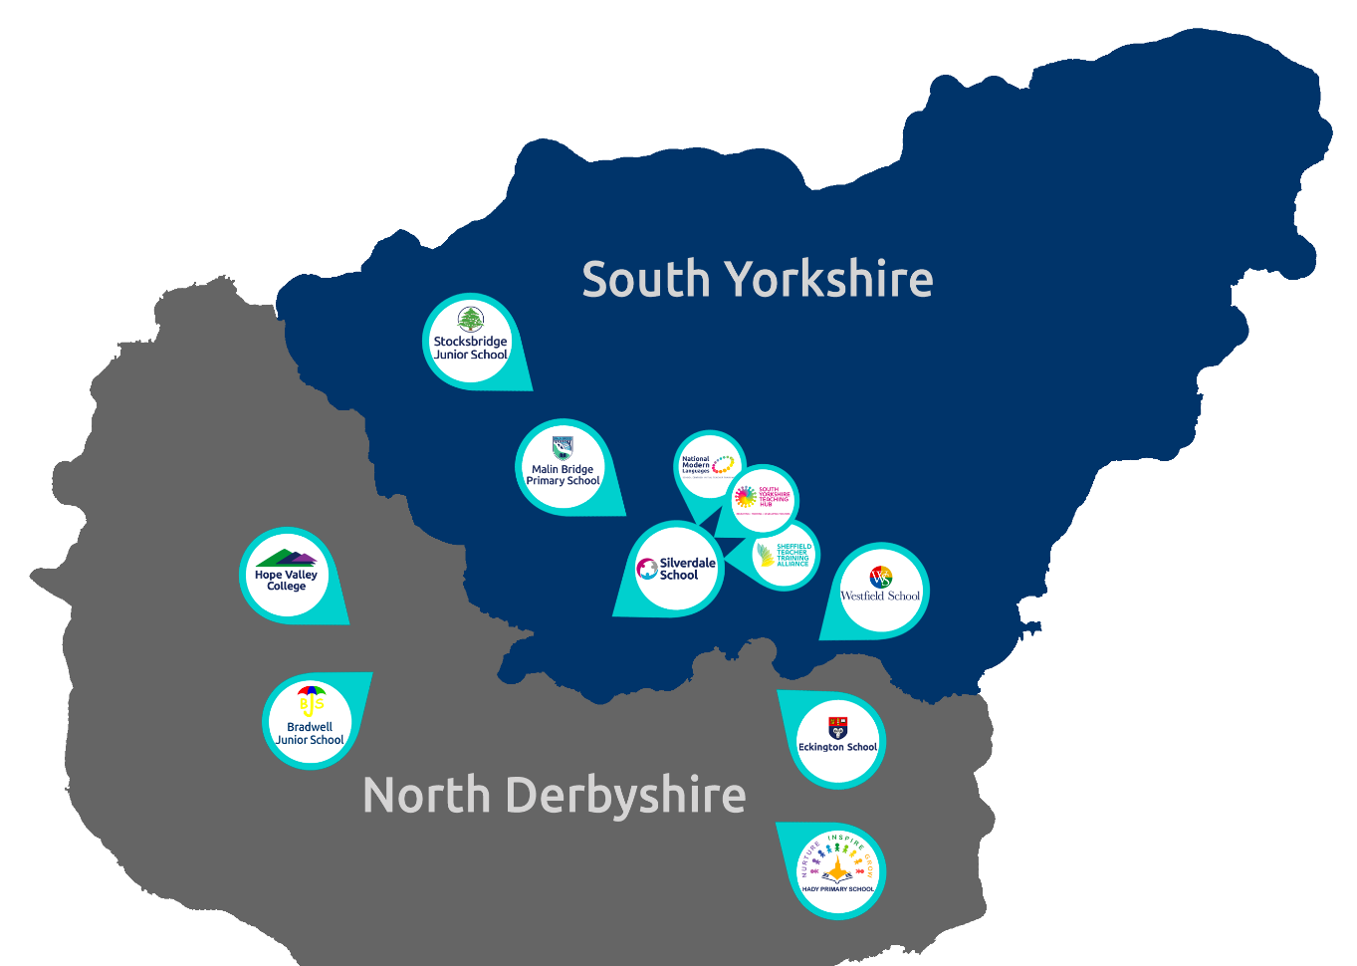
Chorus Trust is a growing trust, committed to providing every child with the best education in both primary and secondary schools across South Yorkshire and Derbyshire. We train and develop teachers, giving our children access to the very best educational thinking and practice.
Our vision is ‘Outstanding Achievement for All’. We want to create a culture of success in which our children and young people can succeed. We do this through the provision of safe and supportive schools, collaborating to ensure our children benefit from a more effective spend of public money.
As part of the Chorus Trust Team, all staff have access to:
 | An ethos of being a force for good; of being part of a team that enables ‘outstanding achievement for all’. |  | Leading edge training and development through the South Yorkshire Teaching Hub.
 | A collaborative environment encouraging knowledge sharing and support. |  | Discounted health schemes through Westfield Health and Westfield Rewards Schemes.
 | Competitive pension schemes: Teacher’s Pension Scheme (teaching staff) and local government pension scheme (support staff). |  | Term-time only contract postholders have the freedom of having school holidays off.
 | Career progression opportunities within a growing, local trust. |  | Support for flexible working arrangements.

You can read more about Chorus Trust at www.chorustrust.org.

To apply
- Full application pack and application forms available from: www.chorustrust.org/vacancies
- Completed application forms are to be sent to: Amanda Proost
at: aproost@chorustrust.org - Please indicate whether you are apply for role of Breakfast Club worker, After School club worker or both roles.
- Please note that CVs and council application forms will not be accepted.
- Deadline for applications: 11.59pm on 01.06.2025
- Interviews to be held: week beginning 09.06.2025.


Disability confident
Chorus Trust is part of the disability confident scheme. We guarantee to interview all disabled applicants who meet the minimum criteria for the vacancy.

Safeguarding
At Chorus Trust we are committed to the safeguarding of all our pupils, please visit our website to access our safeguarding and child protection policy at www.chorustrust.org/policies.
The trust will conduct an online search of the successful candidate in line with the DfE’s keeping children safe in education advice.
The successful candidate will be required to complete a Disclosure and Barring Service (DBS) check in line with the Rehabilitation of Offenders Act (ROA) 1974 (Exceptions) Order 1975 and the Police Act Regulations.

