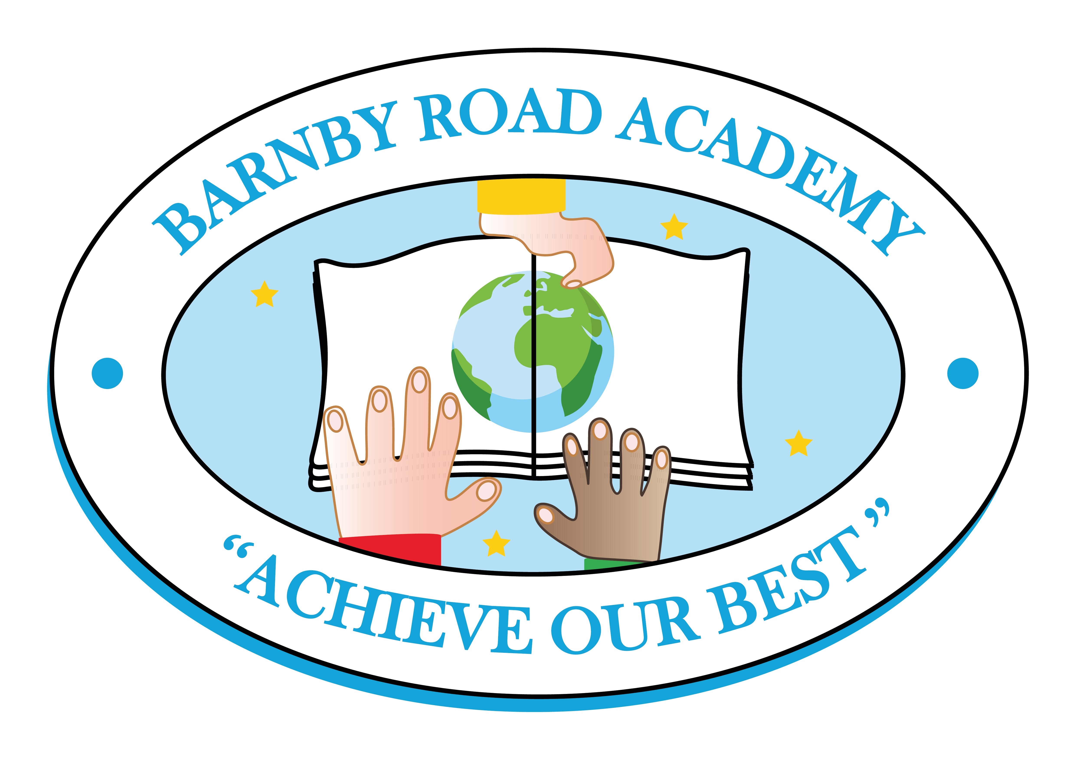
Barnby Road Academy
Person Specification – Year 1 Class Teacher

Essential | Desirable
Qualifications
- Qualified Teacher Status | - Evidence of commitment to continuing professional development
Experience
- Experience of teaching in the KS1 phase (This would be a successful placement for an NQT)  - Experience of working within a team | - Experience of the assessment procedures within KS1  - Experience of working with children with special educational needs/English as an additional language  - Experience of working with other adults in the classroom e.g. teaching assistants, students, parent helpers
Knowledge and Understanding
- A thorough knowledge of good/outstanding KS1 practice  - Knowledge and understanding of a broad, balanced and relevant curriculum  - A secure understanding of the processes by which children learn  - An ability to differentiate the curriculum to meet the needs of all children  - Competent use of ICT across the curriculum  - An understanding of the use of assessment to inform future learning and teaching  - An understanding of the importance of establishing positive behaviour and learning attitudes  - An understanding of how teaching assistants can enhance children’s learning and achievement  - An understanding of the importance of safeguarding children | - Knowledge of current developments in the national curriculum  - Knowledge and understanding of working with parents to develop a learning partnership  - Effective use of ICT to support planning and assessment
Personal Qualities
- A caring ethos  - Excellent communication skills  - Good organisational skills  - A commitment to working co-operatively  - Energy, creativity and passion  - A sense of humour  - An ability to embrace change with enthusiasm and a positive outlook  - A commitment to working in partnership with parents  - High expectations of self and others  - An ability to motivate and inspire children to achieve their best | - Expertise in a specific area  - A commitment to supporting all aspects of school life e.g. clubs, ‘Friends’ events

