Dollis Primary School

September 2024, Teacher information pack
for a Main Pay Range Teacher
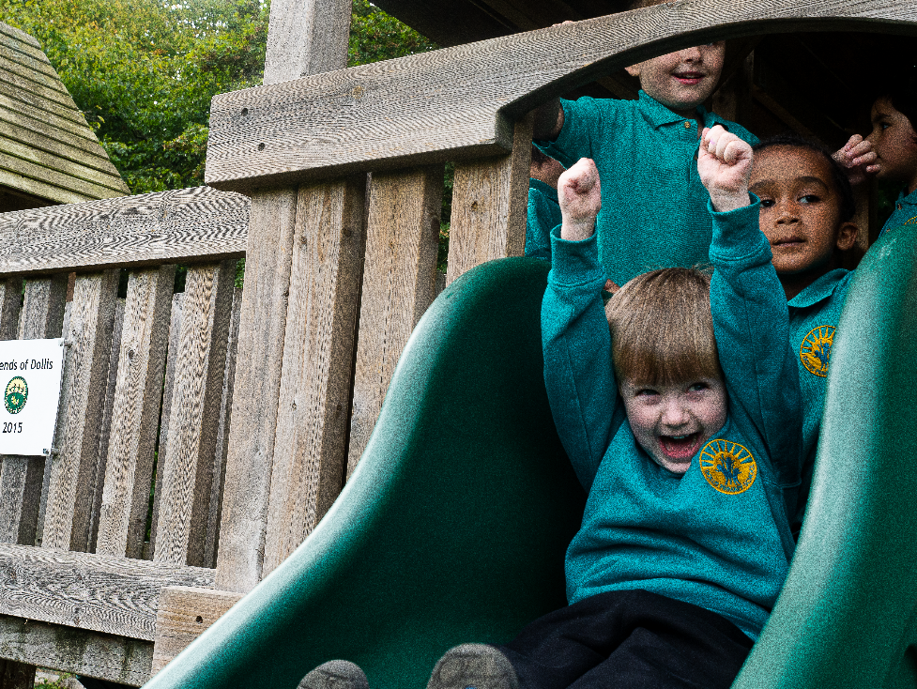

Dollis Primary School
Pursley Road, Mill Hill, London NW7 2BU
tel: 020 8959 8881. email: office@dollisprimary.com
www.dollisprimary.com
Headteacher: Rosetta Dyer
Deputy Headteachers: Anouska Sehmi & Steve Lee

Welcome from our Headteacher
June 2024
Dear Applicant,

Many thanks for your interest in the position of Teacher at Dollis Primary School. I hope that you will find this information pack a useful introduction to the role and that it will encourage you to apply for this exciting opportunity to join our happy school staff team.

Dollis Primary School is a welcoming two-form entry community school with a rich curriculum. Our vision is ‘Excellence in all we do: shaping attitudes, efforts and ambitions’. Graded ‘Good’ by Ofsted in 2023, we are excited about continuing our journey towards become an outstanding institution!

Reading is at the heart of everything we do. All of our classes are named after authors and we promote reading fluency, reading for pleasure and reading across the curriculum with passion and enthusiasm.

We are looking to recruit an experienced Key Stage 1 class teacher who is looking to further develop their skills and talents. We are looking for a hardworking, confident and resilient teacher who has the energy and skills to improve pupil outcomes for the community that we serve.

We are proud of our professional development programme, designed to suit teachers at different stages in their careers. It includes internal and external professional development, alongside coaching, mentoring, shadowing experienced staff in other settings and NPQs,

I strongly encourage you to visit the school, where you will see first-hand, our inclusive ethos and the great potential of our pupils. You are most welcome to visit Dollis during the weeks commencing 24th June and 1st July. Our Deputy Head, Steve Lee, will be your guide, and I would most certainly be delighted to meet you informally and answer any questions related to the role and the school community. Please contact Leana Hook, School Office Manager, on lhook@dollisprimary.barnet.sch.uk / 020 8959 8881 to arrange a convenient time.

I very much look forward to receiving your application.

Rosetta Dyer
Headteacher

Advert

Are you hardworking, friendly, enthusiastic and resilient with the energy, intelligence, skills and confidence to improve pupil outcomes for a diverse community? If yes – please apply to Dollis Primary School.

We are looking to recruit an outstanding primary teacher who will inspire our pupils to learn with enthusiasm; enjoy the raft of experiences from our irresistible curriculum and to flourish from their excellent outcomes.

The ideal candidate will:
- Have passion and enthusiasm for teaching children
- Be educated to degree level with QTS
- Love encouraging, motivating and inspiring children through the support they give in order to encourage their learning
- Be committed to our vision: Excellence in all we do: shaping attitude, efforts and ambitions
- Have great references demonstrating they are a suitable candidate, safe to work with children.

At Dollis we aim to:
- Encourage all our pupils to go beyond what they think they can achieve, to enjoy learning, helping them to lead healthy and happy lives
- Imbue our pupils with a broad and rich curriculum that includes, Compass for Life, UNICEF Rights of a Child, Mental Health, Sustainable Development Goals
- Ensure our staff are happy at work, taking pride in pupils’ progress and development
- Equip our staff to deliver their best every day
- Continue improving, developing and sharing their teaching and research with others
- Deliver training and guidance relevant to job role so expectations are understood and staff feel motivated.

Candidates who wish to visit our school are most welcome to do so. Your visit will include an informal chat with our Deputy Headteacher, Steve Lee. Please email our School Office Manager, Leana Hook at lhook@dollisprimary.barnet.sch.uk or call the school on 0208 959 8881 to organise a time to visit.

Candidate packs can be downloaded at www.dollisprimary.com/vacancies and completed forms should be returned to Leana Hook.

Closing date and shortlisting: NOON, Friday 5th July 2024.
Interview: Monday 8th July 2024

Teacher Job Description

Main Pay Range
The appointment of a Classroom Teacher is subject to QTS status and the current conditions of employment for teachers contained in the School Teachers’ Pay and Conditions Document (STCPD) and other current legislation.

Salary: £34,514 – £46,001 (Main Pay Range M1 – M6)
Hours: 32.5 hours per week
Contract type: Permanent from 1st September 2024
Reporting to: The Headteacher

Main purpose
The teacher will:
- Fulfil the professional responsibilities of a teacher, as set out in the School Teachers’ Pay and Conditions Document.
- Meet the expectations set out in the Teachers’ Standards.
- Be responsible for teaching and improving the progress, learning and attainment of a class of approximately 30 children.

Duties and responsibilities
Teaching
Aspire to be an exceptional teacher and lifelong learner.
Plan and teach well-structured lessons to assigned classes, following the school’s plans, curriculum and schemes of work.
Assess, monitor, record and report on the learning needs, progress and achievements of assigned pupils, making accurate and productive use of assessment.
Adapt teaching to respond to the strengths and needs of pupils.
Prepare resources in advance of teaching to enhance lessons and pupils’ access to the curriculum.
Set high expectations which inspire, motivate and challenge pupils.
Promote good progress and outcomes by pupils.
Demonstrate good subject and curriculum knowledge.
Participate in arrangements for preparing pupils for external tests.
Maintain a highly organised and tidy learning environment.
Monitor class work and homework, provide constructive feedback and set informed targets for pupil progress.

Whole-school organisation, strategy and development
Understand and follow the 0-25 SEN Code of Practice to support and plan for pupils with complex needs.
Contribute to the development, implementation and evaluation of the school’s policies, practices and procedures, so as to support the school’s vision and values.
Enforce the School’s Behaviour Policy.
Be committed to the school’s targets and monitoring system for pupil progress.
Make a positive contribution to the wider life and ethos of the school.
Work with others on curriculum and pupil development to secure coordinated outcomes.
Provide cover, in the unforeseen circumstance that another teacher is unable to teach.
Attend parents’ evenings at least 3 times a year to report on progress for every child.
Run a club for pupils for at least 6 weeks of the academic year (1 half term).

Health, safety and discipline
Promote the safety and wellbeing of pupils.
Maintain good order and discipline among pupils, managing behaviour effectively to ensure a good and safe learning environment.
Plan and organise class trips.
.
Professional development
Attend all weekly Professional Development Meetings (PDMs).
Take part in the school’s appraisal procedures.
Participate in further training and development in order to improve own teaching.
Participate in the appraisal and professional development of others, where appropriate.
Undertake research in line with the School Development Plan Priorities.

Communication
Communicate effectively with pupils, parents and carers.
Write and publish termly newsletters for parents and carers.
Write an annual report for all of the pupils in your class, which will be shared with your phase leader, Headteacher and Parents and Carers.

Working with colleagues and other relevant professionals
Collaborate and work with colleagues and other relevant professionals within and beyond the school.
Develop effective professional relationships with colleagues.

Personal and professional conduct
Uphold public trust in the profession and maintain high standards of ethics and behaviour,
within and outside school.
Have proper and professional regard for the ethos, policies and practices of the school, and maintain high standards of attendance and punctuality.
Understand and act within the statutory frameworks setting out their professional duties and
responsibilities.

Safeguarding
Be able to identify the DSL, Designated Safeguarding Lead and Deputy DSLs.
Work in line with statutory safeguarding guidance (e.g. Keeping Children Safe in Education,
Prevent) and our safeguarding and child protection policies.
Work with the Designated Safeguarding Lead (DSL) to promote the best interests of pupils, including sharing concerns where necessary.
Promote the safeguarding of all pupils in the school.

Person Specification
criteria | qualities
Qualifications  and experience | - Qualified teacher status  - Degree  - Previous experience working in a school  - Willingness to undertake CPD
Skills and knowledge | - Secure knowledge and understanding of the National Curriculum  - Knowledge of effective teaching and learning strategies  - A good understanding of how children learn  - Ability to adapt teaching to meet pupils’ needs  - Ability to build effective working relationships with pupils  - Knowledge of guidance and requirements around safeguarding children  - Good behaviour management skills and knowledge of effective behaviour management strategies  - Good ICT skills, particularly using ICT to support learning  - Ability to work as part of a team  - Awareness of the needs of children who speak English as an additional language and who have SEND.
Personal qualities | - Flexible, approachable, enthusiastic, resourceful and resilient.  - A commitment to getting the best outcomes for all pupils and promoting the ethos and values of the school  - Passionate about teaching and self-reflective  - High expectations for children’s attainment and progress  - Ability to work under pressure and prioritise effectively  - Commitment to maintaining confidentiality at all times  - Ability to anticipate workload and plan ahead  - Commitment to safeguarding and equality  - Ability to develop interpersonal relationships with children and staff.

Please note that this is illustrative of the general nature and level of responsibility of the role. It is not a comprehensive list of all tasks that the teacher will carry out.

The postholder may be required to do other duties appropriate to the level of the role, as directed by the Headteacher or line manager.

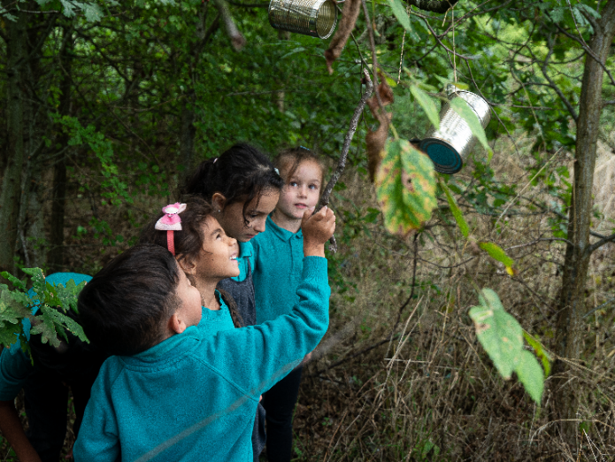
How to apply
- Read the Job Description and Person Specification very carefully

- Complete the Barnet Teacher application electronically. Make sure that your application form indicates the name and address of the school where you have most recently taught and the age group that you are currently working with (if applicable)

- Ensure that your accompanying supporting statement relates to the job description and person specification.

- Send your competed application form by NOON Friday 5th July 2024 to
to: lhook@dollisprimary.barnet.sch.uk
OR by post to
C/O Mrs Leana Hook
Teacher Application for September 2024
Dollis Primary School,
Pursley Road,
Mill Hill, Barnet
London NW72BU

- If you have been shortlisted, you will be informed by 4pm on Friday 5th July 2024 and your interview will be on Monday 8th July 2024. Please note these dates!

Meeting the National Teacher Standards

  - 1. Pupil Achievement and Standards

  - Standards
  - Promotes good progress and outcomes by pupils
  - Is accountable for pupils’ attainment, progress and outcomes.
  - Plans teaching to build on pupils’ capabilities and prior knowledge.
  - Guides pupils to reflect on the progress they have made and their emerging needs.
  - Demonstrates knowledge and understanding of how pupils learn and how this impacts on teaching.
  - Encourages pupils to take a responsible and conscientious attitude to their own work and study

  - Adapts teaching to respond to the strengths and needs of all pupils
- Knows when and how to differentiate appropriately, using approaches which enable pupils to be taught effectively.
- Has a secure understanding of how a range of factors can inhibit pupils’ ability to learn, and how best to overcome these.
- Demonstrates an awareness of the physical, social and intellectual development of
children, and know how to adapt teaching to support pupils’ education at different stages of development.
- Has a clear understanding of the needs of all pupils, including those with special educational needs; those of high ability; those with English as an additional
language; those with disabilities; and be able to use and evaluate distinctive teaching approaches to engage and support them.

- Makes accurate and productive use of assessment
- Knows and understand how to assess the relevant subject and curriculum areas, including statutory assessment requirements.
- Makes use of formative and summative assessment to secure pupils’ progress.
- Uses relevant data to monitor progress, set targets, and plan subsequent lessons.
- Gives pupils regular feedback, both orally and through accurate marking, and encourage pupils to respond to the feedback.

Performance Expectations
- Ensures all pupils taught are able to understand their capabilities and track their own progress.
- Works with the team to ensure that pupils have a conscientious attitude towards the subject and work hard at all times.
- Uses and applies information about each pupil’s needs Understands the learning needs of a wide range of learners including those with SEN, those of high ability, those with EAL and those with disabilities.
- Consistently makes secure and accurate assessments of pupils’ competencies and progress.
- Is highly effective in using assessment in lessons.
- Provides feedback to pupils and gives them opportunities to respond to this feedback.

2. The Quality of Provision

Demonstrates good subject and curriculum knowledge
- Has a secure knowledge of the relevant subject(s) and curriculum areas, fosters and maintains pupils’ interest in the subject, and address misunderstandings.
- Demonstrates a critical understanding of developments in the subject and curriculum areas, and promotes the value of scholarship.
- Demonstrates an understanding of and takes responsibility for promoting high standards of literacy, articulacy and the correct use of standard English, whatever the teacher’s specialist subject.
- If teaching early reading, demonstrates a clear understanding of systematic synthetic phonics.
- If teaching early mathematics, demonstrates a clear understanding of appropriate teaching strategies.

- Plans and teaches well-structured lessons
- Imparts knowledge and develop understanding through effective use of lesson time.
- Promotes a love of learning and children’s intellectual curiosity.
- Sets homework and plan other out-of-class activities to consolidate and extend the knowledge and understanding pupils have acquired.
- Reflects systematically on the effectiveness of lessons and approaches to teaching.
- Contributes to the design and provision of an engaging curriculum within the relevant subject area(s).

Performance Expectations
- Develops ways to encourage pupils to appreciate and be interested and engaged in the subject.
- Prepares and delivers consistently good lessons
- Promotes pupils’ love of learning and their intellectual curiosity
- Sets homework that is stimulating and fosters learning outside the classroom by incorporating innovative approaches.

3. Behaviour and safety of pupils

Standards

Sets high expectations which inspire, motivate and challenge pupils
- Establishes a safe and stimulating environment for pupils, rooted in mutual respect.
- Sets goals that stretch and challenge pupils of all backgrounds, abilities and dispositions.
- Demonstrates consistently the positive attitudes, values and behaviour which are expected of pupils.

Manages behaviour effectively to ensure a good and safe learning environment
- Has clear rules and routines for behaviour in classrooms, and take responsibility for promoting good and courteous behaviour both in classrooms and around the school, in accordance with the school’s behaviour policy.
- Has high expectations of behaviour, and establish a framework for discipline with a range of strategies, using praise, sanctions and rewards consistently and fairly.
- Manages classes effectively, using approaches which are appropriate to pupils’ needs in order to involve and motivate them.
- Maintains good relationships with pupils, exercise appropriate authority, and act decisively when necessary.

Performance Expectations
- Provides a stimulating learning environment through excellent, interactive classroom display.
- Supports other colleagues in their consistent application of the school’s data and tracking processes.
- Is a role model for adopting high expectations for all classes and groups.
- Supports colleagues in having high standards of professionalism and to support the team in being clear about the quality and standards they want to be known for.
