Vision, Aim and Values

The development of the whole child – Character Education– is central to the Morden Primary community. We are a nurturing school where positive relationships are core to all we do.
Education is most successful when there is a strong and positive partnership between home and school. At Morden we strive to provide challenging, relevant and exciting learning experiences. We have high aspirations for the children at Morden Primary and our vision is that we ensure we are preparing children to be successful in the ever-changing world and community they will grow up in.

National and international events have had massive implications for our community in the last few years. Our team are well informed of the impact these events have had on our school wider community and we are dedicated to supporting our children and families to ensure they have all the necessary resources and skills to succeed.

In the years since they were born, many of our children have seen the increased use of the iPad and widespread use of smartphones, literally putting knowledge into the hands of millions. The development curve of knowledge and technology and the impact on our lives means that we need to prepare for a future in which change might be rapid. The future potentially holds jobs that don’t even exist yet! To provide our children with a firm foundation for a lifetime of learning, we must equip them with the ability to learn and re-learn new skills and knowledge.

Team spirit is very much part of the ethos here and there are high expectations of staff, pupils and families to work cooperatively, to make a positive contribution to the life of the school and to give their best.

To this end, we are committed to:

• Encouraging and teaching the children to be kind human beings – to show respect by treating others as they’d like to be treated with a capacity to build and maintain relationships;
• Working as a team and being fully inclusive and teaching children to respect and value every individual – regardless of their gender, ability, ethnicity or religion – we celebrate diversity;
• Challenging children to have a good grasp of basic knowledge and skills – particularly in literacy and maths;
• Challenging children to take responsibility to develop their necessary skills (including beyond academic) to function effectively as local, national and global citizens;
• Developing creativity and the ability to problem solve;
• Encouraging children, through character education, to think for themselves; be responsible, cooperate, collaborate and be resilient to succeed.
Our aim is simply put through our school motto – Learn, Achieve, Enjoy: Reaching your personal best!

At Morden Primary our values underpin our vision and aim:

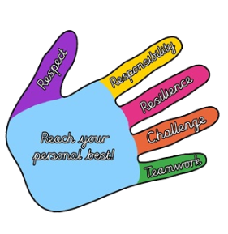
- Respect
- Responsibility
- Resilience
- Challenge
- Teamwork
Children are rewarded weekly for demonstrating these values and we encourage them to aim for the ‘high five’ or ‘go for five’.

