
About our School
The school was founded in 1731. Its long standing in the community has resulted in Morden Primary being established as a local, friendly school which holds a parent and school partnership most important as we feel this offers the best possible education for your child.
Over that time, the school has grown from a small infant school to a one form entry (3-11) Primary School. 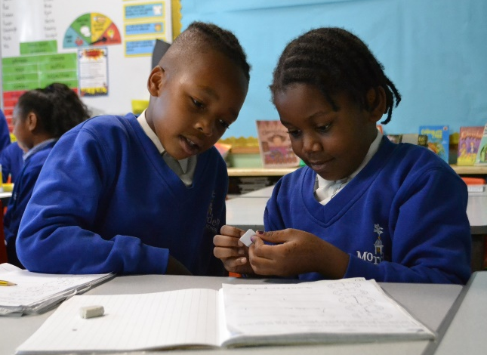
At Morden we believe children should reach their personal best through learning, achieving and enjoying.

“High levels of pastoral support are at the heart of the school community. Relationships between pupils and adults are respectful and warm, which helps pupils to feel safe. Parents and carers appreciate the school and consider it a family. They value the efforts that the school makes to support them and their children in a range of circumstances.
Ofsted 2024
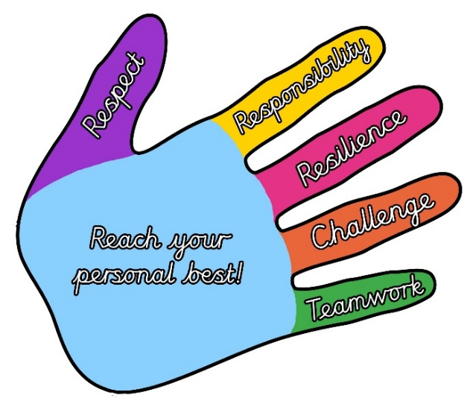

Vision & Values
We have high aspirations for the children at Morden Primary and our vision is that we ensure we are preparing children to be successful in the ever-changing world and community they will grow up in.
Our aim is simply put through our school motto – Learn, Achieve, Enjoy: Reaching your personal best!
At Morden Primary our values underpin our vision and aim:
- Respect
- Responsibility
- Resilience
- Challenge
- Teamwork
Children are rewarded weekly in assembly for demonstrating these values and we encourage them to aim for the “high five” values.
Hummingbird
At Morden, every child receives a hummingbird achievement card and can work towards earning stickers for demonstrating their personal best. Children aim to earn bronze, silver, gold and platinum certificates and badges. When a platinum hummingbird certificate and badge has been achieved, children work towards being awarded with a special hummingbird badge.
Why the hummingbird? In Native American culture, the hummingbird symbolizes hope for accomplishing that which seems impossible. Our hope is that every child who walks through our door accomplishes their personal best.
There are various ways for children to gain hummingbird stickers. Trying their best and demonstrating good work is one way children earn a Hummingbird sticker. Hummingbird stickers are given to those children demonstrating the Morden Values (Respect, Responsibility, Resilience, Challenge, Teamwork). At Morden we value children striving to be the best they can be.
Parental Involvement
We believe that the best possible experience for each individual child is achieved when home and school work together. The expectations of staff, parents and children are set out in our home school agreement which we ask parents to sign when your child starts at Morden and it is kept in their school record in the office.

Absence and Attendance
It is the responsibility of parents to ensure their children come to school. Absence other than for sickness is not allowed. We work closely with
the Merton EWO (Education Welfare Officer) to monitor children’s attendance.
Medical appointments, where possible, should be made after school hours or in holiday time. Family holidays should not be booked during term time. The Government’s guidance does not authorise holiday leave during term time.
Parents should phone the school on the first day of a child’s absence, and indicate why the child is absent and when they will be expecting their child to return.
Please see our website www.morden.merton.sch.uk for more detail on our attendance policy.


The School Day
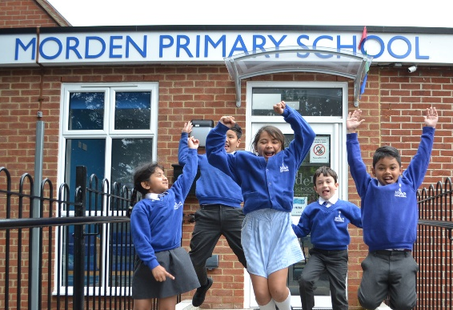
Children need to arrive at school on time in order to start their day in a calm, orderly way. A senior member of staff greets the children each morning. After this gate closes for the individual year groups, your child will be deemed late.
It is important that you collect your children on time at the end of the school day. Late collection may result in a childcare fee being charged.
For safety reasons, we will not allow a child to leave school with an adult we do not know or with a sibling under 16 years old. It is important that the office is informed when there is any change to the normal routine of who collects your child.
Nursery hours
Entry through the EYFS gate
Gate opens: 8:30am/12:30pm
Gate closes: 8:35am/12:35pm
Morning session: 8:30 – 11:30am
Afternoon session: 12:30 – 3:30pm
30hr provision: 8:30 – 3:30pm
(limited spaces)
Reception and Y1
Entry through the EYFS gate
Gate opens: 8.40am
Gate closes: 8.50am
Start time 8.50am
Lunch time 12.20pm-1.20pm
Reception Finish time: 3.10pm

Y2 – Y6
Entry through Office gate
Gate opens: 8.40am
Gate closes: 8.50am
Start time: 8.50am
Lunch time: 12.20-1.20pm
Finish time: 3.10pm
Break times
Children at Morden play well together with access to a range of activities. Children are only permitted fruit at playtime.
Breakfast Club
We operate a breakfast club that runs from 7.45am to 8.45am. Any child from Reception to Year 6 can attend. Days can be variable; whether you need a place every day or odd days occasionally. These must be pre-booked. The children are provided with a healthy, nutritional breakfast and have the opportunity to socialise and interact with others before the start of the school day.
After School Club
Children can attend the St Helier after school club which runs every day. Children are picked up from the school and taken to the club via a walking bus. Further information can be obtained from the school office.

Behaviour
We expect the children at Morden to be responsible, make good choices and show respect for the whole school community. We work in partnership with parents and carers to encourage good behaviour. Good behaviour is rewarded in a weekly behaviourally themed assembly.
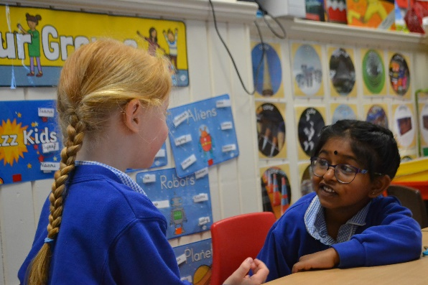
We expect parents to act as positive role models for all children. We expect that the respect we promote between the children is modelled by all the adults involved with the children. Threatening or violent behaviour will not be tolerated.
“Behaviour in lessons and around the school is exemplary.” Ofsted 2018.

We have the following Golden Rules:
- Be Kind
- Be Respectful
- Be Truthful
- Be Safe
- Be Ready

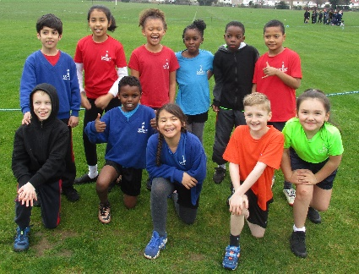

Help us to keep your children safe
A watch and earrings are the only jewellery permitted to be worn. If your child has pierced ears, only stud earrings may be worn. Hoop earrings and rings are not permitted and are considered a health and safety hazard.
Following LA safety guidelines, earrings must be removed for all PE activities and swimming lessons. Removing, storing and replacing earrings is the sole responsibility of the child. If your child is unable to remove their earrings, they must tape them for PE and swimming lessons. We consider it unnecessary for pupils to have mobile phones and electronic equipment (PSP’s, IPods, MP3 players etc) in school and take no responsibility for any loss or damage if this advice is not followed.
We expect that all staff including volunteers, have a full and active part to play in protecting our pupils from harm. Full details are available in our Safeguarding policy on our website.
Children are not permitted to dispense their own medication at school. A permission to dispense consent form must be completed at the office and all medication is stored in the office.
Across the country every school has a designated Safeguarding Leader (DSL) responsible for child protection and they have a legal duty to report to Social Care any children who appear to be at risk and are giving cause for concern.

Our DSL team is:
Mrs Blow (HT-DSL)
Miss A Diamant (DHT-DSL)
Mr Carrington (AHT – DSL)
Mrs Danaher
(EYFS/KS1 Leader – DDSL)

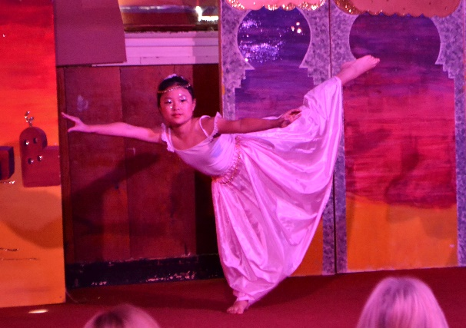
Please ensure that the information on your child’s emergency contact form is kept up to date and that you advise the office immediately of any changes to phone numbers or addresses.
Clubs
Children at Morden are fortunate to have hard working and dedicated staff members who volunteer their time to lead clubs at both lunchtimes and after school. Some of these clubs include art club, board games, dance, drama, football club, tennis, fitness, ICT, maths games, netball, and running club.
Musical and Drama activities
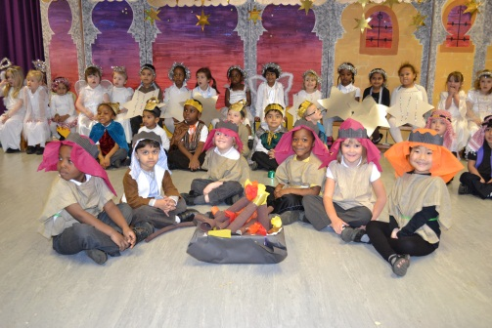
We encourage drama across the curriculum and develop children’s performance skills across the school. In the Foundation Stage and KS1, children participate in a Christmas nativity. KS2 children lead a Christmas carol concert which is held at St Lawrence’s church and parents are invited to attend this service.
KS2 children are also encouraged to audition and participate in the Summer term musical.
This is held at St Lawrence’s parish hall on the stage and tickets are sold to family and friends of the school prior to the performance.
Home Learning
At Morden we believe home learning is an important link between home and school. It supports and extends the curriculum, can raise children’s achievement and creates independence. Home learning may include spellings, times tables, literacy and maths related work and topic based tasks. It is also expected that children will read every night for at least 10 minutes. With younger children, this involves reading to an adult.
With older independent readers, this involves the child reading individually. Parents are expected to sign their child’s home/school reading record. KS1 and KS2 children also complete half termly projects linked to the work they are studying in topic.

Learning Environments
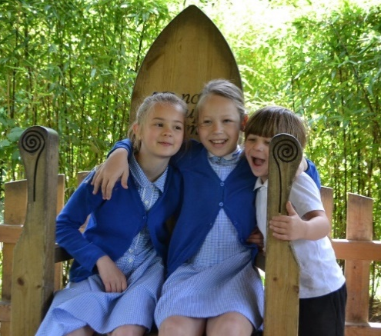
At Morden we pride ourselves on creating attractive and stimulating environments which are conducive to learning.
Displays are used in a positive way to highlight key themes and illustrate examples of work from all ages and all curriculum areas. Classrooms are appealing and attractive making good use of space, display and learning prompts.
Uniform
All children from Nursery to Year 6 are required to wear uniform. We believe that it not only looks smart, but contributes positively to the ethos of the school. School colours are royal blue with the school logo highlighted in white and gold. School uniform can be ordered online via our website or directly with www.mapac.co.uk
Nursery Only
Grey elasticated trousers or tracksuit bottoms
White polo shirt
Blue school logo jumper
Suitable school shoes.
Boys – Reception-Year 6
Grey trousers/shorts
Black, grey or white socks
White shirt (Y1-Y6)
Polo shirt (Early Years only)
Blue school logo jumper
School tie
(KS1 elasticated; KS2 regular tie)
Girls – Reception-Year 6
Grey skirt/trousers
Black or grey socks with trousers, white socks with dresses/skirts. Black/grey/ white tights in winter.
White shirt (Y1-Y6)
Polo shirt (Early Years only)
Blue and white summer dresses
Blue school logo jumper/cardigan
School tie
(KS1 elasticated; KS2 regular tie)
PE kit – Reception-Year 6

T-shirt to match the colour of their allocated hummingbird team; black shorts
Black school logo tracksuit bottoms/plain black tracksuit bottoms
Black Morden Hoodie
Black plimsolls (indoor)
Trainers (outdoor)


Outdoor
Blue school logo fleeces (outdoor only)
Educational Visits
At various times throughout the school year there are many opportunities to take learning outside the classroom into the surrounding locality or further afield. Being so close to central London we have an exciting and stimulating range of places of interest to support and extend curriculum topics. Parents are asked for voluntary contributions; without which these trips could not take place. Wherever possible, we make use of Transport for London’s free travel scheme for schools.
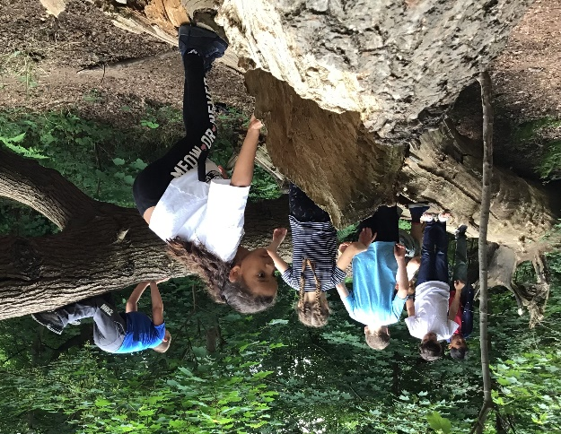
In Year 5 & 6 children are offered the opportunity to take part in a week’s long annual residential trip which compliments many areas of the curriculum as well as being a great life experience. Activities offered are often ones which children may not normally have access to, and provide children with a fantastic boost to self-confidence. Year 3 & 4 are offered an overnight residential. Charges for such trips are in accordance with the school’s ‘Charging and Remissions’ policy.
Healthy School
Morden Primary is a healthy school. We actively encourage all aspects of a healthy lifestyle, with a particular focus of healthy eating. For children’s lunches parents can select between school dinners or packed lunches. A broad range of nutritional school
dinners are cooked on site every day.
Packed lunches should be healthy and contain only one treat. On Mondays, we do not permit chocolate or crisps – a rule created by the children!
Children in KS1 & EYFS are entitled to a daily free school meal under the infant universal free school meal scheme.
House Teams
At Morden we have five teams which are based on our hummingbird theme. They are:
Comet – Yellow
Firecrown – Red
Rufous – Orange
Xantus – Green
Zafiro – Blue

Children are placed into one of these teams in Reception and will move through the school in this team.
Team points are given as rewards for achieving their personal best; good behaviour; effort with work; goodwill and kindness towards others; and for motivation. Weekly totals are recorded in assembly, with termly rewards given to the winning team.
PTA
Every parent is an automatic member of the PTA when your child joins our school community. The PTA raises money for those additional treats and experiences that the school budget cannot provide. We have regular tuckshops, raffles and film nights. We look forward to you joining our team.

