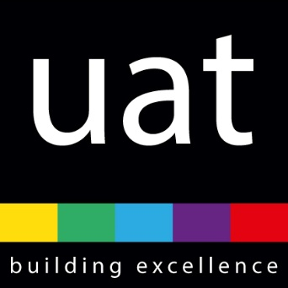

Year 1 Class Teacher: Maternity Cover
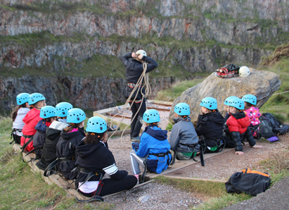
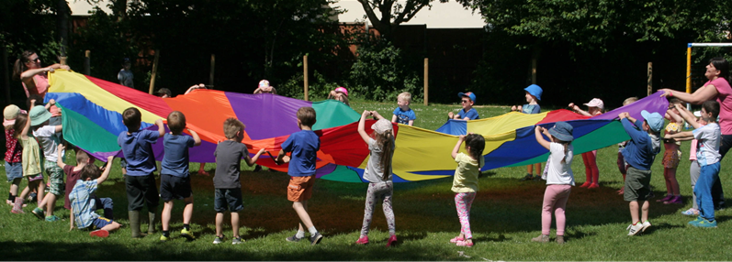
(Required for February 2022)

Letter from the Chief Executive Officer of Uffculme Academy Trust
Dear Applicant
I would like to thank you very much for your interest in the fixed term role of Year 1 class teacher based at Uffculme Primary School. I hope that this recruitment pack will give you an idea of Uffculme Academy Trust, what we stand for and what it might be like to work with us.
We have a simple and compelling vision for education. We believe that our schools should sit at the heart of our communities; that there are no limits to what our children and young people can achieve; and that they should be great places to work and learn.
We are incredibly proud of our Trust and the schools within it. Strong partnerships, collaboration and generosity are the bonds which underpin our collective mission to provide great education for all children no matter what their starting point or their background.
I have been associated with Uffculme Academy Trust for more than 10 years, and I have no doubt that it is a very special organisation. Having moved from Headteacher to Executive Head to CEO, I know first-hand how a strong ethos, ambitious culture and compassionate environment drive success. We are lucky enough to employ brilliant people who share our vision, many of whom have started careers with us and stayed to progress these careers. We want people to join us who believe that, whatever their role, they can make a difference to the life chances of students. We are totally committed therefore to helping all our staff thrive and fulfil their professional ambitions.
We are looking for an individual who shares the same vision and values - if you believe that you have the skills, drive and vision to help us achieve our aims we would be delighted to receive your application.
The closing date for applications is 9.30am on Tuesday 25th January 2022.
We look forward to receiving your application.
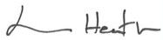
Lorraine Heath OBE
Chief Executive Officer

Uffculme Academy Trust

Uffculme Academy Trust is a multi-academy trust (MAT) working across Devon and Somerset. It was born of the partnership between Uffculme Secondary School, an outstanding 11-16 comprehensive, and Uffculme Primary School, which is the nearest and biggest of the secondary school's eight feeder schools. In September 2019 Holyrood Academy and Axe Valley Academy joined the Trust and we welcomed Neroche Primary school on the 1st January 2021
The founding school of Uffculme Academy Trust (the Trust), Uffculme Secondary School, was a successful, high performing school with an outstanding Ofsted rating for many years. Uffculme Academy Trust first grew to include Uffculme Primary School and the support of the Trust enabled a process of substantial school improvement: moving from an undersubscribed to an oversubscribed school in less than two years; and to achieve impressive outcomes almost immediately.
In September 2019 Holyrood Academy and Axe Valley Academy joined the Trust bringing a wealth of experience in working with students from age 11 to 18 and greater opportunities to share knowledge and experience across all the schools within the Trust. In January 2021 we were delighted when Neroche Primary school joined us, meaning that Uffculme Academy Trust is now able to offer an all- through provision for students aged between 2 and 18 years in its own locality.
The Trust is a single organisation which works collaboratively to improve, secure and maintain high standards in education. All schools coalesce around a compulsion to recruit and retain great staff in order to achieve this. We are responsible for the good governance of our schools and are accountable for their performance.
The Trust's mission is therefore to provide outstanding educational experiences to all the children and young people who are educated within our schools.
This is underpinned by our core beliefs and values that:
- every child has the right to a high-quality education where excellence is the norm
- teachers have the right to teach free from disruption and distractions, and
- parents have the right to know that their children are well cared for and supported to achieve their best.

Our Locations
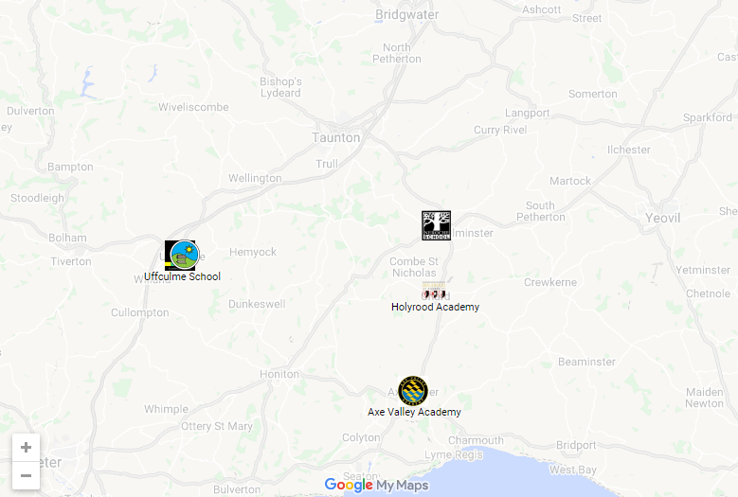

All our schools are situated in the beautiful countryside of Devon and South Somerset, within easy commuting distance of Exeter to the west and Bristol to the North, being close to some of the most beautiful coastlines of Devon and Dorset.

Our schools’ varied locations allow our staff to access not only beautiful beaches, but also some of the best areas for walking, biking and other outdoor activities; yet the cities of Exeter, Bristol and Bath are close by.

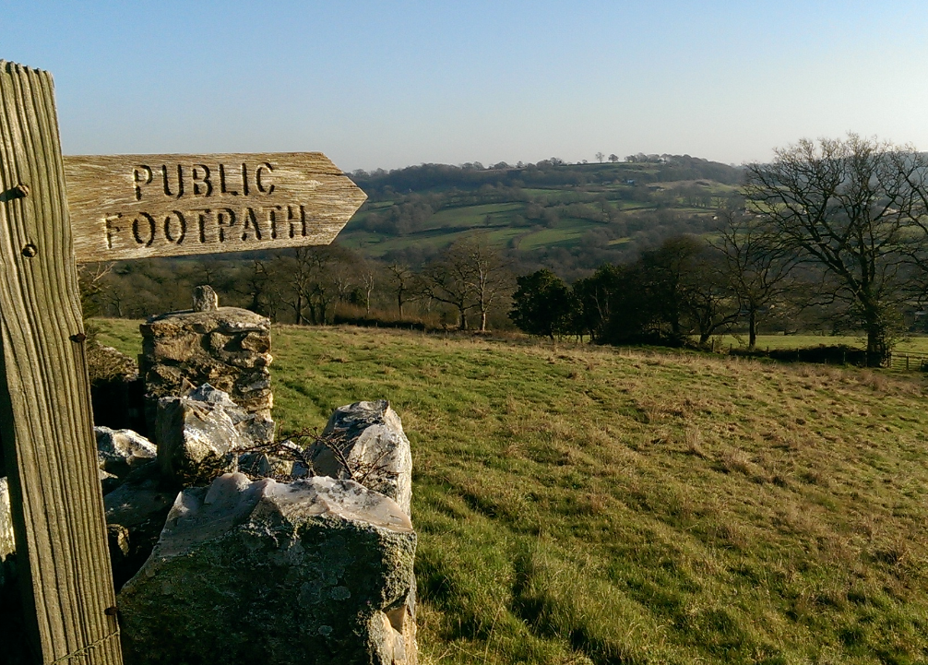

What we can offer you
We believe firmly that as a small MAT, we can combine the benefits of collaborative working with those of knowing our schools and the individuals who work within them well. We set great store by positive professional relationships and never want to lose sight of the unique characteristics and contexts of all of our schools.

By joining Uffculme Academy Trust you become part of a Trust that delivers the highest possible standards of education for our children through a varied and diverse curriculum that values extra-curricular opportunities to develop the whole child.

We are committed to your professional development and there are opportunities to work in partnership with colleagues across the Trust. Each school within the Trust shares good practice and provides exceptional opportunities to learn from each other. All of our senior leaders are system leaders and regularly contribute to the leadership programmes of Teaching Schools across the region including those put on by our own Teaching School, WCTSA.
In addition, the Trust is serious about the wellbeing of its staff and operates in a culture of mutual respect, trust and compassion that recognises the importance of a work-life balance. Our Wellbeing offer includes personal training and fitness, counselling, cognitive behavioural therapy, nutrition and injury rehabilitation as well as membership to either of our two Fitness Centres.

Safeguarding
Uffculme Academy Trust is committed to safeguarding and promoting the welfare of children, young people and vulnerable adults and expects all staff and volunteers to share this commitment. We particularly welcome applications from underrepresented groups including ethnicity, gender, transgender, age, disability, sexual orientation or religion.

We operate in accordance with our Child Protection and Safeguarding Policy, and applicants will be subject to a full Disclosure and Barring service check.

Equality and Diversity
The Trust recognises that by valuing and promoting equal opportunities in employment for
all employees and job applicants and avoiding unlawful discrimination in employment and
delivery of services, we will be able to deliver first class education.

We aim to create a working environment in which all individuals are able to make best use of their skills, free from discrimination or harassment, and in which all decisions are based on merit. We also value diversity and recognise the varied contributions that a diverse workforce brings to an organisation; we are committed to drawing on different perspectives and experiences of individuals which will add value to what we do.

Letter from the Headteacher of Uffculme Primary School

Dear Applicant,

On behalf of Uffculme Primary School, I would like to thank you for your interest in the role of Year 1 Class teacher.

This is an exciting role and is an excellent development opportunity for someone who is keen to develop as a teacher and work with a strong, committed staff to provide the very best outcomes for our children. This post is suitable for an Early Career Teacher.

We are a forward-thinking school, and we are looking to appoint a highly motivated and inspiring teacher to join our team. You will have a passion for working with children from different backgrounds to ensure they receive the education they deserve. You will bring an innovative and creative approach to teaching, learning and outcomes for pupils within your class.

We can offer:
- A happy, forward looking school with a hard-working team
- Strong systems to support vulnerable learners
- An excellent Teaching Assistant team who undertake interventions and support
- A commitment to professional development
- The support of the Multi-Academy Trust and a network of teachers across our schools

If you share our vision and values, enjoy a challenge and the rewards associated with supporting young people to reach their full potential, then we would like to hear from you.

To apply, please complete an application form and attach a separate supporting letter of no more than two sides explaining your suitability for the post at Uffculme Primary School.

If you would like to know more, or you would like an informal discussion about the role, then please contact me on 01884 840282. Alternatively, you can email me at admin@primary.uffculmeschool.net

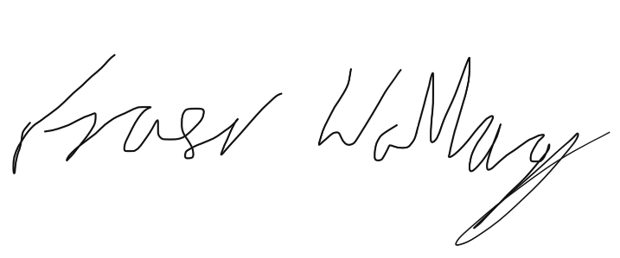
Fraser Wallace
Headteacher

Uffculme Primary School

Uffculme Primary School is a single form of entry school with one class for each year group, with over 220 pupils from Reception to Year 6.
We place great emphasis on knowing children as individuals and identifying their individual needs. We provide a safe and happy environment in which all children can reach their full potential.
Our experienced, committed and dedicated team of teachers and support staff continually strive to provide the best quality of teaching and care to all our pupils so that each one can thrive and reach their full potential. We aim to deliver a creative and challenging curriculum across the whole school through a thematic approach with many enrichment activities.
We expect every child to work to their best ability in all aspects of their school life and to contribute to the life of the school and the communities we are part of. We believe in building links with our local community and beyond to help our children make sense of the world today and find their place in tomorrow’s world.

Full-time Class Teacher: Maternity cover

Location: Uffculme Primary School
Pay Grade M1 – M3
Hours of Work: Full-time
Responsible For: Teaching and learning within the classroom
Key Relationships: Key Stage Leader; Headteacher, Uffculme Primary School; CEO
Reporting to: Headteacher, Uffculme Primary School

Main purpose of the role:
- To perform a leading role in raising standards, challenging performance and supporting improvement, to ensure that all children attending Uffculme Primary School achieve their full potential
- To ensure the achievement of excellent educational standards by assisting the headteacher in monitoring the teaching and learning across the school
- To ensure the ethos and practice of the school reflects the ethos and principles of the Academy Trust
- To promote and safeguard the welfare of the children

Teaching and Learning:
- Design learning experiences that inspire and motivate all children to succeed
- Promote excellent progress and outcomes for all pupils
- Accurately assess the learning and progress of pupils and make effective use of this information
- Record pupils’ progress and achievements systematically, using this as a platform for further development
- Track progress of individual pupils to identify those who are exceeding expectations, or those who are underachieving, reporting to the headteacher
- Effectively manage pupil behaviour
- Perform a leading role in raising standards, with an emphasis on curriculum development
- Be an exceptional classroom practitioner, able to demonstrate, and support others to achieve excellent classroom technique, leading to effective learning.
- Have extensive and up to date subject and pedagogical knowledge to inform the development of teaching and learning
- Contribute to the effective work and strategic planning of the Senior Leadership Team

Professional Practice:
- Demonstrating and promoting the positive values, attitudes and behaviours that are expected from the whole learning community
- Identifying and taking responsibility for professional development in line with the school’s improvement priorities and own objectives
- Demonstrating strong and up-to-date subject and curriculum knowledge
- Contributing positively to the safeguarding and wellbeing of all pupils in the school
- Making a positive contribution to the continued development of all teams of which you are a member and their positive profile across the academy

Special Factors
- The post-holder will support the achievement of the Trust’s objectives by working proactively with colleagues on projects or activities outside their direct area of responsibility as required.
- The post-holder is expected to familiarise themselves with and adhere to all relevant Trust and School based Policies and Procedures.
- To be aware of and assume the appropriate level of responsibility for safeguarding and promoting the welfare of children and to report any concerns in accordance with the Trust’s safeguarding policies.
- As this post meets the requirements in respect of exempted questions under the Rehabilitation of Offenders Act 1974, all applicants who are offered employment will be subject to an Enhanced Disclosure and Barring Service Check (DBS) before the appointment is confirmed. This will include details of ALL cautions, reprimands or final warnings as well as convictions, whether “spent” or “unspent”. Criminal convictions will only be taken into account when they are relevant to the post.

This job description sets out the duties and responsibilities of the post at the time when it was drawn up. Such duties and responsibilities may vary from time to time without changing the general character of the duties or the level of responsibility entailed. Such variations are a common occurrence and cannot themselves justify a reconsideration of the grading of the post.

Uffculme Academy Trust is seeking to promote the employment of disabled people and will make any adjustments considered reasonable to the above duties under the terms of the Equality Act 2010 to accommodate a suitable disabled candidate.

Person Specification

Essential | Assessed through
Good hons degree (2:2 or higher) in a relevant subject | Application
QTS status | Application
Experience of teaching in the primary age range | Application
Excellent interpersonal skills | Letter/references/interview
A genuine love of teaching and rapport with children | Letter/references
Evidence of ability to secure good outcomes for children within the class | Letter/interview
Relevant additional subject or age-specific training | Application
Willingness to go the extra mile to secure high levels of pupil performance and engagement | Letter/references
Excellent ICT skills | Letter/references
Excellent organisational and time management skills | Application/letter/interview
Evidence of ability to build productive working relationships with parents and fellow professionals | Letter/References/interview
Excellent relationships with colleagues | References
Evidence of support for and input into the enrichment or extra-curricular programme | Letter/interview
Ability to communicate effectively at all levels | Letter/References/interview
A clear understanding of the national agenda and key areas of curriculum change | Interview
Tact and diplomacy | Interview
A sense of humour | Interview
Infectious enthusiasm and relentless positivity | Interview
Creativity, imagination and ideas | Letter/interview
Flexibility | Letter/interview

Desirable | Assessed through
Experience of teaching in different key stages | Application
Participation in relevant development training | Application
Ambitions to develop your career further | Letter/interview
Evidence of wider professional learning | Letter/interview

