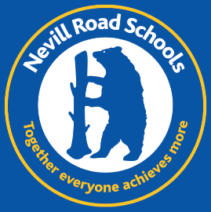
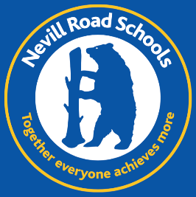
Nevill Road Infant School
Teachers … we need you!
Maternity cover for Spring and Summer 2023
We are looking for someone who can:
Make us as excited as Tigger
Help us find out who we are
Guide us through the rainforest
Discover bugs and creepy crawlies
Challenge our brains
Help us escape the Great Fire of London
Build the best fairy-tale castle

We are looking for someone who is:
- An outstanding practitioner
- Experienced in working within Key Stage 1
- Exciting, creative and motivating
- Nurturing and passionate about early education
- A real team player
- Able to go the extra mile for our children and families

We can offer:
- Outstanding behaviour and pupil attitudes
- Bright, motivated and engaged children
- Supportive and interested parents
- An amazing PTA
- A focused, dedicated and inspiring team
- A place in our Nevill Road family
- Free staff lunch

We are looking for a passionate and self-motivated teacher to join our hard-working and dedicated team.
We would love to show you around, please contact us to arrange this.

Nevill Road Infant School is committed to safeguarding and promoting the welfare of children and young people and expects all staff and volunteers to share this commitment. The successful applicant will be required to have an Enhanced Disclosure from the Disclosure and Barring Service.

For further information and an application pack, please contact:

Mrs. Sharon Kyne
School Business Manager
Nevill Road Infant School
Closing Date: 28th November 2022
Shortlisting Date: 29th November 2022
Interview Date: 2nd December 2022
Nevill Road
Stockport SK7 3ET
0161 4394817

www.nevillroadinfant.co.uk admin@nevillroad-inf.stockport.sch.uk

