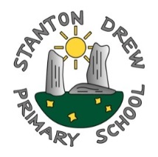
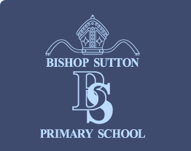
Stanton Drew Primary School
Upper Stanton
Stanton Drew BS39 4EQ
Tel: 01275 332820
sdps@bishopsuttonstantondrew.co.uk
Bishop Sutton Primary School
Wick Rd
Bishop Sutton BS39 5XD
Tel: 01275 332817
bsps@bishopsuttonstantondrew.co.uk
The Federation of
Bishop Sutton and Stanton Drew Primary Schools

Job Title: Class Teacher Year 3/4
Location: Stanton Drew Primary School
Closing Date: Thursday 8th July 2021
Interview Date: week commencing 12th July 2021
Start Date: 1st September 2021
Contract: Fixed Term contract until 31/08/2022
Hours: Part-time (0.66 FTE) (Monday, Tuesday and Wednesday)
Grade: Main Pay Range 1-6 (£25714 - £36961 pro rata)
Advert Details: Applications are invited from qualified teachers for the above post in our ‘Outstanding’ village Primary School. We welcome applications from both experienced and less experienced colleagues. The successful applicant will begin post on 1st September 2021.
We are looking for a teacher who has:
- High expectations of pupil achievement and will be an excellent classroom practitioner, capable of working across all phases but especially in Key Stage 2.
- A passion for teaching and learning via a skills-based curriculum.
- A commitment for raising aspirations.
- A positive approach to behaviour management and a commitment to fostering positive relationships with every child.
- An understanding of and experience in a range of strategies for raising attainment and achievement.
- Excellent team work and communication skills as this is a job share.
- The ability to build on and develop existing good practice.

Stanton Drew School is a member of the Lighthouse Schools Partnership we are a small village school in the beautiful Chew Valley. At the moment we have 56 pupils organised into 3 classes, Reception Year 1 & 2, Year 3 & 4, Year 5 & 6. We are federated with Bishop Sutton School sharing a head teacher, deputy head teacher and governing body.
Stanton Drew School can offer you:
- A friendly and supportive staff team.
- A school graded as ‘outstanding’ by Ofsted in 2012, providing excellent teaching and learning.
- Caring and respectful pupils who are proud of their school and work with independence and enthusiasm.
- A commitment to CPD opportunities.
- A supportive team of governors.
- Opportunities to work across the federation and with our trust colleagues at Lighthouse Schools Partnership.

Please contact our federated school at Bishop Sutton for further details:
Telephone 01275 332817 Email bsps@bishopsuttonstantondrew.co.uk

We are committed to safeguarding and promoting the welfare of children. We follow safer recruitment practices and appointments are subject to an enhanced DBS check.
Application details: Please return completed application forms to Bishop Sutton Primary School, Wick Road, Bishop Sutton, Bristol. BS39 5XD or email to bsps@bishopsuttonstantondrew.co.uk or apply via the eTeach website.
Safeguarding Statement
The Lighthouse Schools Partnership including Bishop Sutton School is committed to safeguarding and promoting the welfare of children, young people and vulnerable adults and expects and staff and volunteers to share this commitment. We particularly welcome applications from underrepresented groups including ethnicity, gender, transgender, age, disability, sexual orientation or religion.

